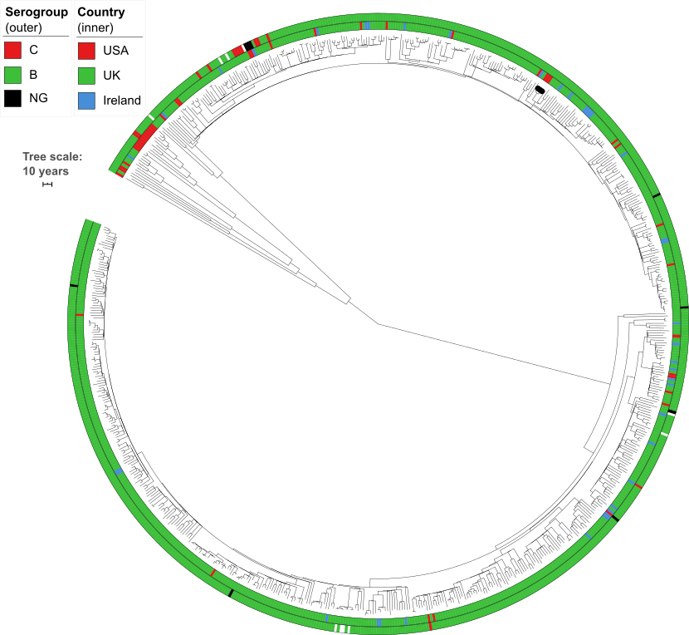
S4 Fig: Time-calibrated phylogeny of genomic cluster 4 (CC269, 710 isolates, 1,045,137bp core genome alignment). Inner ring shows the country of origin, outer ring shows serogroup. Black dots on leaf tips indicate isolates from one outbreak clade in the USA. Tree scale bar is 10 years. The estimated evolutionary rate is 8.6×10⁻⁷ subs/site/year.

