**Supplementary digital content**

**eTable 1.** Adjusteda singleb-chemical associations of maternal serum concentrations of persistent endocrine disrupting chemical (EDC) exposure with birth weight in the Avon Longitudinal Study of Parents and Children (ALSPAC) sub-study using linear regression. Beta estimates represent the change in birth weight for 10% higher chemical concentration.

|  |  |  |
| --- | --- | --- |
|  | **Single-chemical modelsb** | |
|  | **β** | **95% CI** |
| **Per- and polyfluoroalkyl substances (PFAS)** (ng/mL) | | |
| PFOA | -25 | -36, -14 |
| PFOS | -18 | -29, -6 |
| PFHxS | -2 | -8, 4 |
| PFNA | -7 | -17, 3 |
| MeFOSAA | -5 | -10, 0 |
| EtFOSAA | -14 | -21, -7 |
| **Polychlorinated biphenyls (PCBs)** (ng/g lipid) | | |
| PCB28 | -1 | -8, 5 |
| PCB74 | -8 | -20, 4 |
| PCB99 | -4 | -14, 5 |
| PCB105 | -12 | -23, -1 |
| PCB118 | -2 | -11, 8 |
| PCB138c | -12 | -23, -1 |
| PCB146 | -7 | -17, 3 |
| PCB153 | -18 | -31, -5 |
| PCB156 | -9 | -21, 2 |
| PCB170 | -23 | -38, -8 |
| PCB172 | 3 | -6, 12 |
| PCB177 | -9 | -18, 0 |
| PCB178 | -8 | -19, 2 |
| PCB180 | -23 | -38, -9 |
| PCB183 | -6 | -17, 5 |
| PCB187 | -10 | -21, 1 |
| PCB194 | -3 | -12, 6 |
| PCB195 | -4 | -14, 6 |
| PCB196c | -19 | -34, -5 |
| PCB199 | -4 | -14, 6 |
| PCB206 | -14 | -25, -2 |
| **Organochlorine pesticides (OCPs)** (ng/g lipid) | | |
| HCB | -4 | -16, 9 |
| β-HCH | -5 | -14, 3 |
| p,p'-DDE | -3 | -10, 4 |
| p,p'-DDT | -5 | -14, 4 |

Abbreviations: CI, confidence interval; ng/mL, nanogram per milliliter; ng/g lipid, nanogram per gram lipid  
a Adjusted for parity, pre-pregnancy BMI, maternal age, education, smoking, and gestational age at sample collection.

b Single-chemical linear regression models were run to examine independent associations between each chemical and birth weight. Betas represent a change of 10% higher chemical concentration.  
c PCB congeners 138 and 158 could not be separated and were quantified as a summed concentration, referred to as PCB138. Similarly, PCB congeners 196 and 203 could not be separated and were quantified as a summed concentration, referred to as PCB196.

**eTable 2.** Adjusteda associations of mixtures with accompanying weights of maternal serum concentrations of persistent endocrine disrupting chemical (EDC) exposure with birth size measures in the Avon Longitudinal Study of Parents and Children (ALSPAC) sub-study using repeated holdout weighted quantile sum regression (N=313).

|  |  |  |  |  |  |  |  |  |  |
| --- | --- | --- | --- | --- | --- | --- | --- | --- | --- |
|  | **Birth weight (g)** | | | **Head circumference (cm)** | | | **Crown-to-heel length (cm)** | | |
|  | **βb** | **95% CI** | **Weight** | **βb** | **95% CI** | **Weight** | **βb** | **95% CI** | **Weight** |
| **PFAS** | -36 | -63, -10 |  | -0.08 | -0.15, 0.00 |  | -0.22 | -0.39, -0.04 |  |
| PFOA |  |  | 0.23d |  |  | 0.05 |  |  | 0.17d |
| PFOS |  |  | 0.09 |  |  | 0.03 |  |  | 0.07 |
| PFHxS |  |  | 0.20d |  |  | 0.32d |  |  | 0.24d |
| PFNA |  |  | 0.12 |  |  | 0.12 |  |  | 0.09 |
| MeFOSAA |  |  | 0.18d |  |  | 0.26d |  |  | 0.21d |
| EtFOSAA |  |  | 0.18d |  |  | 0.23d |  |  | 0.22d |
| **PCBs** | -34 | -61, -8 |  | -0.08 | -0.14, -0.01 |  | -0.11 | -0.21, 0.00 |  |
| PCB28 |  |  | 0.05d |  |  | 0.12d |  |  | 0.04 |
| PCB74 |  |  | 0.02 |  |  | 0.05d |  |  | 0.02 |
| PCB99 |  |  | 0.03 |  |  | 0.04 |  |  | 0.04 |
| PCB105 |  |  | 0.01 |  |  | 0.01 |  |  | 0.01 |
| PCB118 |  |  | 0.02 |  |  | 0.01 |  |  | 0.02 |
| PCB138c |  |  | 0.02 |  |  | 0.03 |  |  | 0.03 |
| PCB146 |  |  | 0.09d |  |  | 0.08d |  |  | 0.09d |
| PCB153 |  |  | 0.08d |  |  | 0.04 |  |  | 0.04 |
| PCB156 |  |  | 0.08d |  |  | 0.02 |  |  | 0.03 |
| PCB170 |  |  | 0.03 |  |  | 0.04 |  |  | 0.03 |
| PCB172 |  |  | 0.03 |  |  | 0.05d |  |  | 0.03 |
| PCB177 |  |  | 0.05 |  |  | 0.02 |  |  | 0.02 |
| PCB178 |  |  | 0.05 |  |  | 0.08d |  |  | 0.02 |
| PCB180 |  |  | 0.10d |  |  | 0.06d |  |  | 0.06d |
| PCB183 |  |  | 0.10d |  |  | 0.04 |  |  | 0.15d |
| PCB187 |  |  | 0.05d |  |  | 0.02 |  |  | 0.05d |
| PCB194 |  |  | 0.03 |  |  | 0.05d |  |  | 0.11d |
| PCB195 |  |  | 0.05d |  |  | 0.06d |  |  | 0.11d |
| PCB196c |  |  | 0.02 |  |  | 0.02 |  |  | 0.03 |
| PCB199 |  |  | 0.05 |  |  | 0.09d |  |  | 0.04 |
| PCB206 |  |  | 0.05d |  |  | 0.05d |  |  | 0.04 |
| **Organochlorine pesticides** | -20 | -40, 0 |  | -0.03 | -0.08, 0.02 |  | -0.05 | -0.14, 0.04 |  |
| HCB |  |  | 0.33d |  |  | 0.31d |  |  | 0.40d |
| β-HCH |  |  | 0.31d |  |  | 0.32d |  |  | 0.32d |
| p,p'-DDE |  |  | 0.21 |  |  | 0.23 |  |  | 0.14 |
| p,p'-DDT |  |  | 0.15 |  |  | 0.15 |  |  | 0.14 |

Abbreviations: CI, confidence interval; PFAS, per- and polyfluoroalkyl substances; PCBs, polychlorinated biphenyls  
a Adjusted for maternal education, parity, pre-pregnancy body mass index, maternal age, prenatal smoking, and gestational week at sample collection

b β for one-unit higher of the WQS index (representing a one-decile increase in chemical concentrations)

c PCB congeners 138 and 158 could not be separated and were quantified as a summed concentration, referred to as PCB138. Similarly, PCB congeners 196 and 203 could not be separated and were quantified as a summed concentration, referred to as PCB196  
d Significant contributor to the overall mixture effect (>1/number of chemicals in mixture)

**eTable3.** Adjusteda associations of mixtures with accompanying weights of maternal serum concentrations of persistent endocrine disrupting chemical (EDC) exposure with ponderal index and small-for-gestational age measures in the Avon Longitudinal Study of Parents and Children (ALSPAC) sub-study using repeated holdout weighted quantile sum regression (N=313).

|  |  |  |  |  |  |  |
| --- | --- | --- | --- | --- | --- | --- |
|  | **Ponderal Index** | | | **SGA** | | |
|  | **βb** | **95% CI** | **Weight** | **ORc** | **95% CI** | **Weight** |
| **PFAS** | 0.00 | -0.01, 0.01 |  | 1.20 | 0.84, 1.69 |  |
| PFOA |  |  | 0.14 |  |  | 0.20f |
| PFOS |  |  | 0.11 |  |  | 0.10 |
| PFHxS |  |  | 0.17f |  |  | 0.12 |
| PFNA |  |  | 0.23f |  |  | 0.17f |
| MeFOSAA |  |  | 0.20f |  |  | 0.17f |
| EtFOSAA |  |  | 0.16 |  |  | 0.23f |
| **PCBs** | -0.01 | -0.02, 0.01 |  | 1.19 | 0.94, 1.51 |  |
| PCB28 |  |  | 0.11f |  |  | 0.03 |
| PCB74 |  |  | 0.06f |  |  | 0.06f |
| PCB99 |  |  | 0.03 |  |  | 0.11f |
| PCB105 |  |  | 0.11f |  |  | 0.07f |
| PCB118 |  |  | 0.05 |  |  | 0.14f |
| PCB138d |  |  | 0.03 |  |  | 0.04 |
| PCB146 |  |  | 0.05f |  |  | 0.05f |
| PCB153 |  |  | 0.02 |  |  | 0.02 |
| PCB156 |  |  | 0.04 |  |  | 0.06f |
| PCB170 |  |  | 0.02 |  |  | 0.03 |
| PCB172 |  |  | 0.04 |  |  | 0.04 |
| PCB177 |  |  | 0.05f |  |  | 0.04 |
| PCB178 |  |  | 0.08 |  |  | 0.06f |
| PCB180 |  |  | 0.04 |  |  | 0.04 |
| PCB183 |  |  | 0.05 |  |  | 0.03 |
| PCB187 |  |  | 0.05f |  |  | 0.02 |
| PCB194 |  |  | 0.02 |  |  | 0.04 |
| PCB195 |  |  | 0.02 |  |  | 0.03 |
| PCB196d |  |  | 0.01 |  |  | 0.02 |
| PCB199 |  |  | 0.05 |  |  | 0.03 |
| PCB206 |  |  | 0.07f |  |  | 0.04 |
| **Organochlorine pesticides** | -0.01 | -0.02, 0.00 |  | 1.15 | 0.94, 1.41 |  |
| HCB |  |  | 0.20 |  |  | 0.27f |
| β-HCH |  |  | 0.23 |  |  | 0.30f |
| p,p'-DDE |  |  | 0.29f |  |  | 0.18 |
| p,p'-DDT |  |  | 0.29f |  |  | 0.24 |
| **Overalle** | 0.00 | -0.02, 0.01 |  | 1.21 | 0.88, 1.66 |  |
| PFOA |  |  | 0.03 |  |  | 0.04f |
| PFOS |  |  | 0.02 |  |  | 0.02 |
| PFHxS |  |  | 0.05f |  |  | 0.04f |
| PFNA |  |  | 0.04f |  |  | 0.06f |
| MeFOSAA |  |  | 0.07f |  |  | 0.03 |
| EtFOSAA |  |  | 0.04f |  |  | 0.07f |
| PCB28 |  |  | 0.07f |  |  | 0.02 |
| PCB74 |  |  | 0.03f |  |  | 0.03 |
| PCB99 |  |  | 0.02 |  |  | 0.04f |
| PCB105 |  |  | 0.05f |  |  | 0.03f |
| PCB118 |  |  | 0.03 |  |  | 0.06f |
| PCB138d |  |  | 0.01 |  |  | 0.02 |
| PCB146 |  |  | 0.03 |  |  | 0.04f |
| PCB153 |  |  | 0.02 |  |  | 0.02 |
| PCB156 |  |  | 0.02 |  |  | 0.02 |
| PCB170 |  |  | 0.01 |  |  | 0.02 |
| PCB172 |  |  | 0.03 |  |  | 0.03 |
| PCB177 |  |  | 0.02 |  |  | 0.04f |
| PCB178 |  |  | 0.06f |  |  | 0.04f |
| PCB180 |  |  | 0.02 |  |  | 0.02 |
| PCB183 |  |  | 0.02 |  |  | 0.02 |
| PCB187 |  |  | 0.02 |  |  | 0.02 |
| PCB194 |  |  | 0.01 |  |  | 0.02 |
| PCB195 |  |  | 0.01 |  |  | 0.02 |
| PCB196d |  |  | 0.01 |  |  | 0.02 |
| PCB199 |  |  | 0.03f |  |  | 0.02 |
| PCB206 |  |  | 0.06f |  |  | 0.03f |
| HCB |  |  | 0.02 |  |  | 0.05f |
| β-HCH |  |  | 0.05f |  |  | 0.08f |
| p,p'-DDE |  |  | 0.05f |  |  | 0.02 |
| p,p'-DDT |  |  | 0.05f |  |  | 0.03f |

Abbreviations: SGA, small for gestational age; OR, odds ratio; CI, confidence interval; PFAS, per- and polyfluoroalkyl substances; PCBs, polychlorinated biphenyls  
a Adjusted for maternal education, parity, pre-pregnancy body mass index, maternal age, prenatal smoking, and gestational week at sample collection

b β for one-unit higher of the WQS index (representing a one-decile increase in chemical concentrations)  
c OR for one-unit higher of the WQS index (representing a one-decile increase in chemical concentrations)

d PCB congeners 138 and 158 could not be separated and were quantified as a summed concentration, referred to as PCB138. Similarly, PCB congeners 196 and 203 could not be separated and were quantified as a summed concentration, referred to as PCB196

e Overall mixture includes PFAS, PCB, and organochlorine pesticide classes  
f Significant contributor to the overall mixture effect (>1/number of chemicals in mixture)

**eTable 4.** Posterior inclusion probabilities (PIPs) for adjusteda associations of mixtures of maternal serum concentrations of persistent endocrine disrupting chemical (EDC) exposure with birth size measures in the Avon Longitudinal Study of Parents and Children (ALSPAC) sub-study using Bayesian kernel machine regression with component-wise variable selection and hierarchical variable selection. For the PFAS, PCB, and OCP mixtures, component-wise variable selection was used to estimate PIPs. For the overall mixture of all three class, hierarchical variable selection was used to provide group PIPs for pre-defined mutually exclusive groups of variables (each class: PFAS, PCBs, and OCPs) and conditional PIPs for the importance of a chemical given that the group containing the chemical was important. A higher PIP indicates greater importance to the model.

|  |  |  |  |  |  |  |  |  |  |  |
| --- | --- | --- | --- | --- | --- | --- | --- | --- | --- | --- |
|  | **Birth weight (g)** | | **Head circumference (cm)** | | **Crown to Heel Length (cm)** | | **Ponderal Index** | | **SGA** | |
|  | **PIP** | | **PIP** | | **PIP** | | **PIP** | | **PIP** | |
| **PFAS** |  | |  | |  | |  | |  | |
| PFOA | 0.55 | | 0.30 | | 0.83 | | 0.17 | | 0.46 | |
| PFOS | 0.52 | | 0.31 | | 0.45 | | 0.15 | | 0.61 | |
| PFHxS | 0.15 | | 0.44 | | 0.49 | | 0.13 | | 0.44 | |
| PFNA | 0.19 | | 0.32 | | 0.37 | | 0.27 | | 0.67 | |
| MeFOSAA | 0.16 | | 0.37 | | 0.45 | | 0.14 | | 0.30 | |
| EtFOSAA | 0.87 | | 0.44 | | 0.51 | | 0.14 | | 0.79 | |
| **PCBs** |  | |  | |  | |  | |  | |
| PCB28 | 0.46 | | 0.08 | | 0.43 | | 0.31 | | 0.34 | |
| PCB74 | 0.54 | | 0.13 | | 0.18 | | 0.27 | | 0.44 | |
| PCB99 | 0.49 | | 0.10 | | 0.17 | | 0.19 | | 0.27 | |
| PCB105 | 0.44 | | 0.08 | | 0.19 | | 0.30 | | 0.39 | |
| PCB118 | 0.56 | | 0.10 | | 0.19 | | 0.24 | | 0.46 | |
| PCB138b | 0.53 | | 0.10 | | 0.28 | | 0.28 | | 0.29 | |
| PCB146 | 0.58 | | 0.19 | | 0.23 | | 0.31 | | 0.16 | |
| PCB153 | 0.47 | | 0.16 | | 0.27 | | 0.28 | | 0.26 | |
| PCB156 | 0.56 | | 0.08 | | 0.23 | | 0.29 | | 0.13 | |
| PCB170 | 0.42 | | 0.08 | | 0.18 | | 0.21 | | 0.19 | |
| PCB172 | 0.63 | | 0.05 | | 0.20 | | 0.25 | | 0.17 | |
| PCB177 | 0.40 | | 0.04 | | 0.15 | | 0.31 | | 0.40 | |
| PCB178 | 0.41 | | 0.06 | | 0.10 | | 0.23 | | 0.09 | |
| PCB180 | 0.57 | | 0.17 | | 0.19 | | 0.30 | | 0.15 | |
| PCB183 | 0.48 | | 0.08 | | 0.29 | | 0.24 | | 0.27 | |
| PCB187 | 0.57 | | 0.07 | | 0.19 | | 0.30 | | 0.22 | |
| PCB194 | 0.48 | | 0.09 | | 0.16 | | 0.26 | | 0.14 | |
| PCB195 | 0.51 | | 0.09 | | 0.22 | | 0.47 | | 0.52 | |
| PCB196b | 0.52 | | 0.13 | | 0.19 | | 0.24 | | 0.10 | |
| PCB199 | 0.40 | | 0.17 | | 0.10 | | 0.29 | | 0.13 | |
| PCB206 | 0.48 | | 0.07 | | 0.16 | | 0.30 | | 0.08 | |
| **OCPs** |  | |  | |  | |  | |  | |
| HCB | 0.18 | | 0.48 | | 0.31 | | 0.28 | | 0.40 | |
| β-HCH | 0.25 | | 0.52 | | 0.40 | | 0.27 | | 0.76 | |
| p,p'-DDE | 0.23 | | 0.47 | | 0.30 | | 0.43 | | 0.30 | |
| p,p'-DDT | 0.77 | | 0.40 | | 0.30 | | 0.46 | | 0.31 | |
|  | **Group PIP** | **Cond. PIP** | **Group PIP** | **Cond. PIP** | **Group PIP** | **Cond. PIP** | **Group PIP** | **Cond. PIP** | **Group PIP** | **Cond. PIP** |
| **Overallc** |  |  |  |  |  |  |  |  |  |  |
| PFOA | 0.76 | 0.18 | 0.98 | 0.92 | 0.56 | 0.12 | 0.59 | 0.17 | 0.46 | 0.08 |
| PFOS | 0.76 | 0.10 | 0.98 | 0.05 | 0.56 | 0.08 | 0.59 | 0.16 | 0.46 | 0.13 |
| PFHxS | 0.76 | 0.00 | 0.98 | 0.01 | 0.56 | 0.19 | 0.59 | 0.15 | 0.46 | 0.12 |
| PFNA | 0.76 | 0.03 | 0.98 | 0.01 | 0.56 | 0.12 | 0.59 | 0.21 | 0.46 | 0.30 |
| MeFOSAA | 0.76 | 0.01 | 0.98 | 0.01 | 0.56 | 0.19 | 0.59 | 0.15 | 0.46 | 0.06 |
| EtFOSAA | 0.76 | 0.68 | 0.98 | 0.01 | 0.56 | 0.30 | 0.59 | 0.16 | 0.46 | 0.31 |
| PCB28 | 0.61 | 0.01 | 0.48 | 0.25 | 0.61 | 0.02 | 0.60 | 0.05 | 0.57 | 0.03 |
| PCB74 | 0.61 | 0.02 | 0.48 | 0.01 | 0.61 | 0.03 | 0.60 | 0.05 | 0.57 | 0.02 |
| PCB99 | 0.61 | 0.04 | 0.48 | 0.01 | 0.61 | 0.02 | 0.60 | 0.04 | 0.57 | 0.04 |
| PCB105 | 0.61 | 0.04 | 0.48 | 0.02 | 0.61 | 0.02 | 0.60 | 0.05 | 0.57 | 0.05 |
| PCB118 | 0.61 | 0.04 | 0.48 | 0.04 | 0.61 | 0.04 | 0.60 | 0.06 | 0.57 | 0.33 |
| PCB138b | 0.61 | 0.08 | 0.48 | 0.07 | 0.61 | 0.05 | 0.60 | 0.04 | 0.57 | 0.11 |
| PCB146 | 0.61 | 0.06 | 0.48 | 0.05 | 0.61 | 0.05 | 0.60 | 0.05 | 0.57 | 0.02 |
| PCB153 | 0.61 | 0.11 | 0.48 | 0.06 | 0.61 | 0.05 | 0.60 | 0.05 | 0.57 | 0.07 |
| PCB156 | 0.61 | 0.07 | 0.48 | 0.07 | 0.61 | 0.06 | 0.60 | 0.03 | 0.57 | 0.02 |
| PCB170 | 0.61 | 0.03 | 0.48 | 0.08 | 0.61 | 0.04 | 0.60 | 0.07 | 0.57 | 0.03 |
| PCB172 | 0.61 | 0.04 | 0.48 | 0.04 | 0.61 | 0.04 | 0.60 | 0.04 | 0.57 | 0.03 |
| PCB177 | 0.61 | 0.03 | 0.48 | 0.03 | 0.61 | 0.02 | 0.60 | 0.07 | 0.57 | 0.04 |
| PCB178 | 0.61 | 0.03 | 0.48 | 0.01 | 0.61 | 0.08 | 0.60 | 0.04 | 0.57 | 0.02 |
| PCB180 | 0.61 | 0.11 | 0.48 | 0.04 | 0.61 | 0.10 | 0.60 | 0.05 | 0.57 | 0.04 |
| PCB183 | 0.61 | 0.03 | 0.48 | 0.05 | 0.61 | 0.05 | 0.60 | 0.05 | 0.57 | 0.02 |
| PCB187 | 0.61 | 0.10 | 0.48 | 0.03 | 0.61 | 0.08 | 0.60 | 0.03 | 0.57 | 0.02 |
| PCB194 | 0.61 | 0.02 | 0.48 | 0.03 | 0.61 | 0.04 | 0.60 | 0.04 | 0.57 | 0.01 |
| PCB195 | 0.61 | 0.01 | 0.48 | 0.01 | 0.61 | 0.02 | 0.60 | 0.05 | 0.57 | 0.07 |
| PCB196b | 0.61 | 0.03 | 0.48 | 0.02 | 0.61 | 0.04 | 0.60 | 0.05 | 0.57 | 0.03 |
| PCB199 | 0.61 | 0.07 | 0.48 | 0.03 | 0.61 | 0.10 | 0.60 | 0.04 | 0.57 | 0.01 |
| PCB206 | 0.61 | 0.05 | 0.48 | 0.04 | 0.61 | 0.05 | 0.60 | 0.04 | 0.57 | 0.01 |
| HCB | 0.65 | 0.10 | 0.34 | 0.17 | 0.56 | 0.15 | 0.59 | 0.17 | 0.73 | 0.14 |
| β-HCH | 0.65 | 0.16 | 0.34 | 0.18 | 0.56 | 0.32 | 0.59 | 0.25 | 0.73 | 0.65 |
| p,p'-DDE | 0.65 | 0.32 | 0.34 | 0.34 | 0.56 | 0.29 | 0.59 | 0.29 | 0.73 | 0.06 |
| p,p'-DDT | 0.65 | 0.41 | 0.34 | 0.31 | 0.56 | 0.23 | 0.59 | 0.29 | 0.73 | 0.15 |

Abbreviations: PIP, posterior inclusion probability; SGA, small for gestational age; cond. PIP, conditional posterior inclusion probability; PFAS, per- and polyfluoroalkyl substances; PCBs, polychlorinated biphenyls; OCPs, organochlorine pesticides

a Adjusted for education, parity, pre-pregnancy body mass index, age, smoking, and gestational week at sample collection

b PCB congeners 138 and 158 could not be separated and were quantified as a summed concentration, referred to as PCB138. Similarly, PCB congeners 196 and 203 could not be separated and were quantified as a summed concentration, referred to as PCB196

c Overall mixture includes PFAS, PCB, and OCP classes

**eTable 5.** Sensitivity analysis exploring associationsab of detectable versus non-detectable serum concentrations of persistent endocrine disrupting chemicals with birth weight in the Avon Longitudinal Study of Parents and Children (ALSPAC) sub-study using linear regression. Beta estimates represent the change in birth weight for those with detectable concentrations, compared to those with non-detectable concentrations.

|  |  |  |
| --- | --- | --- |
|  | **βc** | **95% CI** |
| **Per- and polyfluoroalkyl substances (PFAS)** (ng/mL) | | |
| PFOA | N/A |  |
| PFOS | N/A |  |
| PFHxS | N/A |  |
| PFNA | N/A |  |
| FOSA | -120 | -218, -23 |
| MeFOSAA | -95 | -235, 44 |
| EtFOSAA | N/A |  |
| PFDA | N/A |  |
| **Polychlorinated biphenyls (PCBs)** (ng/g lipid) | | |
| PCB28 | 62 | -98, 223 |
| PCB44 | 9 | -95, 113 |
| PCB49 | -13 | -108, 83 |
| PCB52 | -10 | -114, 94 |
| PCB66 | 82 | -21, 186 |
| PCB74 | N/A |  |
| PCB87 | 39 | -57, 135 |
| PCB99 | N/A |  |
| PCB101 | -92 | -196, 12 |
| PCB105 | 44 | -122, 210 |
| PCB110 | 15 | -80, 109 |
| PCB118 | N/A |  |
| PCB128 | 48 | -115, 211 |
| PCB138d | N/A |  |
| PCB146 | N/A |  |
| PCB149 | 51 | -43, 146 |
| PCB151 | -10 | -128, 107 |
| PCB153 | N/A |  |
| PCB156 | N/A |  |
| PCB157 | 81 | -19, 182 |
| PCB167 | 10 | -97, 117 |
| PCB170 | N/A |  |
| PCB172 | 69 | -41, 179 |
| PCB177 | 62 | -120, 244 |
| PCB178 | 72 | -84, 229 |
| PCB180 | N/A |  |
| PCB183 | N/A |  |
| PCB187 | N/A |  |
| PCB189 | -41 | -140, 58 |
| PCB194 | N/A |  |
| PCB195 | -29 | -157, 99 |
| PCB196d | N/A |  |
| PCB199 | N/A |  |
| PCB206 | -88 | -276, 99 |
| PCB209 | -28 | -143, 88 |
| **Organochlorine pesticides (OCPs)** (ng/g lipid) | | |
| HCB | N/A |  |
| β-HCH | N/A |  |
| γ-HCH | -28 | -137, 81 |
| Oxychlordane | -82 | -189, 24 |
| Trans-nonachlor | -5 | -118, 107 |
| p,p'-DDE | N/A |  |
| o,p'-DDT | N/A |  |
| p,p'-DDT | 61 | -85, 208 |
| Mirex | N/A |  |

Abbreviations: CI, confidence interval; ng/mL, nanogram per milliliter; ng/g lipid, nanogram per gram lipid  
a Adjusted for parity, pre-pregnancy BMI, maternal age, education, smoking, and gestational age at sample collection  
b Restricted to those with % <LOD between 5% and 95%

c β represents the change in birth weight for those with detectable concentrations, compared to those with non-detectable concentrations (coded as a dichotomous variable)

d PCB congeners 138 and 158 could not be separated and were quantified as a summed concentration, referred to as PCB138. Similarly, PCB congeners 196 and 203 could not be separated and were quantified as a summed concentration, referred to as PCB196

**eTable 6.** Sensitivity analysis showing adjusteda associations of mixtures with accompanying weights of maternal serum concentrations of persistent endocrine disrupting chemical (EDC) exposure with birth weight in the Avon Longitudinal Study of Parents and Children (ALSPAC) sub-study using repeated holdout weighted quantile sum regression for mother-daughter dyads with blood samples collected at or before 20 weeks gestation (n=211). Estimates represent the change for one-unit higher of the WQS index (representing a one-decile increase in chemical concentrations).

|  |  |  |  |
| --- | --- | --- | --- |
|  | **Birth weight (g)** | | |
|  | **βb** | **95% CI** | **Weightc** |
| **Overalld** | -56 | -93, -19 |  |
| PFOA |  |  | 0.03† |
| PFOS |  |  | 0.02 |
| PFHxS |  |  | 0.08† |
| PFNA |  |  | 0.04† |
| MeFOSAA |  |  | 0.12† |
| EtFOSAA |  |  | 0.15† |
| PCB28 |  |  | 0.02 |
| PCB74 |  |  | 0.02 |
| PCB99 |  |  | 0.05† |
| PCB105 |  |  | 0.01 |
| PCB118 |  |  | 0.00 |
| PCB138e |  |  | 0.01 |
| PCB146 |  |  | 0.05† |
| PCB153 |  |  | 0.02 |
| PCB156 |  |  | 0.00 |
| PCB170 |  |  | 0.01 |
| PCB172 |  |  | 0.03† |
| PCB177 |  |  | 0.02 |
| PCB178 |  |  | 0.02 |
| PCB180 |  |  | 0.02 |
| PCB183 |  |  | 0.02 |
| PCB187 |  |  | 0.01 |
| PCB194 |  |  | 0.01 |
| PCB195 |  |  | 0.04† |
| PCB196e |  |  | 0.02 |
| PCB199 |  |  | 0.06† |
| PCB206 |  |  | 0.01 |
| HCB |  |  | 0.02 |
| β-HCH |  |  | 0.03 |
| p,p'-DDE |  |  | 0.02 |
| p,p'-DDT |  |  | 0.02 |

Abbreviations: PFAS, per- and polyfluoroalkyl substances; PCBs, polychlorinated biphenyls, OCPs, organochlorine pesticides  
a Adjusted for maternal education, parity, pre-pregnancy body mass index, maternal age, prenatal smoking, and gestational week at sample collection

b β for one-unit higher of the WQS index (representing a one-decile increase in chemical concentrations)

c Weights greater than 1/number of chemicals in the mixture are considered significant contributors to the overall mixture effect

d Overall mixture includes PFAS, PCB, and OCP classes

e PCB congeners 138 and 158 could not be separated and were quantified as a summed concentration, referred to as PCB138. Similarly, PCB congeners 196 and 203 could not be separated and were quantified as a summed concentration, referred to as PCB196  
† Significant contributor to the overall mixture effect (>1/number of chemicals in mixture)

**eTable 7**. Comparison of characteristics of various sub-samples of mother-daughter dyads from the Avon Longitudinal Study of Parents and Children (ALSPAC) population. The nested case-control study (N=448) was drawn from cohort daughters who were enrolled at puberty (N=3338). Complete data for mixture analyses was available for 313 mother-daughter dyads.

|  |  |  |  |
| --- | --- | --- | --- |
|  | **Enrolled at Puberty**  **N=3338** | **Nested Case-Control**  **N=448** | **Complete Data**  **N=313** |
| **Characteristic** | **n (%)**a | **n (%)**a | **n (%)** |
| Maternal race  White  Non-white  Maternal educationb  < O-level  O-level  >O-level  Maternal pre-pregnancy BMI  <25 kg/m2 (under/normal weight)  ≥25 kg/m2 (overweight/obese)  Prenatal smoking  Any  None  Prenatal alcohol use  Any  None  Physical activity  Any  None  Maternal age at delivery  <25 years  25–29 years  ≥30 years  Child birth order  First born  Second born or later  Child birth weight  <2500 g  ≥2500 g | 3050 (98)  54 (2)  549 (18)  1083 (36)  1385 (46)  2379 (81)  566 (19)  410 (13)  2677 (87)  1585 (52)  1491 (48)  1901 (67)  929 (33)  473 (15)  1275 (40)  1439 (45)  1469 (48)  1593 (52)  134 (4)  3010 (96) | 423 (98)  8 (2)  75 (18)  140 (34)  200 (48)  313 (78)  89 (22)  79 (18.5)  348 (81.5)  215 (51)  208 (49)  252 (65)  133 (35)  92 (21)  164 (37)  189 (42)  208 (50)  211 (50)  17 (4)  423 (96) | 308 (98)  5 (2)  53 (17)  104 (33)  156 (50)  243 (78)  70 (22)  47 (15)  266 (85)  155 (50)  153 (50)  184 (65)  99 (35)  54 (17)  122 (39)  137 (44)  156 (50)  157 (50)  8 (3)  305 (97) |

Abbreviations: g, grams; kg/m2, kilograms per meter-squared   
a Missing data not represented

b <O-level=none, Certificate of Secondary Education, and vocational education, which are equivalent to no diploma or a GED in the United States. O-levels (ordinary levels) are required and completed at the age of 16. >O-level=A-levels (advanced levels) completed at 18, which are optional, but required to get into university; and a university degree.

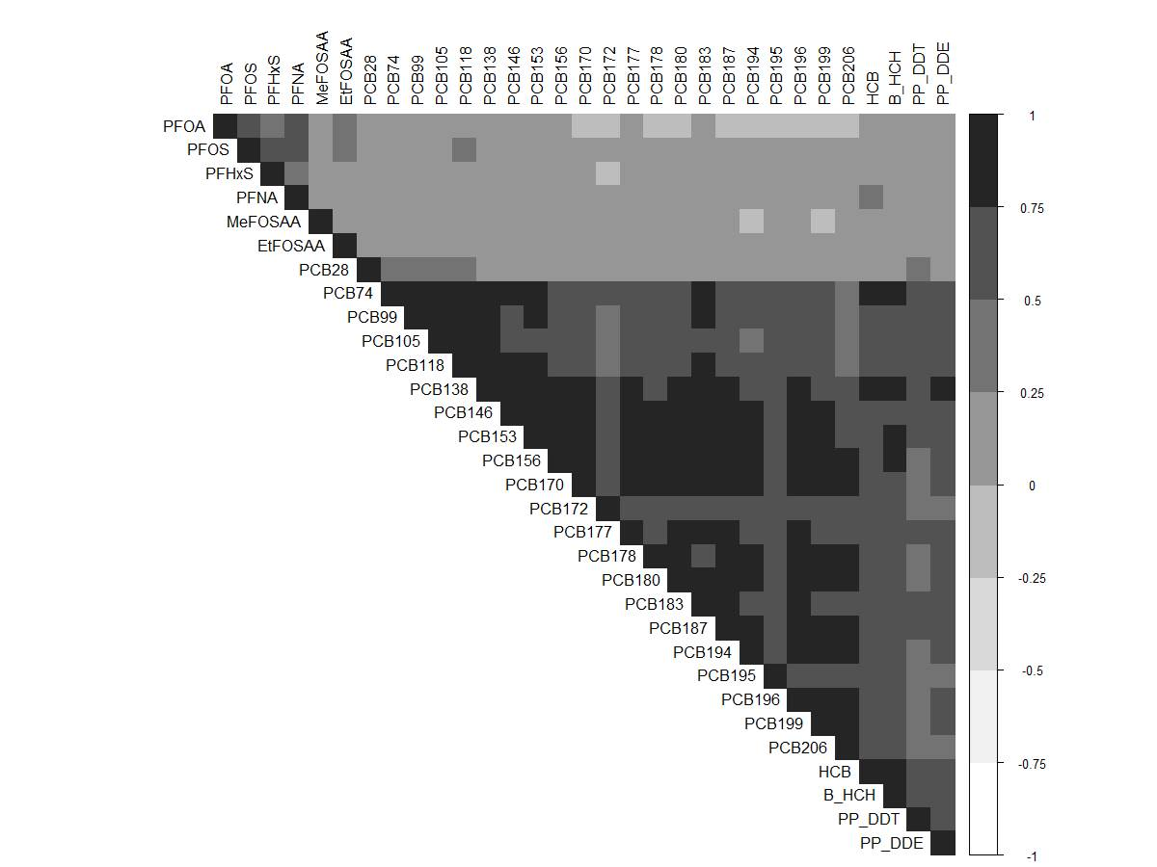

**eFigure 1.** Correlation heatmap of serum concentrations of persistent endocrine disrupting chemicals in women during pregnancy in the Avon Longitudinal Study of Parents and Children (N=448). Spearman correlation coefficients presented for per- and polyfluoroalkyl substances (PFAS), polychlorinated biphenyls (PCBs), and organochlorine pesticides (OCPs). PCB and OCP concentrations were lipid-adjusted.

|  |  |  |  |  |
| --- | --- | --- | --- | --- |
|  | **PFAS** | **PCBs** | **OCPs** | **Overall** |
| **Birth weight** |  |  |  |  |
| **Head Circumference** |  |  |  |  |
| **Crown to Heel Length** |  |  |  |  |
| **Ponderal Index** |  |  |  |  |
| **SGA** |  |  |  |  |

**eFigure 2.** Overall effect of the PFAS, PCB, OCP, and overall (all three classes combined) mixtures on birth size measures (estimates and 95% credible intervals) (N=313). The overall effect is defined as the change in the mean outcome when all the exposures are fixed at a particular quantile as compared to when all the exposures are fixed at the median, with all of the covariates held constant. All outcomes are continuous, standardized measures with the exception of SGA, which is dichotomous (SGA vs. not SGA). The model adjusted for maternal education, parity, pre-pregnancy body mass index, maternal age, prenatal smoking, and gestational week at sample collection. All chemical concentrations were natural log-transformed and standardized; PCB and OCP concentrations were lipid-adjusted.

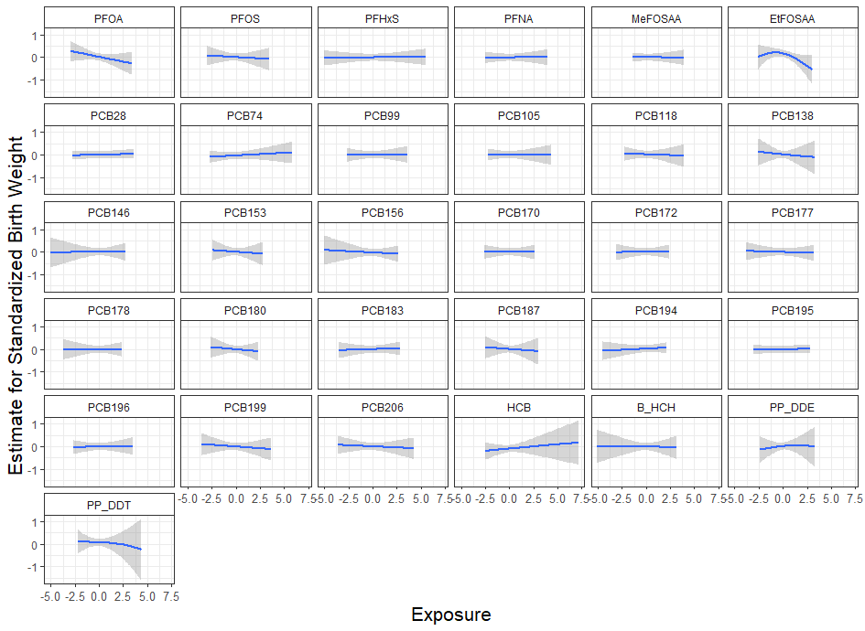

**A**

**B**

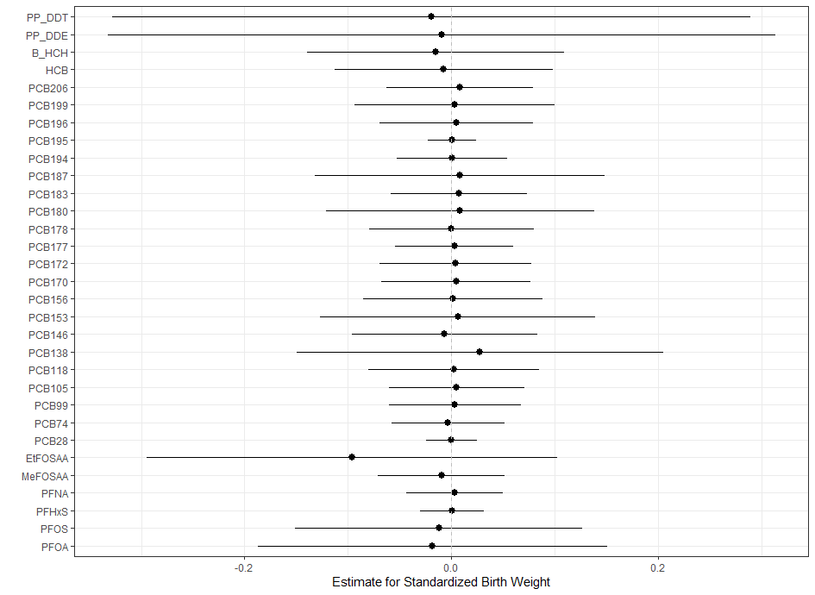

**eFigure 3. A** Chemical-specific effect estimates of mixture members on birth weight in ALSPAC mother-daughter dyads (N=313) estimated by BKMR. Single chemical associations and 95% credible bands are presented with other chemicals fixed at their median. **B** Interaction terms for individual mixture members and the remaining chemicals in ALSPAC mother-daughter dyads estimated by BKMR (N=313). Each point represents the difference between the effect size of the chemical when all other chemicals are held at their 75th percentiles and the effect size of the same chemical when all other chemicals are held at their 25th percentiles. Range indicates 95% credible interval. The model adjusted for maternal education, parity, pre-pregnancy body mass index, maternal age, prenatal smoking, and gestational week at sample collection. All chemical concentrations were natural log-transformed and standardized; PCB and OCP concentrations were lipid-adjusted.

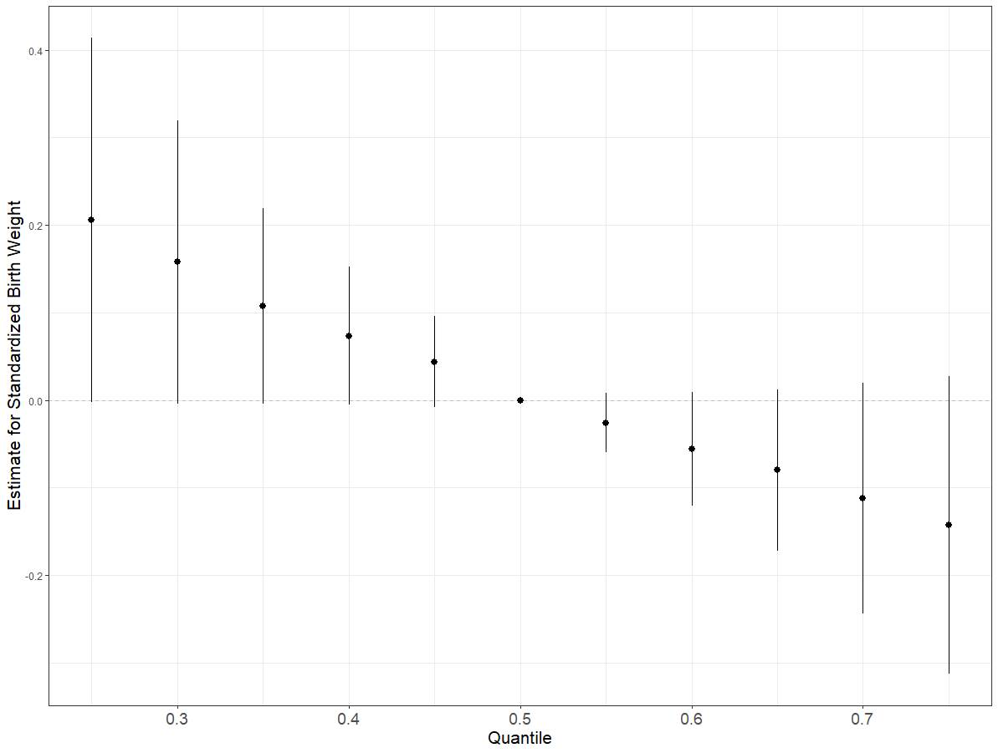

**eFigure 4.** Sensitivity analysis for the overall effect of the mixture representing prenatal exposure to all three classes combined (PFAS, PCBs, and OCPs) on birth weight (estimates and 95% credible intervals) in the Avon Longitudinal Study of Parents and Children (ALSPAC) sub-study using Bayesian kernel machine regression for mother-daughter dyads with blood samples collected at or before 20 weeks gestation (n=211). The overall effect is defined as the change in the mean outcome when all the exposures are fixed at a particular quantile as compared to when all the exposures are fixed at the median, with all of the covariates held constant. The model adjusted for maternal education, parity, pre-pregnancy body mass index, maternal age, prenatal smoking, and gestational week at sample collection. All chemical concentrations were natural log-transformed and standardized; PCB and OCP concentrations were lipid-adjusted. In this model, the group posterior inclusion probability (PIP) was highest for PCBs (0.89), followed by PFAS and OCPs (both 0.41). PCB153 had the highest conditional PIP (0.33) within the PCB class, while EtFOSAA (0.54) and p,p'-DDE (0.38) had the highest PIPs within the PFAS and OCP classes, respectively.

Missing birth weight (n=8)

Missing lipids (n=19)

Missing exposure data (n=43)

Missing covariate information (n=65)

**N=313**

Analytic dataset for mixture analyses

**N=378**

**N=421**

**N=440**

**N=448**

Complete nested case-control study

**eFigure 5.** Flowchart depicting missing data in the study of prenatal exposure to mixtures of persistent endocrine disrupting chemicals and birth size in a sub-study of the Avon Longitudinal Study of Parents and Children.