The Impact of Climate Change and Emissions Control on Future Ozone Levels: Implications for Human Health
Jennifer D. Stowell¹, Young-min Kim², Yang Gao³, Joshua S. Fu⁴, Howard H. Chang⁵, *Yang Liu¹
¹Department of Environmental Health, Rollins School of Public Health,
Emory University, Atlanta, GA
²Department of Pediatrics, Samsung Medical Center,
Sungkyunkwan University School of Medicine, Seoul, Korea
³College of Environmental Science and Engineering,
Ocean University of China, Qingdao, Shandong, China
⁴Department of Civil and Environmental Engineering,
University of Tennessee, Knoxville, Tennessee
⁵Department of Biostatistics and Bioinformatics, Rollins School of Public Health,
Emory University, Atlanta, GA

*Corresponding Author
Yang Liu
Department of Environmental Health
Rollins School of Public Health, Emory University
1518 Clifton Road NE, Atlanta, GA
404-727-2131
yang.liu@emory.edu

Appendix
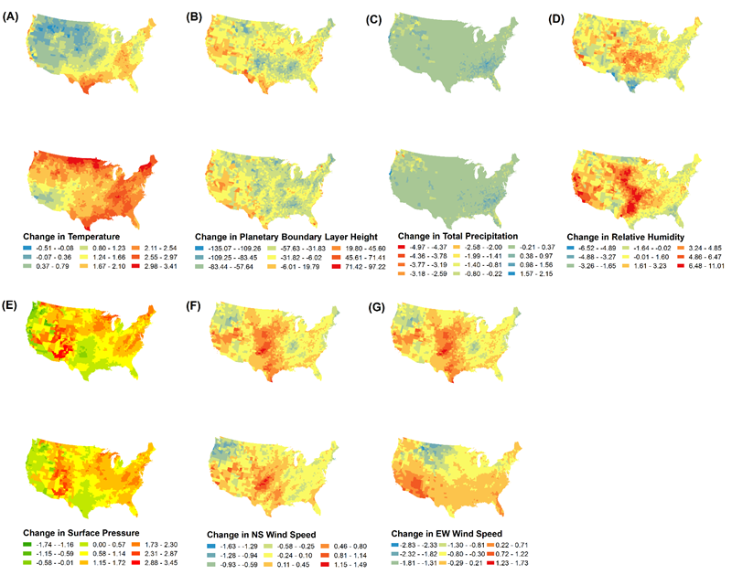
Supplemental Figure 1. Differences between 2000s and 2050s in (A) temperature, (B) planetary boundary layer, (C) precipitation, (D) relative humidity, (E) surface pressure, and (F and G) meridional and zonal wind speeds. Top row reflects RCP4.5 and bottom row reflects RCP8.5.
Supplemental Table 1. NARR vs. WRF Parameter Correlation
Parameter | Normal Distribution | Correlation Test | Average Correlation Coefficient
Temperature | Y | Pearson | 0.963
Pressure | N | Spearman | 0.990
Planetary Boundary Layer Height | Y | Pearson | 0.412
Relative Humidity | N | Spearman | 0.924
Precipitation | N | Spearman | 0.559
Wind Speeds  at 10 hPa | Y | Pearson | 0.800
Wind Speeds  at 500 hPa | N | Spearman | 0.947
V Wind Vector | N | Spearman | 0.862
U Wind Vector | Y | Pearson | 0.770

Supplemental Table 1. Correlation of NARR climate parameters to WRF modeled climate parameters for use in statistical modeling.

Supplemental Table 2. Excess Mortality by Population Scenario: RCP 8.5
 | CLIMATE CHANGE |  |  |  | EMISSIONS |  |  |  |  | COMBINED CLIMATE AND EMISSIONS
REGION | ICLUS A2  RCP 8.5 | ICLUS A1  RCP 8.5 | ICLUS B2  RCP 8.5 | ICLUS B1  RCP 8.5 | ICLUS A2  RCP 8.5 |  | ICLUS A1  RCP 8.5 | ICLUS B2  RCP 8.5 | ICLUS B1  RCP 8.5 | ICLUS A2  RCP 8.5 | ICLUS A1  RCP 8.5 | ICLUS B2  RCP 8.5 | ICLUS B1  RCP 8.5
National | 47 | 48 | 63 | 80 | 2167 |  | 1940 | 1853 | 1897 | 2217 | 2012 | 1992 | 2029
 | (SE=525) | (SE=433) | (SE=505) | (SE=458) | (SE=1386) |  | (SE=1139) | (SE=1319) | (SE=1233) | (SE=900) | (SE=802) | (SE=876) | (SE=874)
Northeast | 330 | 310 | 305 | 318 | 365 |  | 365 | 338 | 373 | 678 | 653 | 623 | 671
 | (SE=17) | (SE=22) | (SE=19) | (SE=27) | (SE=43) |  | (SE=57) | (SE=48) | (SE=68) | (SE=59) | (SE=79) | (SE=66) | (SE=95)
Southeast | -100 | -99 | -88 | -89 | 405 |  | 403 | 312 | 344 | 298 | 283 | 236 | 253
 | (SE=17) | (SE=19) | (SE=16) | (SE=20) | (SE=35) |  | (SE=39) | (SE=34) | (SE=42) | (SE=19) | (SE=20) | (SE=17) | (SE=21)
East North Central | -35 | -31 | -34 | -33 | 161 |  | 137 | 152 | 145 | 126 | 106 | 118 | 112
 | (SE=1) | (SE=1) | (SE=1) | (SE=1) | (SE=3) |  | (SE=2) | (SE=3) | (SE=2) | (SE=3) | (SE=2) | (SE=3) | (SE=2)
Central | 87 | 71 | 98 | 93 | 161 |  | 132 | 141 | 130 | 239 | 205 | 239 | 224
 | (SE=4) | (SE=3) | (SE=4) | (SE=4) | (SE=12) |  | (SE=10) | (SE=12) | (SE=12) | (SE=15) | (SE=12) | (SE=17) | (SE=15)
West North Central | 5 | 4 | 6 | 5 | 9 |  | 7 | 10 | 9 | 13 | 11 | 15 | 14
 | (SE=1) | (SE=1) | (SE=1) | (SE=1) | (SE=1) |  | (SE=1) | (SE=1) | (SE=1) | (SE=1) | (SE=1) | (SE=1) | (SE=1)
South | -13 | -13 | -16 | -15 | 169 |  | 149 | 146 | 144 | 152 | 135 | 131 | 130
 | (SE=3) | (SE=3) | (SE=2) | (SE=2) | (SE=6) |  | (SE=5) | (SE=5) | (SE=5) | (SE=6) | (SE=5) | (SE=6) | (SE=5)
Southwest | 18 | 18 | 13 | 13 | 98 |  | 83 | 83 | 82 | 114 | 102 | 99 | 94
 | (SE=7) | (SE=6) | (SE=5) | (SE=4) | (SE=15) |  | (SE=13) | (SE=13) | (SE=12) | (SE=13) | (SE=11) | (SE=10) | (SE=9)
Northwest | -5 | -3 | -4 | -1 | 122 |  | 114 | 115 | 116 | 112 | 107 | 108 | 115
 | (SE=2) | (SE=2) | (SE=2) | (SE=3) | (SE=8) |  | (SE=9) | (SE=8) | (SE=9) | (SE=9) | (SE=10) | (SE=8) | (SE=10)
West | -170 | -144 | -130 | -138 | 678 |  | 551 | 557 | 553 | 475 | 404 | 417 | 409
 | (SE=182) | (SE=143) | (SE=169) | (SE=153) | (SE=468) | (SE=367) |  | (SE=440) | (SE=395) | (SE=287) | (SE=228) | (SE=273) | (SE=242)

Supplemental Table 3. Excess Mortality by Population Scenario: RCP 4.5
 | CLIMATE CHANGE |  |  |  | EMISSIONS |  |  |  | COMBINED CLIMATE AND EMISSIONS
REGION | ICLUS A2  RCP 4.5 | ICLUS A1  RCP 4.5 | ICLUS B2  RCP 4.5 | ICLUS B1  RCP 4.5 | ICLUS A2  RCP 4.5 | ICLUS A1  RCP 4.5 | ICLUS B2  RCP 4.5 | ICLUS B1  RCP 4.5 | ICLUS A2  RCP 4.5 | ICLUS A1  RCP 4.5 | ICLUS B2  RCP 4.5 | ICLUS B1  RCP 4.5
National | 72 | 120 | 105 | 110 | -41 | -20 | -70 | 31 | 50 | 68 | 27 | 84
 | (SE=456) | (SE=369) | (SE=431) | (SE=400) | (SE=1037) | (SE=839) | (SE=967) | (SE=882) | (SE=615) | (SE=526) | (SE=586) | (SE=591)
Northeast | 204 | 195 | 186 | 193 | -2 | 30 | -1 | 37 | 208 | 220 | 183 | 232
 | (SE=12) | (SE=15) | (SE=13) | (SE=19) | (SE=28) | (SE=37) | (SE=31) | (SE=45) | (SE=40) | (SE=52) | (SE=44) | (SE=63)
Southeast | -47 | -50 | -41 | -48 | -186 | -145 | -149 | -139 | -237 | -199 | -198 | -181
 | (SE=10) | (SE=11) | (SE=9) | (SE=11) | (SE=14) | (SE=16) | (SE=14) | (SE=16) | (SE=5) | (SE=5) | (SE=4) | (SE=5)
East North Central | -18 | -15 | -16 | -16 | 22 | 19 | 10 | 11 | 4 | 4 | -7 | -6
 | (SE=1) | (SE=1) | (SE=1) | (SE=1) | (SE=1) | (SE=1) | (SE=1) | (SE=1) | (SE=1) | (SE=1) | (SE=1) | (SE=1)
Central | 76 | 65 | 85 | 80 | -42 | -37 | -77 | -72 | 30 | 27 | 9 | 15
 | (SE=4) | (SE=3) | (SE=4) | (SE=4) | (SE=7) | (SE=6) | (SE=8) | (SE=7) | (SE=11) | (SE=9) | (SE=12) | (SE=11)
West North Central | 5 | 4 | 5 | 5 | -20 | -16 | -24 | -22 | -15 | -12 | -19 | -17
 | (SE=1) | (SE=1) | (SE=1) | (SE=1) | (SE=1) | (SE=1) | (SE=1) | (SE=1) | (SE=1) | (SE=1) | (SE=1) | (SE=1)
South | -11 | -13 | -13 | -15 | -80 | -66 | -83 | -78 | -91 | -78 | -98 | -92
 | (SE=3) | (SE=2) | (SE=3) | (SE=3) | (SE=3) | (SE=3) | (SE=3) | (SE=3) | (SE=4) | (SE=3) | (SE=4) | (SE=3)
Southwest | 20 | 18 | 13 | 13 | -71 | -59 | -54 | -48 | -52 | -40 | -40 | -35
 | (SE=7) | (SE=6) | (SE=5) | (SE=4) | (SE=7) | (SE=6) | (SE=6) | (SE=5) | (SE=3) | (SE=2) | (SE=2) | (SE=2)
Northwest | -12 | -11 | -11 | -10 | 46 | 44 | 37 | 42 | 34 | 34 | 27 | 33
 | (SE=2) | (SE=1) | (SE=2) | (SE=1) | (SE=6) | (SE=6) | (SE=6) | (SE=7) | (SE=5) | (SE=6) | (SE=5) | (SE=6)
West | -143 | -73 | -103 | -91 | 292 | 209 | 270 | 299 | 165 | 119 | 156 | 137
 | (SE=154) | (SE=121) | (SE=145) | (SE=131) | (SE=355) | (SE=281) | (SE=328) | (SE=294) | (SE=199) | (SE=155) | (SE=183) | (SE=167)

Supplemental Tables 2 and 3. Projected excess deaths using ICLUS population A1, A2, B1 and B2 scenarios attributable to climate change only, anthropogenic emissions only, and combined effects of both climate change and emissions for 2050s from baseline 2000s by US climatic region. Supplemental Table 2 shows results for RCP8.5 and Supplemental Table 3 shows results for RCP4.5. (SE: standard error)
Supplemental Table 4. Excess Mortality by Population Scenario for California
 | Representative Concentration Pathway
Source | Population | RCP4.5 | RCP8.5
Combined Climate Change and Emissions | A2 | 230 | 486
 |  | (SE=31.54) | (SE=44.13)
 | A1 | 160 | 398
 |  | (SE=23.97) | (SE=35.24)
 | B2 | 201 | 428
 |  | (SE=28.11) | (SE=41.50)
 | B1 | 147 | 406
 |  | (SE=25.95) | (SE=37.51)
Climate Change Only | A2 | 110 | 180
 |  | (SE=21.63) | (SE=23.92)
 | A1 | 89 | 122
 |  | (SE=17.06) | (SE=18.56)
 | B2 | 115 | 161
 |  | (SE=20.34) | (SE=22.36)
 | B1 | 99 | 136
 |  | (SE=18.40) | (SE=19.86)
Emissions Only | A2 | 86 | 314
 |  | (SE=8.98) | (SE=21.21)
 | A1 | 66 | 252
 |  | (SE=7.12) | (SE=16.37)
 | B2 | 79 | 292
 |  | (SE=7.33) | (SE=19.89)
 | B1 | 70 | 262
 |  | (SE=7.47) | (SE=17.45)
Supplemental Table 4. Projected excess deaths using ICLUS population A1, A2, B1 and B2 scenarios attributable to climate change only, anthropogenic emissions only, and combined effects of both climate change and emissions for 2050s from baseline 2000s for California.

