Supplemental Table 1: Multilinear regression (β coefficients and SE) between Log Natural-transformed BMI and BLL quartile in adult participants in NHANES 1999-2006, NHANES 1999-2002, and NHANES 2003-2006.
 | NHANES 1999 - 2006 |  | NHANES 1999 - 2002 |  | NHANES 2003 - 2006
 | % (SE)¹ | β (SE) | % (SE)¹ | β (SE) | % (SE)¹ | β (SE)
BLL Quartile 1  (≤0.70 µg/dL) | 25.0 (0.72) | 0 (Reference) | 21.8 (0.82) | 0 (Reference) | 28.2 (1.12) | 0 (Reference)
BLL Quartile 2  (0.71 – 1.09 µg/dL) | 24.5 (0.47) | -0.03 (0.01)  p≤0.01 | 22.6 (0.70) | -0.02 (0.01)  p=0.06 | 26.1 (0.63) | -0.03 (0.01)  p≤0.01
BLL Quartile 3  (1.10 – 1.60 µg/dL) | 25.0 (0.55) | -0.04 (0.01)  p≤0.01 | 26.9 (0.66) | -0.04 (0.01)  p≤0.01 | 23.2 (0.82) | -0.04 (0.01)  p≤0.01
BLL Quartile 4  (≥1.61 µg/dL) | 25.5 (0.54) | -0.08 (0.01)  p≤0.01 | 28.7 (0.69) | -0.08 (0.01)  p≤0.01 | 22.5 (0.84) | -0.08 (0.01)  p≤0.01
p trend |  | p≤0.01 |  | p≤0.01 |  | p≤0.01

Supplement Figure Legend.
Supplement Figure 1. Dose-response association between BMI Z score and blood lead in children and adolescents adjusted for age, gender, race/ethnicity, hematocrit, Calorie intake, TV and video game use, serum cotinine, Poverty Income Ratio. A solid line shows dose-response curve between blood lead and BMI Z-score in NHANES 1999-2002 (Figure 1a) and in NHANES 2003-2006 (Figure 1b). Y-axis represents the difference in BMI Z-score between individuals with any value of blood lead with individuals with 0.7 μg/dL of blood lead. The dashed lines represent the 95% confidence of interval. Knots are represented by dots.
Supplement Figure 2.

Dose-response association between obesity and blood lead in children and adolescents adjusted for age, gender, race/ethnicity, hematocrit, Calorie intake, TV and video game use, Serum cotinine, Poverty Income Ratio. A solid line shows dose-response curve between obesity and blood lead in NHANES 1999-2006 (Figure 2a), in NHANES 1999-2002 (Figure 2b) and in NHANES 2003-2006 (Figure 2c). Y-axis represents the OR to have obesity between individuals with any value of blood lead compared to individuals with 0.7 μg/dL of blood lead. The dashed lines represent the 95% confidence of interval. Knots are represented by dots.

Supplement Figure 3.
Dose-response association between BMI and blood lead in adults adjusted for race/ethnicity, gender, age, Hematocrit, smoking status, serum cotinine, alcohol consumption, education, caloric intake and moderate and vigorous activity covariates. A solid line shows dose-response curve between blood lead and BMI, in NHANES 1999-2002 (Figure 3a) and in NHANES 2003-2006 (Figure 3b). Y-axis represents the difference in BMI between individuals with any value of blood lead with individuals with 1.0 μg/dL of blood lead. The dashed lines represent the 95% confidence of interval. Knots are represented by dots.

Supplement Figure 4. Dose-response association between obesity and blood lead in adults adjusted for race/ethnicity, gender, age, hematocrit, smoking status, serum cotinine, alcohol consumption, education, caloric intake and moderate and vigorous activity covariates. A solid line shows dose-response curve between obesity and blood lead in NHANES 1999-2006 (Figure 4a), in NHANES 1999-2002 (Figure 4b) and in NHANES 2003-2006 (Figure 4c). Y-axis represents the OR to have obesity between individuals with any value of blood lead compared to individuals with 1.0 μg/dL of blood lead. The dashed lines represent the 95% confidence of interval. Knots are represented by dots.

Figure 1a

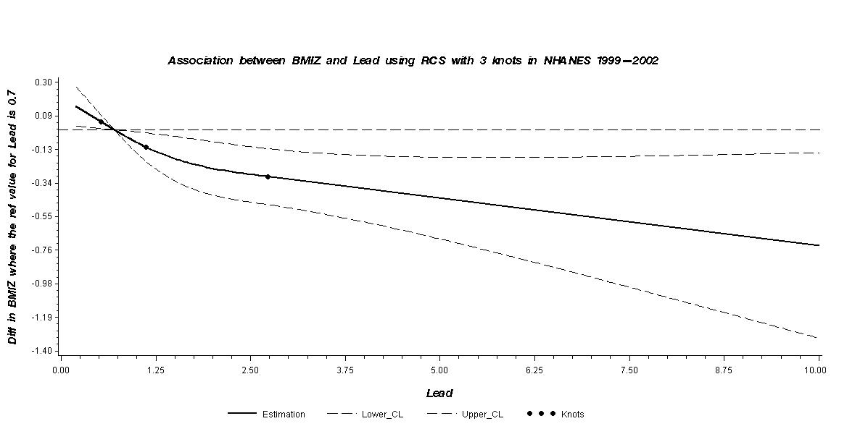
Figure 1b
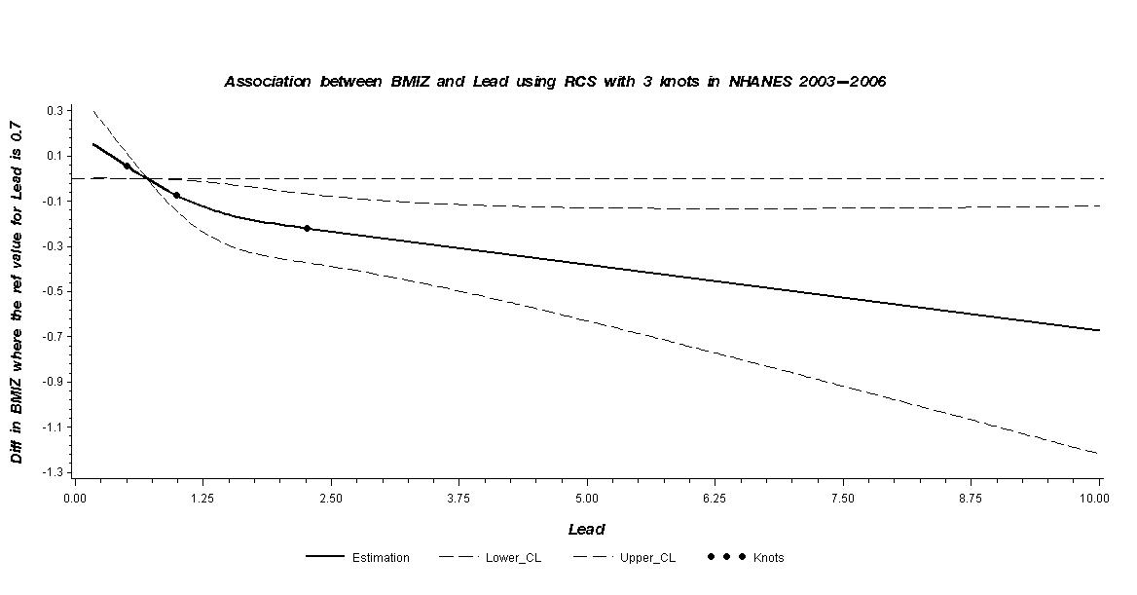
Figure 2a
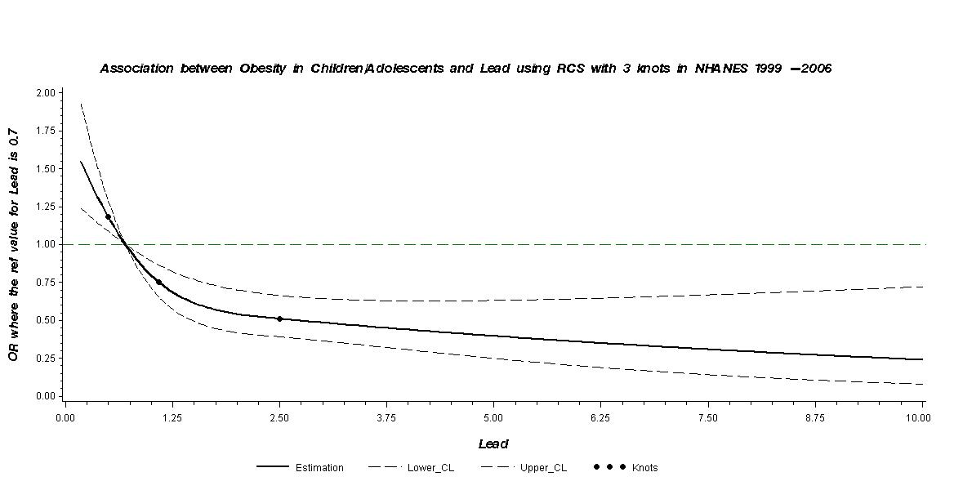

Figure 2b
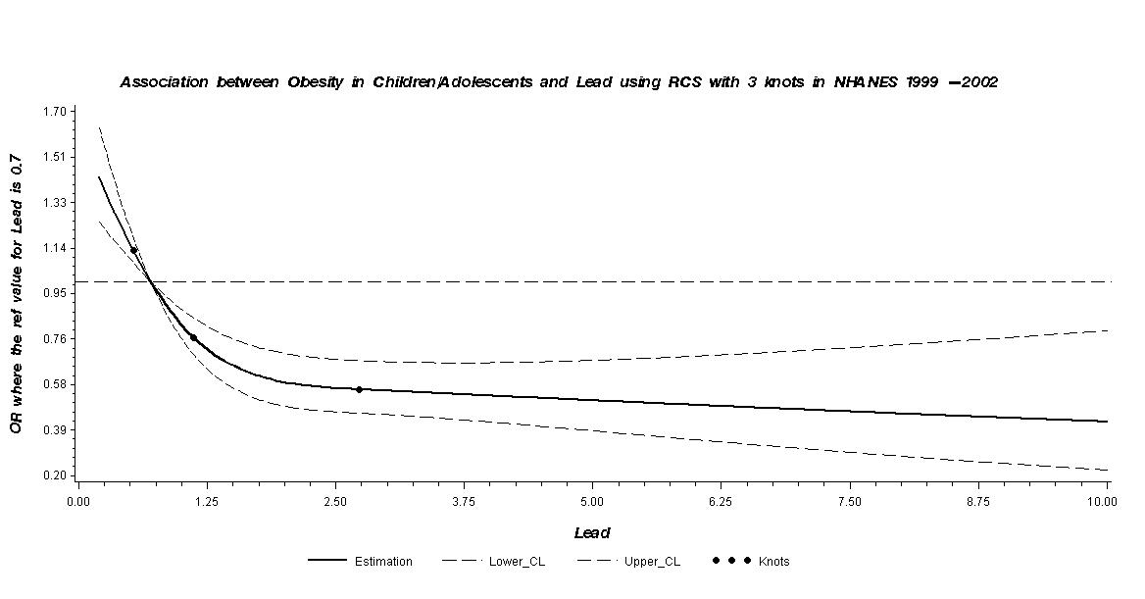

Figure 2c

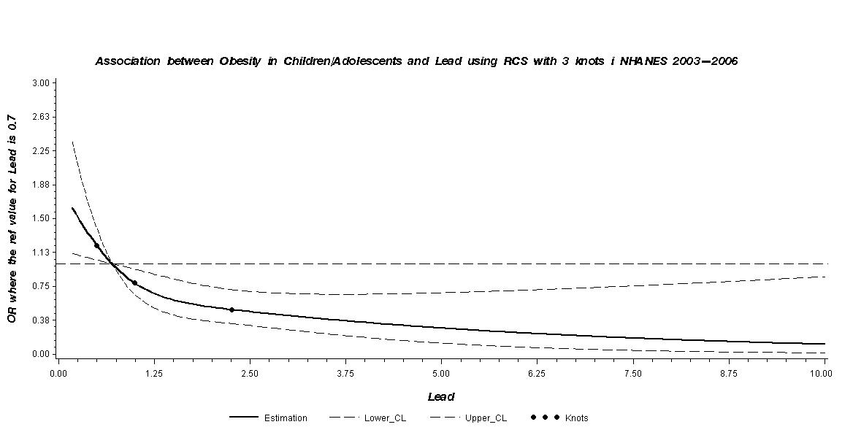

Figure 3a

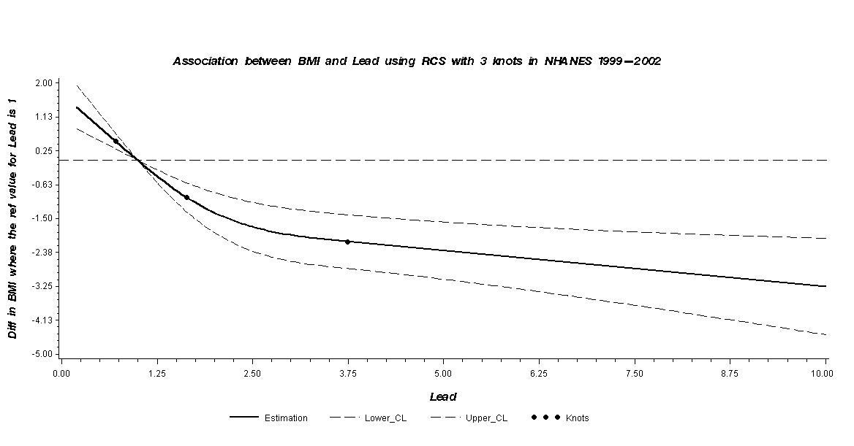

Figure 3b

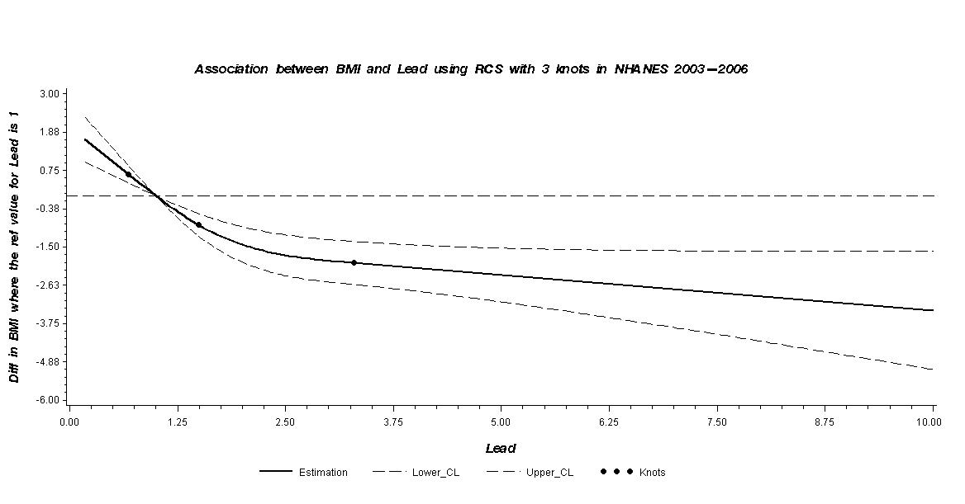

Figure 4a
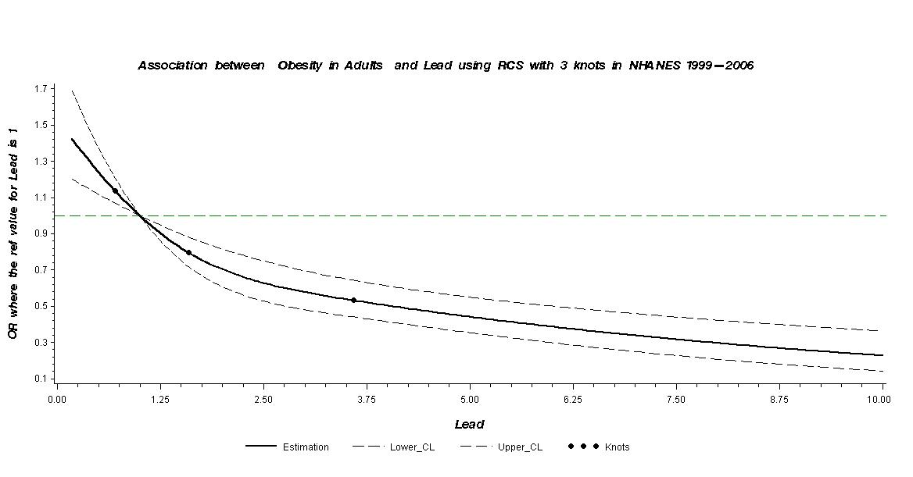

Figure 4b
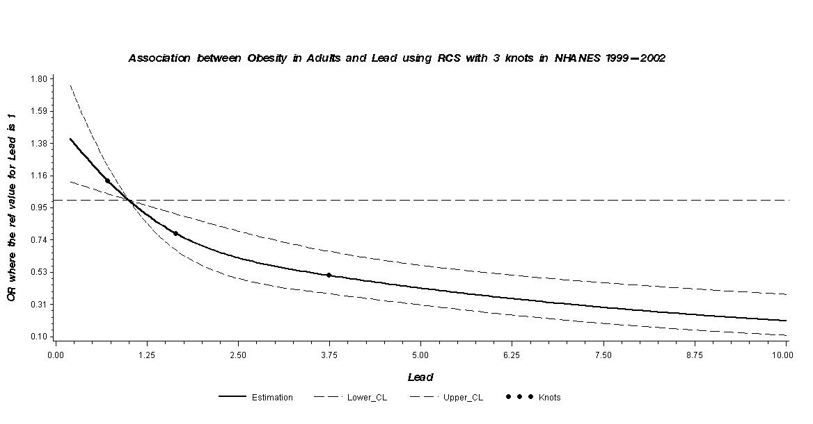
Figure 4c
