### Take-Home Kit Packaging Information

**Please follow the instructions below to ship your collected nose and throat swabs.**

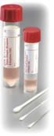

1. **Insert swabs into specimen tube.**

Specimen tube with screw-top containing nose and throat swabs,

labeled with your barcode ID, is your “primary packaging.”

**Proper labeling of swab tube:**

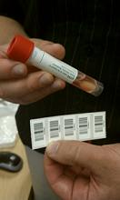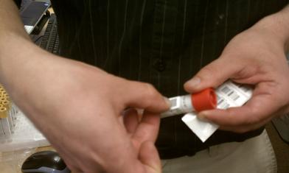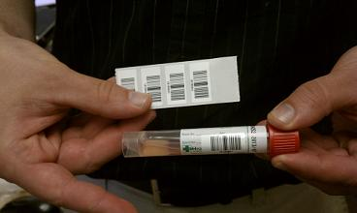

Return THESE unused labels to us in the biohazard bag along with the specimen swab collection tube (see Step 4).

1

**2.**

**3.**

Remaining labels should be included in bag with tube, but not peeled off backing.

Swab Delivery Form should be completed from the link in your weekly email.

1. **Place the specimen tube inside the biohazard bag with absorbent sheet.**

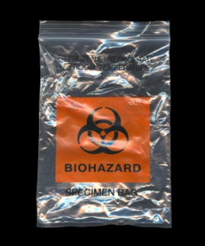

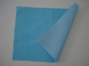Biohazard bag with absorbent sheet is your “secondary packaging.”



1. **Place the remaining 4 (not peeled off the backing) specimen barcode ID labels in biohazard bag with specimen tube.**
2. **Place biohazard bag (“secondary packaging”) into FedEx padded envelope. Then place this envelope into FedEx box.**

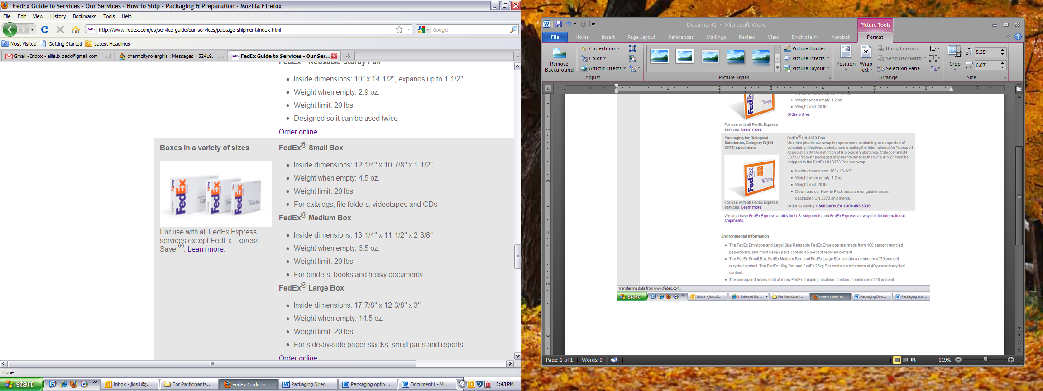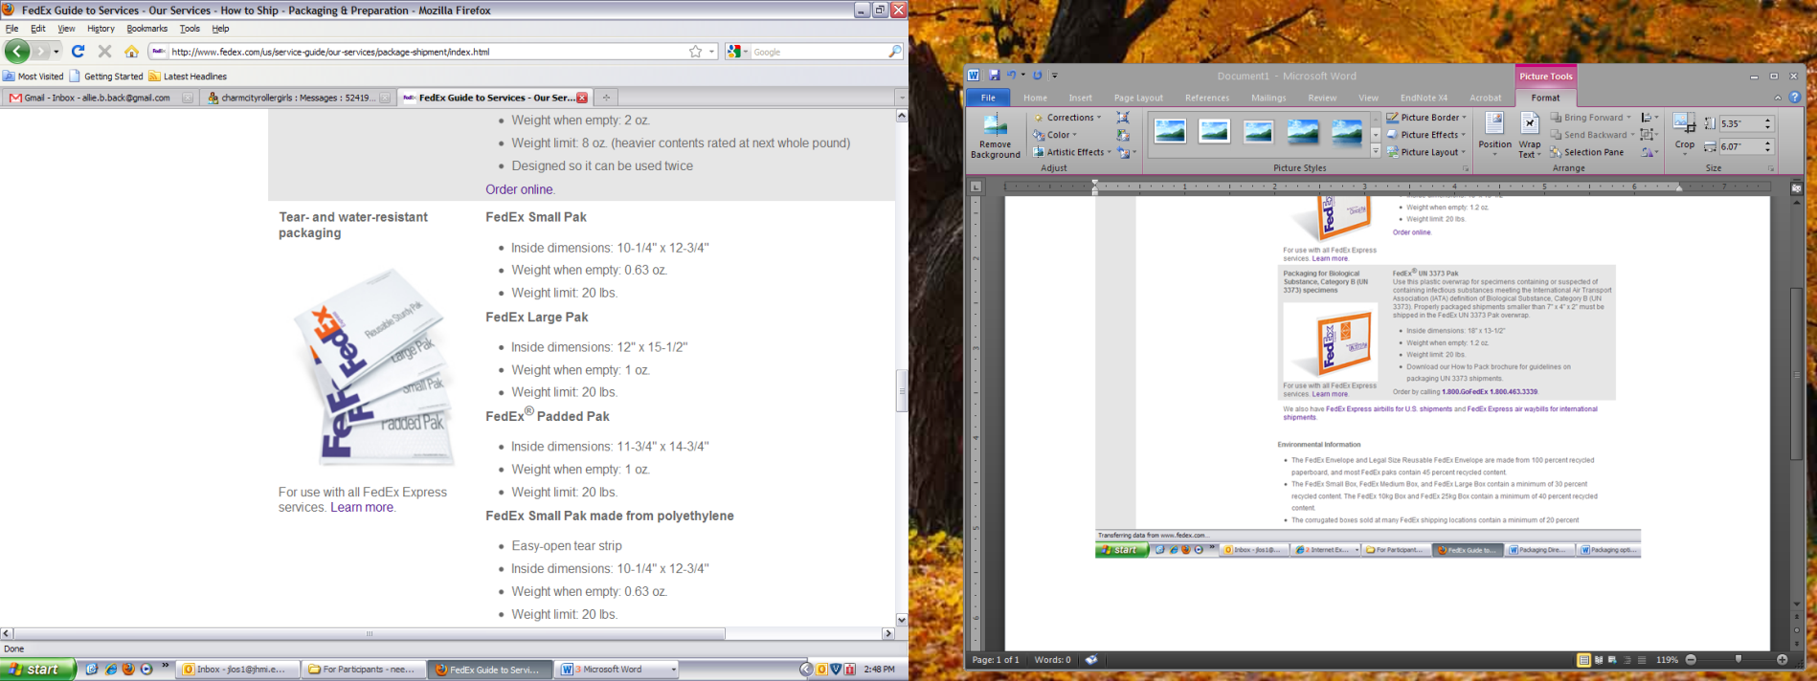

The FedEx box will be your “outer packaging.”

The padded envelope provides protection.

1. **Insert the ‘For Any Questions’ contact information sheet between the FedEx box and the padded envelope.**
2. **Seal the FedEx® corrugated cardboard box with its contents.**
3. **Seal the orange FedEx UN 3373 Pak.**

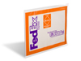

FedEx® UN 3373 Pak [intended for Biological Substance, Category B (UN 3373) specimens] is an extra layer, an “outer-outer packaging,” used because it already comes with the required hazardous materials labels.

1. **Keep your prepared FedEx® package in a secure area until collection by shipper.**
2. **Call 1.800.463.3339 to schedule a FedEx Express pick up from your home. In case needed by FedEx agent, the account number is xxx-xxx-x (located on the pre-printed waybill).**
3. **Complete online your “Swab Delivery Form.”**

**Biological samples cannot be put into a FedEx Drop Box.**