SUPPLEMENTAL MATERIAL
SUPPLEMENTAL METHODS
To describe ambulatory clinic encounters and ED visits, we used data from two IBM MarketScan® Research Databases: Commercial and Medicare Supplemental. These databases contain de-identified individual-level data and include enrollment, diagnostic, procedural, and financial information for approximately 20 million individuals <65 years with employer-sponsored commercial insurance plans and Medicare-eligible retired persons (≥65) with employer-sponsored Medicare Supplemental plans [8]. Hospitalization data were obtained from the National Inpatient Sample of the Healthcare Cost and Utilization Project (NIS-HCUP), a nationally representative administrative database of community hospital discharges [9]. NIS-HCUP is the largest publicly available all-payer inpatient health care database in the United States, representing more than 97% of the U.S. population. Deaths were identified from the National Center for Health Statistics (NCHS) multiple-cause-of-mortality dataset. Due to a known ICD-10 coding error, for children <5 years old, we also included acute and unspecified vascular codes from 2001 through 2004 [10]. Census data were collected from the NCHS Bridged Race population estimates for 2001 – 2015, available through the National Vital Statistics System [16, 17].
Negative binomial models were constructed with candidate predictors of monthly counts of age group-specific rotavirus, C. difficile, and non-C. difficile bacterial infections, as well as monthly counts of parasitic infections summed across all ages due to low counts. In a sensitivity analysis, a C. diff*time interaction term was included given observed secular increases in C. diff-coded outcomes. For models of mortality in the <5 years old and 5–64 years old age groups, all predictors were summed across all age groups, given low counts. Because our goal was to estimate cause-unspecified outcomes based on cause-specified outcomes, we forced all estimated pathogen coefficients to be >0 using a modified function from the zetadiv package for R [15]. The negative binomial distribution was used, as the Poisson assumption of equal mean and variance was not met. These models also assume that the distribution of causative pathogens amongst the cause-unspecified encounters is similar to that amongst the cause-specified encounters.
The second step of estimation involved analysis of model residuals. We calculated the minimum residual by seasonal year (July – June), and then subtracted this value from the residual for each month to obtain an estimate of norovirus-associated outcomes. This calculation results in one month per seasonal year with 0 norovirus-associated outcomes; this approach also attributes to norovirus the “excess” seasonality not captured by the model predictions. Finally, norovirus-coded outcomes were added to model-estimated norovirus outcomes, to generate the final values, hereafter referred to as “estimated norovirus.” For mortality estimates, additional calculations on model residuals were completed for the <5 years old and 5–64 years old age groups, because less distinct seasonality was observed in estimated norovirus deaths in these groups. To generate final norovirus mortality estimates in these age groups, we averaged estimated norovirus deaths across all 14 seasonal years by month and subtracted the minimum of these values from each averaged monthly value. As a result, for the <5 years old and 5–64 years old age groups we report only the mean monthly number of norovirus deaths over the 14-year study period. For those 65+ years old, we still estimated monthly norovirus deaths for the 14-year time period.
A secondary aim of this analysis was to estimate norovirus-associated healthcare charges in the United States. The median charges for cause-unspecified gastroenteritis encounters were calculated by age group for each year and for each outcome available in the MarketScan databases: ambulatory clinic encounters, emergency department visits, and hospitalizations. These charges were updated to 2016 U.S. dollars using the Personal Consumption Expenditures (PCE) Health Index[19, 20], and the mean was then taken across years. These “average charges” were applied to the estimated average total annual number of norovirus-associated healthcare encounters across the study period to generate a total estimate for norovirus-associated healthcare charges, by setting and age group.

Appendix Table 1: ICD-9-CM and ICD-10 codes with their specific diagnostic text
Diagnosis | ICD-9-CM | ICD-10*
Cause-Unspecified Codes
Ill-defined intestinal infections | 009.0-009.3 | A09
Infectious colitis, enteritis, and gastroenteritis | 009.0
Colitis, enteritis, and gastroenteritis of presumed infectious origin | 009.1
Infectious diarrhea | 009.2
Diarrhea of presumed infectious origin | 009.3
Other organism, not elsewhere classified | 008.8 | A08.8
Other or unspecified viral enteritis | 008.69 | A08.3, A08.4
Other and unspecified noninfectious gastroenteritis | 558.9 | K52.9
Diarrhea unspecified | 787.91
Vomiting (alone, with nausea) | 787.01, 787.03 | R11.1
Cause-Specified Codes
Viral
Rotavirus | 008.61 | A08.0
Adenovirus | 008.62 | A08.2
Norovirus | 008.63, 008.64, 008.65 | A08.1
Other specified viruses | 008.66-008.67
Bacterial
Cholera | 001 | A00
Typhoid | 002 | A01
Salmonella | 003.0, 003.1, 003.8, 003.9 | A02.0, A02.1, A02.8, A02.9
Shigella | 004 | A03
Other food poisonings | 005 | A05
E. coli | 008 | A04.0-A04.4
Other unspecified bacteria | 008.1-008.5 (excl. 008.45) | A04.5-A04.9 (excl. A04.7)
C. difficile | 008.45 | A04.7
Parasitic
Amoebiasis (intestinal) | 006.0-006.2, 006.8, 006.9 | A06.0-A06.3, A06.8, A06.9
Other protozoal (intestinal) | 007 | A07
*In some cases, there is no exact 1:1 match from ICD-9-CM to ICD-10. ICD-10 also features only 1 decimal place.

Appendix Table 2: Estimated parameters for final models used in norovirus estimation for all outcomes and age groups. As described in Methods, all models are negative binomial and on the natural scale. All pathogen-associated coefficients were forced to be non-negative.
 | 0-4 years |  |  | 5-17 years |  | 18-64 years |  |  | 65-74 years |  |  |  |  |  | 75-84 years |  | ≥85 years
 | Estimate | P value* |  | Estimate | P value* | Estimate | P value* |  | Estimate | P value* |  |  |  |  | Estimate | P value* | Estimate | P value*
Ambulatory Clinic Encounters
Intercept | 987.52 |  | <0.0001 | 359.39 | 0.082 | 1607.49 |  | 0.00010 | 882.7 |  |  |  | <0.0001 |  | 1161.12 | <0.0001 | 227.04 | <0.0001
C. difficile | 28.24 |  | 0.034 | 35.72 | 0.001 | 0 |  | 1.00000 | 0.21 |  |  |  | 0.62620 |  | 0 | 1.00000 | 0.08 | 0.54840
Other bacteria | 46.72 |  | <0.0001 | 54.98 | <0.0001 | 53.03 |  | <0.0001 | 16.16 |  |  |  | <0.0001 |  | 24.36 | <0.0001 | 11.9 | <0.0001
Rotavirus | 37.5 |  | <0.0001 | 137.53 | <0.0001 | 507.72 |  | <0.0001 | 52.75 |  |  |  | 0.14310 |  | 53.57 | 0.30260 | 4.11 | 0.88670
Parasites | 7.15 |  | 0.076 | 3.58 | 0.374 | 31.46 |  | 0.00020 | 8.83 |  |  |  | <0.0001 |  | 4.85 | 0.00090 | 2.67 | <0.0001
Time | 34.67 |  | <0.0001 | 9.18 | 0.364 | 25.73 |  | 0.13390 | 13.56 |  |  |  | <0.0001 |  | 8.17 | 0.03070 | 8.62 | <0.0001
ED Visits
Intercept | 193.22 | <0.0001 |  | 215.11 | <0.0001 | 677.75 |  | <0.0001 | 135.7 |  |  | <0.0001 |  |  | 138.62 | <0.0001 | 34.55 | <0.0001
C. difficile | 40.53 | <0.0001 |  | 32.64 | <0.0001 | 11.14 |  | <0.0001 | 3.73 |  |  | <0.0001 |  |  | 2.52 | <0.0001 | 1.97 | <0.0001
Other bacteria | 4.78 | 0.362 |  | 4.78 | 0.279 | 13.99 |  | 0.002 | 0.00 |  |  | 1.00 |  |  | 0.20 | 0.916 | 3.04 | 0.075
Rotavirus | 9.84 | <0.0001 |  | 35.29 | <0.0001 | 235.49 |  | <0.0001 | 12.27 |  |  | 0.187 |  |  | 35.35 | 0.009 | 8.34 | 0.398
Parasites | 1.49 | 0.703 |  | 0.00 | 1.00 | 0.00 |  | 1.00 | 0.00 |  |  | 1.00 |  |  | 0.00 | 1.00 | 0.00 | 1.00
Time | 9.73 | <0.0001 |  | 10.66 | <0.0001 | 26.47 |  | <0.0001 | 2.61 |  |  | <0.0001 |  |  | 2.36 | <0.0001 | 1.46 | <0.0001
Hospitalizations
Intercept | 4412.48 | <0.0001 |  | 2774.64 | <0.0001 | 18775.14 |  | <0.0001 | 4548.34 |  | <0.0001 |  |  |  | 4369.79 | <0.0001 | 1192.51 | 0.049
C. difficile | 0.00 | 1.00 |  | 0.00 | 1.00 | 1.08 |  | 0.009 | 1.12 |  | <0.0001 |  |  |  | 1.29 | <0.0001 | 1.41 | <0.0001
Other bacteria | 0.00 | 1.00 |  | 0.00 | 1.00 | 0.00 |  | 1.00 | 0.00 |  | 1.00 |  |  |  | 0.00 | 1.00 | 6.07 | 0.091
Rotavirus | 1.75 | <0.0001 |  | 3.66 | <0.0001 | 24.27 |  | 0.004 | 21.24 |  | 0.004 |  |  |  | 30.53 | 0.003 | 28.14 | 0.005
Parasites | 0.00 | 1.00 |  | 0.00 | 1.00 | 0.55 |  | 0.874 | 0.00 |  | 1.00 |  |  |  | 0.00 | 1.00 | 0.00 | 1.00
Time | 0.00 | 1.00 |  | 0.00 | 1.00 | 71 |  | 0.001 | 21.66 |  | 0.00 |  |  |  | 0.38 | 0.908 | 0.00 | 1.00
 | 0-4 years |  |  |  |  | 5-64 years |  |  |  |  |  |  |  | ≥65 years
 | Estimate |  |  | P value* |  | Estimate |  |  | P value* |  |  |  |  |  | Estimate |  | P value*
Mortality
Intercept | 44.96 |  |  | <0.0001 |  | 32.69 |  |  | <0.0001 |  |  |  |  |  | 181.70 |  | <0.0001
C. difficile | 0.01 |  |  | 0.005 |  | 0.04 |  |  | <0.0001 |  |  |  |  |  | 0.34 |  | <0.0001
Other bacteria | 0.01 |  |  | 0.963 |  | 0.29 |  |  | 0.139 |  |  |  |  |  | 1.87 |  | 0.096
Rotavirus | 1.25 |  |  | 0.182 |  | 1.45 |  |  | 0.283 |  |  |  |  |  | 26.40 |  | 0.119
Parasites | 0.37 |  |  | 0.39 |  | 1.44 |  |  | 0.012 |  |  |  |  |  | 7.19 |  | 0.008
Time | -0.20 |  |  | <0.0001 |  | 0.00 |  |  | 1 |  |  |  |  |  | -0.87 |  | <0.0001
*P values based on Wald chi-square.

Appendix Fig 1: Estimated and actual rates of acute gastroenteritis outcomes, with estimated norovirus, by month, for the oldest age group in each outcome. Estimated monthly rates of cause-unspecified acute gastroenteritis (red dashed line) and norovirus (gray line) outcomes, overlaid with actual monthly rates of cause-unspecified acute gastroenteritis (black dashed line) and total gastroenteritis (black solid line), over the study period. For each outcome, only oldest age group is presented. A winter seasonality in estimated norovirus can be seen during most years, and elevation during pandemic years of 2002/03 and 2006/07 can also be noted.
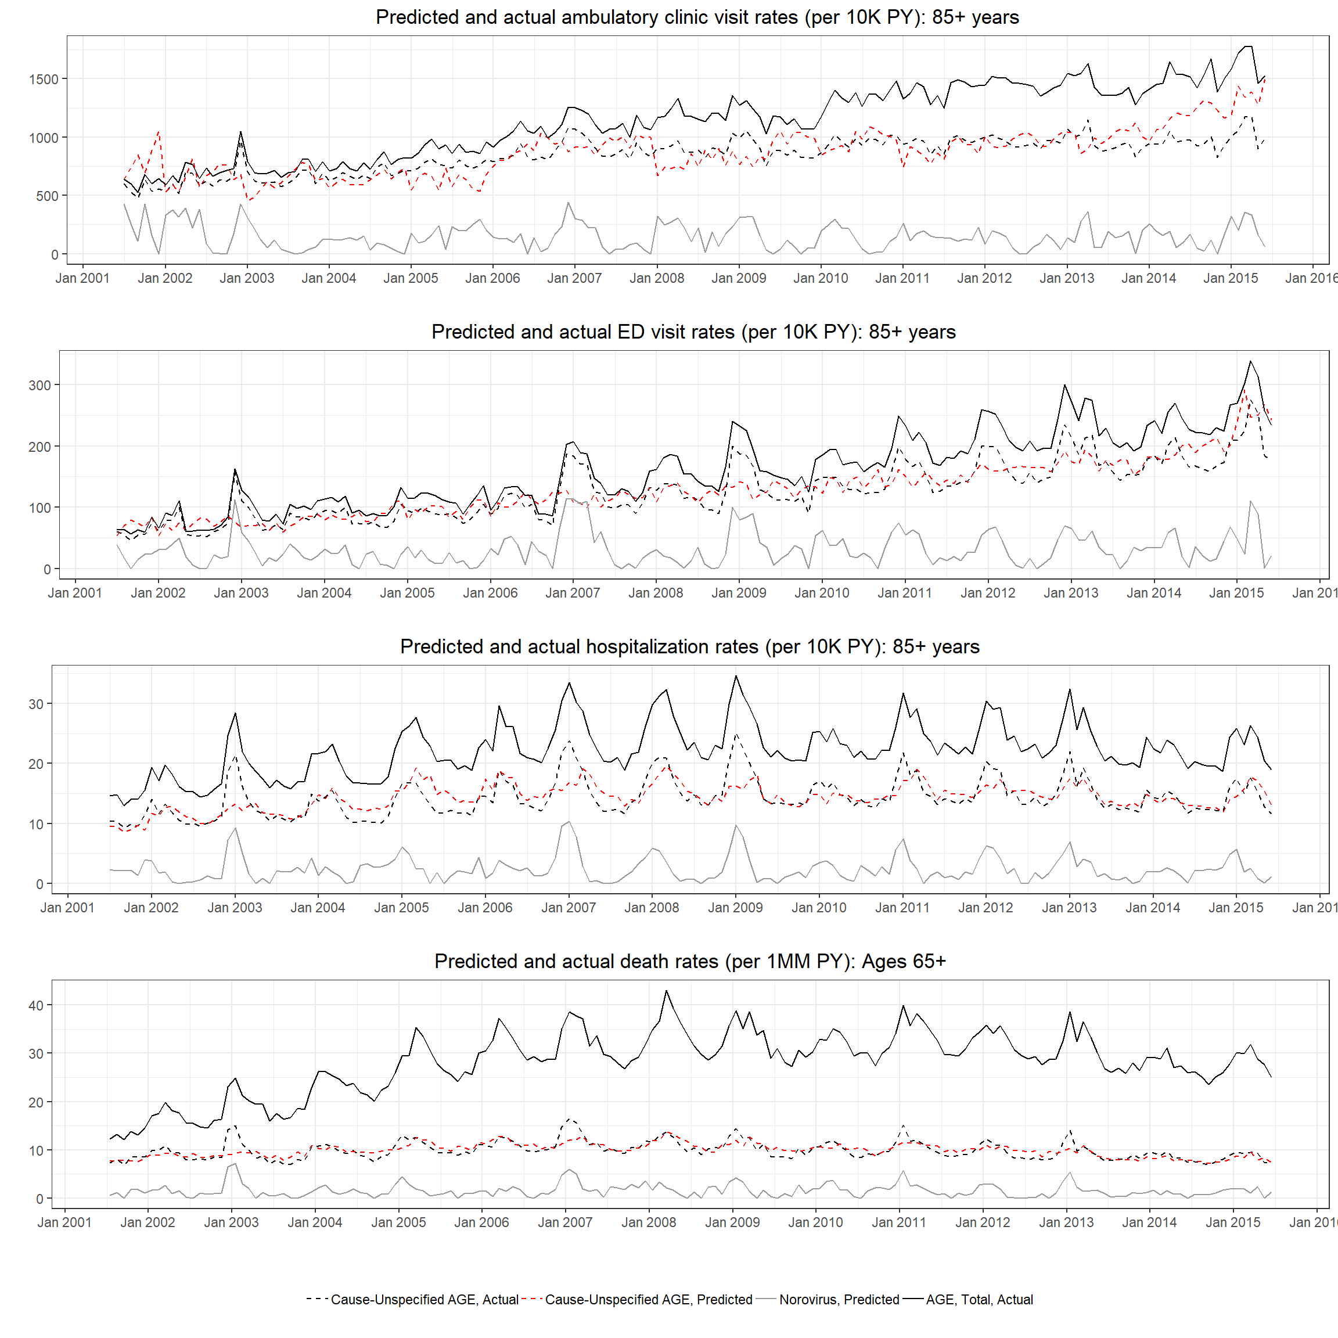

Appendix Fig 2: Annual median and interquartile ranges of estimated monthly norovirus rates, with norovirus pandemic years presented separately. Estimated monthly rates of norovirus outcomes, by setting and age group, over the study period. For mortality, only the 65+ age group is presented. Rates for seasonal years during which pandemic norovirus strains emerged (2002/2003, 2006/2007, and 2012/2013) are represented by colored lines (red, green, and blue, respectively). Black lines represent the median rates, while the gray shaded area represents the interquartile range (25th and 75th percentile), for years not including the pandemic years. A pronounced winter seasonality can be seen clearly in most age groups and settings, and pandemic years tend to have higher rates than others, though this varies by season, setting, and age group.
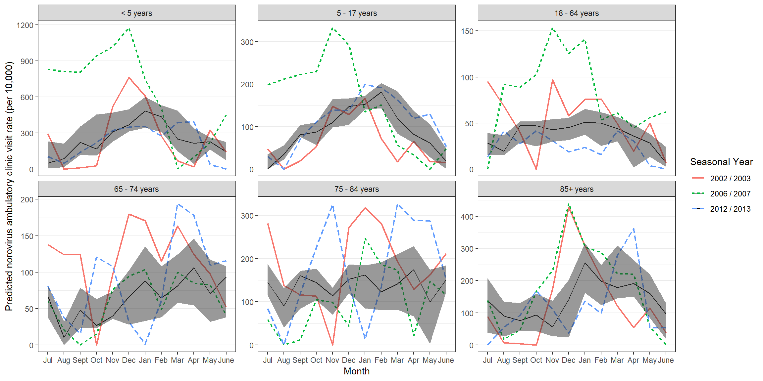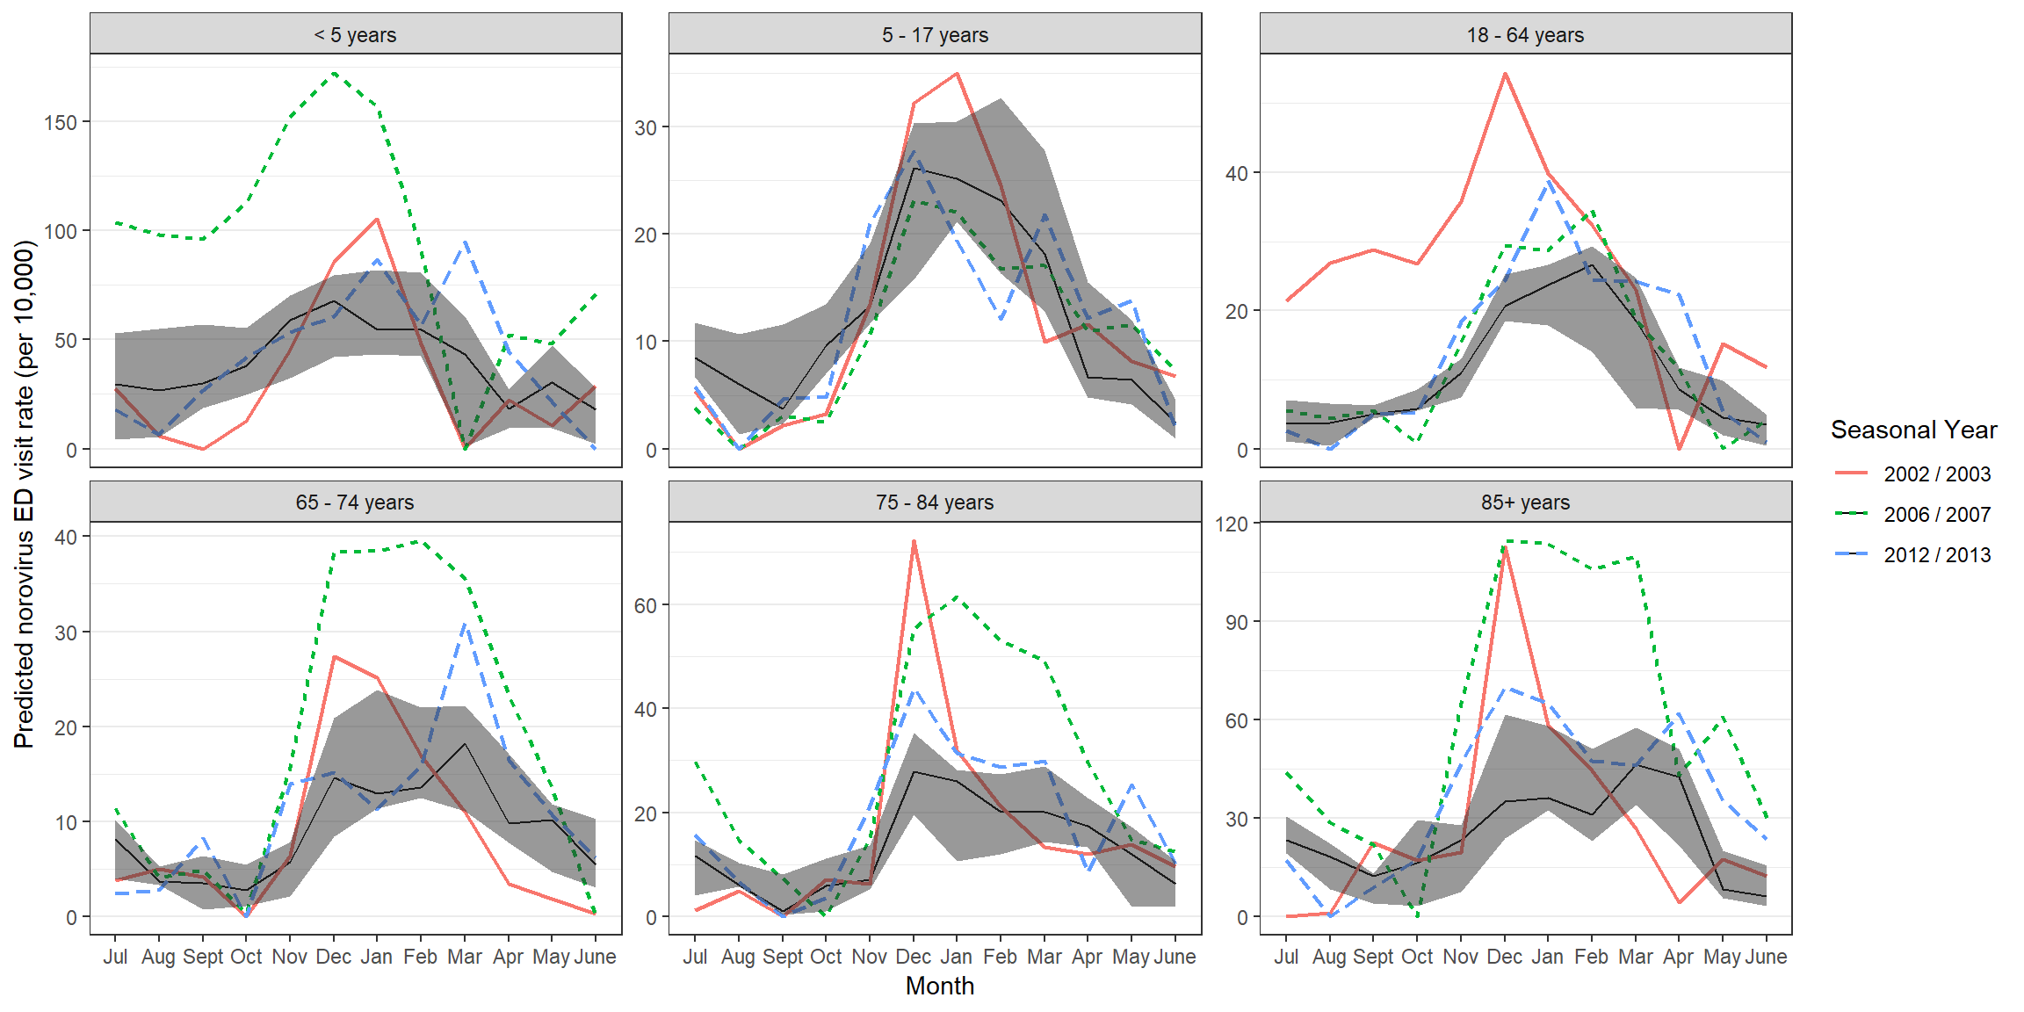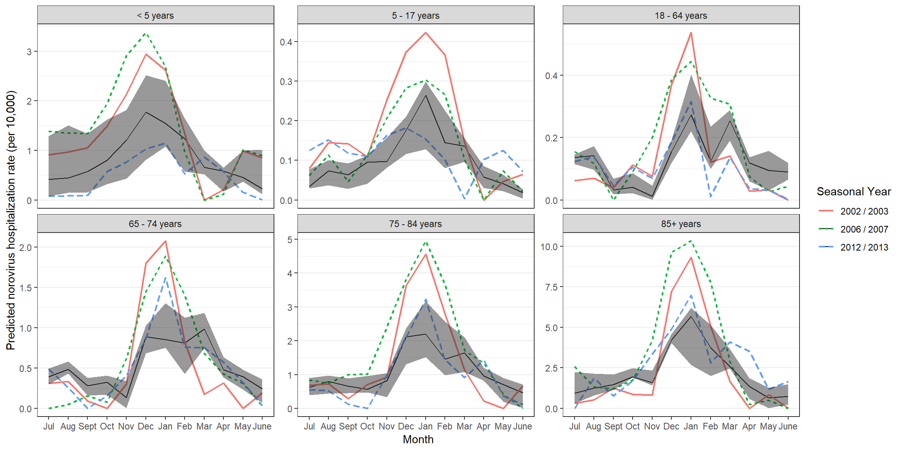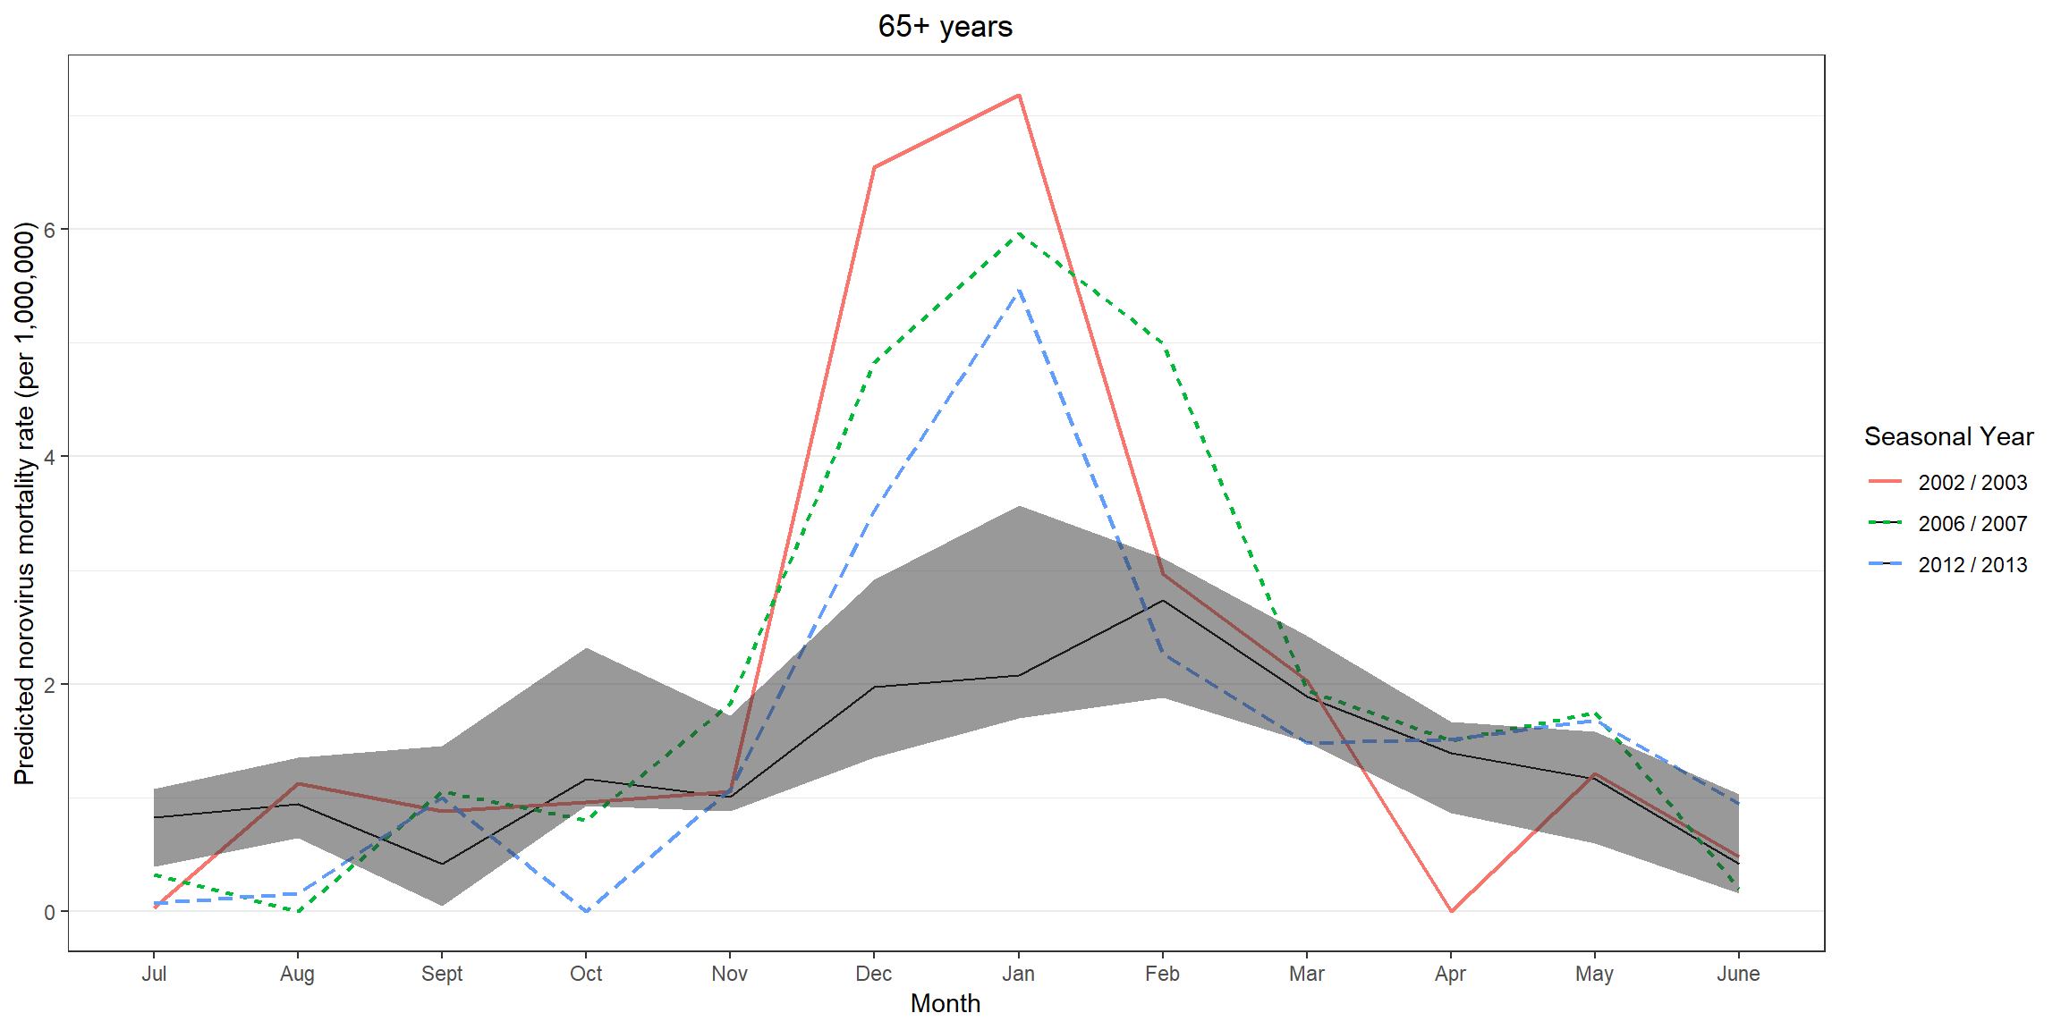

Appendix Table 3: Mean Annual Encounters (in 10,000s) and Deaths (counts) Associated with Acute Gastroenteritis (AGE) by Pathogen Category, with Detail for Specific Pathogens—United States, 2001 – 2015*
Cause | ICD-9 Codes | ICD-10 Codes | Estimated Ambulatory Clinic Encounters†  (database counts) | Estimated Emergency Department Visits†  (database counts) | Hospitalizations | Deaths‡
Cause-unspecified AGE | 009.0–009.3, 558.9, 787.91, 008.69, 008.8 | A09, K52.9, A08.3-A08.4, A08.8, K55.0§, K55.9§ | 1377 (129.1) | 202 (20.0) | 90.2 | 6089
Cause-specified AGE‖ |  |  | 80 (7.0) | 14 (1.4) | 32.3 | 9890
Viral | 008.61–008.67 | A08.0–A08.2 | 9 (0.9) | 2 (0.2) | 1.8 | 22
Rotavirus | 008.61 | A08.0 | 2 (0.1) | 1 (0.1) | 1.6 | 4
Norovirus | 008.63, 008.64, 008.65 | A08.1 | 0 (0.0) | 0 (0.0) | 0.1 | 16
Bacterial | 001.0–01.9, 002.0–002.9, 003.0–003.1, 003.3–003.9, 004.0–004.9, 005.0–005.9, 008.0–008.5 | A00.0–A05.9 | 73 (6.3) | 13 (1.2) | 30.1 | 9843
C. difficile | 008.45 | A04.7 | 57 (4.8) | 9 (0.9) | 27.5 | 9623
Other bacteria | 001.0–01.9, 002.0–002.9, 003.0–003.1, 003.3–003.9, 004.0–004.9, 005.0–005.9, 008.0–008.44, 008.46–008.5 | A00.0–A04.6, A04.8–A05.9 | 16 (1.5) | 4 (0.4) | 2.7 | 220
Parasitic | 006.0–006.2, 006.8–006.9, 007.0–007.9 | A06.0–A07.9 | 4 (0.4) | 0 (0.0) | 0.3 | 27
All-cause AGE |  |  | 1456 (136.1) | 217 (21.3) | 122.4 | 15,979
Abbreviations: ICD-9-CM, International Classification of Diseases, Ninth Revision, Clinical Modification. ICD-10-CM, International Classification of Diseases, Ninth Revision, Clinical Modification. *From July 1 2001 through June 30 2015. †Extrapolated to the population using census data. Actual database values shown in parentheses. ‡Raw numbers presented (i.e., not in 10,000). §Included only for children <5 in years 2001 – 2004. ‖Multiple codes may be assigned to a given record; thus, the sum of cases for each specific cause exceeds the subtotals for “cause unspecified” and “cause specified.” However, if any cause-specified code was included in the record, the encounter was categorized as such.

Appendix Table 4: Mean Annual Cases and Rates of All-Cause and Norovirus Gastroenteritis by Age Group—United States, Seasonal Years 2001/2002 – 2014/2015. Despite being known as a common cause of acute gastroenteritis (AGE), norovirus-specific ICD codes rarely appear in standard administrative datasets, presenting a challenge for estimating burden. Below, we present the average annual counts and rates associated with ICD-coded norovirus, by outcome and age group. Norovirus-specific codes make up less than 1% of all-cause AGE.
 | All-Cause AGE |  |  | Coded NV
 | Counts  (in 10K)* | Rates per 10K* |  | Counts  (Actual) | Rates per 10K* | % of All-Cause AGE
Ambulatory Clinic Encounters
< 5 years | 240.9 | 1209.3 |  | 297 | 0.15 | 0.01
5 – 17 years | 166.3 | 309.6 |  | 307 | 0.07 | 0.02
18 – 64 years | 756.1 | 397.4 |  | 1411 | 0.09 | 0.02
65 – 74 years | 119.4 | 561.1 |  | 237 | 0.12 | 0.02
75 – 84 years | 112.4 | 855.5 |  | 331 | 0.27 | 0.03
85+ years | 61.2 | 1172.2 |  | 408 | 0.9 | 0.07
All ages | 1456.4 | 479.8 |  | 2991 | 0.1 | 0.02
ED Visits
< 5 years | 30.3 | 151.9 |  | 58 | 0.03 | 0.02
5 – 17 years | 24.5 | 45.6 |  | 54 | 0.01 | 0.02
18 – 64 years | 124.8 | 65.6 |  | 310 | 0.02 | 0.02
65 – 74 years | 14 | 65.9 |  | 83 | 0.04 | 0.06
75 – 84 years | 14.2 | 108.4 |  | 159 | 0.12 | 0.11
85+ years | 8.8 | 167.5 |  | 194 | 0.37 | 0.22
All ages | 216.6 | 71.4 |  | 859 | 0.03 | 0.04
Hospitalizations
< 5 years | 9.9 | 49.6 |  | 125 | 0.06 | 0.13
5 – 17 years | 4.5 | 8.4 |  | 70 | 0.01 | 0.16
18 – 64 years | 51.2 | 26.9 |  | 373 | 0.02 | 0.07
65 – 74 years | 20 | 94.1 |  | 164 | 0.08 | 0.08
75 – 84 years | 22.7 | 172.9 |  | 227 | 0.17 | 0.10
85+ years | 14.1 | 270.2 |  | 247 | 0.47 | 0.17
All ages | 122.4 | 40.3 |  | 1204 | 0.04 | 0.10
Deaths (Rates per 1M PY)
< 5 years | 472 | 23.7 |  | 1 | 0.04 | 0.17
5 – 64 years | 2031 | 8.3 |  | 2 | 0.01 | 0.09
65+ years | 13476 | 339.9 |  | 14 | 0.34 | 0.10
All ages | 15979 | 52.6 |  | 16 | 0.05 | 0.10
Abbreviations: AGE – Acute Gastroenteritis; NV – Norovirus; K – thousands; M – Millions; PY – Person-Years. *Deaths presented as actual counts for both all-cause and norovirus gastroenteritis. Death rates presented per 1M PY.

Appendix Table 5: Counts and Rates of All-Cause AGE and Estimated Norovirus, Including Vomiting-Only Presentations in All-Cause AGE, with Comparison to Primary Analysis—United States, Seasonal Years 2001/2002 – 2014/2015. Given that norovirus can also present as vomiting in the absence of diarrhea, we conducted another sensitivity analysis where we included within “cause-unspecified gastroenteritis” records with vomiting-associated ICD codes in the absence of any other gastroenteritis-associated code. We then re-ran the analysis using this dataset. Overall rates of acute gastroenteritis as well as estimated norovirus were increased by a non-negligible amount when compared to the primary analysis (with the exception of deaths in children <5), with the greatest increase seen in the emergency department setting and the smallest increase seen in mortality. It seems probable that actual norovirus rates are somewhere between these two estimates, so our primary analysis likely represents an underestimate of the true norovirus burden in the U.S.
 | All-Cause AGE |  |  |  | Estimated NV*
 | Counts in 10K† | Rate per 10K PY‡ | % Increase§ |  | Counts in 10K†  (95% CI) | Rate per 10K PY‡ (95% CI) | % of All-Cause AGE | % Increase§
Ambulatory Clinic Encounters
<5 years | 307.9 | 1545.5 | 28% |  | 71.9 (56.3 - 91.2) | 360.9 (282.6 - 458.0) | 23.4 | 28%
5 – 17 years | 237.5 | 442.2 | 43% |  | 75.9 (59.5 - 94.9) | 141.4 (110.9 - 176.6) | 32.0 | 42%
18 – 64 years | 1028.6 | 540.7 | 36% |  | 104.0 (80.3 - 131.9) | 54.7 (42.2 - 69.3) | 10.1 | 38%
65 – 74 years | 174.2 | 818.3 | 46% |  | 24.3 (17.6 - 32.2) | 114.0 (82.6 - 151.5) | 13.9 | 52%
75 – 84 years | 160.8 | 1224.0 | 43% |  | 26.8 (19.3 - 35.5) | 203.9 (146.7 - 270.4) | 16.7 | 45%
85+ years | 85.3 | 1632.1 | 39% |  | 11.2 (7.9 - 15.2) | 214.7 (151.0 - 290.4) | 13.2 | 42%
All ages | 1994.3 | 657.0 | 37% |  | 314.1 (240.9 - 400.9) | 103.5 (79.4 - 132.1) | 15.7 | 38%
ED Visits
<5 years | 60.8 | 305.2 | 101% |  | 17.5 (13.5 - 22.5) | 87.7 (67.9 - 112.9) | 28.7 | 90%
5 – 17 years | 52.8 | 98.3 | 116% |  | 15.4 (11.5 - 19.8) | 28.7 (21.5 - 36.9) | 29.2 | 108%
18 – 64 years | 241.3 | 126.9 | 93% |  | 39.7 (29.9 - 51.8) | 20.9 (15.7 - 27.2) | 16.4 | 65%
65 – 74 years | 25.7 | 120.9 | 84% |  | 3.6 (2.6 - 4.8) | 17.0 (12.3 - 22.5) | 14.0 | 64%
75 – 84 years | 25.6 | 195.2 | 80% |  | 3.3 (2.4 - 4.6) | 25.5 (18.0 - 34.8) | 13.1 | 57%
85+ years | 15.5 | 296.5 | 76% |  | 2.5 (1.9 - 3.3) | 48.4 (36.0 - 63.3) | 16.3 | 47%
All ages | 421.8 | 139 | 95% |  | 82.0 (61.8 - 106.8) | 27.0 (20.4 - 35.2) | 19.4 | 76%
Hospitalizations
<5 years | 11.8 | 59.2 | 19% |  | 2.5 (1.9 - 3.2) | 12.5 (9.8 - 16.0) | 21.1 | 0%
5 – 17 years | 7.0 | 13.0 | 56% |  | 0.9 (0.6 - 1.1) | 1.6 (1.2 - 2.1) | 12.3 | 29%
18 – 64 years | 71.5 | 37.6 | 40% |  | 4.0 (2.8 - 5.4) | 2.1 (1.5 - 2.8) | 5.6 | 29%
65 – 74 years | 25.1 | 117.8 | 26% |  | 1.6 (1.2 - 2.1) | 7.6 (5.6 - 9.9) | 6.5 | 14%
75 – 84 years | 27.2 | 206.7 | 20% |  | 1.9 (1.4 - 2.5) | 14.6 (10.6 - 19.2) | 7.1 | 6%
85+ years | 16.5 | 315.3 | 17% |  | 1.5 (1.1 - 2.0) | 28.8 (20.9 - 38.0) | 9.1 | 0%
All ages | 159 | 52.4 | 30% |  | 12.4 (9.1 - 16.3) | 4.1 (3.0 - 5.4) | 7.8 | 14%
Deaths (Rates per 1M PY)
<5 years | 486 | 24.4 | 3% |  | 33 (26 - 40) | 1.6 (1.3 - 2.0) | 6.7 | -9%
5 – 64 years | 2337 | 9.6 | 15% |  | 94 (74 - 115) | 0.4 (0.3 - 0.5) | 4.0 | 10%
65+ years | 14410 | 363.5 | 7% |  | 886 (675 - 1127) | 22.3 (17.0 - 28.4) | 6.1 | 19%
All ages | 17232 | 0.6 | 8% |  | 1012 (774 - 1283) | 3.3 (2.6 - 4.2) | 5.9 | 17%
Abbreviations: AGE – Acute Gastroenteritis; NV – Norovirus; K – thousands; M – Millions; PY – Person-Years. *Estimated norovirus defined as model-estimated plus coded norovirus. Estimates given with 95% CI in parentheses. †Deaths represented as actual numbers. ‡Death rates presented per 1M PY. §Percent increase presented for percent over primary analysis results, which do not include vomit-only presentations

Appendix Table 6: Estimated Counts and Rates of Norovirus (NV) by Age Group and Model—United States, Seasonal Years 2001/2002 – 2014/2015. Our a priori set of predictors included C. difficile bacteria, other bacteria, rotavirus, parasites, and time (all pathogen categories were age-specific with the exception of parasites, given small counts). Estimated model parameters were forced to be non-negative using a modified function from the R package zetadiv, and all models converged with acceptable fit. Here we present, as a sensitivity analysis, estimated counts and rates of norovirus based on alternative models, using the same forcing algorithm but with different parameters included. Each model gives slightly different results, but the magnitude of the estimated norovirus burden is similar across alternative and primary models, suggesting that the method is not overly sensitive to minor variations in the predictors included in the model.
 | Main Analysis* |  | Alternative Model 1*† |  |  | Alternative Model 2*‡
 | Counts in 10K | Rate per 10K PY |  | Counts in 10K | Rate per 10K PY |  | Counts in 10K | Rate per 10K PY
Ambulatory Clinic Encounters
<5 years | 56.1 (44.0 - 71.0) | 281.4 (221.0 - 356.2) |  | 56.1 (43.1 - 72.2) | 281.4 (216.5 - 362.3) |  | 55.8 (43.5 - 70.3) | 280.1 (218.6 - 353.1)
5 – 17 years | 53.3 (41.8 - 66.4) | 99.2 (77.9 - 123.6) |  | 54.3 (42.4 - 68.0) | 101.0 (79.0 - 126.5) |  | 52.3 (41.1 - 65.3) | 97.3 (76.4 - 121.5)
18 – 64 years | 75.6 (58.2 - 95.5) | 39.7 (30.6 - 50.2) |  | 75.6 (56.9 - 97.2) | 39.7 (29.9 - 51.1) |  | 79.6 (61.9 - 100.0) | 41.8 (32.5 - 52.6)
65 – 74 years | 16.0 (11.7 - 21.3) | 75.2 (55.0 - 100.0) |  | 16.0 (11.4 - 21.8) | 75.2 (53.5 - 102.2) |  | 21.6 (16.8 - 27.1) | 101.5 (79.0 - 127.2)
75 – 84 years | 18.5 (13.2 - 24.6) | 140.8 (100.2 - 187.6) |  | 18.5 (12.7 - 25.3) | 140.9 (96.8 - 192.5) |  | 20.0 (14.7 - 26.2) | 152.2 (111.7 - 199.7)
85+ years | 7.9 (5.6 - 10.6) | 151.3 (107.3 - 202.5) |  | 7.9 (5.4 - 10.9) | 151.5 (103.2 - 208.4) |  | 8.9 (6.5 - 11.8) | 170.5 (124.6 - 225.0)
All ages | 227.3 (174.5 - 289.4) | 74.9 (57.5 - 95.3) |  | 228.4 (171.9 - 295.3) | 75.2 (56.6 - 97.3) |  | 238.2 (184.5 - 300.7) | 78.5 (60.8 - 99.1)
ED Visits
<5 years | 9.2 (7.2 - 11.8) | 46.2 (36.1 - 59.4) |  | 9.2 (7.0 - 12.1) | 46.2 (35.3 - 60.5) |  | 9.0 (7.0 - 11.5) | 44.9 (35.0 - 57.9)
5 – 17 years | 7.4 (5.5 - 9.7) | 13.8 (10.2 - 18.0) |  | 7.4 (5.3 - 9.9) | 13.8 (9.8 - 18.5) |  | 7.4 (5.5 - 9.7) | 13.8 (10.2 - 18.0)
18 – 64 years | 24.0 (17.8 - 31.6) | 12.6 (9.4 - 16.6) |  | 24.0 (17.2 - 32.5) | 12.6 (9.0 - 17.1) |  | 24.0 (17.9 - 31.6) | 12.6 (9.4 - 16.6)
65 – 74 years | 2.2 (1.6 - 3.0) | 10.5 (7.6 - 13.9) |  | 2.2 (1.6 - 3.1) | 10.5 (7.3 - 14.3) |  | 2.2 (1.6 - 3.0) | 10.5 (7.7 - 13.9)
75 – 84 years | 2.1 (1.4 - 2.8) | 15.7 (11.0 - 21.4) |  | 2.1 (1.4 - 2.9) | 15.7 (10.6 - 22.0) |  | 2.1 (1.4 - 2.8) | 15.6 (11.0 - 21.4)
85+ years | 1.7 (1.2 - 2.1) | 31.7 (23.6 - 41.0) |  | 1.7 (1.2 - 2.2) | 31.7 (22.7 - 42.2) |  | 1.6 (1.2 - 2.1) | 31.4 (23.4 - 40.7)
All ages | 46.5 (34.8 - 61.0) | 15.3 (11.5 - 20.1) |  | 46.5 (33.6 - 62.6) | 15.3 (11.1 - 20.6) |  | 46.3 (34.6 - 60.7) | 15.2 (11.4 - 20.0)
Hospitalizations
<5 years | 2.5 (2.0 - 3.2) | 12.5 (10.0 - 15.9) |  | 2.5 (1.9 - 3.2) | 12.5 (9.8 - 16.1) |  | 2.5 (2.0 - 3.2) | 12.5 (10.0 - 15.9)
5 – 17 years | 0.7 (0.5 - 1.0) | 1.3 (0.9 - 1.8) |  | 0.7 (0.5 - 1.0) | 1.3 (0.9 - 1.8) |  | 0.8 (0.6 - 1.0) | 1.4 (1.1 - 1.8)
18 – 64 years | 3.1 (2.1 - 4.2) | 1.6 (1.1 - 2.2) |  | 3.2 (2.3 - 4.3) | 1.7 (1.2 - 2.2) |  | 3.1 (2.2 - 4.2) | 1.6 (1.1 - 2.2)
65 – 74 years | 1.4 (1.0 - 1.8) | 6.5 (4.6 - 8.6) |  | 1.4 (0.9 - 1.9) | 6.5 (4.5 - 8.8) |  | 1.4 (1.0 - 1.8) | 6.6 (4.7 - 8.7)
75 – 84 years | 1.8 (1.3 - 2.4) | 13.7 (9.7 - 18.2) |  | 1.8 (1.2 - 2.4) | 13.6 (9.4 - 18.5) |  | 1.8 (1.3 - 2.4) | 13.9 (9.9 - 18.5)
85+ years | 1.5 (1.1 - 2.0) | 28.5 (20.9 - 37.5) |  | 1.5 (1.0 - 2.0) | 28.5 (20.1 - 38.4) |  | 1.5 (1.0 - 1.9) | 27.8 (20.1 - 37.0)
All ages | 10.9 (8.0 - 14.5) | 3.6 (2.6 - 4.8) |  | 11.0 (7.9 - 14.8) | 3.6 (2.6 - 4.9) |  | 11.0 (8.1 - 14.5) | 3.6 (2.7 - 4.8)
Mortality (Rates per 1M PY)
<5 years | 36 (28 - 44) | 1.8 (1.4 - 2.2) |  | 34 (27 - 43) | 1.7 (1.3 - 2.2) |  | 27 (22 - 34) | 1.4 (1.1 - 1.7)
5 – 64 years | 85 (68 - 104) | 0.3 (0.3 - 0.4) |  | 81 (65 - 100) | 0.3 (0.3 - 0.4) |  | 87 (71 - 105) | 0.4 (0.3 - 0.4)
65+ years | 744 (560 - 959) | 18.8 (14.1 - 24.2) |  | 745 (548 - 977) | 18.8 (13.8 - 24.6) |  | 762 (572 - 979) | 19.2 (14.4 - 24.7)
All ages | 865 (656 - 1107) | 2.8 (2.2 - 3.6) |  | 861 (639 - 1120) | 2.8 (2.1 - 3.7) |  | 877 (665 - 1117) | 2.9 (2.2 - 3.7)
Abbreviations: AGE – Acute Gastroenteritis; NV – Norovirus; K – thousands; M – Millions; PY – Person-Years. *Estimated norovirus defined as model-estimated plus coded norovirus. Estimates given with 95% CI in parentheses. †This model includes counts for age-specific C. difficile, age-specific non-C. diff. bacteria, age-specific rotavirus, and all-ages (summed) parasites, as well as a term for time and a time*C. diff. interaction term. ‡For Ambulatory Clinic Encounters and ED Visits, this model includes age-specific counts for C. diff., non-C. diff. bacteria, rotavirus, and parasites, as well as a term for time, as in Gastañaduy et al.(12). For Hospitalizations, this model includes age-specific C. diff. counts, age-specific non-C. diff. bacteria counts, counts of rotavirus among ages 0 – 4, age-specific parasite counts, and a term for time, as in Lopman et al.(14). For mortality, models for age groups 0 – 4 years and 5 – 64 years include age-specific counts for C. diff., non-C. diff. bacteria, rotavirus, and parasites, as well as a term for time. The mortality model for ages ≥65 includes all-ages (summed) counts for C. diff., non-C. diff. bacteria, rotavirus, and parasites, as well as a term for time, as in Hall et al.(13)

Appendix Table 7: Comparison of estimated norovirus hospitalization rates and counts by age group and data source—United States, Seasonal Years 2001/2002 – 2014/2015. As another sensitivity analysis, we also calculated the estimated norovirus hospitalization burden based on the MarketScan database (which is non-nationally representative), and compared this to the results found using data from the National Inpatient Sample of the Healthcare Cost and Utilization Project (NIS-HCUP), which is nationally representative. The estimated hospitalization rates were similar, with the largest discrepancies seen in those <65 years of age. The higher rates in MarketScan may reflect higher care-seeking among persons with commercial, employer-sponsored insurance plans. Alternatively, they could be the result of demographic differences, differences in coding practices, or differences in decisions of whether to admit patients or manage them in an outpatient (emergency department) setting.
 | NIS-HCUP |  | MarketScan
Age Group | Estimated Annual Counts in 10K  (95% CI)* | Hospitalization Rate per 10K PY  (95% CI)* | Estimated Annual Counts in 10K  (95% CI)* | Hospitalization Rate per 10K PY  (95% CI)*
<5 years | 2.5 (2.0 - 3.2) | 12.5 (10.0 - 15.9) | 1.9 (1.5 - 2.4) | 9.5 (7.4 - 12.3)
5 – 17 years | 0.7 (0.5 - 1.0) | 1.3 (0.9 - 1.8) | 1.1 (0.8 - 1.4) | 2.0 (1.5 - 2.6)
18 – 64 years | 3.1 (2.1 - 4.2) | 1.6 (1.1 - 2.2) | 4.6 (3.3 - 6.1) | 2.4 (1.7 - 3.2)
65 – 74 years | 1.4 (1.0 - 1.8) | 6.5 (4.6 - 8.6) | 1.3 (0.9 - 1.7) | 5.9 (4.3 - 7.8)
75 – 84 years | 1.8 (1.3 - 2.4) | 13.7 (9.7 - 18.2) | 1.9 (1.4 - 2.4) | 14.3 (10.6 - 18.3)
85+ years | 1.5 (1.1 - 2.0) | 28.5 (20.9 - 37.5) | 1.5 (1.1 - 2.0) | 28.9 (21.4 - 37.5)
All ages | 10.9 (8.0 - 14.5) | 3.6 (2.6 - 4.8) | 12.2 (9.0 - 16.0) | 4.0 (3.0 - 5.3)
Abbreviations: AGE – Acute Gastroenteritis; NV – Norovirus; K – thousands; M – Millions; PY – Person-Years. *Estimated norovirus defined as model-estimated plus coded norovirus. Estimates given with 95% CI in parentheses.

