Online Supplemental Materials
Urinary Metals and Adipokines in Midlife Women: The Study of Women’s Health Across the Nation (SWAN)
Xin Wangª, Carrie A. Karvonen-Gutierrezª, Bhramar Mukherjee^{b},
William H. Herman^{a,c}, Sung Kyun Park^{a,d}
ª Department of Epidemiology, School of Public Health, University of Michigan, Ann Arbor, MI
^{b} Department of Biostatistics, School of Public Health, University of Michigan, Ann Arbor, MI
^{c} Department of Internal Medicine, University of Michigan, Ann Arbor, MI
^{d} Department of Environmental Health Sciences, School of Public Health, University of Michigan, Ann Arbor, MI

TABLE OF CONTENTS
Table S1. Detection rates and concentrations of urinary metals.
Table S2. Association between urinary molybdenum concentration and serum adipokine levels by racial/ethnic groups.
Figure S1. Schematic diagram of analytic sample.
Figure S2. Spearman correlation matrix of metal concentrations after adjusting for specific gravity.

Table S1. Detection rates and concentrations of urinary metals.
Metals | LOD | Percent >LOD | Median concentration (IQR), μg/L
Arsenic | 0.3 | 100 | 15.0 (7.0, 38.8)
Barium | 0.1 | 99.5 | 1.8 (1.0, 3.1)
Cadmium | 0.06 | 94.7 | 0.44 (0.22, 0.79)
Cobalt | 0.05 | 99.3 | 0.62 (0.37, 0.94)
Cesium | 0.01 | 100 | 4.71 (3.03, 7.25)
Copper | 2.5 | 96.7 | 9.4 (6.1, 14.4)
Mercury | 0.05 | 99.8 | 1.23 (0.67, 2.34)
Manganese | 0.08 | 99.5 | 0.89 (0.59, 1.44)
Molybdenum | 0.3 | 100 | 44.1 (25.0, 70.9)
Nickel | 0.8 | 95.9 | 3.8 (2.4, 5.8)
Lead | 0.1 | 98.0 | 0.8 (0.5, 1.3)
Antimony | 0.04 | 78.2 | 0.08 (0.04, 0.13)
Tin | 0.1 | 97.2 | 0.9 (0.5, 1.8)
Thallium | 0.02 | 92.4 | 0.14 (0.08, 0.22)
Zinc | 2 | 100 | 306 (166, 513)
LOD: limit of detection; IQR: interquartile range.

Table S2. Association between urinary molybdenum concentration and serum adipokine levels by racial/ethnic groups.
Racial/ethnic groups | Percentage change (95% CI) in adipokine levels for 1-SD increase in log-transformed urinary molybdenum concentrations)
 | HMW-adiponectinª | Leptinª | sOB-Rª
White (n=631) | 6.13 (1.51, 10.96) | -2.07(-7.96, 4.19) | 3.65 (0.86, 6.52)
Black (n=257) | -3.64 (-11.11, 4.45) | -6.03(-13.88, 2.52) | -3.54 (-8.56, 1.75)
Asian^{b} (n=340) | 2.34 (-4.41, 9.55) | -12.46 (-20.46, -3.66) | 2.83 (-1.75, 7.63)
SD: standard deviation; HMW: high molecular weight; sOB-R: soluble leptin receptor.
ª All linear regression models were adjusted for age, study site, education, waist circumference, smoking, physical activity, menopausal status, and urinary specific gravity.
^{b} Asian include both Chinese and Japanese.

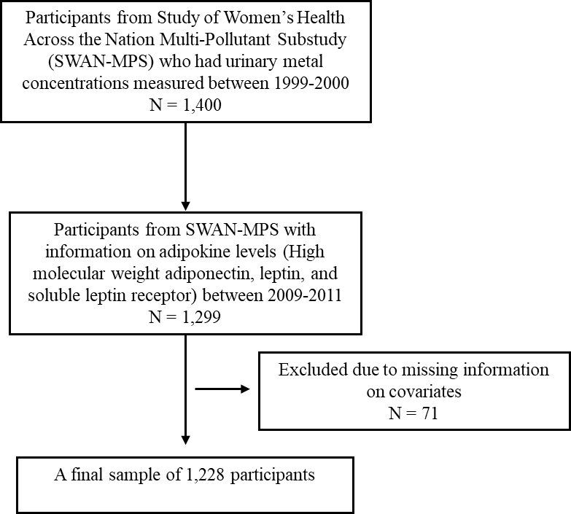

Figure S1. Schematic diagram of analytic sample.

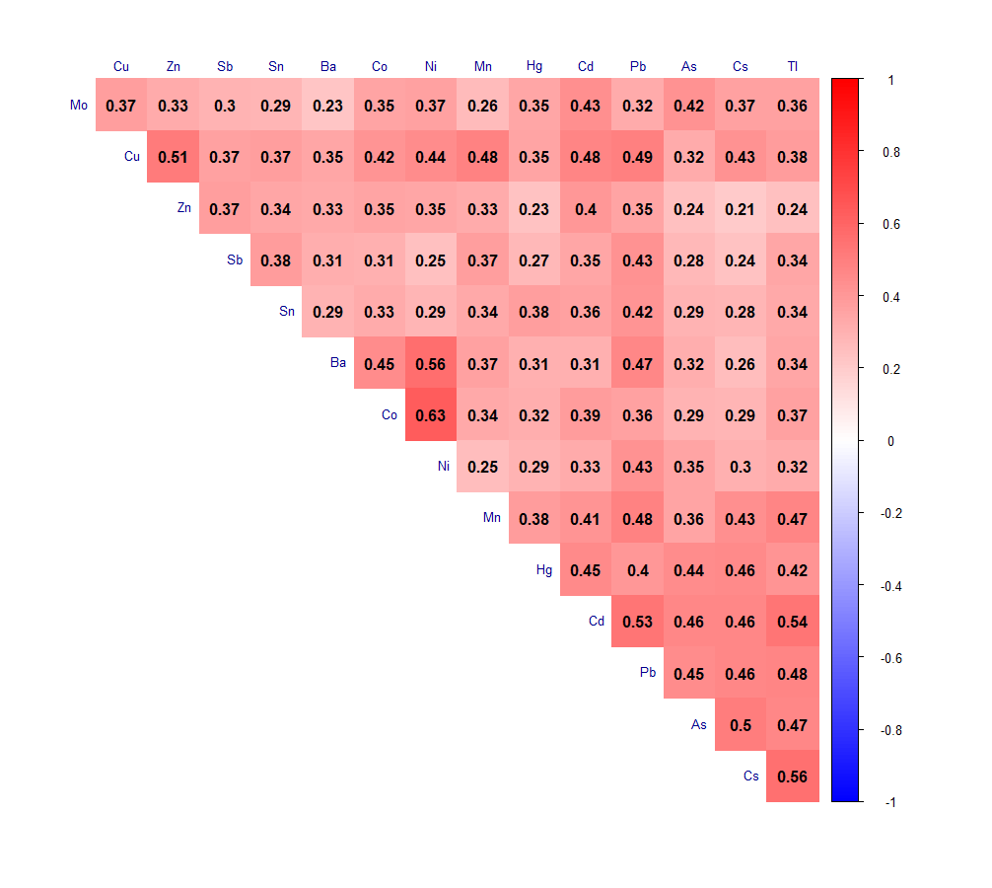
Figure S2. Spearman correlation matrix of metal concentrations after adjusting for specific gravity. As: arsenic, Ba: barium, Cd: cadmium, Co: cobalt, Cs: cesium, Cu: copper, Hg: mercury, Mn: manganese, Mo: molybdenum, Ni: nickel, Pb: lead, Sb: antimony, Sn: tin, Tl: thallium, Zn: zinc.

