Supplementary Figure 1 Receiver Operating Characteristic
(ROC) Curves for IBIS (Tyrer-Cuzick),
BCRAT (Gail), and BRCAPRO Models
Using the Marin Women’s Study Data

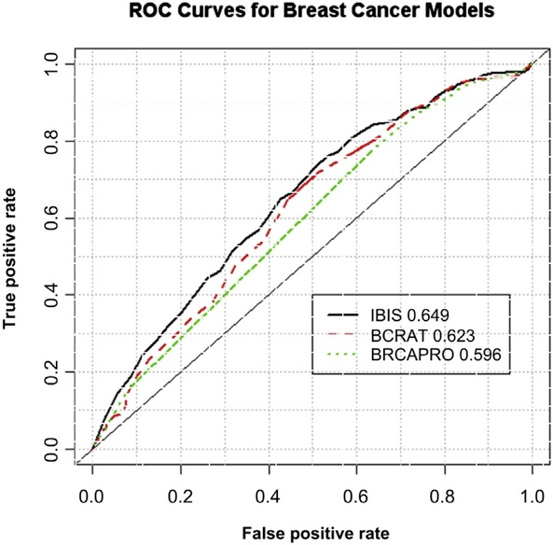

Abbreviations: BCRAT = Breast Cancer Risk Assessment Tool; IBIS = International Breast
Intervention Study.

