Supplementary Methods
Study population
The Breast Cancer Association Consortium (BCAC) database includes 104 studies. A description of all studies is presented in Supplementary Table S1. Of 85 studies with risk factor information, vital status and follow-up, 17 studies that oversampled familial cases and one study that oversampled bilateral cases were excluded; from two studies, subsets of patients oversampled for familial cases were also excluded. From the remaining 67 studies, female patients were included if vital status and time to last follow-up was known, if they had a primary invasive tumor (in situ and tumors with unknown behavior and patients with second tumors were excluded) without reported distant metastases at diagnosis. The final study population consisted of 121 435 breast cancer patients from 67 studies participating in the BCAC.
Thirty-five out of 67 studies in our analysis were population-based consisting of 51 037 out of 121 435 women. Risk factor information provided by individual studies was harmonized according to a common data dictionary by the BCAC Risk Factor Working Group at the German Cancer Research Center, Heidelberg, Germany. Clinical-pathological and treatment information as well as outcome was harmonized by the BCAC Survival, Pathology and Treatment Working Group at the Netherlands Cancer Institute, Amsterdam, the Netherlands. The risk factor and clinical-pathological data of the BCAC database version 12 were used.

Multiple imputation of missing data
Of the 67 studies in our analysis dataset, 6 studies came from Asia; the remaining 61 were mostly from Europe and North America (henceforth referred to as Western studies). Multiple imputation was performed after applying the exclusion criteria for individual subjects and studies, separately for Asian and Western countries. Percentages of missing values ranged from 0.05 for age at diagnosis to 84.37 for cumulative alcohol consumption (median (IQR): 41.53 (23.24-57.36)). Missing data was imputed separately for 6 studies from Asian countries and for 61 studies from Western countries to avoid imputations within Asian studies being driven by the much larger dataset from Western studies, in case of heterogeneity in risk factor and clinical-pathological distributions or in risk factor-outcome associations between Asian and Western countries. Twenty imputed datasets were generated—10 for Asian studies and 10 for Western studies. Women of non-European ancestry in Western studies was minor (5.1%).
Imputed datasets were generated using the R package MICE (version 3.2.0) through 30 iterations of the Multivariate Imputation by Chained Equations (MICE) algorithm. The list of imputed variables, with corresponding percentage of missing values, specific imputation method, and additional information about pre-processing of the data and imputation post-processing can be found in Supplementary Table S2. Pre-processing refers to adjustments in the data made before imputation. Post-processing refers to the procedure implemented in the MICE R package, which allows modification of imputed values directly after imputation, based on specified conditions. Variables have been imputed in ascending order of the number of missing values.
For each imputed variable, predictors to be included in the corresponding imputation model were selected among the other variables listed in Supplementary Table S2 if their correlation coefficient with the variable to impute was larger than 0.15 and their proportion of observed values among the cases with missing data on the variable to impute was at least 0.15. Parity status, breastfeeding status (ever=1; never=0), and oral contraceptive (OC) use (ever=1; never=0) were added as predictors in the imputation model of parity, breastfeeding duration, and OC duration, respectively. The variable “study” was included in all imputation models, in order to preserve the heterogeneity among studies.
In order to improve imputation, outcome variables, i.e., the Nelson-Aalen estimator and event indicator of both all-cause and breast cancer-specific mortality, were included in all imputation models.¹ Ordinal categorical variables derived from numeric variables (which were not already coded in the database) were not actively imputed, but their values were computed based on the values of the corresponding imputed numeric variables (passive imputation).
Estimates from the analyses across different imputed datasets were combined via the Rubin’s rule.^{2, 3} For more details related to the multiple imputation approach we used, we refer to the book of Stef van Buuren.⁴

Pooling of Western and Asian studies
To assess the appropriateness of pooling Western and Asian studies, fixed-effects meta-analyses of the results from Western and Asian studies were performed and heterogeneity was evaluated by means of the I² statistic and corresponding 95%CI, and the χ² test based on Cochran’s Q statistic.^{5, 6} I² values equal to 25%, 50% and 75% have been suggested for low, moderate, and high heterogeneity, respectively.^{5, 6} Risk factors showing I²$≥50\%$ with corresponding 95%CI not including 0% were considered heterogeneous. In cases where I²$>0\%$ and corresponding 95%CI could not be estimated, heterogeneity was determined using the Cochran’s test p-value < 0.05 (Supplementary Tables S5-S6).
Supplementary Tables S5 and S6 show the results of the meta-analyses of the associations of individual risk factors with all-cause mortality and breast cancer-specific mortality in Western and Asian studies. Given the general lack of evidence of heterogeneity by study origin, our main results focus on analyses based on the pooled data set of Western and Asian studies.

Correction for multiple testing
Associations of individual risk factors with all-cause and breast cancer-specific mortality
Multiple testing was accounted for using the Benjamini-Hochberg method for false discovery rate (FDR) control ⁷ on $17×8=136$ tests (17 exposure variables, since BMI was investigated overall and for post-menopausal and pre/perimenopausal women separately, and 8 patient groups, ie., all patients and 7 tumor subtypes (ER-positive and negative, and five intrinsic-like subtypes).

Heterogeneity of associations between tumor subtypes
To assess the potential heterogeneity of associations between tumor subtypes, a likelihood ratio test was used, comparing multivariable models with and without the interaction between the variable representing a specific risk factor and the variable representing the subtype (based on ER status only or according to the intrinsic-like classification). Investigations into the unexpected significant subtype heterogeneity despite similar HRs and overlapping 95%CIs for OC use and survival across subtypes (in Table 2) led to the detection of an interaction between OC use and age at diagnosis. To investigate this interaction, a second heterogeneity test was performed, where a full model including interactions between OC use and age at diagnosis, OC use and subtype, and subtype and age at diagnosis was compared to a reduced model without the interaction between OC use and subtype. Age at diagnosis was included as covariate, rather than used as time scale, and modeled via a quadratic term. The p-value of this test was 1.6E-01. The Benjamini-Hochberg method was used to account for multiple testing on $17×2=34$ tests (performed for all-cause mortality and breast cancer-specific mortality).

Time-dependent ROC curve analysis
We performed time-dependent ROC curve analyses to assess whether the additional inclusion of the putative risk factors that we investigated would add in terms of discriminative power compared to a prognostic model based only on the established prognostic factors that we included as covariates in the multivariable Cox regression models (Supplementary Figure S19 and Supplementary Figure S20). More precisely, we evaluated the discrimination ability of the models by computing the corresponding AUC values at different time horizons from diagnosis. We estimated the time-dependent sensitivity and specificity for censored event-times using the definition based on cumulative cases and dynamic controls.⁸ For a given time horizon, the model with the highest AUC has the highest ability to identify patients who experience the event and patients who are event-free at that specific time point. Since we used age of the patients as time scale in all the analyses, time horizons are in our case age horizons, namely ages at specific time horizons from diagnosis. We further computed the concordance index to have a global assessment of the discriminative power of the two different models over all ages.

References

1. White IR, Royston P. Imputing missing covariate values for the Cox model. 2009; 28: 1982-98.
2. Rubin DB. Multiple Imputation for Nonresponse in Surveys. New York: John Wiley & Sons, Inc.; 1987.
3. Barnard J, Rubin DB. Small-Sample Degrees of Freedom with Multiple Imputation. Biometrika 1999; 86: 948-55.
4. Buuren Sv. Flexible imputation of missing data. Second edition ed: Chapman & Hall/CRC; 2018.
5. Higgins JPT, Thompson SG. Quantifying heterogeneity in a meta-analysis. Stat Med 2002; 21: 1539-58.
6. Ioannidis JP, Patsopoulos NA, Evangelou E. Uncertainty in heterogeneity estimates in meta-analyses. BMJ (Clinical research ed) 2007; 335: 914-6.
7. Goeman JJ, Solari A. Multiple hypothesis testing in genomics. Statistics in Medicine 2014; 33: 1946-78.
8. Kamarudin AN, Cox T, Kolamunnage-Dona R. Time-dependent ROC curve analysis in medical research: current methods and applications. BMC medical research methodology 2017; 17: 53.

Supplementary Table S2. List of imputed variables with corresponding percentage of missing values, by Western and Asian studies, imputation method and processing.ª
Variable | Missing data percentage |  | Pre-processing of the data performed before imputation | Imputation method | Post-processing & post-imputation adjustments
 | Non-Asian | Asian
Age at diagnosis | 0.1 | 0.0 | Predictive mean matching | Predictive mean matching
Year of diagnosis | 3.9 | < 0.1 | Predictive mean matching | Predictive mean matching
Ethnicity | 10.9 | 0.0 | Polytomous regression | Polytomous regression
Morphology group of the tumor | 12.4 | 24.6 | Polytomous regression | Polytomous regression
Menopausal status at diagnosis | 14.1 | 17.2 | Set to “post-menopausal” if missing and Age at diagnosis ≥ 54 years. | Polytomous regression
ER status | 15.3 | 4.4 | Logistic regression | Logistic regression
Nodal status | 20.8 | 22.3 | Logistic regression | Logistic regression
Grade | 22.7 | 27.5 | Polytomous regression | Polytomous regression
Parity status (nulliparous=0; parous=1) | 23.7 | 21.6 | If missing and Parity not missing, then filled in according to Parity. If missing and never breastfed or duration of breastfeeding >0, then set to 1. | Predictive mean matching
Parity (numeric) | 24.2 | 21.6 | If missing and Parity status=0 not missing, then set to 0. | Predictive mean matching
Parity (categorical) | 24.2 | 21.6 |  | Passive based on Parity (numeric)
BMI (continuous) | 24.2 | 29.6 |  | Predictive mean matching
BMI (categorical) | 24.2 | 29.6 |  | Passive based on BMI (continuous)
PR status | 26.2 | 9.9 |  | Logistic regression
Adult height | 27.4 | 29.5 |  | Predictive mean matching
Bilaterality status | 28.1 | 29.3 |  | Polytomous regression
Age at menarche | 29.6 | 24.8 |  | Predictive mean matching
Tumor size | 33.8 | 27.2 |  | Predictive mean matching
Tumor stage | 39.2 | 14.3 |  | Polytomous regression
Age at first full term pregnancy | 42.6 | 47.1 |  | Predictive mean matching | Only imputed within parous women, using post-processing.
Surgery | 41.3 | 33.7 |  | Polytomous regression
Adjuvant chemotherapy | 41.4 | 12.7 |  | Logistic regression
Current smoking (no=0; yes=1) | 42.9 | 28.9 | If missing and corresponding value of Smoking observed and equal to 0 or 1, then set equal to 0. If missing and corresponding value of Smoking observed and equal to 2, then set equal to 2 (current smoker). If missing and corresponding value of pack-years of smoking observed and equal to 0, then set equal to 0. | Logistic regression
Endocrine therapy | 44.5 | 32.3 |  | Logistic regression
HER2 status | 45.1 | 29.5 |  | Logistic regression
MHT | 45.5 | 41.8 |  | Polytomous regression
Radiation therapy | 46.0 | 32.6 |  | Polytomous regression
Oral contraceptive use (0=no; 1=yes) | 46.5 | 31.8 | If missing and corresponding values of duration are observed and smaller than 4, then set equal to 0. If missing and corresponding values of duration are observed and at least 4, then set equal to 1. | Logistic regression
Smoking (never=0; past=1; current=2) | 46.6 | 28.9 | If missing and the corresponding value of Current smoking observed and equal to 1, then set equal to 2. | Polytomous regression
Breastfeeding (never=0; ever=1) | 48.9 | 40.0 | If missing and Parity status=0, then set equal to 0. | Predictive mean matching | Only for imputed values: if corresponding imputed value of Parity=0, then set equal to 0.
Neo-adjuvant chemotherapy | 49.5 | 50.7 |  | Logistic regression
Pack-years of smoking (continuous) | 53.5 | 30.2 | If missing and corresponding value of Smoking observed and equal to 0, then set equal to 0. | Predictive mean matching
Trastuzumab | 54.3 | 72.6 | If missing and corresponding value of Year of diagnosis observed and < 1998, then set equal to 0. | Logistic regression | Only for imputed values: if corresponding imputed value of Year of diagnosis<1998, then set equal to 0.
Oral contraceptive (duration in months) | 56.2 | 52.7 | If missing and corresponding values of Ever use equal to 0, then set equal to 0. | Predictive mean matching
Breastfeeding (duration in months) | 58.4 | 40.9 | If missing and never breastfed, then set equal to 0. | Predictive mean matching | Only for imputed values: if corresponding imputed value of Parity=0, then set equal to 0.
Age at last full-term birth | 63.3 | 55.6 |  | Predictive mean matching | Only imputed within parous women, using post-processing.
Alcohol intake (glasses/week)^{b} | 79.2 | 99.9 |  | Predictive mean matching
Alcohol intake (g/week) | 81.5 | 94.5 |  | Predictive mean matching
Cumulative lifetime alcohol intake (g/day) | 83.3 | 94.5 |  | Predictive mean matching
Physical activity (hours/week) | 83.3 | 74.3 |  | Predictive mean matching
Abbreviations: ER estrogen receptor, PR progesterone receptor, HER2 human epidermal growth factor receptor 2, MHT: Menopausal Hormone Therapy.
ª The Nelson-Aalen estimator and event indicator of both all-cause and breast cancer specific mortality were included in all models to improve imputation. Pre-processing refers to adjustment in the data made pre-imputation. Post-processing refers to the procedure implemented in the MICE R package, that allow to modify imputed values directly after imputation of an imputed variable (so that the adjusted values can be used in the imputation of the other variables in the same imputed dataset within the same iteration of the algorithm).
^{b} Could not be imputed within Asian studies.

Supplementary Table S3. Associations between individual risk factors and 10-year all-cause mortality by ER status and intrinsic-like subtype based on the complete-case dataset.
Risk factor | Overall | ER+ | ER- | Luminal A-like | Luminal B HER2-negative-like | Luminal B HER2-like | HER2-enriched-like | Triple negative
 | P  HR [95% CI] | P  HR [95% CI] | P  HR [95% CI] | P  HR [95% CI] | P  HR [95% CI] | P  HR [95% CI] | P  HR [95% CI] | P  HR [95% CI]
Age at menarche, per 1 year increase | 7.0E-01  1.01 [0.98,1.04] | 9.2E-01  0.99 [0.96,1.03] | 2.1E-01  1.06 [1.00,1.11] | 8.1E-01  0.99 [0.94,1.04] | 7.8E-01  0.98 [0.90,1.05] | 6.1E-01  1.05 [0.95,1.17] | 9.1E-01  0.98 [0.87,1.10] | 4.6E-01  1.06 [0.98,1.14]
Parity | 1.4E-02 | 1.3E-01 | 2.4E-01 | 2.1E-01 | 9.8E-01 | 6.9E-01 | 6.9E-01 | 1.3E-01
0 | Ref. | Ref. | Ref. | Ref. | Ref. | Ref. | Ref. | Ref.
1 | 0.82 [0.72,0.95] | 0.84 [0.71,1.00] | 0.72 [0.55,0.94] | 0.75 [0.59,0.97] | 0.85 [0.59,1.24] | 1.02 [0.64,1.62] | 0.62 [0.34,1.13] | 0.58 [0.39,0.85]
2 | 0.78 [0.69,0.88] | 0.77 [0.66,0.90] | 0.75 [0.59,0.95] | 0.73 [0.59,0.92] | 0.92 [0.66,1.28] | 0.78 [0.52,1.18] | 0.73 [0.43,1.25] | 0.60 [0.43,0.84]
3 | 0.88 [0.77,1.02] | 0.88 [0.74,1.04] | 0.81 [0.61,1.06] | 0.89 [0.70,1.14] | 0.92 [0.63,1.35] | 0.86 [0.53,1.38] | 0.81 [0.44,1.50] | 0.57 [0.39,0.84]
4+ | 0.94 [0.80,1.11] | 0.88 [0.72,1.07] | 0.98 [0.71,1.35] | 0.90 [0.68,1.19] | 0.93 [0.59,1.46] | 0.59 [0.31,1.12] | 1.17 [0.56,2.45] | 0.75 [0.48,1.17]
Age at first full term pregnancyª, years | 2.1E-02 | 4.6E-02 | 9.1E-01 | 3.2E-01 | 1.3E-01 | 8.6E-01 | 7.8E-01 | 9.1E-01
< 20 | Ref. | Ref. | Ref. | Ref. | Ref. | Ref. | Ref. | Ref.
20 to < 25 | 0.83 [0.71,0.96] | 0.81 [0.67,0.99] | 0.86 [0.64,1.15] | 0.70 [0.53,0.92] | 0.87 [0.55,1.38] | 1.24 [0.67,2.31] | 0.66 [0.34,1.29] | 1.01 [0.65,1.55]
25 to < 30 | 0.75 [0.64,0.89] | 0.71 [0.57,0.87] | 0.91 [0.67,1.24] | 0.71 [0.53,0.95] | 0.54 [0.33,0.88] | 1.23 [0.64,2.36] | 0.90 [0.44,1.82] | 1.06 [0.67,1.68]
≥ 30 | 0.72 [0.60,0.87] | 0.70 [0.56,0.88] | 0.85 [0.60,1.19] | 0.76 [0.55,1.05] | 0.69 [0.41,1.17] | 0.93 [0.45,1.91] | 0.71 [0.34,1.51] | 0.83 [0.50,1.39]
Time since last full term birthª, years | 3.6E-01 | 5.9E-01 | 5.9E-01 | 9.7E-02 | 9.6E-01 | 6.9E-01 | 1.3E-01 | 2.0E-01
≥ 10 | Ref. | Ref. | Ref. | Ref. | Ref. | Ref. | Ref. | Ref.
≥ 5 - < 10 | 0.98 [0.69,1.41] | 1.14 [0.70,1.85] | 0.72 [0.38,1.36] | 0.76 [0.30,1.91] | 1.29 [0.47,3.52] | 1.98 [0.61,6.43] | 0.52 [0.13,2.00] | 0.44 [0.14,1.34]
> 0 - < 5 | 1.66 [1.09,2.54] | 1.88 [1.01,3.49] | 1.68 [0.84,3.38] | 4.13 [1.63, 10.44] | 0.89 [0.18,4.50] | 1.36 [0.28,6.66] | 8.86 [1.85, 42.42] | 1.49 [0.56,3.94]
Breastfeedingª
Per 6 months increase | 5.9E-01  1.02 [0.99,1.05] | 5.9E-01  1.02 [0.98,1.07] | 9.6E-01  1.01 [0.94,1.08] | 4.7E-01  1.04 [0.98,1.10] | 7.2E-01  1.04 [0.94,1.15] | 5.3E-01  0.91 [0.78,1.08] | 6.9E-01  0.91 [0.72,1.15] | 9.6E-01  0.99 [0.91,1.09]
Ever vs never | 6.9E-01  0.93 [0.79,1.10] | 9.6E-01  0.98 [0.79,1.20] | 6.9E-01  0.88 [0.64,1.21] | 9.9E-01  1.00 [0.75,1.34] | 9.6E-01  0.96 [0.58,1.60] | 9.6E-01  1.03 [0.60,1.78] | 6.9E-01  0.72 [0.36,1.47] | 5.2E-01  0.75 [0.48,1.18]
BMI, kg/m²
All women | 1.2E-03 | 1.4E-02 | 2.4E-01 | 2.1E-02 | 9.2E-01 | 6.9E-01 | 3.6E-01 | 8.7E-01
18.5 to < 25 | Ref. | Ref. | Ref. | Ref. | Ref. | Ref. | Ref. | Ref.
< 18.5 | 1.74 [1.31,2.31] | 1.97 [1.38,2.80] | 1.43 [0.85,2.39] | 2.60 [1.58,4.28] | 0.91 [0.36,2.30] | 1.82 [0.78,4.24] | 1.49 [0.29,7.67] | 1.41 [0.71,2.79]
25 to < 30 | 0.97 [0.88,1.07] | 1.01 [0.89,1.14] | 0.86 [0.71,1.04] | 0.97 [0.81,1.16] | 1.06 [0.82,1.38] | 0.92 [0.65,1.31] | 0.69 [0.44,1.08] | 0.94 [0.71,1.25]
≥ 30 | 1.17 [1.04,1.30] | 1.16 [1.01,1.33] | 1.11 [0.90,1.38] | 1.17 [0.96,1.44] | 1.17 [0.87,1.56] | 1.17 [0.80,1.72] | 1.26 [0.77,2.05] | 1.09 [0.80,1.50]
Postmenopausal women | 1.2E-03 | 2.2E-02 | 1.6E-01 | 9.1E-03 | 7.9E-01 | 9.9E-01 | 3.5E-01 | 8.1E-01
18.5 to < 25 | Ref. | Ref. | Ref. | Ref. | Ref. | Ref. | Ref. | Ref.
< 18.5 | 2.12 [1.49,3.01] | 2.44 [1.58,3.77] | 1.57 [0.84,2.94] | 3.60 [2.05,6.34] | 1.92 [0.65,5.72] | 1.19 [0.25,5.53] | 0.58 [0.07,5.17] | 1.45 [0.61,3.44]
25 to < 30 | 0.96 [0.85,1.09] | 1.00 [0.86,1.15] | 0.82 [0.64,1.04] | 0.94 [0.77,1.16] | 1.13 [0.81,1.58] | 1.00 [0.63,1.58] | 0.55 [0.30,1.00] | 0.96 [0.68,1.35]
≥ 30 | 1.17 [1.02,1.34] | 1.11 [0.94,1.30] | 1.15 [0.89,1.50] | 1.11 [0.88,1.41] | 1.22 [0.85,1.73] | 1.05 [0.61,1.81] | 1.12 [0.63,1.99] | 1.21 [0.83,1.76]
Pre/perimenopausal women | 6.9E-01 | 3.6E-01 | 9.8E-01 | 6.9E-01 | 6.9E-01 | 1.3E-01 | 3.6E-01 | 9.6E-01
18.5 to < 25 | Ref. | Ref. | Ref. | Ref. | Ref. | Ref. | Ref. | Ref.
< 18.5 | 1.30 [0.74,2.28] | 1.35 [0.65,2.80] | 1.32 [0.48,3.61] | 1.01 [0.24,4.25] | 0.30 [0.04,2.27] | 6.36 [1.35,29.94] | Inf [0.00, Inf] | 1.51 [0.42,5.39]
25 to < 30 | 0.96 [0.78,1.18] | 0.91 [0.69,1.20] | 1.00 [0.69,1.45] | 1.10 [0.73,1.64] | 0.67 [0.36,1.23] | 0.57 [0.24,1.34] | 1.06 [0.47,2.40] | 0.89 [0.49,1.59]
≥ 30 | 1.19 [0.93,1.52] | 1.38 [1.01,1.88] | 0.97 [0.60,1.57] | 1.55 [0.94,2.55] | 0.78 [0.38,1.61] | 1.57 [0.73,3.38] | 0.73 [0.17,3.24] | 0.88 [0.44,1.76]
Adult height, per 5 cm increase | 5.8E-01  0.98 [0.95,1.01] | 4.6E-01  0.97 [0.93,1.01] | 8.1E-01  1.02 [0.95,1.09] | 3.4E-01  0.95 [0.90,1.01] | 7.2E-01  0.97 [0.88,1.06] | 7.6E-01  0.96 [0.85,1.08] | 9.6E-01  0.99 [0.85,1.16] | 9.6E-01  1.01 [0.92,1.11]
Oral contraceptive use | 1.7E-01 | 5.0E-01 | 4.6E-01 | 5.3E-01 | 3.2E-01 | 9.6E-01 | 6.9E-01 | 3.2E-01
Ever vs never | 0.88 [0.77,0.99] | 0.91 [0.78,1.05] | 0.84 [0.65,1.08] | 0.88 [0.71,1.09] | 0.74 [0.53,1.03] | 0.95 [0.65,1.39] | 1.26 [0.75,2.12] | 0.72 [0.50,1.04]
Menopausal hormone therapy | 5.8E-02 | 1.2E-01 | 5.3E-01 | 4.3E-01 | 5.4E-01 | 9.0E-01 | 9.6E-01 | 5.2E-01
Never use, postmenopausal | Ref. | Ref. | Ref. | Ref. | Ref. | Ref. | Ref. | Ref.
Former^{b} use of ET | 0.80 [0.59,1.07] | 0.87 [0.62,1.21] | 0.62 [0.32,1.21] | 0.68 [0.42,1.12] | 0.57 [0.22,1.50] | 1.67 [0.69,4.00] | 1.09 [0.29,4.10] | 0.40 [0.14,1.10]
Former^{b} use of EPT | 0.77 [0.55,1.07] | 0.77 [0.52,1.14] | 0.80 [0.43,1.49] | 0.77 [0.45,1.30] | 0.64 [0.19,2.14] | 0.84 [0.19,3.77] | 0.38 [0.08,1.75] | 1.22 [0.55,2.71]
Former^{b} use (unknown type) | 0.84 [0.70,1.01] | 0.82 [0.66,1.03] | 0.78 [0.53,1.15] | 0.81 [0.60,1.09] | 1.12 [0.71,1.76] | 0.71 [0.29,1.75] | 0.97 [0.40,2.35] | 0.55 [0.30,1.01]
Current^{c} use of ET | 0.74 [0.51,1.07] | 0.65 [0.41,1.04] | 0.92 [0.46,1.87] | 0.79 [0.42,1.49] | 0.26 [0.06,1.16] | 0.56 [0.07,4.35] | 0.97 [0.21,4.58] | 0.93 [0.34,2.55]
Current^{c} use of EPT | 0.63 [0.50,0.81] | 0.61 [0.46,0.82] | 0.63 [0.39,1.02] | 0.57 [0.37,0.88] | 0.46 [0.21,1.00] | 0.84 [0.39,1.81] | 0.75 [0.27,2.07] | 0.60 [0.28,1.28]
Current^{c} use (unknown type) | 0.82 [0.64,1.05] | 0.74 [0.55,1.00] | 1.00 [0.62,1.63] | 0.70 [0.45,1.07] | 1.20 [0.57,2.51] | 1.64 [0.59,4.56] | 0.57 [0.13,2.57] | 0.96 [0.47,1.97]
Smoking | 1.2E-02 | 2.6E-03 | 9.0E-01 | 2.0E-03 | 4.4E-01 | 7.0E-01 | 1.4E-01 | 9.6E-01
Never | Ref. | Ref. | Ref. | Ref. | Ref. | Ref. | Ref. | Ref.
Former^{d} | 1.05 [0.92,1.20] | 1.08 [0.92,1.27] | 1.11 [0.85,1.44] | 1.15 [0.90,1.46] | 1.30 [0.88,1.90] | 0.82 [0.52,1.29] | 2.14 [1.17,3.88] | 0.96 [0.66,1.40]
Current^{e} | 1.37 [1.16,1.61] | 1.55 [1.27,1.88] | 1.10 [0.81,1.49] | 1.91 [1.44,2.53] | 1.56 [0.95,2.57] | 0.70 [0.37,1.30] | 0.84 [0.40,1.80] | 1.11 [0.71,1.74]
No. of pack-years of smoking, per 10 units increase | 1.2E-03  1.12 [1.06,1.17] | 1.2E-03  1.13 [1.07,1.20] | 5.9E-01  1.07 [0.95,1.19] | 8.8E-04  1.20 [1.12,1.29] | 5.3E-01  1.10 [0.94,1.29] | 9.8E-01  0.99 [0.82,1.20] | 3.6E-01  1.21 [0.96,1.52] | 9.0E-01  0.97 [0.81,1.15]
Alcohol consumption^{e}, per 10 g/week | 9.6E-01  1.00 [0.99,1.01] | 9.0E-01  1.00 [0.99,1.02] | 7.2E-01  0.99 [0.96,1.02] | 9.6E-01  1.00 [0.98,1.02] | 3.2E-01  1.04 [1.00,1.08] | 9.0E-01  0.99 [0.97,1.02] | 9.8E-01  1.00 [0.96,1.05] | 6.9E-01  0.97 [0.92,1.04]
Cumulative alcohol consumption, per 10 g/day | 9.6E-01  0.99 [0.90,1.09] | 9.6E-01  0.99 [0.89,1.11] | 9.8E-01  1.00 [0.81,1.22] | 7.7E-01  0.95 [0.81,1.11] | 2.5E-02  1.45 [1.17,1.80] | 6.9E-01  0.91 [0.69,1.20] | 8.1E-01  1.11 [0.80,1.52] | 9.6E-01  0.94 [0.57,1.55]
Physical activity^{e,f}, hours/week | 7.3E-01 | 3.6E-01 | 8.4E-01 | 5.0E-01 | 9.8E-01 | 3.6E-01 | 4.5E-01 | 9.1E-01
< 1.8 | Ref. | Ref. | Ref. | Ref. | Ref. | Ref. | Ref. | Ref.
≥ 1.8 - < 5.5 | 0.87 [0.65, 1.17] | 0.78 [0.56, 1.11] | 1.34 [0.62, 2.89] | 0.56 [0.30, 1.06] | 0.90 [0.23, 3.51] | 1.22 [0.43, 3.48] | 6792100618.49 [0.00, Inf] | 0.95 [0.26, 3.53]
≥ 5.5 | 0.84 [0.62, 1.12] | 0.70 [0.50, 0.98] | 1.42 [0.70, 2.86] | 0.76 [0.48, 1.21] | 1.02 [0.29, 3.55] | 0.59 [0.23, 1.52] | 2976783314.29 [0.00, Inf] | 1.39 [0.46, 4.20]
All the analyses have been stratified by study and adjusted for lymph nodes status, tumor size, tumor grade and (neo)adjuvant systemic treatment. Age of the patients was used as time scale. Reported p-values (P) are from likelihood-ratio tests comparing a model with and without a particular risk factor and are adjusted for multiple testing using the Benjamini-Hochberg method for false discovery rate (FDR) control on 136 tests. Numbers of patients and events included in the analyses are shown in Supplementary Figures S1 (overall), S3 (ER+), S5 (ER-), S7 (Luminal A-like), S9 (Luminal B HER2-negative-like), S11 (Luminal B HER2-positive-like), S13 (HER2-enriched-like) and S15 (triple negative).
Abbreviations: ET: estrogen therapy; EPT: combined estrogen and progestin therapy. ª Association estimated in parous women. ^{b} More than 6 months before diagnosis. ^{c} At diagnosis or within 6 months before diagnosis. ^{d} More than 1 year before diagnosis. ^{e} At diagnosis or within 1 year before diagnosis. ^{f} Categories based on the tertiles of the observed distribution of the variable.

Supplementary Table S4. Associations between individual risk factors and 10-year breast cancer-specific mortality by ER status and intrinsic-like subtype based on the complete-case dataset.
Risk factor | Overall | ER+ | ER- | Luminal A | Luminal B HER2-negative-like | Luminal B HER2-like | HER2-enriched-like | Triple negative
 | P  HR [95% CI] | P  HR [95% CI] | P  HR [95% CI] | P  HR [95% CI] | P  HR [95% CI] | P  HR [95% CI] | P  HR [95% CI] | P  HR [95% CI]
Age at menarche, per 1 year increase | 8.8E-01  1.02 [0.98,1.06] | 9.3E-01  0.99 [0.94,1.04] | 3.2E-01  1.08 [1.01,1.16] | 9.1E-01  0.98 [0.91,1.05] | 4.2E-01  0.91 [0.83,1.01] | 4.2E-01  1.14 [0.99,1.31] | 9.3E-01  1.03 [0.88,1.20] | 8.4E-01  1.05 [0.94,1.16]
Parity | 5.3E-01 | 8.0E-01 | 9.5E-01 | 8.8E-01 | 9.3E-01 | 9.1E-01 | 8.3E-01 | 7.7E-01
0 | Ref. | Ref. | Ref. | Ref. | Ref. | Ref. | Ref. | Ref.
1 | 0.83 [0.68,1.01] | 0.82 [0.64,1.06] | 0.90 [0.63,1.30] | 0.75 [0.51,1.10] | 0.79 [0.49,1.28] | 1.35 [0.67,2.70] | 1.04 [0.47,2.30] | 0.76 [0.45,1.28]
2 | 0.79 [0.67,0.94] | 0.79 [0.64,0.98] | 0.85 [0.61,1.17] | 0.79 [0.57,1.10] | 0.85 [0.56,1.29] | 1.07 [0.57,2.04] | 1.00 [0.48,2.10] | 0.70 [0.45,1.09]
3 | 0.86 [0.71,1.05] | 0.89 [0.69,1.14] | 0.85 [0.58,1.23] | 0.95 [0.66,1.37] | 0.74 [0.44,1.22] | 1.15 [0.54,2.48] | 0.95 [0.39,2.29] | 0.54 [0.32,0.92]
4+ | 0.87 [0.68,1.11] | 0.85 [0.63,1.16] | 0.98 [0.61,1.55] | 0.93 [0.60,1.45] | 1.03 [0.57,1.88] | 0.50 [0.15,1.75] | 2.65 [0.92,7.63] | 0.68 [0.36,1.29]
Age at first full term pregnancyª, years | 4.2E-01 | 3.5E-01 | 9.3E-01 | 5.3E-01 | 3.2E-01 | 9.1E-01 | 9.3E-01 | 8.8E-01
< 20 | Ref. | Ref. | Ref. | Ref. | Ref. | Ref. | Ref. | Ref.
20 to < 25 | 0.80 [0.65,0.98] | 0.77 [0.58,1.01] | 0.87 [0.60,1.25] | 0.64 [0.43,0.95] | 0.71 [0.41,1.24] | 1.23 [0.51,2.98] | 0.75 [0.34,1.66] | 0.76 [0.44,1.32]
25 to < 30 | 0.77 [0.62,0.95] | 0.72 [0.54,0.96] | 0.93 [0.63,1.38] | 0.77 [0.51,1.16] | 0.42 [0.23,0.76] | 1.54 [0.59,3.98] | 0.67 [0.26,1.69] | 1.06 [0.58,1.91]
≥ 30 | 0.75 [0.58,0.95] | 0.62 [0.45,0.87] | 1.04 [0.68,1.58] | 0.63 [0.39,1.02] | 0.63 [0.33,1.21] | 0.88 [0.29,2.66] | 0.95 [0.39,2.35] | 0.99 [0.53,1.86]
Time since last full term birthª, years | 3.2E-01 | 5.3E-01 | 6.3E-01 | 3.0E-01 | 9.3E-01 | 6.6E-01 | 4.2E-01 | 3.2E-01
≥ 10 | Ref. | Ref. | Ref. | Ref. | Ref. | Ref. | Ref. | Ref.
≥ 5 - < 10 | 0.93 [0.57,1.51] | 1.07 [0.57,2.03] | 0.55 [0.22,1.36] | 0.87 [0.30,2.56] | 1.39 [0.38,5.14] | 1.81 [0.15, 21.43] | 0.77 [0.13,4.68] | 0.16 [0.02,1.27]
> 0 - < 5 | 2.16 [1.28,3.63] | 2.49 [1.16,5.32] | 1.85 [0.78,4.39] | 5.68 [1.78, 18.15] | 2.81 [0.48, 16.57] | 0.51 [0.04,6.27] | 13.99 [1.22, 160.2] | 1.53 [0.47,4.97]
Breastfeedingª
Per 6 months increase | 9.3E-01  1.01 [0.95,1.08] | 9.1E-01  1.03 [0.95,1.11] | 9.2E-01  1.04 [0.90,1.20] | 9.3E-01  1.02 [0.88,1.18] | 9.9E-01  1.00 [0.85,1.17] | 8.0E-01  1.14 [0.91, 1.41] | 8.8E-01  1.13 [0.83,1.53] | 9.2E-01  0.94 [0.72,1.21]
Ever vs never | 9.1E-01  0.93 [0.74,1.17] | 9.3E-01  0.94 [0.70,1.28] | 9.8E-01  0.98 [0.63,1.52] | 9.3E-01  1.10 [0.71,1.71] | 4.6E-01  0.58 [0.31,1.09] | 9.3E-01  0.91 [0.44,1.89] | 9.3E-01  1.13 [0.46,2.78] | 9.2E-01  0.86 [0.46,1.59]
BMI, kg/m²
All women | 9.7E-01 | 9.3E-01 | 9.1E-01 | 9.2E-01 | 9.1E-01 | 8.0E-01 | 8.3  E-01 | 9.8E-01
18.5 to < 25 | Ref. | Ref. | Ref. | Ref. | Ref. | Ref. | Ref. | Ref.
< 18.5 | 1.20 [0.76,1.90] | 1.17 [0.61,2.23] | 1.26 [0.60,2.61] | 0.98 [0.31,3.12] | 0.70 [0.17,2.96] | 2.34 [0.75,7.34] | 2.77 [0.39, 19.49] | 1.02 [0.37,2.82]
25 to < 30 | 1.00 [0.88,1.13] | 1.09 [0.93,1.28] | 0.89 [0.69,1.14] | 1.04 [0.82,1.34] | 1.16 [0.85,1.57] | 1.08 [0.70,1.67] | 0.82 [0.47,1.42] | 0.91 [0.63,1.31]
≥ 30 | 1.02 [0.88,1.19] | 1.03 [0.85,1.25] | 1.06 [0.81,1.40] | 1.21 [0.91,1.62] | 0.91 [0.63,1.32] | 1.40 [0.87,2.26] | 1.32 [0.72,2.43] | 0.95 [0.63,1.43]
Postmenopausal women | 9.2E-01 | 8.0E-01 | 5.7E-01 | 9.2E-01 | 8.3E-01 | 8.0E-01 | 8.0E-01 | 9.8E-01
18.5 to < 25 | Ref. | Ref. | Ref. | Ref. | Ref. | Ref. | Ref. | Ref.
< 18.5 | 1.56 [0.82,2.97] | 1.61 [0.58,4.49] | 1.54 [0.63,3.78] | 1.85 [0.41,8.35] | 1.82 [0.22, 14.82] | 0.00 [0.00, Inf] | 0.70 [0.05,9.73] | 1.09 [0.30,3.98]
25 to < 30 | 1.05 [0.89,1.24] | 1.18 [0.96,1.46] | 0.78 [0.57,1.08] | 1.03 [0.75,1.41] | 1.29 [0.85,1.96] | 1.81 [0.91,3.61] | 0.53 [0.24,1.15] | 0.85 [0.54,1.36]
≥ 30 | 1.07 [0.88,1.29] | 1.03 [0.81,1.32] | 1.11 [0.79,1.56] | 1.23 [0.86,1.75] | 0.88 [0.54,1.42] | 1.64 [0.72,3.71] | 1.03 [0.49,2.18] | 0.98 [0.59,1.63]
Pre/perimenopausal women | 9.3E-01 | 8.7E-01 | 9.5E-01 | 9.3E-01 | 8.8E-01 | 4.2E-01 | 3.2E-01 | 9.8E-01
18.5 to < 25 | Ref. | Ref. | Ref. | Ref. | Ref. | Ref. | Ref. | Ref.
< 18.5 | 1.07 [0.53,2.15] | 1.03 [0.41,2.59] | 0.96 [0.25,3.71] | 0.61 [0.08,4.49] | 0.62 [0.08,4.79] | 8.25 [1.23, 55.38] | Inf [0.00, Inf] | 0.94 [0.16,5.57]
25 to < 30 | 0.90 [0.71,1.14] | 0.83 [0.60,1.15] | 1.15 [0.75,1.76] | 1.12 [0.70,1.78] | 0.62 [0.31,1.23] | 0.60 [0.23,1.56] | 1.35 [0.51,3.53] | 1.01 [0.57,2.14]
≥ 30 | 1.03 [0.77,1.38] | 1.18 [0.81,1.73] | 0.89 [0.51,1.56] | 1.29 [0.69,2.41] | 0.63 [0.26,1.52] | 1.43 [0.63,3.27] | 0.91 [0.17,4.79] | 0.89 [0.40,1.94]
Adult height, per 5 cm increase | 6.3E-01  0.97 [0.93,1.01] | 6.6E-01  0.96 [0.91,1.02] | 9.3E-01  0.99 [0.91,1.07] | 8.0E-01  0.96 [0.88,1.05] | 9.5E-01  0.99 [0.88,1.11] | 9.3E-01  0.98 [0.84,1.14] | 8.0E-01  0.90 [0.74,1.10] | 9.1E-01  0.96 [0.85,1.08]
Oral contraceptive use | 1.1E-01 | 3.5E-01 | 3.2E-01 | 8.0E-01 | 4.2E-01 | 7.8E-01 | 9.3E-01 | 2.5E-01
Ever vs never | 0.74 [0.62,0.88] | 0.80 [0.65,0.99] | 0.68 [0.48,0.96] | 0.84 [0.61,1.15] | 0.67 [0.43,1.03] | 0.71 [0.40,1.28] | 0.91 [0.45,1.82] | 0.49 [0.29,0.83]
Menopausal hormone therapy | 3.5E-01 | 2.2E-01 | 9.4E-01 | 7.4E-01 | 8.8E-01 | 4.6E-01 | 9.8E-01 | 8.0E-01
Never use, postmenopausal | Ref. | Ref. | Ref. | Ref. | Ref. | Ref. | Ref. | Ref.
Former^{b} use of ET | 0.87 [0.58,1.29] | 0.93 [0.58,1.50] | 0.97 [0.45,2.09] | 0.64 [0.30,1.35] | 0.58 [0.17,2.02] | 3.56 [1.27,9.93] | 1.31 [0.34,5.11] | 0.54 [0.14,2.05]
Former^{b} use of EPT | 1.05 [0.70,1.56] | 0.87 [0.52,1.46] | 1.41 [0.71,2.80] | 0.77 [0.37,1.60] | 0.82 [0.24,2.79] | 1.55 [0.30,7.86] | 0.61 [0.12,3.22] | 2.12 [0.87,5.12]
Former^{b} use (unknown type) | 0.83 [0.63,1.08] | 0.78 [0.56,1.08] | 0.98 [0.59,1.62] | 0.69 [0.43,1.12] | 1.08 [0.57,2.06] | 0.79 [0.22,2.92] | 0.95 [0.31,2.95] | 1.13 [0.51,2.48]
Current^{c} use of ET | 0.59 [0.35,1.01] | 0.30 [0.13,0.68] | 1.22 [0.54,2.74] | 0.68 [0.28,1.67] | 0.15 [0.02,1.21] | 0.00 [0.00, Inf] | 1.57 [0.29,8.34] | 1.67 [0.57,4.83]
Current^{c} use of EPT | 0.60 [0.43,0.83] | 0.51 [0.34,0.78] | 0.70 [0.39,1.28] | 0.45 [0.24,0.86] | 0.55 [0.22,1.38] | 0.97 [0.34,2.74] | 0.74 [0.23,2.38] | 0.62 [0.23,1.68]
Current^{c} use (unknown type) | 0.86 [0.61,1.20] | 0.80 [0.53,1.20] | 0.95 [0.50,1.80] | 0.72 [0.40,1.31] | 1.19 [0.48,2.94] | 2.39 [0.73,7.84] | 0.78 [0.16,3.82] | 0.94 [0.34,2.60]
Smoking | 9.2E-01 | 7.7E-01 | 8.4E-01 | 5.3E-01 | 6.7E-01 | 4.2E-01 | 4.2E-01 | 9.3E-01
Never | Ref. | Ref. | Ref. | Ref. | Ref. | Ref. | Ref. | Ref.
Former^{d} | 0.98 [0.82,1.17] | 0.93 [0.75,1.17] | 1.19 [0.86,1.64] | 1.10 [0.79,1.54] | 1.47 [0.92,2.35] | 0.58 [0.32,1.07] | 2.22 [1.08,4.58] | 1.16 [0.73,1.86]
Current^{e} | 1.10 [0.88,1.38] | 1.21 [0.92,1.60] | 0.89 [0.58,1.34] | 1.53 [1.03,2.27] | 1.45 [0.77,2.74] | 0.45 [0.18,1.12] | 0.91 [0.37,2.22] | 0.95 [0.51,1.77]
No. of pack-years of smoking, per 10 units increase | 3.5E-01  1.08 [1.01,1.16] | 3.2E-01  1.10 [1.02,1.19] | 9.3E-01  1.02 [0.88,1.19] | 2.2E-01  1.19 [1.07,1.33] | 4.6E-01  1.17 [0.99,1.38] | 9.3E-01  0.94 [0.72,1.24] | 5.7E-01  1.23 [0.94,1.61] | 9.1E-01  0.93 [0.72,1.19]
Alcohol consumption^{e}, per 10 g/week | 9.7E-01  1.00 [0.99,1.01] | 8.6E-01  1.01 [0.99,1.02] | 8.8E-01  0.99 [0.95,1.02] | 9.8E-01  1.00 [0.98,1.02] | 2.6E-01  1.05 [1.02,1.10] | 9.4E-01  1.00 [0.97,1.03] | 9.1E-01  1.02 [0.97,1.07] | 9.1E-01  0.98 [0.90,1.06]
Cumulative alcohol consumption, per 10 g/day | 9.8E-01  1.00 [0.89,1.11] | 9.7E-01  1.01 [0.89,1.14] | 9.7E-01  1.01 [0.81,1.27] | 8.0E-01  0.90 [0.72,1.13] | 2.6E-01  1.38 [1.10,1.72] | 9.2E-01  0.93 [0.68,1.26] | 8.0E-01  1.22 [0.85,1.73] | 9.8E-01  1.02 [0.59,1.76]
Physical activity^{e,f}, hours/week | 9.3E-01 | 9.8E-01 | 9.3E-01 | 9.3E-01 | 9.2E-01 | 5.3E-01 | 5.4E-01 | 9.1E-01
< 1.8 | Ref. | Ref. | Ref. | Ref. | Ref. | Ref. | Ref. | Ref.
≥ 1.8 - < 5.5 | 0.86 [0.58, 1.28] | 0.94 [0.58, 1.50] | 0.74 [0.30, 1.82] | 0.8 [0.34, 1.89] | 0.59 [0.14, 2.55] | 2.25 [0.61, 8.37] | 225530120.84 [0.00, Inf] | 0.42 [0.08, 2.17]
≥ 5.5 | 0.98 [0.68, 1.42] | 0.91 [0.59, 1.42] | 0.98 [0.45, 2.16] | 1.08 [0.57, 2.07] | 0.91 [0.25, 3.40] | 0.95 [0.28, 3.23] | 105630301.2 [0.00, Inf] | 0.69 [0.21, 2.31]
All the analyses have been stratified by study and adjusted for lymph nodes status, tumor size, tumor grade and (neo)adjuvant systemic treatment. Age of the patients was used as time scale Reported p-values (P) are from likelihood-ratio tests comparing a model with and without a particular risk factor and are adjusted for multiple testing using the Benjamini-Hochberg method for false discovery rate (FDR) control on 136 tests. Numbers of patients and events included in the analyses are shown in Supplementary Figures S2 (overall), S4 (ER+), S6 (ER-), S8 (Luminal A-like), S10 (Luminal B HER2-negative-like), S12 (Luminal B HER2-positive-like), S14 (HER2-enriched-like) and S16 (triple negative).
Abbreviations: ET: estrogen therapy; EPT: combined estrogen and progestin therapy. ª Association estimated in parous women. ^{b} More than 6 months before diagnosis. ^{c} At diagnosis or within 6 months before diagnosis. ^{d} More than 1 year before diagnosis. ^{e} At diagnosis or within 1 year before diagnosis. ^{f} Categories based on the tertiles of the observed distribution of the variable.
Supplementary Table S5. Meta-analysis of the overall associations between individual risk factors and 10-year all-cause mortality in Western and Asian studies, performed on the imputed datasets.
Risk factor | Western studies |  | Asian studies |  | Fixed Effect Meta-Analysis |  | Heterogeneity
 | HR [95%CI] | P-value | HR [95%CI] | P-value | HR [95%CI] | P-value | I² [95%CI] | P-value^{g}
Age at menarche, per 1 year increase | 1.01 [0.99, 1.04] | 2.0E-01 | 1.05 [1.01, 1.09] | 2.0E-02 | 1.02 [1, 1.04] | 2,6E-02 | 0.53 [0.00, 0.88] | 1,5E-01
Parity
0 | Ref. |  | Ref. |  | Ref.
1 | 0.87 [0.79, 0.97] | 7.4E-03 | 0.94 [0.68, 1.29] | 6.9E-01 | 0.88 [0.80, 0.96] | 6.3E-03 | 0.00 [NA, NA] | 6.6E-01
2 | 0.85 [0.75, 0.95] | 3.5E-03 | 1.11 [0.81, 1.52] | 5.1E-01 | 0.87 [0.79, 0.97] | 9.1E-03 | 0.62 [0.00, 0.91] | 1.0E-01
3 | 0.89 [0.80, 0.99] | 2.3E-02 | 1.17 [0.84, 1.62] | 3.4E-01 | 0.91 [0.83, 1.00] | 5.6E-02 | 0.62 [0.00, 0.91] | 1.0E-01
4+ | 0.95 [0.85, 1.05] | 2.6E-01 | 1.30 [0.91, 1.86] | 1.4E-01 | 0.97 [0.88, 1.06] | 4.9E-01 | 0.66 [0.00, 0.92] | 8.0E-02
Age at first full term pregnancyª, years
< 20 | Ref. |  | Ref. |  | Ref.
20 to < 25 | 0.88 [0.83, 0.94] | 1.5E-04 | 0.83 [0.66, 1.05] | 1.2E-01 | 0.88 [0.83, 0.93] | 3.6E-05 | 0.00 [NA, NA] | 6.4E-01
25 to < 30 | 0.83 [0.77, 0.89] | 3.6E-07 | 0.68 [0.55, 0.85] | 7.8E-04 | 0.81 [0.76, 0.87] | 1.7E-09 | 0.62 [0.00, 0.91] | 1.0E-01
≥ 30 | 0.81 [0.74, 0.88] | 1.6E-06 | 0.60 [0.47, 0.78] | 1.3E-04 | 0.79 [0.73, 0.85] | 4.1E-09 | 0.78 [0.04, 0.95] | 3.0E-02
Time since last full term birthª, years
≥ 10 | Ref. |  | Ref. |  | Ref.
≥ 5 - < 10 | 1.07 [0.95, 1.20] | 2.6E-01 | 1.05 [0.76, 1.46] | 7.6E-01 | 1.07 [0.96, 1.19] | 2.4E-01 | 0.00 [NA, NA] | 9.3E-01
> 0 - < 5 | 1.20 [1.01, 1.41] | 3.0E-02 | 1.29 [0.76, 2.20] | 3.3E-01 | 1.20 [1.03, 1.40] | 1.7E-02 | 0.00 [NA, NA] | 7.8E-01
Breastfeedingª
Per 6 months increase | 1.01 [0.98, 1.04] | 4.3E-01 | 1.03 [1.01, 1.05] | 5.4E-04 | 1.03 [1.01, 1.04] | 8.1E-04 | 0.37 [NA, NA] | 2.1E-01
Never | Ref. |  | Ref. |  | Ref.
Ever | 0.95 [0.83, 1.09] | 4.4E-01 | 1.20 [0.99, 1.46] | 5.6E-02 | 1.02 [0.92, 1.13] | 7.1E-01 | 0.76 [0.00, 0.95] | 4.0E-02
BMI, kg/m²
All women
18.5 to < 25 | Ref. |  | Ref. |  | Ref.
< 18.5 | 1.37 [0.92, 2.04] | 9.0E-02 | 1.21 [0.85, 1.71] | 2.7E-01 | 1.28 [1.00, 1.63] | 4.8E-02 | 0.00 [NA, NA] | 6.2E-01
25 to < 30 | 1.06 [0.92, 1.23] | 3.7E-01 | 0.98 [0.83, 1.16] | 8.2E-01 | 1.03 [0.93, 1.14] | 5.7E-01 | 0.00 [NA, NA] | 4.6E-01
≥ 30 | 1.24 [1.09, 1.42] | 5.4E-04 | 1.05 [0.80, 1.36] | 7.3E-01 | 1.21 [1.08, 1.35] | 6.4E-04 | 0.29 [NA, NA] | 2.4E-01
Postmenopausal women
18.5 to < 25 | Ref. |  | Ref. |  | Ref.
< 18.5 | 1.55 [1.28, 1.89] | 1.2E-05 | 1.34 [0.87, 2.07] | 1.7E-01 | 1.51 [1.27, 1.80] | 2.3E-06 | 0.00 [NA, NA] | 5.4E-01
25 to < 30 | 1.06 [0.98, 1.14] | 1.5E-01 | 0.92 [0.76, 1.12] | 4.2E-01 | 1.04 [0.97, 1.11] | 2.8E-01 | 0.37 [NA, NA] | 2.1E-01
≥ 30 | 1.22 [1.13, 1.31] | 3.8E-07 | 0.97 [0.71, 1.34] | 8.7E-01 | 1.20 [1.12, 1.29] | 2.1E-07 | 0.43 [NA, NA] | 1.8E-01
Pre/perimenopausal women
18.5 to < 25 | Ref. |  | Ref. |  | Ref.
< 18.5 | 1.09 [0.46, 2.59] | 8.3E-01 | 1.06 [0.64, 1.75] | 8.1E-01 | 1.07 [0.71, 1.61] | 7.5E-01 | 0.00 [NA, NA] | 9.6E-01
25 to < 30 | 1.07 [0.74, 1.53] | 6.9E-01 | 1.06 [0.82, 1.37] | 6.6E-01 | 1.06 [0.87, 1.29] | 5.5E-01 | 0.00 [NA, NA] | 9.6E-01
≥ 30 | 1.32 [0.93, 1.88] | 7.7E-02 | 1.29 [0.83, 2.01] | 2.5E-01 | 1.31 [1.02, 1.69] | 3.5E-02 | 0.00 [NA, NA] | 9.3E-01
Adult height, per 5 cm increase | 0.97 [0.92, 1.03] | 2.2E-01 | 0.96 [0.91, 1.02] | 2.0E-01 | 0.97 [0.93, 1] | 7.9E-02 | 0 [NA, NA] | 8.5E-01
Oral contraceptive use
Never | Ref. |  | Ref. |  | Ref.
Ever | 0.88 [0.83, 0.93] | 3.5E-06 | 0.95 [0.82, 1.11] | 5.5E-01 | 0.89 [0.84, 0.93] | 1.2E-06 | 0.00 [NA, NA] | 3.2E-01
Menopausal hormone therapy
Never use, postmenopausal | Ref. |  | Ref. |  | Ref.
Former^{b} use of ET | 0.73 [0.64, 0.84] | 1.0E-05 | NA^{f} | NA^{f}
Former^{b} use of EPT | 0.81 [0.70, 0.93] | 3.9E-03 | NA^{f} | NA^{f}
Former^{b} use (unknown type) | 0.80 [0.75, 0.85] | 6.5E-12 | 0.44 [0.21, 0.90] | 2.2E-02 | 0.8 [0.75, 0.85] | 8.6E-13 | 0.64 [0, 0.92] | 9.0E-02
Current^{c} use of ET | 0.70 [0.62, 0.79] | 2.6E-08 | NA^{f} | NA^{f}
Current^{c} use of EPT | 0.58 [0.52, 0.65] | 0.0E+00 | NA^{f} | NA^{f}
Current^{c} use (unknown type) | 0.75 [0.68, 0.82] | 1.2E-09 | 1.01 [0.46, 2.20] | 9.9E-01 | 0.75 [0.69, 0.82] | 9.5E-10 | 0.00 [NA, NA] | 4.5E-01
Smoking
Never | Ref. |  | Ref. |  | Ref.
Former^{d} | 1.01 [0.97, 1.05] | 6.6E-01 | 1.39 [0.96, 2.01] | 7.4E-02 | 1.01 [0.97, 1.05] | 5.3E-01 | 0.67 [0, 0.92] | 8.0E-02
Current^{e} | 1.38 [1.31, 1.47] | 0.0E+00 | 0.98 [0.67, 1.44] | 9.1E-01 | 1.37 [1.30, 1.45] | 1.6E-29 | 0.69 [0, 0.93] | 7.0E-02
No. of pack-years smoked, per 10 unit increase | 1.11 [1.06, 1.15] | 1.2E-07 | 1.04 [0.83, 1.30] | 7.4E-01 | 1.10 [1.07, 1.14] | 1.1E-08 | 0.00 [NA, NA] | 5.6E-01
Alcohol consumption^{e}, per 10 g/week | 1.00 [0.99, 1.01] | 7.6E-01 | 1.00 [0.97, 1.03] | 8.0E-01 | 1.00 [0.99, 1.01] | 7.1E-01 | 0.00 [NA, NA] | 8.9E-01
Cumulative alcohol consumption, per 10 g/day | 1.01 [0.97, 1.05] | 6.0E-01 | 0.98 [0.75, 1.26] | 8.3E-01 | 1.01 [0.97, 1.05] | 6.3E-01 | 0.00 [NA, NA] | 7.7E-01
Physical activity^{e,h}, hours/week
< 1.8 | Ref. |  | Ref. |  | Ref. |  | Ref.
≥ 1.8 - < 5.5 | 0.73 [0.27, 1.98] | 4.7E-01 | 1.09 [0.87, 1.37] | 4.3E-01 | 1.06 [0.86, 1.31] | 5.6E-01 | 0.00 [NA, NA] | 3.8E-01
≥ 5.5 | 0.38 [0.16, 0.87] | 1.0E-02 | 1.02 [0.70, 1.48] | 9.2E-01 | 0.85 [0.62, 1.16] | 3.0E-01 | 0.83 [0.28, 0.96] | 2.0E-02
All the analyses have been stratified by study and adjusted for lymph nodes status, tumor size, tumor grade and (neo)adjuvant systemic treatment. Age of the patients was used as time scale.
Abbreviations: ET: estrogen therapy; EPT: combined estrogen and progestin therapy.
ª Association estimated in parous women. ^{b} More than 6 months before diagnosis. ^{c} At diagnosis or within 6 months before diagnosis. ^{d} More than 1 year before diagnosis. ^{e} At diagnosis or within 1 year before diagnosis. ^{f} Women participating in Asian studies could be only classified into no HRT or unknown type of former/current HRT or pre/perimenopausal. ^{g} P-value from the ^{χ2} test based on the Cochran’s Q statistic. ^{h} Categories based on the tertiles of the observed distribution of the variable

Supplementary Table S6. Meta-analysis of the overall associations between individual risk factors and 10-year breast cancer-specific mortality from Western and Asian studies, performed on the imputed datasets.
Risk factor | Western studies |  | Asian studies |  | Fixed Effect Meta-Analysis |  | Heterogeneity
 | HR [95%CI] | P-value | HR [95%CI] | P-value | HR [95%CI] | P-value | I2 [95%CI] | P-value^{g}
Age at menarche, per 1 year increase | 1.02 [1.00, 1.04] | 5,1E-02 | 1.13 [1.05, 1.21] | 1,3E-03 | 1.03 [1.01, 1.05] | 6.2E-03 | 0.85 [0.40, 0.96] | 1.0E-02
Parity
0 | Ref. |  | Ref. |  | Ref.
1 | 0.95 [0.86, 1.04] | 2.6E-01 | 1.35 [0.72, 2.50] | 3.5E-01 | 0.96 [0.87, 1.05] | 3.3E-01 | 0.17 [NA, NA] | 2.7E-01
2 | 0.93 [0.85, 1.01] | 9.0E-02 | 1.50 [0.83, 2.73] | 1.8E-01 | 0.94 [0.86, 1.02] | 1.4E-01 | 0.59 [0.00, 0.90] | 1.2E-01
3 | 0.97 [0.88, 1.06] | 5.2E-01 | 1.54 [0.83, 2.87] | 1.7E-01 | 0.98 [0.90, 1.07] | 6.6E-01 | 0.52 [0.00, 0.88] | 1.5E-01
4+ | 1.05 [0.94, 1.18] | 3.5E-01 | 1.70 [0.86, 3.36] | 1.3E-01 | 1.07 [0.96, 1.19] | 2.4E-01 | 0.46 [NA, NA] | 1.7E-01
Age at first full term pregnancyª, years
< 20 | Ref. |  | Ref. |  | Ref.
20 to < 25 | 0.90 [0.82, 0.98] | 1.7E-02 | 0.85 [0.50, 1.47] | 5.6E-01 | 0.90 [0.82, 0.98] | 1.4E-02 | 0.00 [NA, NA] | 8.5E-01
25 to < 30 | 0.86 [0.79, 0.95] | 1.5E-03 | 0.84 [0.49, 1.44] | 5.3E-01 | 0.86 [0.79, 0.94] | 1.1E-03 | 0.00 [NA, NA] | 9.2E-01
≥ 30 | 0.83 [0.76, 0.91] | 1.2E-04 | 0.82 [0.46, 1.47] | 5.0E-01 | 0.83 [0.76, 0.91] | 9.0E-05 | 0.00 [NA, NA] | 9.6E-01
Time since last full term birthª, years
≥ 10 | Ref. |  | Ref. |  | Ref.
≥ 5 - < 10 | 1.11 [0.97, 1.29] | 1.3E-01 | 0.62 [0.21, 1.81] | 3.8E-01 | 1.10 [0.96, 1.27] | 1.6E-01 | 0.13 [NA, NA] | 2.8E-01
> 0 - < 5 | 1.28 [1.10, 1.48] | 1.1E-03 | 1.50 [0.57, 3.95] | 4.1E-01 | 1.28 [1.11, 1.48] | 7.4E-04 | 0.00 [NA, NA] | 7.5E-01
Breastfeedingª
Per 6 months increase | 1.03 [0.99, 1.06] | 1.0E-01 | 1.02 [0.97, 1.07] | 4.0E-01 | 1.02 [1.00, 1.05] | 6.6E-02 | 0.00 [NA, NA] | 8.7E-01
Never | Ref. |  | Ref. |  | Ref.
Ever | 1.01 [0.84, 1.22] | 8.8E-01 | 1.20 [0.75, 1.93] | 4.2E-01 | 1.03 [0.89, 1.21] | 6.8E-01 | 0.00 [NA, NA] | 4.8E-01
BMI, kg/m²
All women
18.5 to < 25 | Ref. |  | Ref. |  | Ref.
< 18.5 | 1.09 [0.74, 1.61] | 6.2E-01 | 1.42 [0.82, 2.44] | 2.1E-01 | 1.18 [0.88, 1.59] | 2.7E-01 | 0.00 [NA, NA] | 4.3E-01
25 to < 30 | 1.06 [0.92, 1.23] | 3.8E-01 | 1.18 [0.9, 1.56] | 2.4E-01 | 1.08 [0.96, 1.22] | 1.9E-01 | 0.00 [NA, NA] | 5.0E-01
≥ 30 | 1.18 [1.05, 1.33] | 4.2E-03 | 1.40 [0.93, 2.10] | 1.0E-01 | 1.20 [1.07, 1.33] | 1.3E-03 | 0.00 [NA, NA] | 4.2E-01
Postmenopausal women
18.5 to < 25 | Ref. |  | Ref. |  | Ref.
< 18.5 | 1.17 [0.91, 1.52] | 2.2E-01 | 2.11 [1.08, 4.11] | 2.8E-02 | 1.27 [1.00, 1.61] | 5.3E-02 | 0.61 [0, 0.91] | 1.1E-01
25 to < 30 | 1.08 [0.98, 1.20] | 1.1E-01 | 1.09 [0.75, 1.59] | 6.5E-01 | 1.08 [0.98, 1.19] | 9.9E-02 | 0.00 [NA, NA] | 9.7E-01
≥ 30 | 1.14 [1.03, 1.26] | 7.8E-03 | 1.49 [0.90, 2.45] | 1.2E-01 | 1.15 [1.05, 1.27] | 3.4E-03 | 0.03 [NA, NA] | 3.1E-01
Pre/perimenopausal women
18.5 to < 25 | Ref. |  | Ref. |  | Ref.
< 18.5 | 1.00 [0.51, 1.98] | 1.0E+00 | 0.71 [0.24, 2.12] | 5.3E-01 | 0.92 [0.54, 1.58] | 7.6E-01 | 0.00 [NA, NA] | 5.9E-01
25 to < 30 | 1.03 [0.79, 1.35] | 8.0E-01 | 1.37 [0.89, 2.09] | 1.5E-01 | 1.11 [0.90, 1.36] | 3.5E-01 | 0.21 [NA, NA] | 2.6E-01
≥ 30 | 1.27 [1.00, 1.60] | 3.2E-02 | 1.46 [0.67, 3.16] | 3.4E-01 | 1.28 [1.04, 1.57] | 1.9E-02 | 0.00 [NA, NA] | 7.3E-01
Adult height, per 5 cm increase | 1.00 [0.95, 1.05] | 9.7E-01 | 0.85 [0.76, 0.95] | 3.6E-03 | 0.98 [0.94, 1.02] | 2.8E-01 | 0.86 [0.46, 0.97] | 1.0E-02
Oral contraceptive use
Never | Ref. |  |  |  | Ref.
Ever | 0.94 [0.86, 1.01] | 9.6E-02 | 0.59 [0.33, 1.04] | 6.0E-02 | 0.93 [0.86, 1.00] | 5.5E-02 | 0.64 [0.00, 0.92] | 1.0E-01
Menopausal hormone therapy
Never use, postmenopausal | Ref. |  | Ref. |  | Ref.
Former^{b} use of ET | 0.82 [0.66, 1.02] | 7.6E-02 | NA^{f} | NA^{f}
Former^{b} use of EPT | 1.06 [0.87, 1.30] | 5.4E-01 | NA^{f} | NA^{f}
Former^{b} use (unknown type) | 0.87 [0.79, 0.96] | 6.2E-03 | 0.73 [0.24, 2.24] | 5.8E-01 | 0.87 [0.79, 0.96] | 5.4E-03 | 0.00 [NA, NA] | 7.5E-01
Current^{c} use of ET | 0.69 [0.56, 0.86] | 9.3E-04 | NA^{f} | NA^{f}
Current^{c} use of EPT | 0.60 [0.51, 0.72] | 9.1E-09 | NA^{f} | NA^{f}
Current^{c} use (unknown type) | 0.83 [0.73, 0.94] | 3.3E-03 | 0.47 [0.06, 3.74] | 4.8E-01 | 0.83 [0.73, 0.94] | 2.8E-03 | 0.00 [NA, NA] | 5.9E-01
Smoking
Never | Ref. |  | Ref. |  | Ref.
Former^{d} | 0.93 [0.87, 0.99] | 2.1E-02 | 1.34 [0.62, 2.90] | 4.6E-01 | 0.93 [0.87, 0.99] | 2.5E-02 | 0.00 [NA, NA] | 3.5E-01
Current^{e} | 1.10 [1.02, 1.20] | 1.7E-02 | 1.73 [0.93, 3.21] | 8.5E-02 | 1.11 [1.03, 1.21] | 9.3E-03 | 0.49 [NA, NA] | 1.6E-01
No. of pack-years smoked, per 10 unit increase | 1.02 [0.98, 1.07] | 3.2E-01 | 1.17 [0.85, 1.61] | 3.4E-01 | 1.02 [0.98, 1.06] | 2.7E-01 | 0.00 [NA, NA] | 4.1E-01
Alcohol consumption^{e}, per 10 g/week | 1.00 [0.99, 1.01] | 8.8E-01 | 0.98 [0.93, 1.03] | 4.1E-01 | 1.00 [0.99, 1.01] | 7.6E-01 | 0.00 [NA, NA] | 4.3E-01
Cumulative alcohol consumption, per 10 g/day | 0.98 [0.91, 1.06] | 5.4E-01 | 0.91 [0.63, 1.33] | 6.0E-01 | 0.98 [0.91, 1.04] | 4.8E-01 | 0.00 [NA, NA] | 6.9E-01
Physical activity^{e,h}, hours/week
< 1.8 | Ref. |  | Ref. |  | Ref. |  | Ref.
≥ 1.8 - < 5.5 | 0.72 [0.17, 3.05] | 6.1E-01 | 1.14 [0.82, 1.60] | 4.3E-01 | 1.11 [0.81, 1.53] | 5.2E-01 | 0.00 [NA, NA] | 4.8E-01
≥ 5.5 | 0.37 [0.11, 1.22] | 6.1E-02 | 0.94 [0.65, 1.35] | 7.2E-01 | 0.84 [0.59, 1.19] | 3.3E-01 | 0.64 [0.00, 0.92] | 1.0E-01
All the analyses have been stratified by study and adjusted for lymph nodes status, tumor size, tumor grade and (neo)adjuvant systemic treatment. Age of the patients was used as time scale.
Abbreviations: ET: estrogen therapy; EPT: combined estrogen and progestin therapy.
ª Association estimated in parous women. ^{b} More than 6 months before diagnosis. ^{c} At diagnosis or within 6 months before diagnosis. ^{d} More than 1 year before diagnosis. ^{e} At diagnosis or within 1 year before diagnosis. ^{f} Women participating in Asian studies could be only classified into no HRT or unknown type of former/current HRT or pre/perimenopausal. ^{g} P-value from the ^{χ2} test based on the Cochran’s Q statistic. ^{h} Categories based on the tertiles of the observed distribution of the variable.

Supplementary Table S7. Multivariable Cox regression model on the complete-case dataset including all risk factors simultaneously with 10-year all-cause mortality as endpoint.
Risk factor | HR [95% CI] | P-value
Age at menarche | 0.99 [0.90, 1.09] | 8.2E-01
Parity
0 | Ref.
1 | 1.06 [0.45, 2.53] | 8.9E-01
2 | 1.15 [0.50, 2.65] | 7.5E-01
3 | 0.85 [0.35, 2.05] | 7.1E-01
4+ | 0.95 [0.29, 3.05] | 9.3E-01
Age at first full term pregnancy, years
< 20 | Ref.
20 to < 25 | 1.01 [0.52, 1.96] | 9.7E-01
25 to < 30 | 1.10 [0.55, 2.21] | 7.8E-01
≥ 30 | 0.73 [0.33, 1.64] | 4.5E-01
Time since last full term birth, years
≥ 10 | Ref.
≥ 5 - < 10 | 8.63 [0.81, 92.03] | 7.4E-02
> 0 - < 5 | NA [NA, NA] | NA
Breastfeeding
Ever vs never | 1.01 [0.65, 1.59] | 9.5E-01
Duration of breastfeeding, per 6 months | 0.94 [0.75, 1.17] | 5.8E-01
BMI, kg/m²
18.5 to < 25 | Ref.
< 18.5 | 3.88 [1.32, 11.41] | 1.4E-02
25 to < 30 | 0.81 [0.55, 1.19] | 2.8E-01
≥ 30 | 0.79 [0.49, 1.29] | 3.5E-01
Adult height, per 5 cm | 1.03 [0.90, 1.19] | 6.5E-01
Oral contraceptive use
Ever vs never | 0.95 [0.67, 1.36] | 7.9E-01
Menopausal hormone therapy
Never use, postmenopausal | Ref.
Formerª use of ET | 0.95 [0.51, 1.77] | 8.8E-01
Formerª use of EPT | 0.85 [0.48, 1.49] | 5.6E-01
Formerª use (unknown type) | 0.99 [0.42, 2.34] | 9.9E-01
Current^{b} use of ET | 0.49 [0.23, 1.02] | 5.7E-02
Current^{b} use of EPT | 0.64 [0.40, 1.04] | 7.1E-02
Current^{b} use (unknown type) | 0.64 [0.27, 1.53] | 3.1E-01
Smoking
Never | Ref.
Former^{c} | 1.69 [1.16, 2.47] | 6.8E-03
Current^{d} | 1.90 [1.20, 3.02] | 6.2E-03
Alcohol consumption^{d}, per 10 g/week | 0.99 [0.97, 1.02] | 5.5E-01
Cumulative alcohol consumption, per 10 g/day | 1.06 [0.92, 1.23] | 4.3E-01
Physical activity^{d,e}, hours/week
< 1.8 | Ref.
≥ 1.8 - < 5.5 | 1.58 [0.81, 3.07] | 1.8E-01
≥ 5.5 | 1.23 [0.67, 2.25] | 5.1E-01
The Cox model was stratified by study and adjusted for lymph nodes status, tumor size, tumor grade, ER status, PR status, HER2 status and (neo)adjuvant systemic treatment. Age of the patients was used as time scale. All the risk factors were simultaneously included in the model. The analysis was based on 1264 cases and 158 deaths from all causes. A comparison between results from imputed data analysis and corresponding complete-case analysis are shown in Supplementary Figure S23.
ª More than 6 months before diagnosis. ^{b} At diagnosis or within 6 months before diagnosis. ^{c} More than 1 year before diagnosis. ^{d} At diagnosis or within a year before diagnosis. ^{e} Categories based on the tertiles of the observed distribution of the variable. Abbreviations: ET: estrogen therapy; EPT: combined estrogen and progestin therapy.

Supllementary Table S8. Multivariable Cox regression model on the complete-case dataset including all risk factors simultaneously, with 10-year breast cancer-specific mortality as endpoint.
Risk factor | HR [95% CI] | P-value
Age at menarche | 0.98 [0.87, 1.1] | 7.5E-01
Parity
0 | Ref.
1 | 0.76 [0.26, 2.24] | 6.2E-01
2 | 0.77 [0.26, 2.22] | 6.2E-01
3 | 0.63 [0.21, 1.89] | 4.1E-01
4+ | 0.49 [0.09, 2.71] | 4.2E-01
Age at first full term pregnancy, years
< 20 | Ref.
20 to < 25 | 1.26 [0.51, 3.10] | 6.2E-01
25 to < 30 | 1.72 [0.68, 4.32] | 2.5E-01
≥ 30 | 1.02 [0.35, 2.91] | 9.8E-01
Time since last full term birth, years
≥ 10 | Ref.
≥ 5 - < 10 | 9.79 [0.81, 118.02] | 7.3E-02
> 0 - < 5 | NA [NA, NA] | NA
Breastfeeding
Ever vs never | 1.00 [0.60, 1.69] | 9.9E-01
Duration of breastfeeding, per 6 months | 0.94 [0.72, 1.23] | 6.7E-01
BMI, kg/m²
18.5 to < 25 | Ref.
< 18.5 | 0.00 [0.00, Inf] | 9.9E-01
25 to < 30 | 0.84 [0.53, 1.33] | 4.6E-01
≥ 30 | 0.75 [0.42, 1.34] | 3.3E-01
Adult height, per 5 cm | 1.01 [0.85, 1.20] | 9.0E-01
Oral contraceptive use
Ever vs never | 0.82 [0.54, 1.26] | 3.7E-01
Menopausal hormone therapy
Never use, postmenopausal | Ref.
Formerª use of ET | 1.20 [0.60, 2.41] | 6.1E-01
Formerª use of EPT | 1.20 [0.65, 2.20] | 5.6E-01
Formerª use (unknown type) | 0.80 [0.24, 2.68] | 7.2E-01
Current^{b} use of ET | 0.30 [0.10, 0.90] | 3.1E-02
Current^{b} use of EPT | 0.55 [0.30, 1.00] | 5.1E-02
Current^{b} use (unknown type) | 0.81 [0.31, 2.16] | 6.8E-01
Smoking
Never | Ref.
Former^{c} | 1.71 [1.07, 2.73] | 2.4E-02
Current^{d} | 1.83 [1.03, 3.26] | 3.9E-02
Alcohol consumption^{d}, per 10 g/week | 1.00 [0.98, 1.03] | 7.6E-01
Cumulative alcohol consumption, per 10 g/day | 1.03 [0.85, 1.24] | 7.8E-01
Physical activity^{d,e}, hours/week
< 1.8 | Ref.
≥ 1.8 - < 5.5 | 2.38 [0.97, 5.84] | 5.8E-02
≥ 5.5 | 1.83 [0.79, 4.25] | 1.6E-01
The Cox model is stratified by and adjusted for lymph nodes status, tumor size, tumor grade, ER status, PR status, HER2 status and (neo)adjuvant systemic treatment. Age of the patient was used as time scale. All risk factors were simultaneously included in the model. The analysis was based on 1264 cases and 114 deaths from breast cancer. A comparison between results from imputed data analysis and corresponding complete-case analysis are shown in Supplementary Figure S24.
ª More than 6 months before diagnosis. ^{b} At diagnosis or within 6 months before diagnosis. ^{c} More than 1 year before diagnosis. ^{d} At diagnosis or within a year before diagnosis. ^{e} Categories based on the tertiles of the observed distribution of the variable. Abbreviations: ET: estrogen therapy; EPT: combined estrogen and progestin therapy.

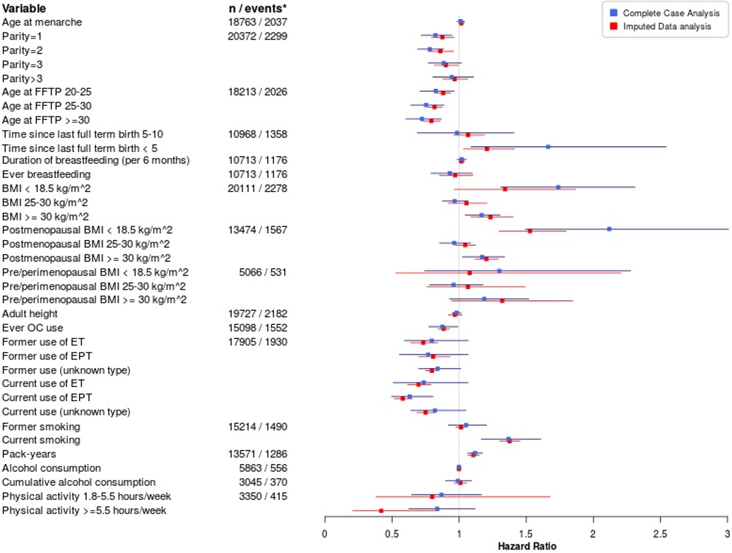
Supplementary Figure S1. Forest-like plot showing the comparison between the results from the imputed data analysis and complete-case analysis for the overall association between individual risk factors and 10-year all-cause mortality shown in Table 2 (imputed data analyses) and Supplementary Table S3 (complete-case analyses).

*Numbers represent total number of breast cancer patients and all-cause deaths from the complete-case analysis for each variable over all categories considered.

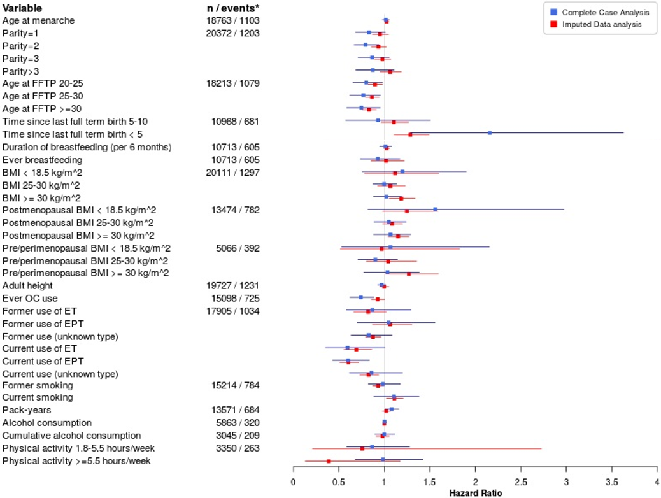
Supplementary Figure S2. Forest-like plot showing the comparison between the results from the imputed data analysis and complete-case analysis for the overall association between individual risk factors and 10-year breast cancer-specific mortality shown in Table 4 (imputed data analyses) and Supplementary Table S4 (complete-case analyses).

* Numbers represent total number of breast cancer patients and breast cancer-specific deaths from the complete-case analysis, for each variable over all categories considered.

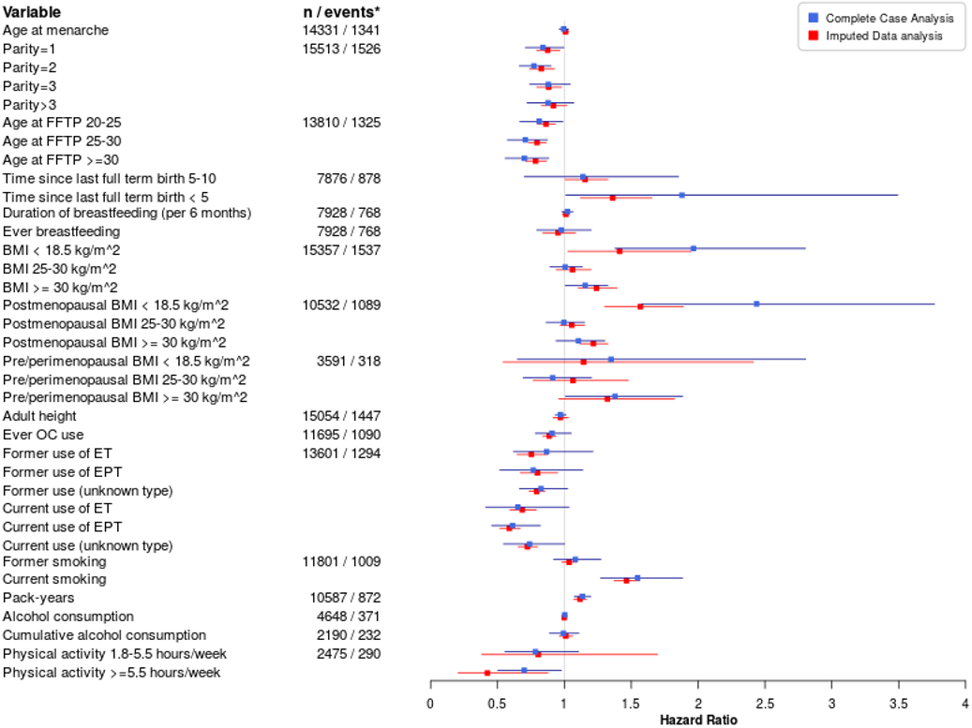
Supplementary Figure S3. Forest-like plot showing the comparison between the results from the imputed data analysis and complete-case analysis for the association between individual risk factors and 10-year all-cause mortality in the group of ER+ cases shown in Table 2 (imputed data analyses) and Supplementary Table S3 (complete-case analyses).

*Numbers represent total number of breast cancer patients and all-cause deaths from the complete-case analysis for each variable over all categories considered.

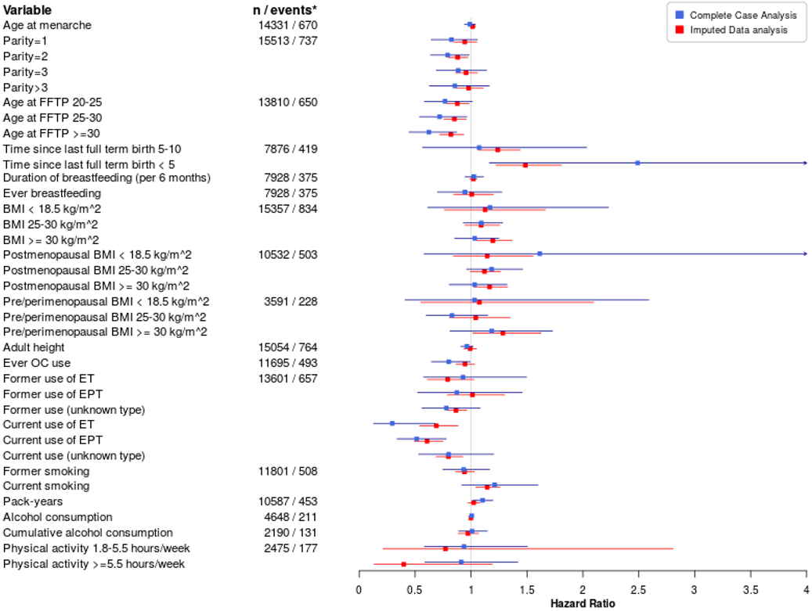
Supplementary Figure S4. Forest-like plot showing the comparison between the results from the imputed data analysis and complete-case analysis for the association between individual risk factors and 10-year breast cancer-specific mortality in the group of ER+ cases shown in Table 4 (imputed data analyses) and Supplementary Table S4 (complete-case analyses).

* Numbers represent total number of breast cancer patients and breast cancer-specific deaths from the complete-case analysis, for each variable over all categories considered.

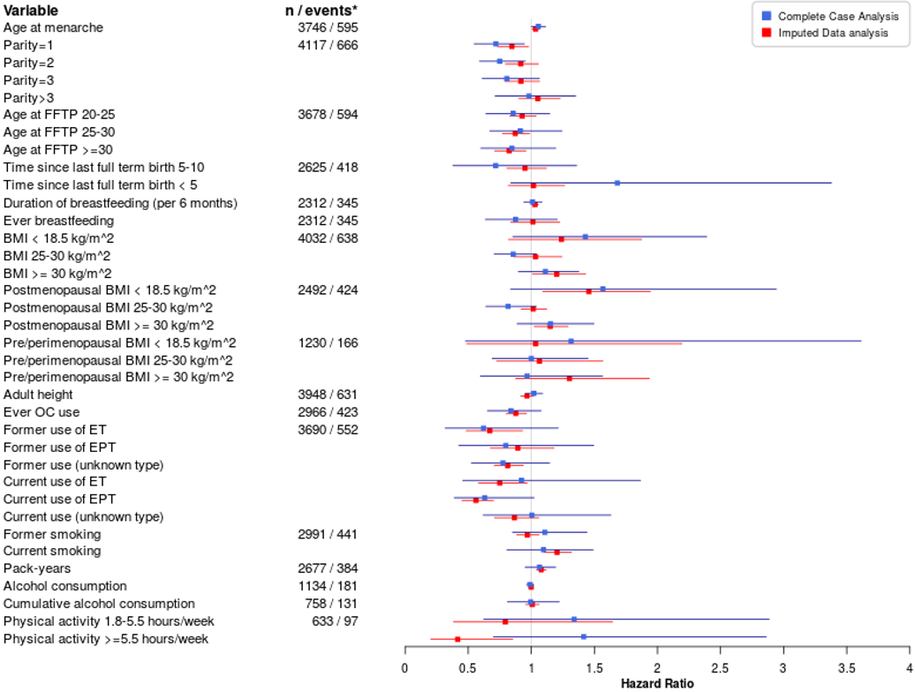Supplementary Figure S5. Forest-like plot showing the comparison between the results from the imputed data analysis and complete-case analysis for the association between individual risk factors and 10-year all-cause mortality in the group of ER- cases shown in Table 2 (imputed data analyses) and Supplementary Table S3 (complete-case analyses).

*Numbers represent total number of breast cancer patients and all-cause deaths from the complete-case analysis for each variable over all categories considered.

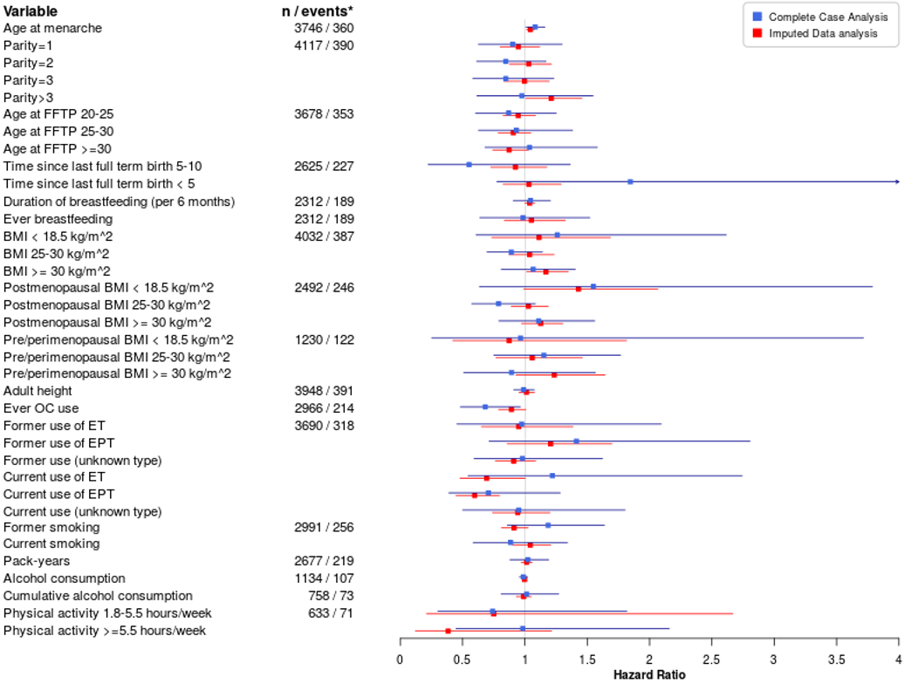

Supplementary Figure S6. Forest-like plot showing the comparison between the results from the imputed data analysis and complete-case analysis for the association between individual risk factors and 10-year breast cancer-specific mortality in the group of ER- cases shown in Table 4 (imputed data analyses) and Supplementary Table S4 (complete-case analyses).

* Numbers represent total number of breast cancer patients and breast cancer-specific deaths from the complete-case analysis, for each variable over all categories considered.

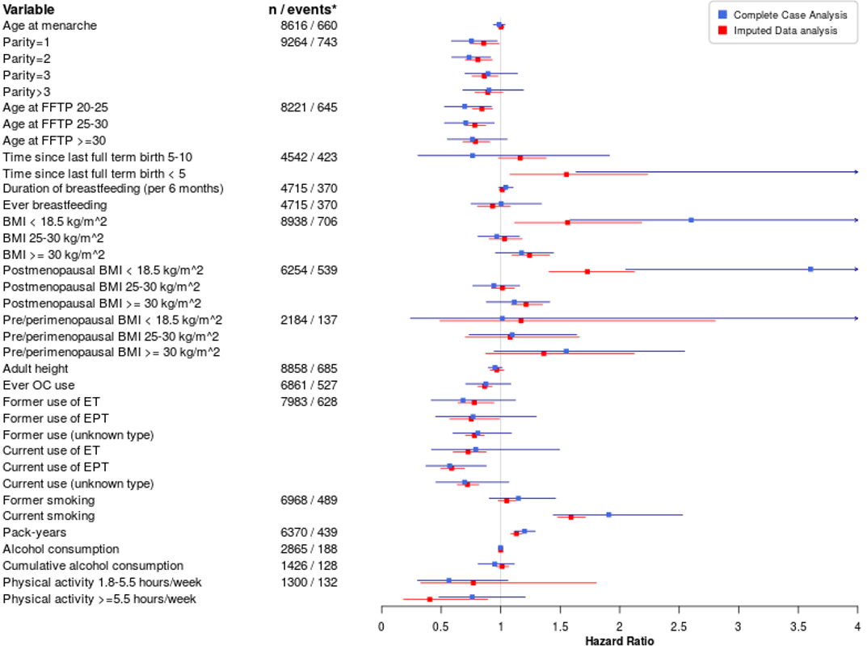
Supplementary Figure S7. Forest-like plot showing the comparison between the results from the imputed data analysis and complete-case analysis for the association between individual risk factors and 10-year all-cause mortality in the group of Luminal A-like cases shown in Table 2 (imputed data analyses) and Supplementary Table S3 (complete-case analyses).

*Numbers represent total number of breast cancer patients and all-cause deaths from the complete-case analysis for each variable over all categories considered.

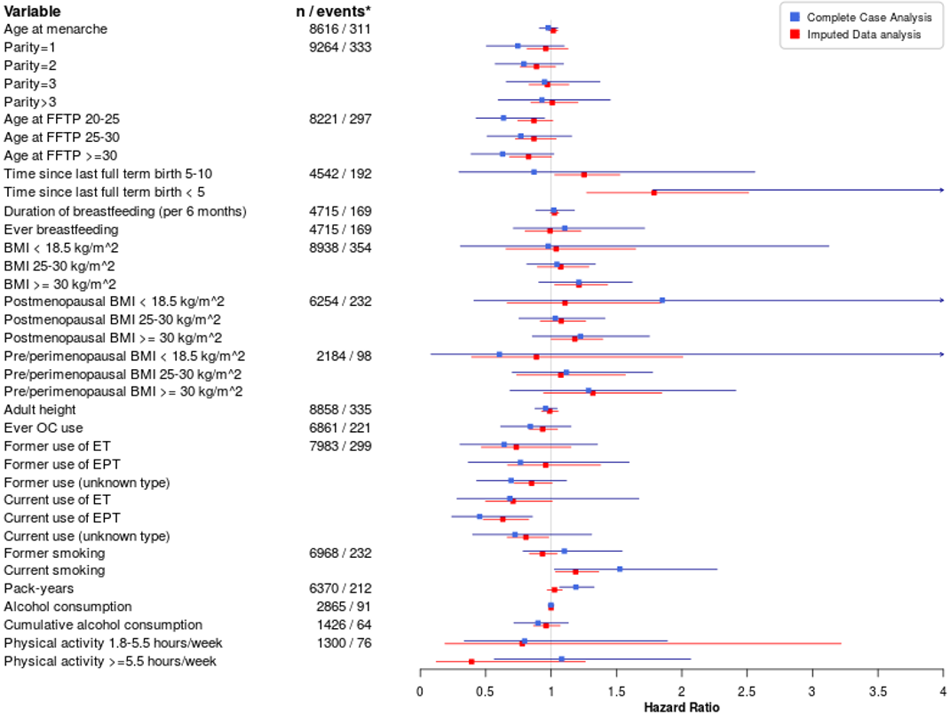

Supplementary Figure S8. Forest-like plot showing the comparison between the results from the imputed data analysis and complete-case analysis for the association between individual risk factors and 10-year breast cancer-specific mortality in the group of Luminal A-like cases shown in Table 4 (imputed data analyses) and Supplementary Table S4 (complete-case analyses).

* Numbers represent total number of breast cancer patients and breast cancer-specific deaths from the complete-case analysis, for each variable over all categories considered.

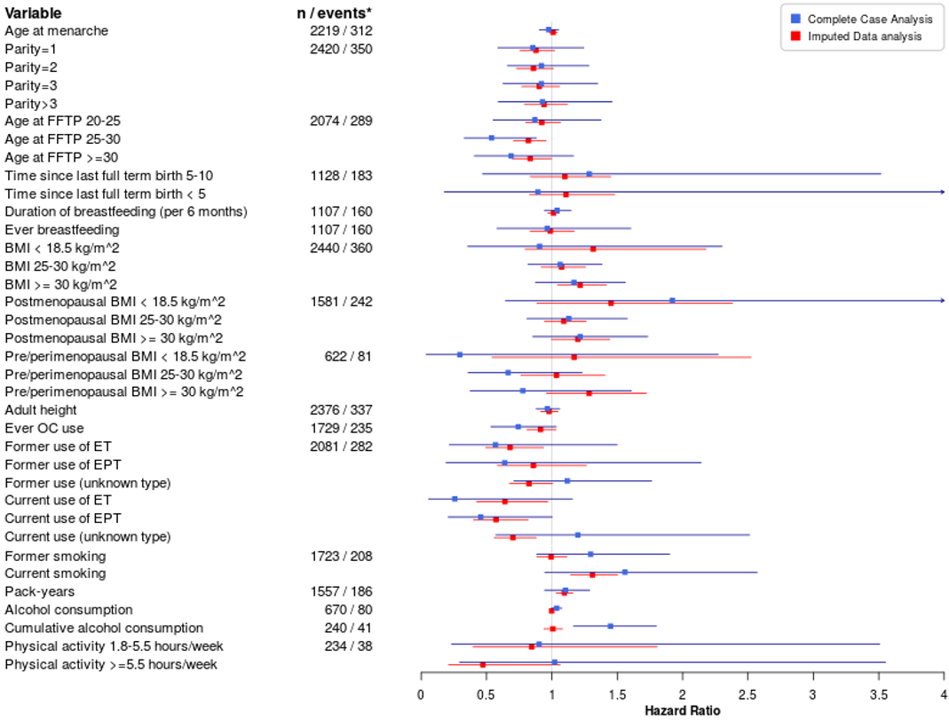

Supplementary Figure S9. Forest-like plot showing the comparison between the results from the imputed data analysis and complete-case analysis for the association between individual risk factors and 10-year all-cause mortality in the group of Luminal B HER2-negative-like cases shown in Table 2 (imputed data analyses) and Supplementary Table S3 (complete-case analyses).

*Numbers represent total number of breast cancer patients and all-cause deaths from the complete-case analysis for each variable over all categories considered.

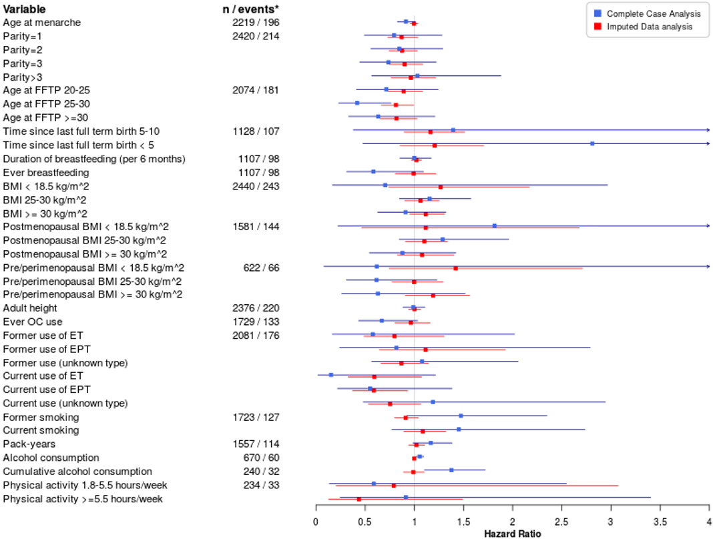

Supplementary Figure S10. Forest-like plot showing the comparison between the results from the imputed data analysis and complete-case analysis for the association between individual risk factors and 10-year breast cancer-specific mortality in the group of Luminal B HER2-negative-like cases shown in Table 4 (imputed data analyses) and Supplementary Table S4 (complete-case analyses).

* Numbers represent total number of breast cancer patients and breast cancer-specific deaths from the complete-case analysis, for each variable over all categories considered.

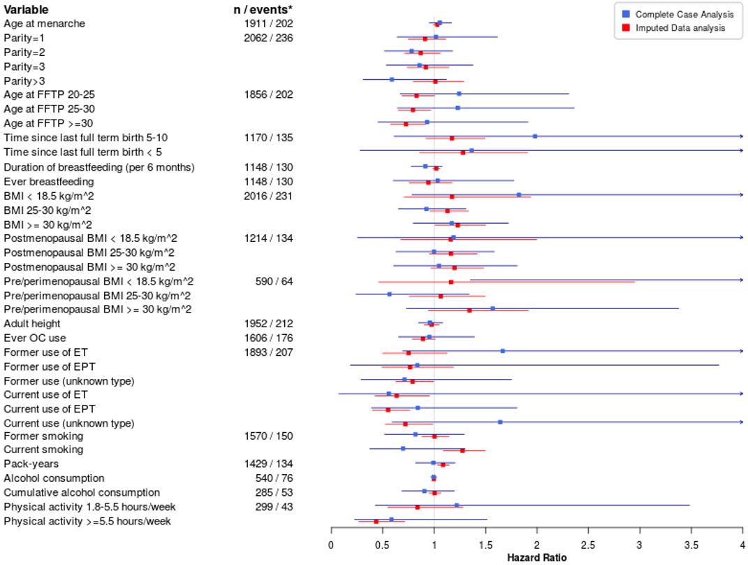
Supplementary Figure S11. Forest-like plot showing the comparison between the results from the imputed data analysis and complete-case analysis for the association between individual risk factors and 10-year all-cause mortality in the group of Luminal B HER2-positive-like cases shown in Table 2 (imputed data analyses) and Supplementary Table S3 (complete-case analyses).

*Numbers represent total number of breast cancer patients and all-cause deaths from the complete-case analysis for each variable over all categories considered.

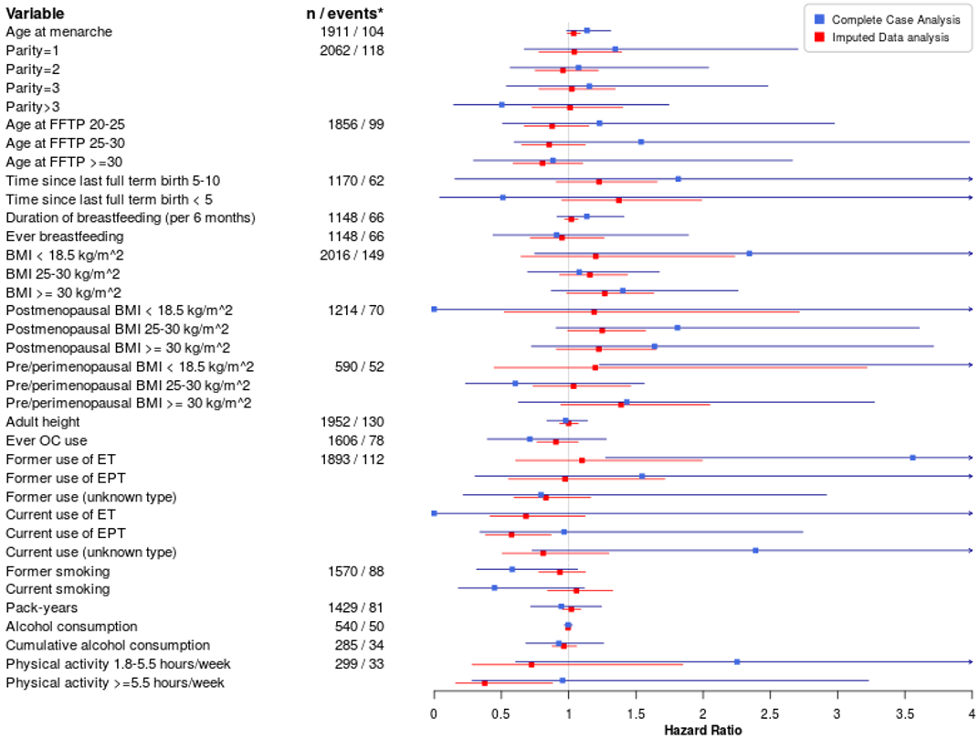

Supplementary Figure S12. Forest-like plot showing the comparison between the results from the imputed data analysis and complete-case analysis for the association between individual risk factors and 10-year breast cancer-specific mortality in the group of Luminal B HER2-positive-like cases shown in Table 4 (imputed data analyses) and Supplementary Table S4 (complete-case analyses).

* Numbers represent total number of breast cancer patients and breast cancer-specific deaths from the complete-case analysis, for each variable over all categories considered.

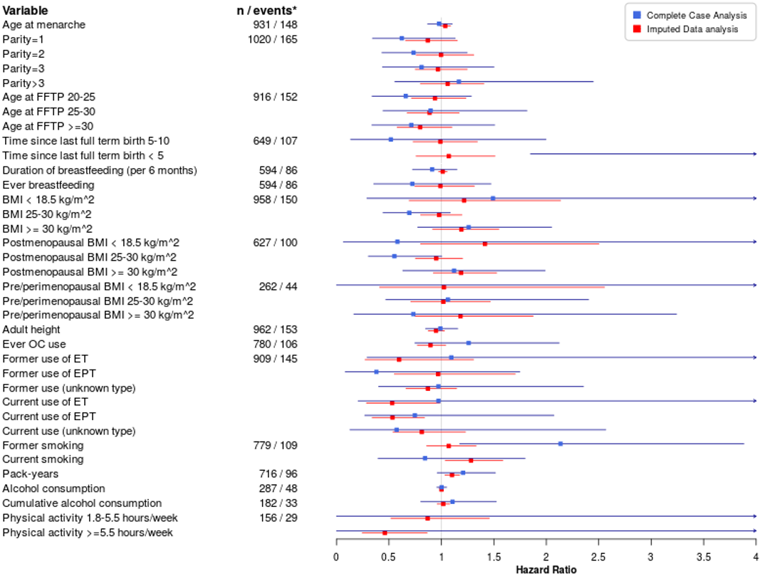
Supplementary Figure S13. Forest-like plot showing the comparison between the results from the imputed data analysis and complete-case analysis for the association between individual risk factors and 10-year all-cause mortality in the group of HER2-enriched-like cases shown in Table 2 (imputed data analyses) and Supplementary Table S3 (complete-case analyses).

*Numbers represent total number of breast cancer patients and all-cause deaths from the complete-case analysis for each variable over all categories considered.

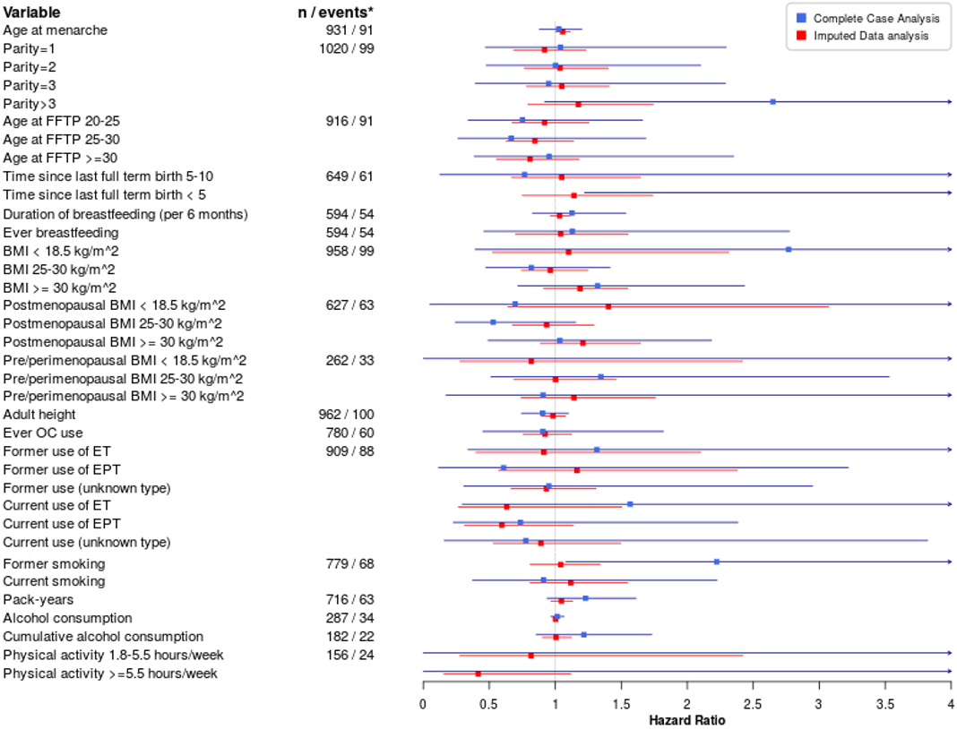
Supplementary Figure S14. Forest-like plot showing the comparison between the results from the imputed data analysis and complete-case analysis for the association between individual risk factors and 10-year breast cancer-specific mortality in the group of HER2-enriched-like cases shown in Table 4 (imputed data analyses) and Supplementary Table S4 (complete-case analyses).

* Numbers represent total number of breast cancer patients and breast cancer-specific deaths from the complete-case analysis, for each variable over all categories considered.

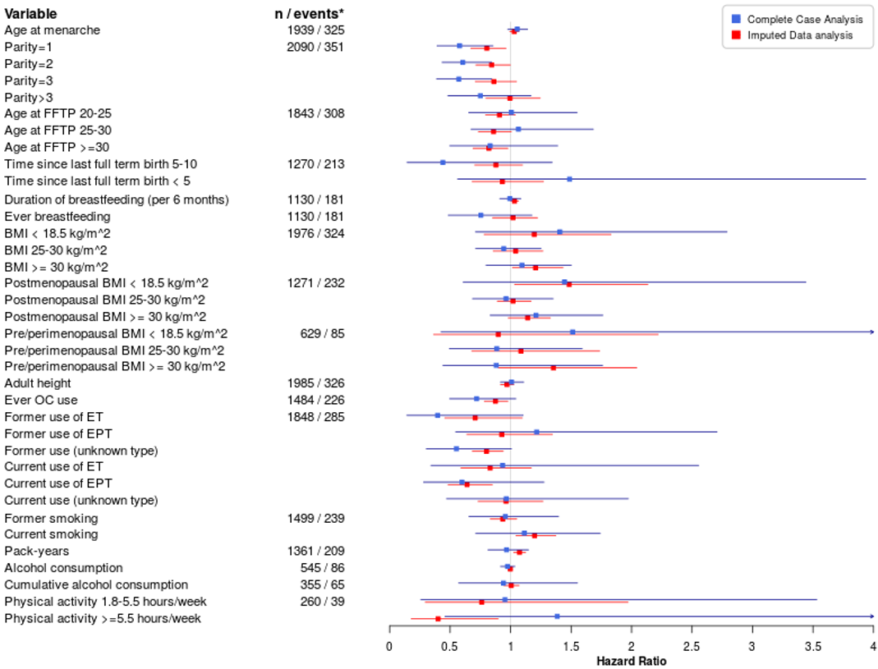
Supplementary Figure S15. Forest-like plot showing the comparison between the results from the imputed data analysis and complete-case analysis for the association between individual risk factors and 10-year all-cause mortality in the group of triple negative cases shown in Table 2 (imputed data analyses) and Supplementary Table S3 (complete-case analyses).

*Numbers represent total number of breast cancer patients and all-cause deaths from the complete-case analysis for each variable over all categories considered.

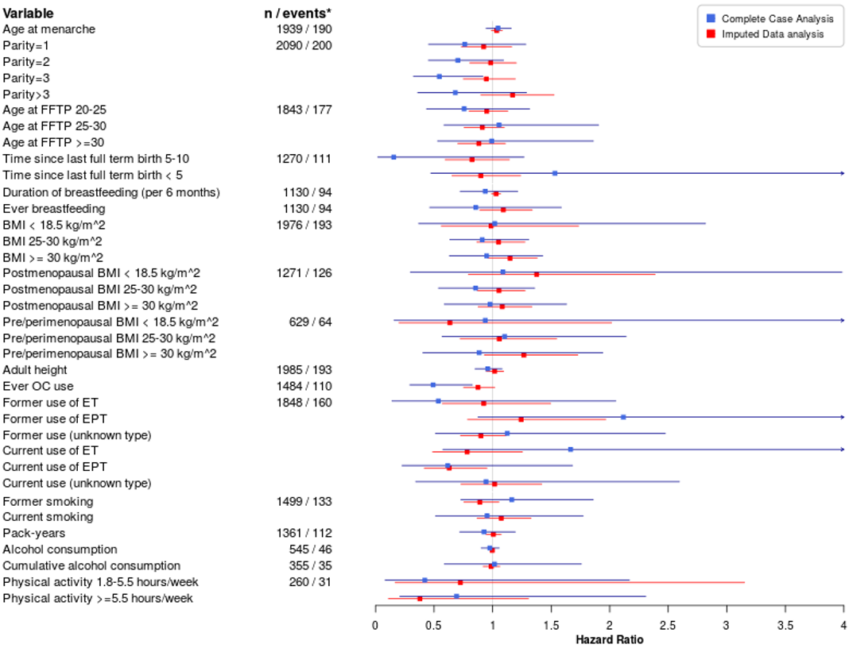

Supplementary Figure S16. Forest-like plot showing the comparison between the results from the imputed data analysis and complete-case analysis for the association between individual risk factors and 10-year breast cancer-specific mortality in the group of triple negative cases shown in Table 4 (imputed data analyses) and Supplementary Table S4 (complete-case analyses).

* Numbers represent total number of breast cancer patients and breast cancer-specific deaths from the complete-case analysis, for each variable over all categories considered.

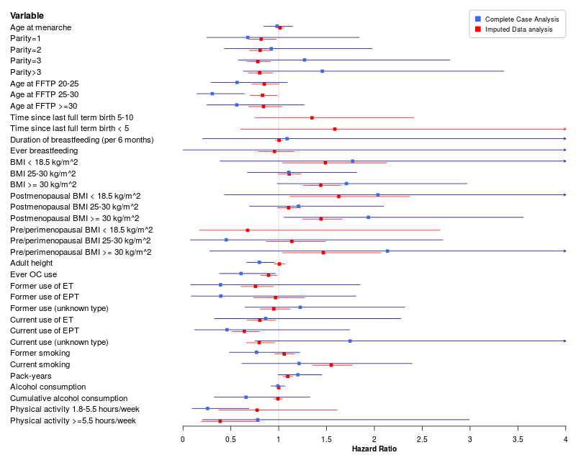
Supplementary Figure S17. Forest-like plot showing the comparison between the results from the imputed data analysis based on prospective studies only and corresponding complete-case analysis for the overall association between individual risk factors and 10-year all-cause mortality.

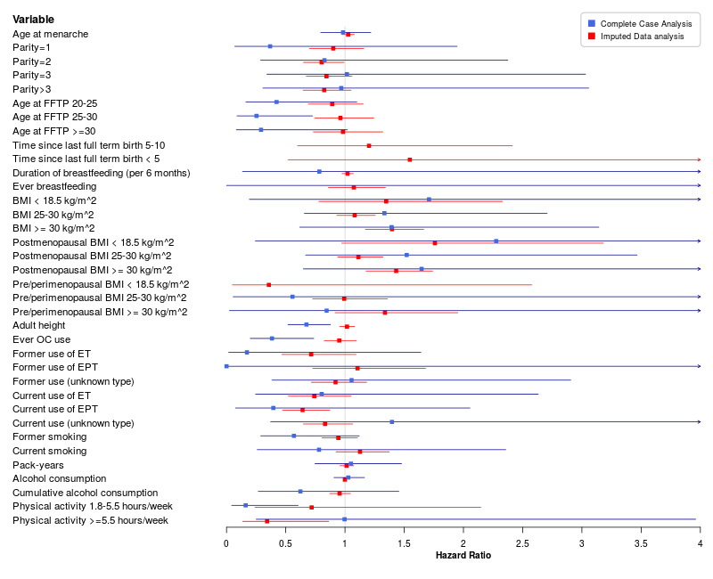
Supplementary Figure S18. Forest-like plot showing the comparison between the results from the imputed data analysis based on prospective studies only and corresponding complete-case analysis for the overall association between individual risk factors and 10-year breast cancer-specific mortality.

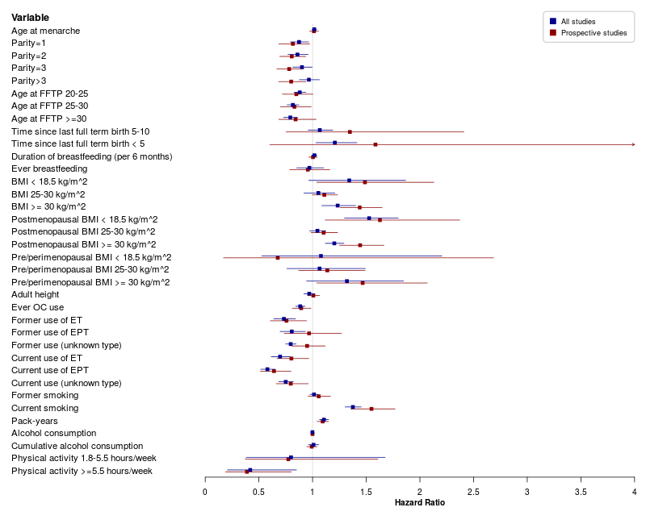
Supplementary Figure S19. Forest-like plot showing the comparison between the results from the imputed data analysis based on prospective studies only and corresponding imputed data analysis based on all studies for the overall association between individual risk factors and 10-year all-cause mortality.

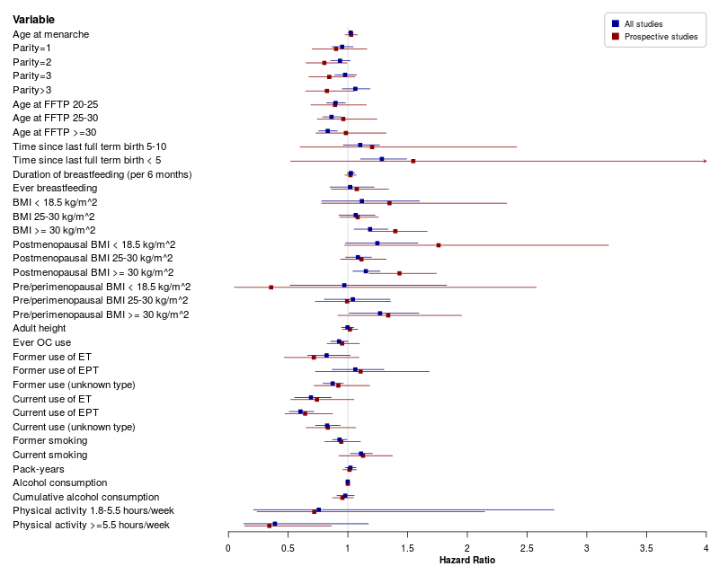
Supplementary Figure S20. Forest-like plot showing the comparison between the results from the imputed data analysis based on prospective studies only and corresponding imputed data analysis based on all studies for the overall association between individual risk factors and 10-year breast cancer-specific mortality.

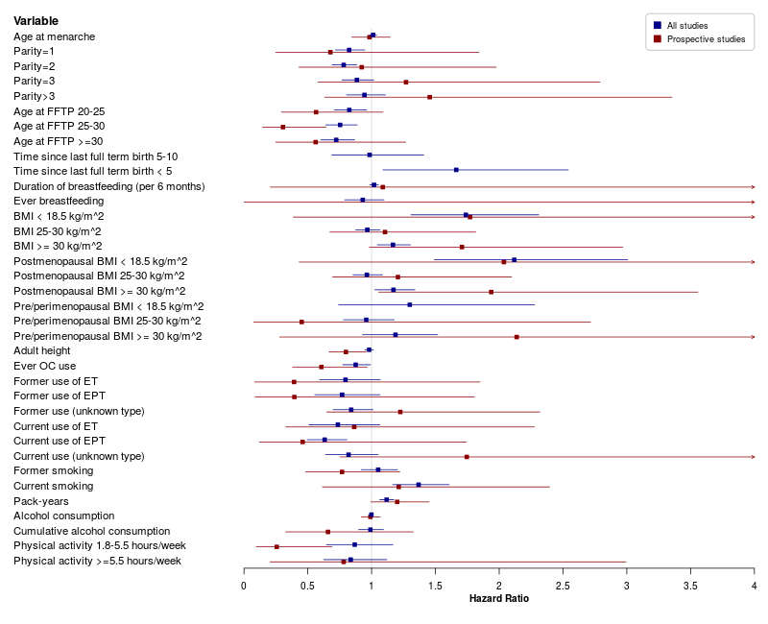
Supplementary Figure S21. Forest-like plot showing the comparison between the results from the complete-case analysis based on prospective studies only and corresponding complete-case analysis based on all studies for the overall association between individual risk factors and 10-year all-cause mortality.

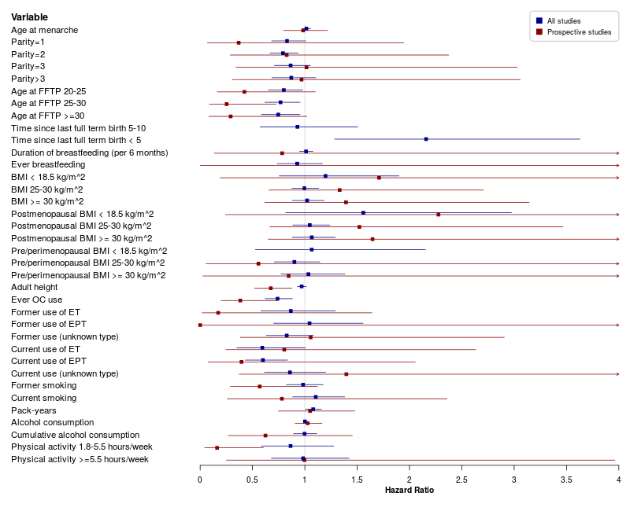
Supplementary Figure S22. Forest-like plot showing the comparison between the results from the complete-case analysis based on prospective studies only and corresponding complete-case analysis based on all studies for the overall association between individual risk factors and 10-year breast cancer-specific mortality.

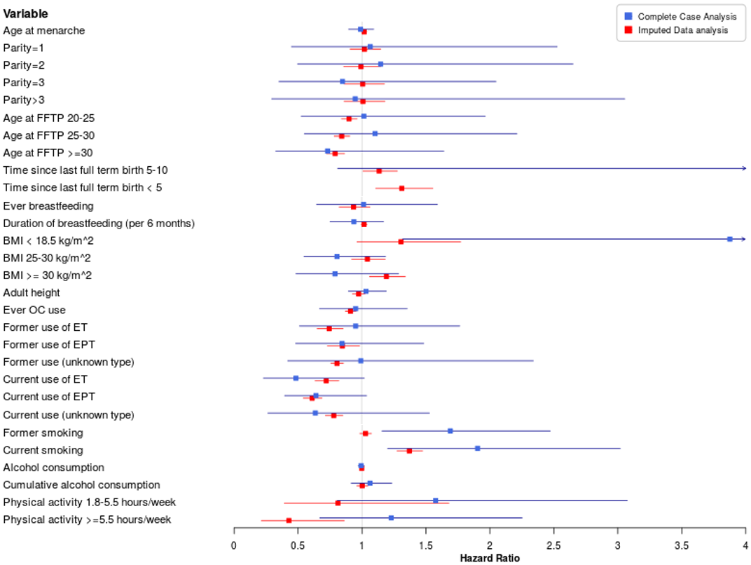
Supplementary Figure S23. Forest-like plot showing the comparison between the results from the imputed data analysis shown in Table 5 and corresponding complete-case analysis for the overall association between multiple risk factors and 10-year all-cause mortality.
Complete-case analysis was based on 1264 cases and 158 deaths from all-causes.

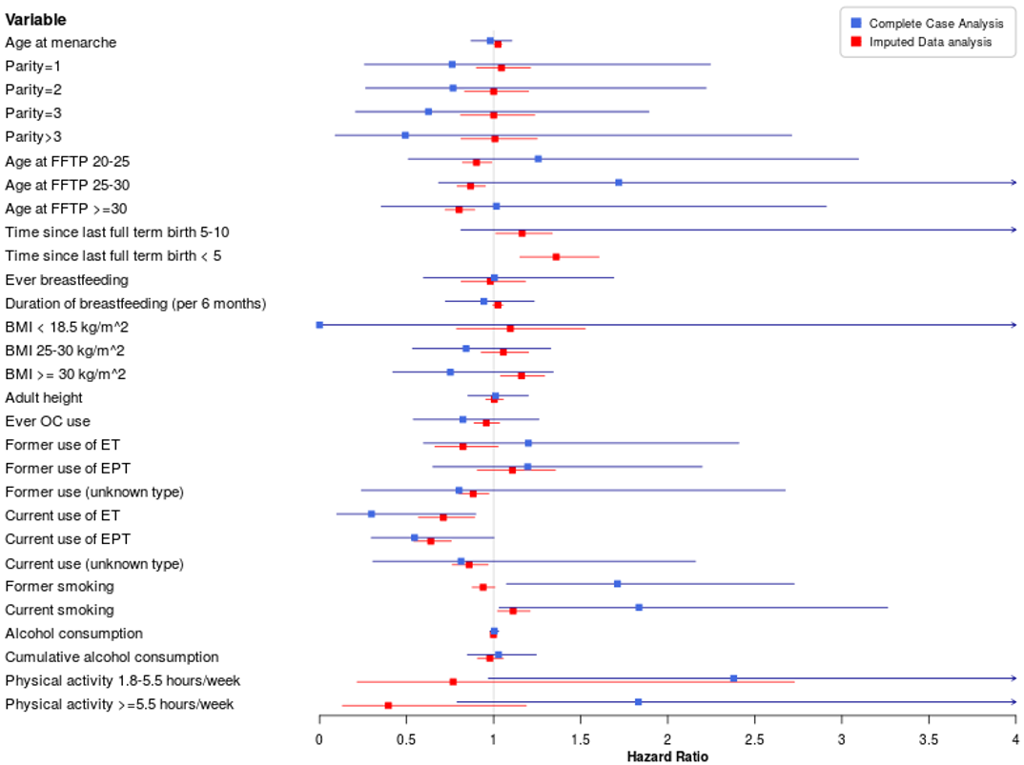
Supplementary Figure S24. Forest-like plot showing the comparison between the results from the imputed data analysis shown in Table 6 and corresponding complete-case analysis for the overall association between multiple risk factors and 10-year breast cancer-specific mortality.
Complete-case analysis was bases on 1264 cases and 114 breast cancer-specific deaths.

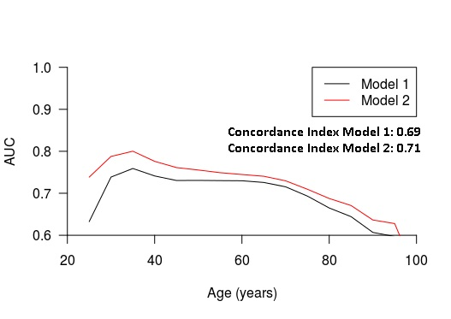
Supplementary Figure S25. AUC of 10-year all-cause mortality at varying ages, and the concordance index overall for two multivariable models.
Model 1 is stratified by study and includes lymph nodes status, tumor size, tumor grade, ER status, PR status, HER2 status and (neo)adjuvant systemic treatment as covariates. Model 2 additionally includes age at menarche, parity, age at first full term pregnancy, time since last full-term birth, breastfeeding, BMI, adult height, oral contraceptive use, menopausal hormone therapy, smoking, alcohol consumption, cumulative alcohol consumption, and physical activity. The Y-axis represents the AUC. The X-axis represents varying time horizons from diagnosis. Such time horizons are used to define cases (all-cause deaths before or at the time horizon) and controls (event-free patients at the time horizon) and to compute the corresponding AUC. For a given time horizon, the model with the highest AUC has the highest ability to identify patients who experience the event up to that specific time point and patients who are event-free at that specific time point. Since age of the patients is used as time scale, time horizons are in this case age horizons, namely ages at specific time horizons from diagnosis. Hence, at a given age horizon a, only patients who died before or at age a and patients who are event-free at age a, are included in the computation of the corresponding AUC. The concordance index provides a global assessment of the discriminative power of the models over all ages.

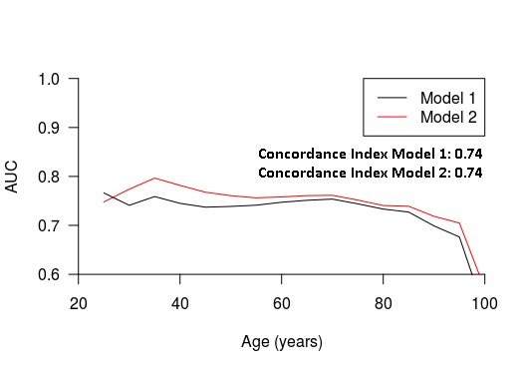
Supplementary Figure S26. AUC for 10-year breast cancer-specific mortality at varying ages, and the concordance index overall for two multivariable models.
Model 1 is stratified by study and includes lymph nodes status, tumor size, tumor grade, ER status, PR status, HER2 status and (neo)adjuvant systemic treatment as covariates. Model 2 additionally includes age at menarche, parity, age at first full term pregnancy, time since last full term birth, breastfeeding, BMI, adult height, oral contraceptive use, menopausal hormone therapy, smoking, alcohol consumption, cumulative alcohol consumption, and physical activity. The Y-axis represents the AUC. The X-axis represents varying time horizons from diagnosis. Such time horizons are used to define cases (breast cancer-specific deaths before or at the time horizon) and controls (event-free patients at the time horizon) and to compute the corresponding AUC. For a given time horizon, the model with the highest AUC has the highest ability to identify patients who experience the event before or at that specific time point and patients who are event-free at that specific time point. Since age of the patients is used as time scale, time horizons are in this case age horizons, namely ages at specific time horizons from diagnosis. Hence, at a given age horizon a, only patients who died of breast cancer before or at age a and patients who are event-free at age a, are included in the computation of the corresponding AUC. The concordance index provides a global assessment of the discriminative power of the models over all ages.

