List of Supplementary Materials:
Figures S1 to S3
Tables S1 to S3
Data S1

 | 1 | 2 | 3 | 4 | 5 | 6 | 7 | 8 | 9 | 10 | 11 |  | 12 | 13 | 14 | 15 | 16 | 17 | 18 | 19 | 20 | 21 |  | 22 | 23 | 24 | 25 | 26 | 27 | 28 | 29 | 30 | 31 |  | 32 | 33 | 34 | 35 | 36 | 37 | 38 | 39
Outcome
1
Home State
2
3
4
5
6
7
8
9
10
11
Interstate
12
13
14
15
16
17
18
19
20
21
County Demographics
22
23
24
25
26
27
28
29
30
31
Human Geography
32
33
34
35
36
37
38
39

eFigure 1. Correlation matrix for outcome and exposure variables; 3107 counties, 2000-2014 (n = 46,605). Key and legend presented on next page.
eFigure 1. Key.

No. | Variable |  |  |  |  | No. | Variable
 | Outcome |  |  |  |  |  | County Demographics
1 | Firearm homicides per 100,000 population |  |  |  |  | 22 | Age < 25 (%)
 |  |  |  |  |  | 23 | Age 25-44 (%)
 | Home State |  |  |  |  | 24 | Age 45-64 (%)
2 | Laws (count) |  |  |  |  | 25 | Age > 64 (%)
3 | Dealer regulations (%) |  |  |  |  | 26 | Black (%)
4 | Buyer regulations (%) |  |  |  |  | 27 | Hispanic (%)
5 | High risk (%) |  |  |  |  | 28 | White [reference]
6 | Background checks (%) |  |  |  |  | 29 | Native (%)
7 | Possession regulations (%) |  |  |  |  | 30 | Median household income (2014 US$10,000)
8 | Concealed carry (%) |  |  |  |  | 31 | Unemployment (%)
9 | Child access prevention (%)
10 | Domestic Violence (%) |  |  |  |  |  | Human Geography
11 | Other (%) |  |  |  |  | 32 | Population inflow
 |  |  |  |  |  | 33 | pollib_median
 | Interstate |  |  |  |  | 34 | drugs_marijua_decrimilization
12 | Laws (count) |  |  |  |  | 35 | apolspt
13 | Dealer regulations (%) |  |  |  |  | 36 | RUCC Metropolitan
14 | Buyer regulations (%) |  |  |  |  | 37 | RUCC Urban
15 | High risk (%) |  |  |  |  | 38 | RUCC Rural
16 | Background checks (%) |  |  |  |  | 39 | Land area (1,000 square kms)
17 | Possession regulations (%)
18 | Concealed carry [reference]
19 | Child access prevention (%)
20 | Domestic Violence (%)
21 | Other (%)

eFigure 1. Legend.

<0.10
0.10 – 0.20
0.20 – 0.30
0.30 – 0.40
0.40 – 0.50
0.50 – 0.60
0.60 – 0.70
0.70 – 0.80
0.80 – 0.90
0.90 – 1.00
1.00

eFigure 2. Scatter plot comparing the observed firearm homicides rate per 100,000 population in 1999 to model predicted firearm homicide rate for 1999, based on parameter estimates derived from Model 2 using 2000-2014 data; US counties.

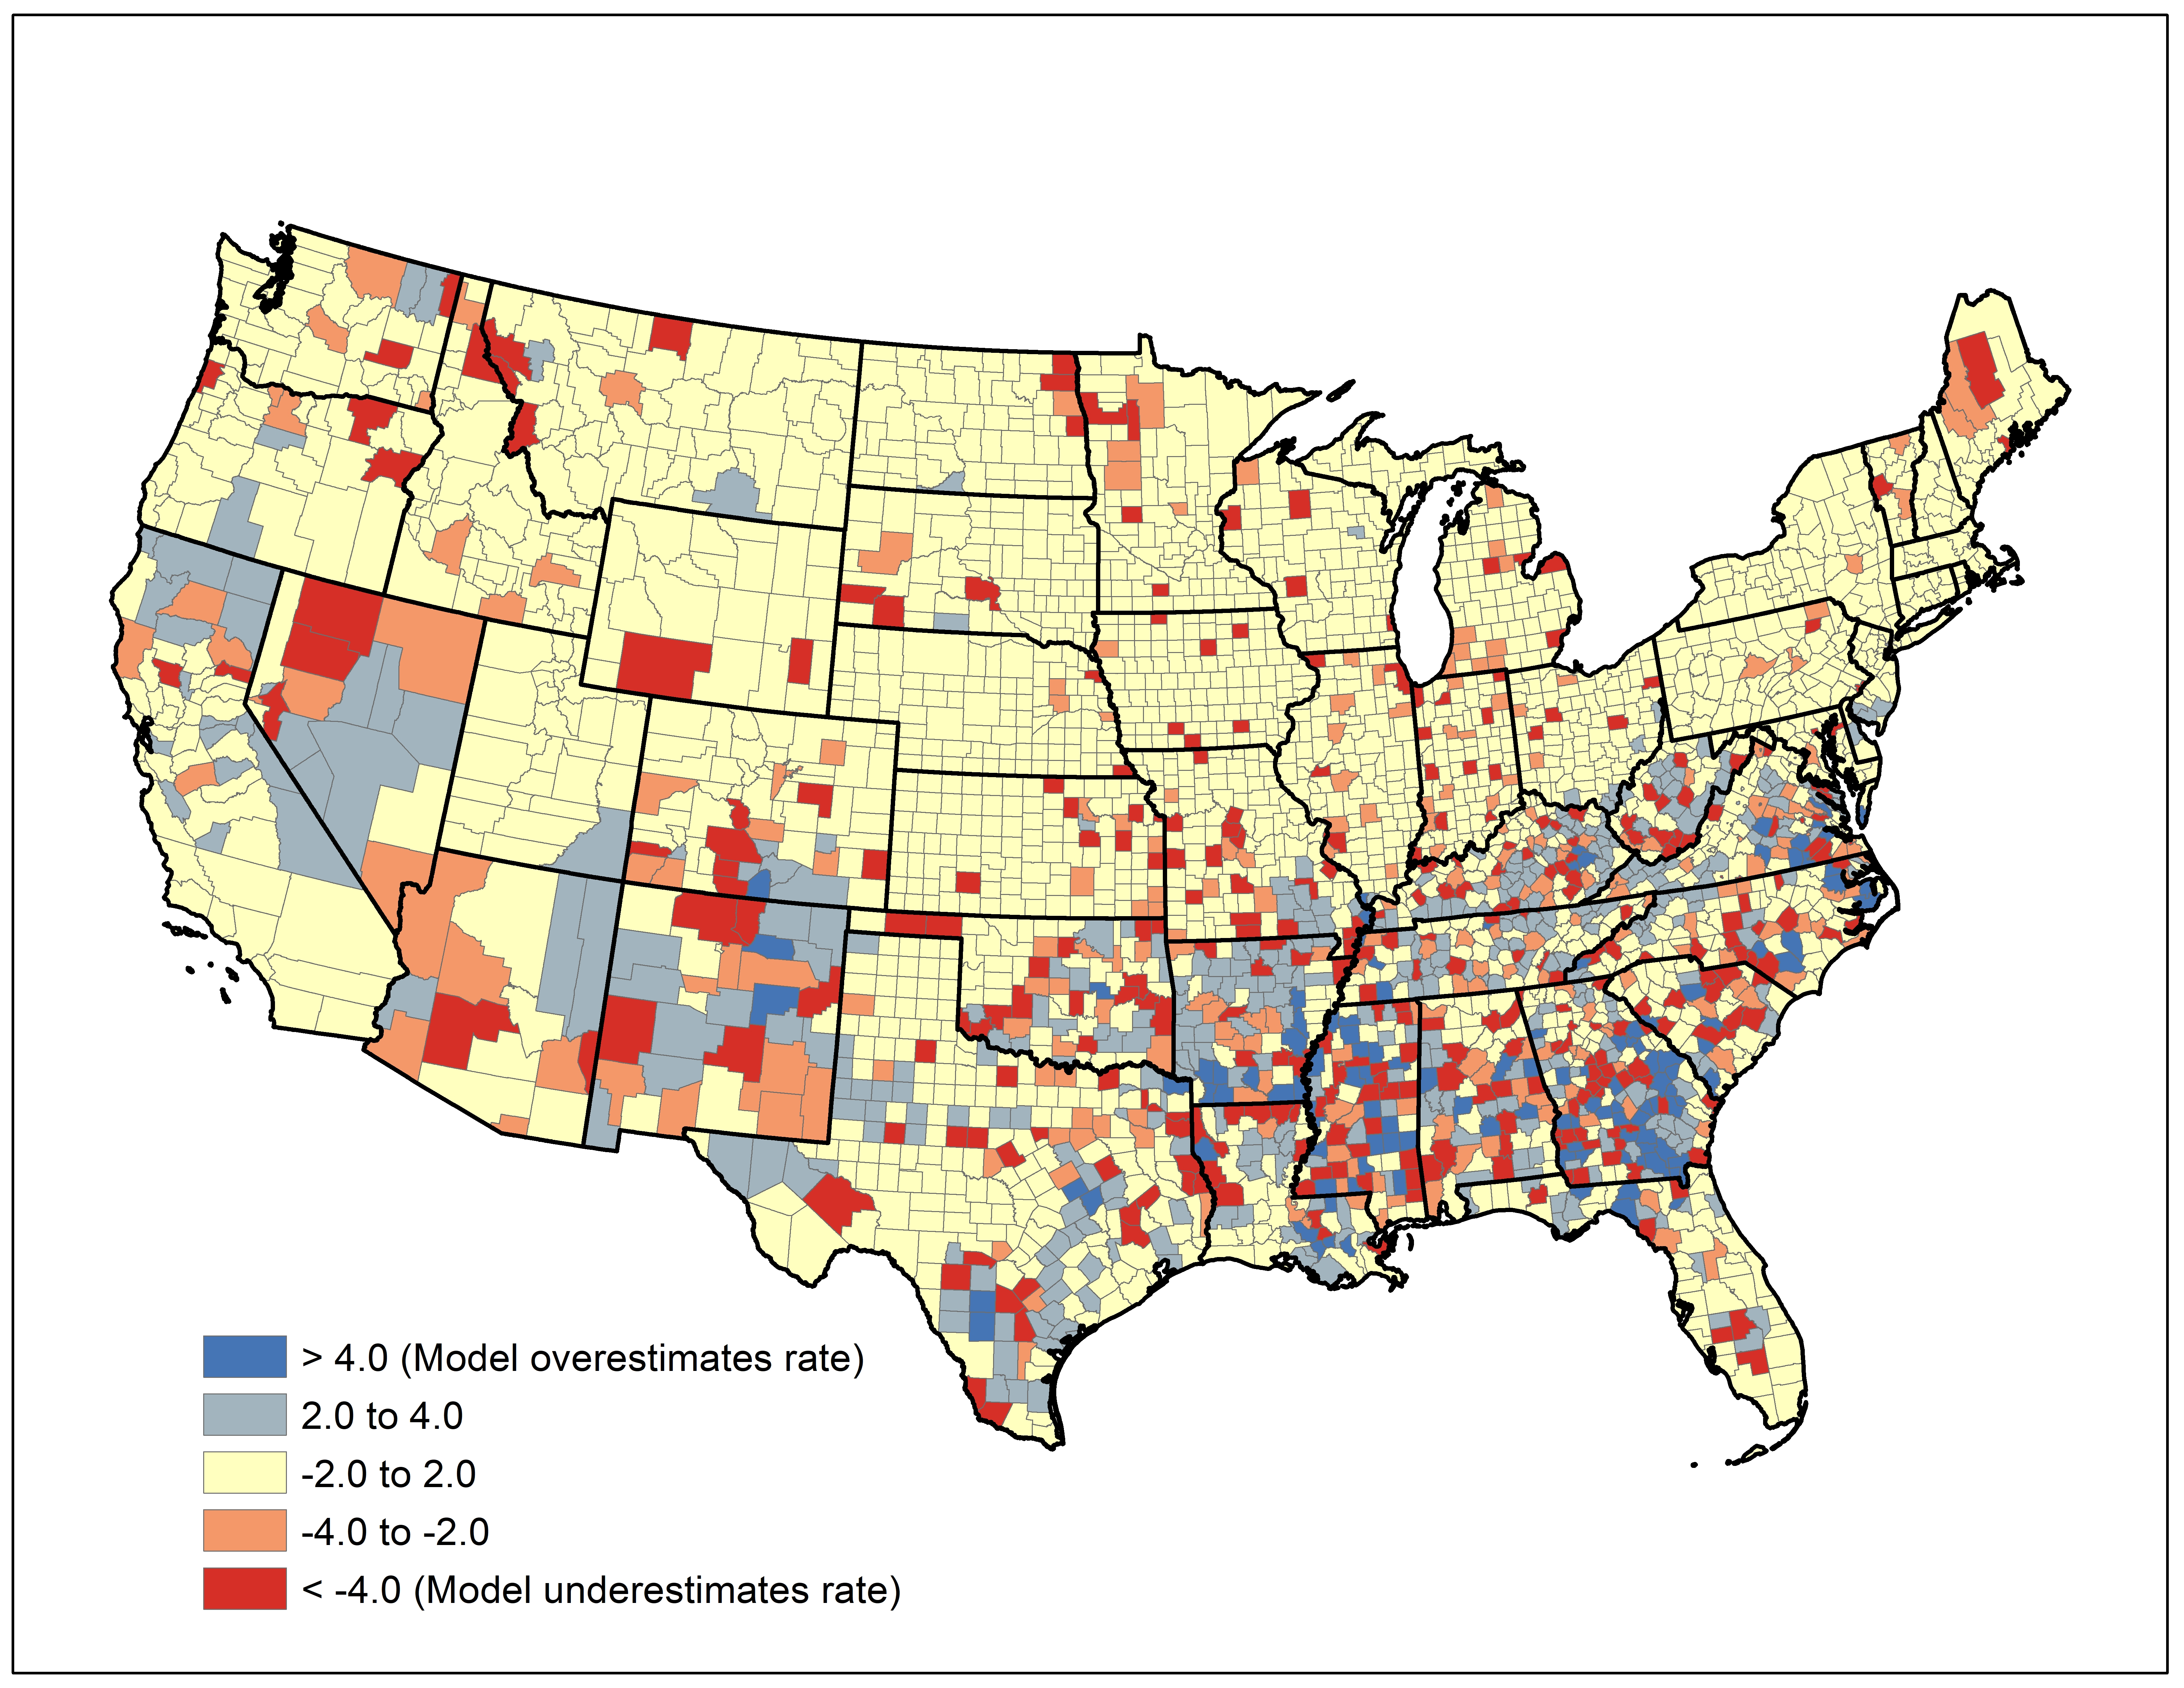
eFigure 3. Difference between observed firearm homicides rate per 100,000 population in 1999 to model-predicted firearm homicide rate for 1999, based on parameter estimates derived from Model 2 using 2000-2014 data; US counties.
eTable 1. Descriptive statistics; 3107 counties, 2000-2014 (n = 46,605)
 | Mean | SD | Min | Max
Firearm homicides per 100,000 population | 2.6 | 5.1 | 0.0 | 172.5
Home State Firearm Laws
Laws (count) | 20.7 | 18.0 | 3.0 | 100.0
Dealer regulations (%) | 6.9 | 10.4 | 0.0 | 50.0
Buyer regulations (%) | 6.0 | 6.7 | 0.0 | 26.1
High risk (%) | 12.0 | 9.8 | 0.0 | 50.0
Background checks (%) | 4.2 | 7.2 | 0.0 | 30.0
Possession regulations (%) | 16.9 | 11.6 | 0.0 | 50.0
Concealed carry (%) | 28.5 | 15.3 | 0.0 | 71.4
Child access prevention (%) | 4.5 | 7.3 | 0.0 | 30.0
Domestic violence (%) | 9.9 | 10.6 | 0.0 | 50.0
Other laws (%) | 11.2 | 10.3 | 0.0 | 66.7
Interstate Firearm Laws
Laws (count) | 28.3 | 10.2 | 9.5 | 90.7
Dealer regulations (%) | 10.3 | 2.8 | 2.4 | 22.3
Buyer regulations (%) | 8.6 | 1.8 | 1.4 | 19.1
High risk (%) | 10.2 | 1.8 | 4.2 | 22.6
Background checks (%) | 7.9 | 2.3 | 1.7 | 25.0
Possession regulations (%) | 12.5 | 4.0 | 4.2 | 29.8
Concealed carry (%) | 17.1 | 4.0 | 5.5 | 41.4
Child access prevention (%) | 6.2 | 1.9 | 0.5 | 18.8
Domestic violence (%) | 13.7 | 3.6 | 1.3 | 32.6
Other laws (%) | 13.5 | 3.3 | 3.2 | 27.8
County Demographics
Population | 96,072 | 310,593 | 40 | 10,116,705
Age < 25 (%) | 33.0 | 4.7 | 10.8 | 66.4
Age 25-44 (%) | 24.7 | 3.5 | 11.7 | 44.6
Age 45-64 (%) | 26.6 | 3.4 | 5.5 | 46.4
Age > 64 (%) | 15.7 | 4.2 | 1.7 | 53.0
Black (%) | 8.9 | 14.4 | 0.0 | 85.9
Hispanic (%) | 7.7 | 12.9 | 0.0 | 97.5
White (%) | 79.5 | 19.3 | 2.1 | 99.6
Native (%) | 1.6 | 6.4 | 0.0 | 94.2
Median household income (2014USD) | 47,397 | 12,103 | 19,833 | 129,792
Unemployment (%) | 6.4 | 2.8 | 1.1 | 28.9
Human Geography
Population inflow (standardized) | 0.0 | 1.0 | -0.6 | 39.2
Policy liberalism | -0.4 | 1.1 | -2.5 | 2.8
Policing expenditure | 3,091 | 3,764 | 103 | 27,789
RUCC Metropolitan | 0.4 | 0.5 | 0.0 | 1.0
RUCC Urban | 0.3 | 0.5 | 0.0 | 1.0
RUCC Rural | 0.2 | 0.4 | 0.0 | 1.0
Land area (1,000 square kms) | 0.2 | 0.3 | 0.0 | 5.2

eTable 2. Sensitivity analyses repeating Model 3 but with social policy variables removed (Model s1) and lagged laws (Model s2); US counties (n = 3,107) from 2000–2014 (t = 15). Models adjust for county demographics and human geography.
 | Model s1 |  |  |  | Model s2
Variable | IRR | (95% | CrI) |  | IRR | (95% | CrI)
Home State Firearm Laws
Laws (count) | 0.993 | 0.991 | 0.996 |  | 0.994 | 0.991 | 0.996
Dealer regulations (%) | 0.999 | 0.996 | 1.002 |  | 1.001 | 0.997 | 1.004
Buyer regulations (%) | 0.998 | 0.995 | 1.001 |  | 1.005 | 1.002 | 1.009
High risk (%) | 0.998 | 0.996 | 1.000 |  | 1.003 | 1.000 | 1.005
Background checks (%) | 0.995 | 0.992 | 0.999 |  | 0.993 | 0.989 | 0.996
Possession regulations (%) | 0.998 | 0.995 | 1.000 |  | 1.002 | 1.000 | 1.005
Concealed carry (%) |  |  |  |  | 1.003 | 1.001 | 1.005
Child access prevention (%) | 1.004 | 0.998 | 1.010 |  | 1.005 | 0.999 | 1.011
Domestic Violence (%) | 0.999 | 0.997 | 1.001 |  | 1.000 | 0.998 | 1.003
Other laws (%) | 0.998 | 0.996 | 1.000
Interstate Firearm Laws
Laws (gravity weighted) | 0.992 | 0.988 | 0.996 |  | 0.991 | 0.985 | 0.995
Dealer regulations (%) | 1.016 | 1.005 | 1.029 |  | 1.004 | 0.992 | 1.015
Buyer regulations (%) | 0.988 | 0.978 | 0.998 |  | 0.991 | 0.975 | 1.004
High risk (%) | 0.989 | 0.981 | 0.996 |  | 0.984 | 0.973 | 0.993
Background checks (%) | 0.995 | 0.986 | 1.005 |  | 1.003 | 0.992 | 1.013
Possession regulations (%) | 0.984 | 0.976 | 0.992 |  | 0.996 | 0.983 | 1.008
Concealed carry (%) |  |  |  |  | 0.994 | 0.983 | 1.002
Child access prevention (%) | 0.990 | 0.976 | 1.004 |  | 0.991 | 0.974 | 1.006
Domestic Violence (%) | 1.008 | 1.001 | 1.014 |  | 1.005 | 0.996 | 1.012
Other laws (%) | 1.000 | 0.992 | 1.007
Constants and Error Terms
Constant | 3.161 | 2.154 | 6.297 |  | 2.564 | 0.756 | 11.775
Trend | 0.984 | 0.978 | 0.991 |  | 0.980 | 0.987 | 0.996
Variance explained by conditional autoregressive random effect (proportion) | 0.808 | 0.712 | 0.890 |  | 0.809 | 0.706 | 0.891
Variance explained by state random effect (proportion) | 0.055 | 0.016 | 0.130 |  | 0.065 | 0.024 | 0.144

