Supporting Information
Phthalate exposure during pregnancy and male offspring growth from the intra-uterine period to five years of age

Jérémie Botton^{1,2}, Claire Philippat^{3,4}, Antonia M. Calafat⁵, Sophie Carles^{1,6}, Marie-Aline Charles^{1,5}, Rémy Slama^{3,4}, the EDEN mother-child cohort study group

¹ INSERM, UMR1153 Epidemiology and Biostatistics Sorbonne Paris Cité Center (CRESS), Team “Early Origin of the Child’s Health and Development” (ORCHAD), Paris Descartes University, Paris, France
² Univ Paris-Sud, Faculty of Pharmacy, Châtenay-Malabry, France
³ Univ. Grenoble Alpes, IAB, Team of Environmental Epidemiology applied to Reproduction and Respiratory Health, F-38000 Grenoble, France
⁴ Inserm, IAB, Team of Environmental Epidemiology applied to Reproduction and Respiratory Health, F-38000 Grenoble, France
⁵ Centers for Disease Control and Prevention, National Center for Environmental Health, Atlanta, GA, USA
⁶ Paris-Descartes University, F-75005 Paris, France

Corresponding author:
Jérémie Botton
Inserm UMR 1153 – Equipe ORCHAD
16 avenue Paul Vaillant-Couturier - 94807 Villejuif Cedex
Phone: +33 1 45 59 60 51 / e-mail: jeremie.botton@inserm.fr

Table S1. Characteristics of the study population (PEnDevE) and comparisons with the whole EDEN cohort delivering boys
Maternal characteristic | All male newborns, EDEN cohort  (n = 995)ª |  |  | EDEN cohort included in PEnDevE study  (n = 520)^{b}
 | n | (%) |  | n | (%)
Age (years)  < 25  25-29  30-34  ≥ 35 | 200  376  285  134 | (20)  (38)  (29)  (13) |  | 85  200  159  76 | (16)  (38)  (31)  (15)
Parity  0  1  ≥ 2  Missing | 434  373  187  1 | (44)  (37)  (19)  (0) |  | 248  192  79  1 | (48)  (37)  (15)  (0)
BMI (kg/m²)  <18.5  ≥ 18.5 to < 25  ≥ 25  Missing | 91  634  249  21 | (9)  (64)  (25)  (2) |  | 45  331  137  7 | (9)  (64)  (26)  (1)
Education  Less than 2y after high school  High school + 2 years  ≥ High school + 3 years  Missing | 457  218  297  23 | (46)  (22)  (30)  (2) |  | 211  124  178  7 | (41)  (24)  (34)  (1)
Active smoking (cig/day)^{c}  0  1 to 5  > 5  Missing | 825  81  86  3 | (83)  (8)  (9)  (0) |  | 453  39  27  1 | (87)  (8)  (5)  (0)
Passive smoking  No  Yes  Missing | 710  277  8 | (71)  (28)  (1) |  | 411  108  1 | (79)  (21)  (0)
Center  Poitiers  Nancy | 530  465 | (53)  (47) |  | 312  208 | (60)  (40)
Gestational duration  < 37 gestational week  ≥ 37 gestational week | 63  932 | (6)  (94) |  | 23  497 | (4)  (96)
Offspring’s growth characteristic | All male newborns, EDEN cohort  (n = 995)ª |  |  | EDEN cohort included in PEnDevE study  (n = 520)^{b}
 | Mean | (SD) |  | Mean | (SD)
Estimated fetal weight (g)  At 1st ultrasound measure  At 2nd ultrasound measure | 533  2013 | (102)  (325) |  | 527  2004 | (97)  (320)
Femoral length (mm)  At 1st ultrasound measure  At 2nd ultrasound measure | 38.9  61.9 | (3.2)  (3.2) |  | 38.7  61.8 | (3.0)  (3.2)
Birth weight (g) | 3340 | (537) |  | 3371 | (466)
Birth length (cm) | 50.0 | (2.3) |  | 50.1 | (2.1)
Weight (kg)  6 months  1 year  2 years  3 years  5 years | 7.9  10.0  12.6  14.8  19.0 | (0.8)  (0.9)  (1.2)  (1.5)  (2.2) |  | 7.9  10.0  12.6  14.8  19.1 | (0.7)  (0.9)  (1.2)  (1.5)  (2.3)
Length or height (cm)  6 months  1 year  2 years  3 years  5 years | 67.3  76.6  87.8  96.0  110.9 | (2.2)  (2.3)  (2.8)  (3.2)  (4.2) |  | 67.2  76.6  87.9  96.1  111.0 | (2.1)  (2.3)  (2.8)  (3.3)  (4.4)
Weight growth velocity (g/month)  3 months  6 months  1 year  2 years  4 years | 756  481  270  189  178 | (101)  (76)  (51)  (35)  (36) |  | 754  479  269  190  178 | (98)  (76)  (52)  (37)  (39)
Height growth velocity (mm/month)  3 months  6 months  1 year  2 years  4 years | 27.1  19.9  12.3  7.5  6.2 | (2.7)  (1.6)  (1.3)  (0.7)  (0.6) |  | 26.9  19.9  12.4  7.5  6.2 | (2.8)  (1.6)  (1.3)  (0.7)  (0.7)
BMI at 5 years (kg/m²) | 15.4 | (1.2) |  | 15.4 | (1.3)
ª Singleton live births.
^{b} Study population of this paper
^{c} Second trimester of pregnancy

Table S2. Pearson correlation coefficients of ln-transformed phthalate metabolite standardized concentrations, as well as the sum of molar concentrations of parabens (methyl paraben, ethyl paraben, propyl paraben, and butyl paraben) and triclosan. Coefficients higher than 0.08 were significantly different from a null association. Individual DEHP metabolites correlations were not shown (all > 0.80 and mostly > 0.90)
 | ΣLMWP | MEP | MBP | MiBP | ΣHMWP | MCPP | MBzP | MCNP | MCOP | ΣDEHP | Σparabens | Triclosan
ΣLow molecular weight Phthalates | 1 | 0.79* | 0.59* | 0.33* | 0.18 | 0.40* | 0.22* | 0.02 | 0.10 | 0.12 | 0.17 | 0.12
MEP |  | 1 | 0.12 | 0.06 | 0.05 | 0.05 | 0.08 | 0.00 | 0.04 | 0.04 | 0.25* | 0.23*
MBP |  |  | 1 | 0.29* | 0.35* | 0.67* | 0.34* | 0.06 | 0.14 | 0.25* | -0.01 | -0.03
MiBP |  |  |  | 1 | 0.34* | 0.17 | 0.42* | 0.08 | 0.16 | 0.26* | 0.03 | -0.02
ΣHigh molecular weight Phthalates ª |  |  |  |  | 1 | 0.38* | 0.57* | 0.29* | 0.42* | 0.93* | -0.08 | -0.03
MCPP |  |  |  |  |  | 1 | 0.24* | 0.33* | 0.31* | 0.27* | 0.00 | -0.06
MBzP |  |  |  |  |  |  | 1 | 0.15 | 0.21* | 0.32* | 0.00 | -0.03
MCNP |  |  |  |  |  |  |  | 1 | 0.40* | 0.21* | 0.02 | 0.03
MCOP |  |  |  |  |  |  |  |  | 1 | 0.35* | 0.03 | 0.02
ΣDEHP metabolites |  |  |  |  |  |  |  |  |  | 1 | -0.10 | -0.02
Σparabens |  |  |  |  |  |  |  |  |  |  | 1 | 0.17
Triclosan |  |  |  |  |  |  |  |  |  |  |  | 1
* Coefficients > 0.20
ª Including DEHP metabolites concentration
Table S3. Adjusted associations between ln-transformed phthalate metabolite concentrations and prenatal biparietal diameter and pre and postnatal head circumference (observed measures at clinical time points, adjusted for continuous age). Results are expressed as beta regression coefficient (95% confidence interval) for one interquartile range increase in exposure variable.
 | Biparietal diameter (mm)ª |  |  |  | Prenatal head circumference (mm) ª |  |  | Postnatal head circumference (cm) ^{b}
Phthalate metabolite | 1st trimester  (12 GW) | 2nd trimester  (22.5 GW) | 3rd trimester  (32.6 GW) | p^{c} | 2nd trimester  (22.5 GW) | 3rd trimester  (32.6 GW) | p^{c} | Birth | 1 year | 3 years | 5 years | p
ΣLMW | -0.06 (-0.37,0.24) | -0.4 (-1.09,0.29) | -1.06 (-2.73,0.61) | 0.82 | 0.10 (-0.97,1.18) | 0.38 (-0.78,1.53) | 0.93 | -0.01 (-0.14,0.13) | 0.01 (-0.14,0.16) | 0.00 (-0.14,0.15) | 0.00 (-0.15,0.15) | 1.00
MEP | -0.09 (-0.4,0.21) | -0.52 (-1.2,0.16) | -1.33 (-2.99,0.33) | 0.63 | 0.00 (-1.04,1.04) | 0.08 (-1.04,1.19) | 0.85 | -0.04 (-0.16,0.09) | -0.02 (-0.17,0.12) | -0.03 (-0.17,0.11) | -0.03 (-0.18,0.11) | 0.99
MBP | -0.03 (-0.25,0.2) | -0.42 (-0.95,0.12) | -1.11 (-2.41,0.19) | 0.52 | 0.27 (-0.52,1.06) | 0.31 (-0.54,1.17) | 0.87 | -0.03 (-0.12,0.07) | 0.00 (-0.11,0.11) | 0.00 (-0.11,0.11) | -0.01 (-0.12,0.10) | 0.97
MiBP | -0.12 (-0.41,0.18) | 0.1 (-0.58,0.78) | 0.27 (-1.33,1.88) | 0.85 | -0.06 (-1.12,1) | 0.03 (-1.1,1.16) | 0.30 | 0.06 (-0.07,0.19) | 0.13 (-0.02,0.27) | 0.10 (-0.04,0.24) | 0.13 (-0.02,0.27) | 0.37
ΣHMW^{d} | -0.45 (-0.73,-0.17) | -1.08 (-1.75,-0.41) | -2.26 (-3.84,-0.68) | 0.01 | -0.51 (-1.47,0.44) | -0.50 (-1.55,0.55) | 0.62 | -0.04 (-0.16,0.07) | -0.09 (-0.22,0.05) | -0.04 (-0.17,0.09) | -0.06 (-0.19,0.08) | 0.50
MBzP | -0.44 (-0.71,-0.16) | -0.68 (-1.33,-0.02) | -1.25 (-2.79,0.3) | 0.02 | -0.73 (-1.7,0.25) | -0.71 (-1.78,0.36) | 0.21 | 0.02 (-0.10,0.14) | 0.11 (-0.02,0.25) | 0.08 (-0.06,0.21) | 0.07 (-0.07,0.21) | 0.51
MCOP | -0.06 (-0.35,0.23) | -0.4 (-1.1,0.29) | -1.14 (-2.86,0.58) | 0.73 | 0.27 (-0.72,1.26) | 0.53 (-0.53,1.59) | 0.79 | -0.01 (-0.13,0.11) | 0.02 (-0.11,0.15) | 0.08 (-0.06,0.21) | 0.06 (-0.08,0.19) | 0.38
MCPP | -0.03 (-0.32,0.26) | -0.8 (-1.48,-0.13) | -2.19 (-3.81,-0.56) | 0.11 | 0.31 (-0.71,1.33) | 0.52 (-0.59,1.62) | 0.80 | -0.03 (-0.16,0.09) | -0.06 (-0.2,0.08) | -0.04 (-0.18,0.10) | -0.03 (-0.17,0.11) | 0.92
MCNP | -0.22 (-0.48,0.04) | -0.58 (-1.27,0.1) | -1.31 (-2.92,0.3) | 0.41 | -0.30 (-1.19,0.59) | 0.33 (-0.64,1.3) | 0.62 | 0.05 (-0.06,0.16) | 0.02 (-0.10,0.15) | 0.04 (-0.08,0.16) | 0.02 (-0.11,0.14) | 0.77
ΣDEHP | -0.38 (-0.67,-0.09) | -1.1 (-1.81,-0.38) | -2.19 (-3.89,-0.49) | 0.02 | -0.45 (-1.45,0.55) | -0.30 (-1.39,0.80) | 0.82 | -0.02 (-0.14,0.10) | -0.10 (-0.24,0.03) | -0.05 (-0.18,0.09) | -0.05 (-0.20,0.09) | 0.43
MECPP | -0.39 (-0.66,-0.11) | -1.03 (-1.7,-0.36) | -2.02 (-3.59,-0.45) | 0.01 | -0.54 (-1.49,0.40) | -0.37 (-1.41,0.67) | 0.70 | -0.02 (-0.14,0.09) | -0.10 (-0.23,0.03) | -0.05 (-0.18,0.08) | -0.05 (-0.19,0.08) | 0.43
MEHHP | -0.33 (-0.61,-0.05) | -0.93 (-1.63,-0.23) | -1.86 (-3.53,-0.18) | 0.06 | -0.39 (-1.36,0.58) | -0.24 (-1.3,0.82) | 0.88 | -0.02 (-0.14,0.1) | -0.09 (-0.22,0.05) | -0.03 (-0.16,0.1) | -0.04 (-0.18,0.10) | 0.52
MEOHP | -0.33 (-0.6,-0.05) | -1.04 (-1.72,-0.35) | -2.05 (-3.69,-0.42) | 0.03 | -0.39 (-1.34,0.57) | -0.19 (-1.23,0.85) | 0.87 | -0.02 (-0.14,0.10) | -0.10 (-0.23,0.03) | -0.05 (-0.18,0.08) | -0.05 (-0.19,0.08) | 0.53
MEHP | -0.3 (-0.6,0.01) | -0.94 (-1.67,-0.2) | -1.81 (-3.56,-0.05) | 0.09 | -0.13 (-1.18,0.92) | -0.32 (-1.46,0.81) | 0.90 | 0.00 (-0.12,0.13) | -0.11 (-0.25,0.04) | -0.05 (-0.20,0.09) | -0.05 (-0.20,0.09) | 0.48
a. Mixed effect model adjusted for maternal height and BMI, maternal active and passive smoking, maternal education level, recruitment center, maternal age, weight gain during pregnancy and parity.
b. GEE model adjusted for maternal and paternal height and BMI, maternal active and passive smoking during pregnancy, maternal education level, recruitment center, maternal age, gestational age, weight gain during pregnancy and parity. Additionally adjusted for age at the measure in a mixed effect model.
c. P-value for the global difference (null hypothesis: no effect of the phthalate metabolite over all the age range)
d. Including DEHP metabolites
Table S4 Adjusted associations between ln-transformed phthalate metabolite concentrations and postnatal length, height and weight (observed measures at clinical time points, adjusted for continuous age). Results are expressed as beta regression coefficient (95% confidence interval) for one interquartile range increase in exposure variable.
 |  | Length or height (cm)ª |  |  |  |  | Weight (g)^{a,b}
Phthalate  metabolite | Birth | 1 year | 3 years | 5 years | p-value^{c} | Birth | 1 year | 3 years | 5 years | p-value^{c}
ΣLMW | 0.01 (-0.22,0.24) | 0.10 (-0.16,0.37) | 0.05 (-0.31,0.42) | -0.02 (-0.52,0.47) | 0.81 | 9 (-26,43) | 19 (-74,113) | 111 (-22,243) | 224 (-2,449) | 0.38
MEP | 0.06 (-0.16,0.28) | -0.12 (-0.38,0.13) | -0.02 (-0.37,0.33) | -0.18 (-0.66,0.30) | 0.22 | 0 (-33,33) | 58 (-33,149) | 159 (30,287) | 271 (52,490) | 0.16
MBP | -0.05 (-0.22,0.12) | 0.19 (-0.01,0.38) | 0.04 (-0.23,0.31) | 0.04 (-0.32,0.40) | 0.07 | 8 (-18,33) | -28 (-97,41) | 24 (-73,121) | 47 (-116,210) | 0.68
MiBP | -0.15 (-0.37,0.08) | 0.24 (-0.02,0.5) | 0.2 (-0.15,0.56) | 0.25 (-0.24,0.73) | 0.14 | 3 (-31,36) | 59 (-34,151) | 13 (-118,144) | 50 (-171,271) | 0.70
ΣHMW^{d} | -0.02 (-0.23,0.18) | 0.14 (-0.10,0.38) | 0.08 (-0.25,0.41) | -0.06 (-0.50,0.39) | 0.28 | -12 (-43,19) | -2 (-88,84) | 37 (-85,159) | -24 (-229,182) | 0.57
MBzP | -0.01 (-0.23,0.2) | 0.30 (0.06,0.55) | 0.24 (-0.10,0.58) | 0.02 (-0.44,0.47) | 0.002 | -4 (-36,28) | 60 (-28,147) | 55 (-69,179) | 129 (-80,337) | 0.60
MCOP | 0.05 (-0.17,0.26) | -0.02 (-0.27,0.22) | 0.01 (-0.32,0.35) | 0.03 (-0.43,0.48) | 0.98 | -20 (-51,12) | 33 (-53,120) | 89 (-34,212) | -24 (-231,183) | 0.04
MCPP | 0.02 (-0.20,0.24) | 0.09 (-0.16,0.34) | -0.08 (-0.43,0.27) | -0.10 (-0.57,0.37) | 0.52 | 10 (-22,43) | -55 (-145,34) | -15 (-142,112) | 3 (-213,219) | 0.67
MCNP | 0.22 (0.02,0.41) | -0.09 (-0.31,0.13) | -0.09 (-0.4,0.21) | -0.08 (-0.5,0.33) | 0.13 | -26 (-54,3) | 3 (-76,82) | -21 (-134,91) | -52 (-241,136) | 0.48
ΣDEHP | -0.02 (-0.23,0.2) | 0.06 (-0.19,0.31) | 0.03 (-0.31,0.38) | -0.10 (-0.57,0.37) | 0.61 | -6 (-38,26) | -3 (-92,86) | 11 (-117,138) | -86 (-301,129) | 0.58
MECPP | -0.01 (-0.21,0.20) | 0.07 (-0.17,0.30) | 0.05 (-0.28,0.38) | -0.04 (-0.48,0.41) | 0.79 | -6 (-36,25) | -11 (-96,73) | 0 (-121,121) | -81 (-285,123) | 0.71
MEHHP | -0.06 (-0.27,0.15) | 0.06 (-0.18,0.30) | 0.04 (-0.29,0.38) | -0.11 (-0.56,0.35) | 0.35 | -2 (-34,29) | 13 (-74,99) | 24 (-99,147) | -76 (-284,132) | 0.49
MEOHP | -0.04 (-0.24,0.17) | 0.07 (-0.17,0.30) | 0.06 (-0.27,0.39) | -0.08 (-0.53,0.37) | 0.43 | -5 (-36,25) | 6 (-79,91) | 15 (-105,136) | -66 (-271,138) | 0.67
MEHP | 0.07 (-0.16,0.30) | 0.02 (-0.24,0.27) | -0.09 (-0.45,0.27) | -0.23 (-0.71,0.26) | 0.68 | -9 (-43,24) | -15 (-108,77) | -5 (-137,126) | -110 (-332,112) | 0.56
a. GEE model adjusted for maternal and paternal height and BMI, maternal active and passive smoking during pregnancy, maternal education level, recruitment center, maternal age, gestational age, weight gain during pregnancy and parity. Adjusted for age at the measure.
b. Additionally adjusted for height at the measure.
c. P-value for the global difference (null hypothesis: no effect of the phthalate metabolite over all the age range)
d. Including DEHP metabolites
Table S5. Adjusted associations between ln-transformed phthalate metabolite concentrations and model-predicted instantaneous height growth velocities (mm/month) at 3, 6, 12, 24 and 48 months. Results are expressed as beta regression coefficient (95% confidence interval) for one interquartile range increase in exposure variable. GEE model adjusted for maternal and paternal height and BMI, maternal active and passive smoking during pregnancy, maternal education level, recruitment center, maternal age, gestational age at birth, weight gain during pregnancy and parity.
 |  | Age (months)
Phthalate metabolite | 3 | 6 | 12 | 24 | 48 | Global test (p-value)ª
ΣLMW | 0.08 (-0.21,0.37) | -0.03 (-0.20,0.14) | -0.06 (-0.20,0.08) | -0.01 (-0.08,0.07) | 0.03 (-0.03,0.10) | 0.50
MEP | -0.16 (-0.44,0.13) | -0.12 (-0.28,0.05) | -0.03 (-0.17,0.10) | 0.02 (-0.06,0.09) | 0.01 (-0.05,0.08) | 0.49
MBP | 0.17 (-0.04,0.39) | 0.01 (-0.11,0.13) | -0.07 (-0.17,0.03) | -0.03 (-0.09,0.02) | 0.02 (-0.03,0.07) | 0.19
MiBP | 0.35 (0.06,0.63) | 0.16 (0,0.32) | 0.00 (-0.14,0.13) | -0.02 (-0.09,0.05) | 0.03 (-0.03,0.10) | 0.14
ΣHMW^{b} | 0.11 (-0.15,0.38) | 0.06 (-0.09,0.21) | 0.00 (-0.13,0.12) | -0.03 (-0.10,0.03) | -0.02 (-0.08,0.04) | 0.47
MBzP | 0.26 (-0.01,0.53) | 0.17 (0.02,0.33) | 0.04 (-0.09,0.17) | -0.03 (-0.10,0.03) | -0.03 (-0.09,0.03) | 0.13
MCPP | 0.01 (-0.27,0.29) | 0.03 (-0.13,0.19) | 0.03 (-0.10,0.16) | 0.00 (-0.07,0.07) | 0.01 (-0.06,0.07) | 0.09
MCOP | -0.08 (-0.35,0.19) | -0.06 (-0.21,0.10) | -0.02 (-0.15,0.11) | 0.01 (-0.06,0.08) | 0.03 (-0.03,0.09) | 0.54
MCNP | -0.26 (-0.50,-0.01) | -0.13 (-0.28,0.01) | -0.03 (-0.15,0.09) | 0.01 (-0.05,0.07) | 0.00 (-0.05,0.06) | 0.32
ΣDEHP | 0.04 (-0.24,0.32) | 0.00 (-0.16,0.16) | -0.03 (-0.16,0.10) | -0.03 (-0.10,0.04) | -0.01 (-0.07,0.05) | 0.80
MECPP | 0.06 (-0.21,0.32) | 0.01 (-0.15,0.16) | -0.03 (-0.16,0.10) | -0.02 (-0.09,0.04) | 0.00 (-0.06,0.06) | 0.83
MEHHP | 0.07 (-0.20,0.34) | 0.04 (-0.12,0.19) | 0.00 (-0.13,0.13) | -0.03 (-0.10,0.04) | -0.02 (-0.08,0.04) | 0.80
MEHP | -0.08 (-0.37,0.21) | -0.10 (-0.27,0.07) | -0.10 (-0.23,0.04) | -0.06 (-0.13,0.02) | -0.02 (-0.08,0.05) | 0.56
MEOHP | 0.05 (-0.21,0.32) | 0.03 (-0.12,0.18) | -0.01 (-0.14,0.12) | -0.03 (-0.10,0.04) | -0.02 (-0.08,0.04) | 0.80
a. P-value for the global difference (null hypothesis: no effect of the phthalate metabolite over the whole age range)
b. Including DEHP metabolites
Figure S1. Directed acyclic graph (DAG) for multivariable prenatal growth models and the corresponding code, built using the Dagitty web interface (http://www.dagitty.net)
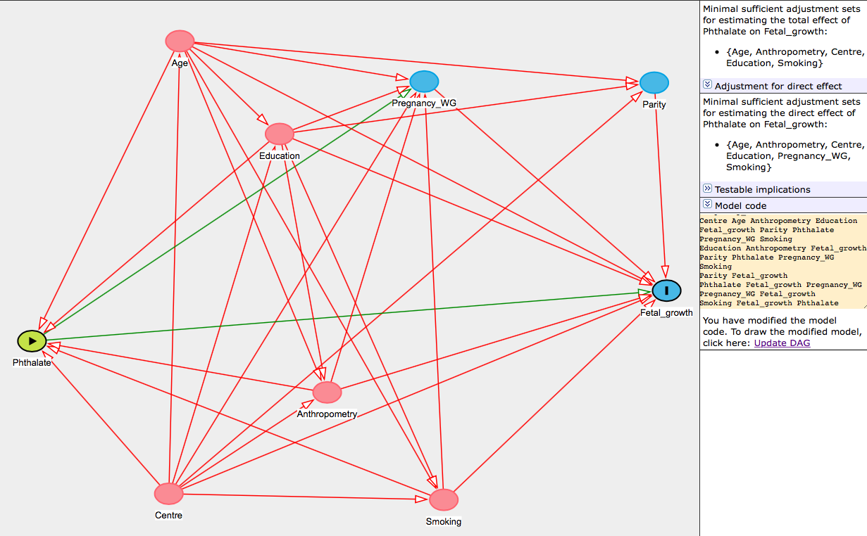 | Age 1 @0.227,-0.090  Anthropometry 1 @0.453,0.780  Centre 1 @0.210,1.031  Education 1 @0.380,0.140  Fetal_growth O @0.974,0.528  Parity 1 @0.955,0.013  Phthalate E @0.000,0.653  Pregnancy_WG 1 @0.602,0.010  Smoking 1 @0.632,1.046  Age Anthropometry Education Fetal_growth Parity Phthalate Pregnancy_WG Smoking  Anthropometry Fetal_growth Phthalate Pregnancy_WG  Centre Age Anthropometry Education Fetal_growth Parity Phthalate Pregnancy_WG Smoking  Education Anthropometry Fetal_growth Parity Phthalate Pregnancy_WG Smoking  Parity Fetal_growth  Phthalate Fetal_growth Pregnancy_WG  Pregnancy_WG Fetal_growth  Smoking Fetal_growth Phthalate Pregnancy_WG
Figure S2. Directed acyclic graph for multivariable postnatal growth models and corresponding code, built using the Dagitty web interface (http://www.dagitty.net). The unobserved U variable can be dietary factors.
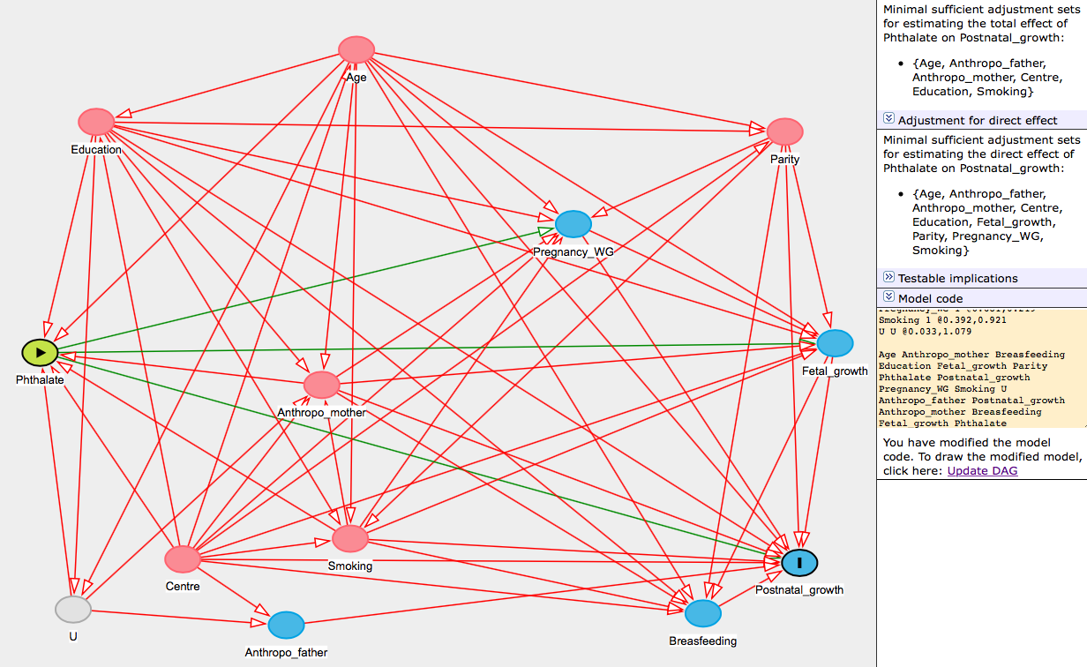 | Age 1 @0.400,-0.170  Anthropo_father 1 @0.309,1.114  Anthropo_mother 1 @0.355,0.578  Breasfeeding 1 @0.849,1.088  Centre 1 @0.175,0.967  Education 1 @0.063,-0.009  Fetal_growth 1 @1.020,0.485  Parity 1 @0.955,0.013  Phthalate E @-0.010,0.506  Postnatal_growth O @0.974,0.975  Pregnancy_WG 1 @0.681,0.219  Smoking 1 @0.392,0.921  U U @0.033,1.079  Age Anthropo_mother Breasfeeding Education Fetal_growth Parity Phthalate Postnatal_growth Pregnancy_WG Smoking U  Anthropo_father Postnatal_growth  Anthropo_mother Breasfeeding Fetal_growth Phthalate Postnatal_growth Pregnancy_WG  Breasfeeding Postnatal_growth  Centre Age Anthropo_father Anthropo_mother Breasfeeding Education Fetal_growth Parity Phthalate Postnatal_growth Pregnancy_WG Smoking  Education Anthropo_mother Breasfeeding Fetal_growth Parity Phthalate Postnatal_growth Pregnancy_WG Smoking U  Fetal_growth Breasfeeding Postnatal_growth  Parity Breasfeeding Fetal_growth Postnatal_growth Pregnancy_WG Smoking  Phthalate Fetal_growth Postnatal_growth Pregnancy_WG  Pregnancy_WG Fetal_growth Postnatal_growth  Smoking Anthropo_mother Breasfeeding Fetal_growth Phthalate Postnatal_growth Pregnancy_WG  U Anthropo_father Anthropo_mother Phthalate

