Supplemental Table 1: Sources of Positive Blood Cultures among those with at least One Positive Culture for *M. FVL 201832*

|  |  |
| --- | --- |
|  | No. (%)a |
| Positive blood cultures from chemotherapy port only | 15 (29%) |
| Positive blood cultures from peripheral vein only | 5 (10%) |
| Positive blood cultures from both chemotherapy port and peripheral vein | 31 (60%) |
| Positive blood cultures from unknown site | 1 (2%) |
| Positive blood cultures identified from aerobic blood culture | 52 (100%) |
| Positive AFB blood cultures | 19/78 (24%) |
| Persons with >1 positive blood culture across different dates | 4 (8%) |
| Median (range) of days between positive blood cultures | 16 (3-48) |

1. *Denominator is 52 unless otherwise noted*

Supplemental Table 2: snvMatrix from SNVPhyl. 2018-32-35-02 served as reference. Core genome: 89.58%

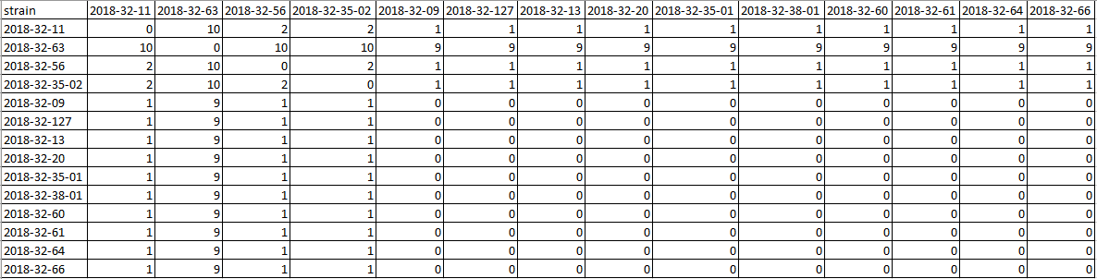

Supplemental Figure 1: Image of novel NTM, FVL 201832, on a Middlebrook 7H11 plate showing the smooth and orange colony morphology