Supplemental Materials:
Biospecimen Collection Procedures
All adult interview respondents were asked to provide urine samples. Full-void urine specimens were self-collected by 21,801 (67.5%) consenting participants. Samples collected in a 500 mL polypropylene container (Globe Scientific, PN 6542) were immediately placed in a Crēdo Cube shipper (Minnesota Thermal Science, Series 4-496) certified to hold contents between 2°C and 8°C for at least 72 hours, and shipped overnight to the PATH Study biorepository. Each specimen was well-mixed, and then divided into aliquots and stored in FluidX® polypropylene cryovials at -80°C. All containers, pipet tips, and vials that came into direct contact with the urine sample were pre-screened by the National Center for Environmental Health, Centers for Disease Control and Prevention (CDC) Laboratories. Additional information on biospecimen collection and storage protocols is available online at https://doi.org/10.3886/Series606 .
Demographic Variables
Sociodemographic data, including gender, age, race/ethnicity and education were derived from self-reported interview data. In this report, we have focused on smokers in age groups of 18-24, 25-34, 35-54 and ≥ 55+ years. The race ethnicity variable was categorized into four groups, including non-Hispanic white (NHW), non-Hispanic black (NHB), Hispanic (HA), and other (OTH) participants. Education levels were also categorized into four groups: less than high school or General Educational Development (GED) status, high school (HS) diploma, some college or associate degree, and bachelor’s or advanced degree. Missing data on these variables were imputed as described in the PATH Study Restricted Use Files User Guide https://doi.org/10.3886/Series606) (United States Department of Health and Human Services 2017).

Regression Modeling Methods
Linear regression parameter estimates for NNAL concentration by demographic and user groups are presented in Tables 4 and Supplemental Table S2A. The referent tobacco user group for the regression models was never users. Model 4 includes current user groups (exclusive and intermittent users of each combined) whereas Model S2 includes exclusive and intermittent users as separate groups. Both models also include former and never users. Geometric least square mean differences between user groups are presented in Tables 4 and Supplemental Table S2B. P-values were Bonferroni corrected to have a family wise error rate of α = 0.05.

Laboratory Methods
Tobacco-Specific Nitrosamines-TSNAs
Urine specimens were shipped overnight on dry ice to the CDC National Center for Environmental Health, Division of Laboratory Sciences, where they were stored at -80°C prior to analysis. In addition, when subject samples are shipped for analysis, the PATH Study team included blinded QC pool samples randomly embedded with the shipped samples to be analyzed during subject sample analysis runs. Blinded replicate subject samples are also included in certain shipments. Total NNAL, NNN, NAB and NAT were measured by isotope dilution high performance liquid chromatography/atmospheric pressure ionization tandem mass spectrometry (HPLC-MS/MS) using a modified version of the method of Xia et al.^{18,19} Briefly, a 1.7 mL urine aliquot was spiked with 50 µL of a stable isotope internal standard mixture (ISTD), and 170 µL of β-glucuronidase (20,000 u/ml) was added. The mixed samples were hydrolyzed at 37 ºC for 24 hours. After hydrolysis, total urinary NNAL, NNN, NAT, and NAB were extracted from the urine matrix by using a series of 96-well plates sequentially including mixed mode of a cation exchange (Biotage Evolute CX 96-well SPE plate, 60 mg), diatomaceous earth (Biotage Isolute 96-well SLE plate, 400 µL), followed by a molecularly imprinted polymer (MIP, Supelco SupelMIP NNAL SPE 96-well plate, 25 mg) solid phase extraction (SPE). This sample extraction procedure was carried out on a fully automated and integrated robotic system. HPLC-MS/MS analysis was performed using a Shimadzu LC-30AD HPLC module (Columbia, MD, U.S.A) coupled with a Sciex API 6500 QQQ mass spectrometer (Framingham, MA, U.S.A). TSNAs separation was achieved using a reversed phase column (Phenomenex, Gemini-NX C18, 2.1 × 150 mm 3.0 µm; CA, U.S.A) with 0.08% ammonium hydroxide in water as mobile phase A and 100% acetonitrile as mobile phase B. The gradient increased from 3% to 30% in mobile phase B in 9 minutes. The limits of detection (LODs) for NNAL, NNN, NAT, and NAB were 0.60, 2.8, 4.2, and 1.6 pg/mL, respectively. For concentrations below the LOD, the measurements were replaced with the LOD divided by the square root of two.⁴⁸ Low and high concentration quality control materials and blank urine aliquots were analyzed together with unknown samples in each analytical run to evaluate method performance. All biomarker results reported in this study met the rigorous accuracy and precision requirements of the quality control/quality assurance program established and followed by the CDC National Center for Environmental Health, Division of Laboratory Sciences.⁴⁹

Nicotine Metabolites-Cotinine (COTT) and Total Nicotine Equivalents (TNE2)
Total urinary nicotine metabolites, including the free and glucuronide conjugated forms (following hydrolysis), were measured by two separate isotope dilution HPLC-MS/MS methods based on a cotinine cutoff value of 20 ng/mL. For samples with cotinine levels above or equal to 20 ng/mL, a “Nicotine Metabolites and Analogs in Urine” method was used to measure anatabine, anabasine, and nicotine, plus six major nicotine metabolites (cotinine-N-oxide, nicotine-N-oxide, trans-3'-hydroxycotinine, norcotinine, cotinine, and nornicotine).²⁰ For samples with cotinine levels less than 20 ng/mL, a “Cotinine and Hydroxycotinine in Urine” method was applied to sensitively measure cotinine and trans-3’-hydroxycotinine using a modified version of the method of Bernert et al.⁵⁰ The limits of detection ranged from 0.030 to 10.5 ng/mL, depending on the analyte. TNE2 (an estimate of total nicotine equivalents based on total cotinine and hydroxycotinine assays) was calculated as the molar sum of the two most abundant metabolites of nicotine in urine: total cotinine and total trans-3'-hydroxycotinine.

Table S1. Unweighted PATH Study Wave 1 demographic counts (N=11,004) with urinary NNAL data
 | Tobacco Users |  |  |  |  |  |  |  |  |  |  |  |  | Nonusers
 |  | Combustible |  |  | Smokeless |  |  | E-cig |  |  | Poly
 | All users | Every day | Intermittent |  | Every day | Intermittent |  | Every day | Intermittent |  | Every day | Intermittent |  | All Non | Former | Never
All Adults | 8,882 | 3,176 | 2,400 |  | 355 | 121 |  | 152 | 106 |  | 1,983 | 589 |  | 2,122 | 559 | 1,563
Sex
Female | 3,756 | 1,569 | 1,029 |  | 19* | 8* |  | 93 | 63 |  | 758 | 217 |  | 1,295 | 308 | 987
Male | 5,126 | 1,607 | 1,371 |  | 336 | 113 |  | 59 | 43* |  | 1,225 | 372 |  | 827 | 251 | 576
Age
18-24 | 2,664 | 652 | 988 |  | 55 | 32* |  | 15* | 41* |  | 602 | 279 |  | 877 | 240 | 637
25-34 | 1,956 | 676 | 505 |  | 61 | 29* |  | 43* | 26* |  | 484 | 132 |  | 385 | 152 | 233
35-54 | 2,856 | 1,199 | 579 |  | 161 | 35* |  | 60 | 26* |  | 663 | 133 |  | 496 | 103 | 393
55+ | 1,406 | 649 | 328 |  | 78 | 25* |  | 34* | 13* |  | 234 | 45* |  | 364 | 64 | 300
Race/Ethnicity
HA | 1,351 | 353 | 620 |  | 10* | 7* |  | 8* | 15* |  | 180 | 158 |  | 494 | 107 | 387
NHB | 1,271 | 548 | 484 |  | 16* | 8* |  | 10* | 14* |  | 139 | 52 |  | 396 | 97 | 299
NHW | 5,558 | 2,053 | 1,100 |  | 301 | 96 |  | 126 | 66 |  | 1,490 | 326 |  | 1,050 | 302 | 748
OTH | 702 | 222 | 196 |  | 28* | 10* |  | 8* | 11* |  | 174 | 53 |  | 182 | 53 | 129
Education
< HS/GED | 2,348 | 1,008 | 507 |  | 91 | 24* |  | 25* | 22* |  | 538 | 133 |  | 369 | 96 | 273
HS | 2,195 | 831 | 519 |  | 103 | 31* |  | 37* | 30* |  | 499 | 145 |  | 540 | 136 | 404
<4 College/Associate | 3,303 | 1,124 | 898 |  | 123 | 38* |  | 67 | 43* |  | 776 | 234 |  | 781 | 239 | 542
Bachelors/Advanced | 1,036 | 213 | 476 |  | 38* | 28* |  | 23* | 11* |  | 170 | 77 |  | 432 | 88 | 344
HA: Hispanic; NHB: Non-Hispanic Black; NHW: Non-Hispanic White; OTH: Other Hispanic/Other Race/Multiracial; HS: High School; GED: General Educational Development. *: Relative standard error is greater than or equal to 30% or unweighted denominator less than 50.

Table S2A. Weighted linear regression model 2 for NNAL (ng/mL)(natural log transformed, N=11,004) in different tobacco user groups (subdivided by frequency) and demographic groups
Predictor | Level | N | %(SE) | Coefficient [95% CI] | p-Value
Intercept |  | . |  | -9.09 [-9.44, -8.75] | <0.0001
Creatinine, urine (Ln) |  | . |  | 0.515 [0.44, 0.59] | <0.0001
Tobacco User Group | Combustible Exclusive Everyday User | 3176 | 19.8 (0.446) | 5.35 [5.20, 5.49] | <0.0001
Tobacco User Group | Combustible Exclusive Intermittent User | 2400 | 14.3 (0.380) | 2.70 [2.54, 2.86] | <0.0001
Tobacco User Group | E-Cigarette Exclusive Everyday User | 152 | 0.704 (0.0652) | 1.60 [1.35, 1.85] | <0.0001
Tobacco User Group | E-Cigarette Exclusive Intermittent User | 106 | 0.595 (0.0662) | 1.24 [0.847, 1.64] | <0.0001
Tobacco User Group | Smokeless Exclusive Everyday User | 355 | 1.68 (0.119) | 6.66 [6.44, 6.88] | <0.0001
Tobacco User Group | Smokeless Exclusive Intermittent User | 121 | 0.678 (0.0962) | 4.60 [4.06, 5.14] | <0.0001
Tobacco User Group | Poly Everyday User | 1983 | 8.57 (0.276) | 5.47 [5.32, 5.62] | <0.0001
Tobacco User Group | Poly Intermittent User | 589 | 2.56 (0.128) | 3.25 [3.02, 3.49] | <0.0001
Tobacco User Group | Former User | 559 | 6.54 (0.404) | 0.747 [0.516, 0.978] | <0.0001
Tobacco User Group | Never User | 1563 | 44.5 (0.793) | Ref. | .
Sex | Male | 5953 | 48.2 (0.369) | Ref. | .
Sex | Female | 5051 | 51.8 (0.369) | 0.0718 [-0.0342, 0.178] | 0.1819
Age Group | 18-24 | 3541 | 17.5 (0.186) | -0.389 [-0.523, -0.254] | <0.0001
Age Group | 25-34 | 2341 | 21.0 (0.726) | Ref. | .
Age Group | 35-54 | 3352 | 35.4 (0.899) | 0.229 [0.0704, 0.388] | 0.0051
Age Group | 55+ | 1770 | 26.1 (0.724) | 0.132 [-0.0217, 0.285] | 0.0916
Race/Ethnicity | Non-Hispanic White | 6608 | 61.4 (1.00) | Ref. | .
Race/Ethnicity | Non-Hispanic Black | 1667 | 14.3 (0.591) | 0.206 [0.0143, 0.398] | 0.0355
Race/Ethnicity | Hispanic | 1845 | 17.0 (0.739) | -0.476 [-0.647, -0.304] | <0.0001
Race/Ethnicity | Other Race/Multiracial | 884 | 7.35 (0.499) | -0.118 [-0.327, 0.0909] | 0.265
Education Level | <High School/GED | 2717 | 20.6 (0.567) | 0.149 [0.00310, 0.295] | 0.0454
Education Level | HS Diploma | 2735 | 26.1 (0.931) | Ref. | .
Education Level | <4y College/Associate | 4084 | 31.2 (0.770) | -0.389 [-0.533, -0.245] | <0.0001
Education Level | Bachelors | 1025 | 13.4 (0.655) | -1.02 [-1.22, -0.832] | <0.0001
Education Level | Advanced | 443 | 8.72 (0.800) | -1.20 [-1.45, -0.957] | <0.0001

Table S2B. Least square mean differences between user groups for NNAL model 2
User Group A | User Group B | Difference (A-B)[95%CI] | Standard Error | Adjusted p-Value ¹
Combustible Exclusive Everyday User | Never User | 5.35[5.10, 5.60] | 0.0746 | <0.0001
Combustible Exclusive Intermittent User | Never User | 2.70[2.43. 2.97] | 0.0809 | <0.0001
E-Cigarette Exclusive Everyday User | Never User | 1.60[1.17, 2.03] | 0.1274 | <0.0001
E-Cigarette Exclusive Intermittent User | Never User | 1.24[0.57, 1.91] | 0.1998 | <0.0001
Smokeless Exclusive Everyday User | Never User | 6.66[6.29, 7.03] | 0.1109 | <0.0001
Smokeless Exclusive Intermittent User | Never User | 4.60[3.68, 5.51] | 0.2729 | <0.0001
Poly Everyday User | Never User | 5.47[5.22, 5.72] | 0.0758 | <0.0001
Poly Intermittent User | Never User | 3.25[2.85, 3.66] | 0.1197 | <0.0001
Former User | Never User | 0.75[0.36, 1.14] | 0.1165 | <0.0001
Combustible Exclusive Everyday User | Former User | 4.60[4.16, 5.04] | 0.1311 | <0.0001
Combustible Exclusive Intermittent User | Former User | 1.96[1.53, 2.39] | 0.1279 | <0.0001
E-Cigarette Exclusive Everyday User | Former User | 0.85[0.34, 1.36] | 0.1509 | <0.0001
E-Cigarette Exclusive Intermittent User | Former User | 0.50[-0.29, 1.28] | 0.2343 | 1.000
Combustible Exclusive Everyday User | Combustible Exclusive Intermittent User | 2.64[2.40, 2.88] | 0.0720 | <0.0001
Combustible Exclusive Everyday User | Smokeless Exclusive Everyday User | -1.32[-1.60, -1.03] | 0.0855 | <0.0001
Combustible Exclusive Intermittent User | Smokeless Exclusive Everyday User | -3.96[-4.30, -3.62] | 0.1022 | <0.0001
E-Cigarette Exclusive Everyday User | Smokeless Exclusive Everyday User | -5.06[-5.54, -4.59] | 0.1422 | <0.0001
E-Cigarette Exclusive Intermittent User | Smokeless Exclusive Everyday User | -5.42[-6.13, -4.70] | 0.2131 | <0.0001
Poly Everyday User | Smokeless Exclusive Everyday User | -1.19[-1.49, -0.89] | 0.0895 | <0.0001
Poly Intermittent User | Smokeless Exclusive Everyday User | -3.41[-3.89, -2.93] | 0.1436 | <0.0001
Former User | Smokeless Exclusive Everyday User | -5.92[-6.44, -5.39] | 0.1566 | <0.0001
Combustible Exclusive Everyday User | Smokeless Exclusive Intermittent User | 0.75[-0.18, 1.68] | 0.2763 | 0.356
Combustible Exclusive Intermittent User | Smokeless Exclusive Intermittent User | -1.89[-2.80, -0.99] | 0.2685 | <0.0001
E-Cigarette Exclusive Everyday User | Smokeless Exclusive Intermittent User | -3.00[-4.01, -1.99] | 0.3000 | <0.0001
E-Cigarette Exclusive Intermittent User | Smokeless Exclusive Intermittent User | -3.35[-4.43, -2.28] | 0.3194 | <0.0001
Poly Everyday User | Smokeless Exclusive Intermittent User | 0.87[-0.02, 1.77] | 0.2661 | 0.064
Poly Intermittent User | Smokeless Exclusive Intermittent User | -1.34[-2.36, -0.33] | 0.3025 | 0.001
Former User | Smokeless Exclusive Intermittent User | -3.85[-4.87, -2.83] | 0.3034 | <0.0001
Smokeless Exclusive Everyday User | Smokeless Exclusive Intermittent User | 2.07[1.13, 3.00] | 0.2778 | <0.0001
Combustible Exclusive Everyday User | Poly Everyday User | -0.12[-0.28, 0.03] | 0.0470 | 0.424
Combustible Exclusive Intermittent User | Poly Everyday User | -2.77[-3.00, -2.53] | 0.0694 | <0.0001
E-Cigarette Exclusive Everyday User | Poly Everyday User | -3.87[-4.30, -3.45] | 0.1261 | <0.0001
E-Cigarette Exclusive Intermittent User | Poly Everyday User | -4.23[-4.88, -3.57] | 0.1956 | <0.0001
Former User | Poly Everyday User | -4.72[-5.16, -4.29] | 0.1302 | <0.0001
Combustible Exclusive Everyday User | Poly Intermittent User | 2.09[1.70, 2.48] | 0.1158 | <0.0001
Combustible Exclusive Intermittent User | Poly Intermittent User | -0.55[-0.94, -0.17] | 0.1147 | 0.0002
E-Cigarette Exclusive Everyday User | Poly Intermittent User | -1.66[-2.18, -1.13] | 0.1558 | <0.0001
E-Cigarette Exclusive Intermittent User | Poly Intermittent User | -2.01[-2.71, -1.31] | 0.2073 | <0.0001
Former User | Poly Intermittent User | -2.51[-3.04, -1.98] | 0.1585 | <0.0001
Poly Everyday User | Poly Intermittent User | 2.22[1.80, 2.63] | 0.1231 | <0.0001
Combustible Exclusive Everyday User | E-Cigarette Exclusive Everyday User | 3.75[3.34, 4.15] | 0.1209 | <0.0001
Combustible Exclusive Intermittent User | E-Cigarette Exclusive Everyday User | 1.10[0.63, 1.57] | 0.1400 | <0.0001
Combustible Exclusive Everyday User | E-Cigarette Exclusive Intermittent User | 4.10[3.49, 4.72] | 0.1835 | <0.0001
Combustible Exclusive Intermittent User | E-Cigarette Exclusive Intermittent User | 1.46[0.80, 2.12] | 0.1960 | <0.0001
E-Cigarette Exclusive Everyday User | E-Cigarette Exclusive Intermittent User | 0.35[-0.35, 1.06] | 0.2086 | 1.000
¹Bonferroni corrected for multiple comparisons.

Table S3. Weighted NNAL geometric mean (GM) with 95% CI (pg/mL) by tobacco use status in PATH Study Wave 1
 | Tobacco Users |  |  |  |  |  |  |  |  | Nonusers
 |  | Combustible |  | Smokeless |  | E-cig |  | Poly
 | All users | Every day | Intermittent | Every day | Intermittent | Every day | Intermittent | Every day | Intermittent | All Non | Former | Never
All Adults | 95.5 [88.5, 102.4] | 279.1 [262.6, 295.6] | 14.6 [12.8, 16.4] | 1,001.9 [839.7, 1164.1] | 96.0 [46.0, 146.0] | 5.5 [4.1, 6.9] | 4.0 [2.5, 5.6] | 270.5 [245.5, 295.5] | 26.2 [19.5, 33.0] | 1.1 [1.0, 1.2] | 2.1 [1.6, 2.6] | 1.0 [0.9, 1.1]
Sex
Female | 97.9 [86.9, 108.9] | 270.6 [247.4, 293.8] | 16.8 [13.7, 20.0] | 318.42 [-573.3, 6941.6]*,$ | 60.1 [-14.3, 134.5]*,$ | 5.1 [3.5, 6.8] | 3.9 [2.5, 5.4] | 251.6 [226.2, 277.0] | 32.5 [19.3, 45.6] | 1.0 [0.9, 1.2] | 2.1 [1.5, 2.6] | 0.9 [0.8, 1.1]
Male | 93.8 [85.4, 102.1] | 287.6 [264.8, 310.4] | 13.3 [11.0, 15.5] | 947.8 [813.0, 1082.6] | 97.8 [45.7, 150.0] | 6.1 [3.3, 8.8] | 4.2 [0.9, 7.4]*,$ | 282.5 [248.0, 317.0] | 23.3 [16.5, 30.2] | 1.2 [1.0, 1.4] | 2.1 [1.3, 2.9] | 1.1 [0.9, 1.3]
Age
18-24 | 29.3 [25.6, 32.9] | 148.0 [123.1, 173.0] | 6.6 [5.5, 7.6] | 407.3 [238.3, 576.3] | 24.7 [7.7, 41.6]*,$ | 6.1 [-1.2, 13.4]*,$ | 4.3 [1.0, 7.6]*,$ | 169.5 [145.9, 193.0] | 12.1 [8.6, 15.6] | 1.4 [1.2, 1.7] | 2.7 [2.0, 3.4] | 1.3 [1.0, 1.5]
25-34 | 75.3 [63.2, 87.4] | 275.0 [242.3, 307.6] | 9.5 [7.3, 11.8] | 807.6 [573.1, 1,042.2] | 52.1 [-17.0, 121.3]*,$ | 6.2 [2.7, 9.7]* | 5.0 [0.5, 9.5]*,$ | 240.9 [199.2, 282.5] | 16.5 [8.9, 24.1] | 1.3 [1.1, 1.6] | 2.8 [1.5, 4.0] | 1.1 [0.9, 1.4]
35-54 | 153.1 [135.0, 171.2] | 324.9 [295.2, 354.6] | 23.2 [17.5, 28.8] | 1,163.6 [1,002.1, 1,325.1] | 189.0 [52.7, 325.3]*,$ | 5.1 [2.8, 7.4] | 2.0 [1.0, 3.0]* | 358.6 [294.8, 422.3] | 56.2 [25.2, 87.1] | 1.0 [0.8, 1.3] | 2.2 [1.2, 3.1] | 1.0 [0.7, 1.2]
55+ | 151.6 [131.3, 171.8] | 291.5 [258.9, 324.1] | 33.4 [21.4, 45.5] | 1,152.2 [654.0, 1,650.5] | 191.7 [-3.8, 387.1]*,$ | 5.3 [2.7, 7.8]* | 7.2 [-0.8, 15.1]*,$ | 301.4 [259.0, 343.7] | 147.2 [64.0, 230.4]* | 0.9 [0.7, 1.0] | 1.3 [0.7, 1.9] | 0.8 [0.7, 1.0]
Race/Ethnicity
HA | 33.7 [27.5, 40.0] | 208.1 [154.8, 261.4] | 11.9 [9.0, 14.7] | 787.6 [401.1, 1,174.2]* | 5.0 [-18.4, 28.3]*,$ | 1.2 [0.1, 2.2]*,$ | 1.2 [0.6, 1.9]* | 140.0 [102.1, 177.9] | 11.2 [6.7, 15.7] | 1.1 [0.9, 1.2] | 2.6 [1.5, 3.6] | 1.0 [0.8, 1.1]
NHB | 139.6 [113.1, 166.1] | 293.8 [251.8, 335.8] | 55.7 [38.8, 72.6] | 1,201.5 [-1,244.2, 3,647.3]*,$ | 62.3 [-163.5, 288.1]*,$ | 10.5 [0.8, 20.3]*,$ | 10.7 [-4.1, 25.5]*,$ | 251.7 [207.9, 295.5] | 65.4 [0.6, 130.3]$ | 1.8 [1.3, 2.3] | 3.3 [0.9, 5.7]$ | 1.6 [1.1, 2.1]
NHW | 116.8 [105.7, 127.9] | 293.4 [273.6, 313.2] | 11.0 [8.9, 13.1] | 1,006.9 [838.6, 1,175.1] | 136.0 [74.5, 197.5] | 5.7 [4.1, 7.4] | 4.1 [2.3, 5.9] | 296.3 [264.2, 328.4] | 33.0 [21.4, 44.5] | 1.0 [0.8, 1.1] | 1.9 [1.3, 2.4] | 0.9 [0.7, 1.0]
OTH | 41.8 [27.0, 56.6] | 197.5 [142.5, 252.6] | 6.8 [3.8, 9.8] | 877.5 [300.2, 1,454.7]*,$ | 60.0 [90.8, 210.8]*,$ | 4.1 [-1.4, 9.5]*,$ | 3.2 [-3.7, 10.0]*,$ | 201.1 [146.6, 255.6] | 20.4 [3.0, 37.8]$ | 0.9 [0.6, 1.2] | 1.5 [0.4, 2.6]$ | 0.9 [0.5, 1.2]
Education
< HS/GED | 189.5 [168.5, 210.4] | 300.2 [270.4, 330.0] | 65.0 [49.4, 80.5] | 1,257.0 [657.4, 1,856.7] | 291.4 [130.6, 452.2]* | 9.3 [2.6, 16.1]*,$ | 4.2 [1.5, 6.9]*,$ | 319.6 [245.8, 393.5] | 48.9 [24.8, 73.0] | 1.4 [1.2, 1.7] | 3.1 [1.0, 5.2]$ | 1.3 [1.0, 1.5]
HS | 149.5 [134.2, 164.9] | 301.8 [274.6, 329.1] | 33.6 [25.6, 41.7] | 956.0 [756.5, 1,155.5] | 93.8 [-25.7, 213.3]*,$ | 7.2 [3.8, 10.5]* | 2.4 [0.3, 4.5]*,$ | 287.8 [249.1, 326.6] | 34.1 [16.3, 51.9] | 1.7 [1.2, 2.1] | 2.6 [1.4, 3.9] | 1.5 [1.1, 2.0]
<4 College/Associate | 79.7 [71.8, 87.6] | 261.3 [233.1, 289.4] | 9.9 [8.0, 11.8] | 895.8 [701.5, 1,090.0] | 86.6 [-9.4, 182.6]*,$ | 5.0 [2'8, 7.2] | 5.4 [1.7, 9.1]*,$ | 234.6 [209.7, 259.6] | 25.9 [16.5, 35.4] | 1.2 [1.0, 1.3] | 2.6 [1.5, 3.6] | 1.0 [0.8, 1.2]
Bachelors/Advanced | 19.3 [15.4, 23.2] | 195.9 [158.0, 233.7] | 3.8 [2.8, 4.8] | 916.4 [631.7, 1,201.1]* | 53.1 [-2.4, 108.7]*,$ | 2.5 [1.5, 3.5]* | 4.3 [0.8, 7.8]*,$ | 257.6 [188.5, 326.7] | 8.5 [3.2,13.7]$ | 0.6 [0.5, 0.7] | 0.9 [0.6, 1.2] | 0.6 [0.5, 0.6]
HA: Hispanic; NHB: Non-Hispanic Black; NHW: Non-Hispanic White; OTH: Other Hispanic/Other Race/Multiracial; HS: High School; GED: General Educational Development. *: sample size is less than 50. $: Relative Standard Error (RSE) is more than 30 percent. The RSE is calculated by 100 x standard Error (estimate)/estimate.

Table S4. Weighted NNN geometric mean (GM) with 95% CI (ng/g Creatinine) by tobacco use status in PATH Study Wave 1
 | Tobacco Users |  |  |  |  |  |  |  |  | Nonusers
 |  | Combustible |  | Smokeless |  | E-cig |  | Poly
 | All users | Every day | Intermittent | Every day | Intermittent | Every day | Intermittent | Every day | Intermittent | All Non | Former | Never
All Adults | 8.0 [7.7, 8.4] | 13.8 [13.0, 14.6] | 3.1 [2.9, 3.3] | 33.8 [29.3, 38.4] | 7.4 [4.4, 10.4] | 5.2 [4.3, 6.0] | 2.2 [1.9, 2.6] | 12.9 [12.1, 13.8] | 3.3 [2.9, 3.7] | 2.0 [1.9, 2.1] | 2.2 [1.9, 2.5] | 1.9 [1.8, 2.0]
Sex
Female | 9.0 [8.4, 9.7] | 15.6 [14.3, 17.0] | 3.5 [3.2, 3.9] | 63.0 [-2.8, 128.8]*,$ | 13.0 [-3.9, 29.9]*,$ | 5.1 [3.9, 6.4] | 2.5 [2.0, 2.9] | 13.4 [11.8, 14.9] | 4.6 [3.8, 5.5] | 2.1 [2.0, 2.3] | 2.4 [2.0, 2.8] | 2.1 [1.9, 2.2]
Male | 7.4 [7.0, 7.8] | 12.3 [11.3, 13.2] | 2.9 [2.7, 3.1] | 32.8 [28.8, 36.9] | 7.2 [4.2, 10.2] | 5.2 [3.8, 6.6] | 2.0 [1.3, 2.6]* | 12.7 [11.5, 13.9] | 2.7 [2.3, 3.0] | 1.7 [1.6, 1.9] | 2.0 [1.7, 2.3] | 1.7 [1.6, 1.8]
Age
18-24 | 3.7 [3.4, 3.9] | 7.1 [6.1, 8.2] | 2.1 [1.9, 2.2] | 9.4 [5.6, 13.3] | 2.8 [1.7, 4.0]* | 5.4 [2.3, 8.4]* | 1.8 [1.4, 2.2]* | 8.0 [7.0, 9.0] | 2.0 [1.8, 2.2] | 1.6 [1.5, 1.7] | 1.7 [1.6, 1.9] | 1.5 [1.4, 1.7]
25-34 | 6.7 [6.0, 7.3] | 11.9 [10.4, 13.4] | 2.6 [2.4, 2.9] | 21.4 [14.6, 28.2] | 5.2 [1.5, 9.0]*,$ | 4.9 [3.2, 6.7]* | 2.1 [1.1, 3.0]* | 11.4 [9.9, 12.9] | 2.8 [2.3, 3.3] | 1.8 [1.6, 1.9] | 2.1 [1.7, 2.5] | 1.7 [1.5, 1.9]
35-54 | 10.6 [9.9, 11.4] | 15.9 [14.4, 17.4] | 3.7 [3.2, 4.1] | 38.9 [32.5, 45.4] | 7.8 [3.6, 12.0]* | 5.3 [3.8, 6.7] | 2.4 [1.7, 3.1]* | 16.4 [14.6, 18.2] | 4.8 [3.6, 6.0] | 2.0 [1.8, 2.2] | 2.4 [1.7, 3.1] | 1.9 [1.7, 2.2]
55+ | 12.4 [11.4, 13.4] | 16.7 [14.9, 18.5] | 5.3 [4.4, 6.2] | 51.8 [36.6, 67.0] | 18.8 [4.9, 32.7]*,$ | 5.2 [3.9, 6.6]* | 3.2 [1.7, 4.8]* | 17.2 [14.8, 19.7] | 10.2 [5.9, 14.5]* | 2.4 [2.2, 2.6] | 2.6 [1.9, 3.3] | 2.3 [2.1, 2.6]
Race/Ethnicity
HA | 4.1 [3.7, 4.4] | 8.8 [7.4, 10.2] | 2.6 [2.4, 2.8] | 32.9 [15.3, 50.6]* | 1.8 [-0.7, 4.3]*,$ | 3.3 [0.4, 6.3]*,$ | 1.4 [1.0, 1.9]* | 6.8 [5.2, 8.4] | 2.4 [1.9, 2.9] | 1.9 [1.7, 2.1] | 2.0 [1.3, 2.7] | 1.9 [1.7, 2.1]
NHB | 6.0 [5.3, 6.7] | 8.8 [7.3, 10.3] | 3.7 [3.2, 4.2] | 23.5 [-5.2, 52.1]*,$ | 5.0 [-2.2, 12.2]*,$ | 1.7 [0.8, 2.5]* | 2.3 [1.0, 3.5]* | 7.6 [6.1, 9.0] | 4.1 [2.1, 6.1] | 1.6 [1.4, 1.7] | 1.5 [1.2, 1.8] | 1.6 [1.3, 1.8]
NHW | 10.1 [9.5, 10.7] | 16.5 [15.4, 17.6] | 3.3 [3.0, 3.5] | 34.9 [29.8, 39.9] | 8.7 [4.6, 12.7] | 5.7 [4.6, 6.8] | 2.1 [1.8, 2.4] | 14.5 [13.5, 15.6] | 3.6 [3.0, 4.2] | 2.1 [1.9, 2.3] | 2.5 [2.1, 2.9] | 2.0 [1.9, 2.2]
OTH | 6.2 [5.2, 7.3] | 13.4 [11.0, 15.9] | 2.6 [2.1, 3.1] | 25.9 [12.1, 39.7]* | 7.5 [-0.6, 15.7]*,$ | 8.5 [-2.9, 19.8]*,$ | 6.3 [-1.0, 13.7]*,$ | 11.5 [8.5, 14.6] | 2.9 [1.5, 4.3] | 2.0 [1.6, 2.4] | 2.4 [1.5, 3.3] | 1.9 [1.5, 2.3]
Education
< HS/GED | 10.4 [9.7, 11.1] | 13.8 [12.6, 14.9] | 4.9 [4.2, 5.6] | 42.5 [29.2, 55.9] | 25.0 [7.3, 42.8]*,$ | 5.4 [3.6, 7.2] * | 3.0 [1.8, 4.3]* | 13.9 [11.8, 15.9] | 3.6 [2.5, 4.7] | 2.0 [1.8, 2.2] | 2.2 [1.6, 2.8] | 2.0 [1.7, 2.2]
HS | 10.0 [9.1, 10.9] | 14.8 [12.9, 16.7] | 4.5 [3.8, 5.1] | 35.4 [27.0, 43.8] | 5.2 [1.9, 8.5]*,$ | 4.8 [3.3, 6.3]* | 2.0 [1.4, 2.5]* | 12.1 [10.4, 13.8] | 3.8 [2.9, 4.7] | 1.9 [1.7, 2.0] | 2.4 [1.7, 3.1] | 1.8 [1.6, 2.0]
<4 College/Associate | 7.1 [6.6, 7.6] | 12.8 [11.5, 14.1] | 2.4 [2.2, 2.6] | 30.9 [23.8, 37.9] | 5.9 [2.2, 9.5]*,$ | 5.4 [3.4, 7.4] | 2.2 [1.6, 2.9]* | 12.4 [11.2, 13.7] | 3.2 [2.5, 3.8] | 1.9 [1.7, 2.0] | 2.2 [1.8, 2.5] | 1.8 [1.7, 2.0]
Bachelors/Advanced | 4.6 [4.2, 5.0] | 13.9 [11.5, 16.4] | 2.3 [2.1, 2.4]* | 23.3 [15.1, 31.4] * | 5.7 [0.9, 10.6]*,$ | 4.9 [2.7, 7.1]* | 1.4 [0.9, 1.9]* | 14.4 [11.9, 16.9] | 2.4 [1.8, 3.1] | 2.1 [1.9, 2.3] | 2.1 [1.6, 2.6] | 2.1 [1.9, 2.3]
HA: Hispanic; NHB: Non-Hispanic Black; NHW: Non-Hispanic White; OTH: Other Hispanic/Other Race/Multiracial; HS: High School; GED: General Educational Development. *: sample size is less than 50. $: Relative Standard Error (RSE) is more than 30 percent. The RSE is calculated by 100 x standard Error (estimate)/estimate.

Table S5. Weighted NAT geometric mean (GM) with 95% CI (ng/g Creatinine) by tobacco use status in PATH Study Wave 1
 | Tobacco Users |  |  |  |  |  |  |  |  | Nonusers
 |  | Combustible |  | Smokeless |  | E-cig |  | Poly
 | All users | Every day | Intermittent | Every day | Intermittent | Every day | Intermittent | Every day | Intermittent | All Non | Former | Never
All Adults | 48.5 [45.1, 51.9] | 125.2 [116.2, 134.1] | 9.1 [8.2, 9.9] | 452.6 [376.0, 529.2] | 39.1 [17.3, 60.9] | 4.5 [3.8, 5.1] | 3.4 [2.7, 4.1] | 130.3 [118.4, 142.2] | 12.8 [10.1, 15.5] | 3.0 [2.8, 3.2] | 3.7 [3.2, 4.3] | 2.9 [2.7, 3.1]
Sex
Female | 56.2 [49.9, 62.5] | 145.6 [129.4, 161.8] | 10.7 [8.9, 12.6] | 928.5 [-288.6, 2145.7]*,$ | 44.9 [-20.3, 110.2]*,$ | 5.5 [4.4, 6.6] | 3.5 [2.7, 4.2] | 133.1 [115.8, 150.3] | 20.3 [13.5, 27.2] | 3.2 [3.0, 3.5] | 4.1 [3.3, 4.8] | 3.1 [2.9, 3.4]
Male | 43.7 [40.3, 47.1] | 108.3 [99.1, 117.6] | 8.1 [7.1, 9.2] | 439.2 [370.9, 507.6] | 38.9 [17.0, 60.8] | 3.4 [2.6, 4.1] | 3.3 [1.8, 4.7]* | 128.7 [112.5, 144.8] | 9.9 [7.5, 12.4] | 2.7 [2.5, 2.9] | 3.3 [2.6, 4.0] | 2.6 [2.4, 2.8]
Age
18-24 | 15.0 [13.5, 16.5] | 59.3 [48.6, 70.0] | 4.4 [4.0, 4.8] | 104.0 [38.3, 169.6]$ | 9.9 [2.2, 17.6]*,$ | 5.1 [0.8, 9.4]*,$ | 3.2 [2.0, 4.4]* | 70.5 [59.3, 81.6] | 5.9 [4.5, 7.3] | 2.4 [2.3, 2.6] | 2.8 [2.5, 3.1] | 2.4 [2.2, 2.5]
25-34 | 38.8 [32.7, 45.0] | 112.1 [95.9, 128.4] | 6.9 [5.8, 8.0] | 290.3 [186.1, 394.6] | 24.7 [-4.6, 53.9]*,$ | 4.1 [2.9, 5.4]* | 3.0 [1.3, 4.7]* | 117.7 [93.2, 142.3] | 9.4 [6.4, 12.5] | 2.8 [2.4, 3.2] | 3.8 [2.8, 4.8] | 2.6 [2.2, 3.0]
35-54 | 73.6 [65.7, 81.6] | 147.4 [132.2, 162.6] | 12.6 [10.0, 15.2] | 517.7 [419.2, 616.1] | 47.4 [6.0, 88.9]*,$ | 4.3 [3.1, 5.5] | 3.2 [2.1, 4.4]* | 173.0 [148.8, 197.2] | 22.6 [12.6, 32.6] | 3.0 [2.7, 3.4] | 4.3 [2.7, 5.9] | 2.9 [2.6, 3.3]
55+ | 82.7 [72.2, 93.2] | 145.7 [122.0, 169.5] | 19.7 [14.2, 25.2] | 729.3 [474.6, 984.1] | 117.8 [-0.5, 236.2]*,$ | 5.2 [3.5, 7.0]* | 4.7 [2.1, 7.3]* | 170.8 [143.4, 198.1] | 79.1 [38.9, 119.4]* | 3.5 [3.2, 3.8] | 4.0 [2.9, 5.2] | 3.5 [3.2, 3.8]
Race/Ethnicity
HA | 18.2 [15.7, 20.7] | 80.2 [63.4, 97.0] | 7.7 [6.0, 9.5] | 420.2 [99.8, 740.6]*,$ | 3.8 [-8.7, 16.3]*,$ | 3.4 [1.6, 5.2]* | 2.1 [1.4, 2.8]* | 54.1 [35.3, 73.0] | 6.7 [4.5, 9.0] | 2.8 [2.5, 3.1] | 3.5 [1.9, 5.1] | 2.8 [2.5, 3.1]
NHB | 24.5 [20.1, 28.9] | 44.9 [36.6, 53.1] | 11.6 [9.2, 14.1] | 153.7 [-140.3, 447.7]*,$ | 18.3 [-13.3, 49.8]*,$ | 2.6 [0.9, 4.3]*,$ | 3.8 [1.1, 6.5]*,$ | 33.6 [22.0, 45.2] | 15.8 [1.9, 29.7]$ | 2.4 [2.1, 2.7] | 2.4 [1.9, 3.0] | 2.4 [2.1, 2.8]
NHW | 71.9 [65.5, 78.3] | 174.1 [160.4, 187.9] | 9.2 [8.0, 10.4] | 485.9 [398.7, 573.1] | 54.0 [20.4, 87.6]$ | 4.8 [4.0, 5.6] | 3.0 [2.4, 3.5] | 161.7 [147.1, 176.4] | 16.3 [11.5, 21.1] | 3.2 [3.0, 3.5] | 4.2 [3.5, 5.0] | 3.1 [2.8, 3.4]
OTH | 29.9 [21.5, 38.4] | 104.8 [79.4, 130.2] | 7.4 [4.6, 10.2] | 344.2 [105.9, 582.4]*,$ | 26.4 [-25.8, 78.5]*,$ | 3.5 [1.5, 5.4]* | 11.4 [-5.4, 28.1]*,$ | 100.4 [65.2, 135.7] | 11.1 [3.9, 18.3]$ | 3.1 [2.4, 3.8] | 4.0 [2.3, 5.6] | 3.0 [2.3, 3.8]
Education
< HS/GED | 81.8 [72.6, 90.9] | 130.7 [114.6, 146.8] | 24.5 [18.3, 30.6] | 635.7 [390.4, 881.0] | 195.6 [34.1, 357.0]*,$ | 3.6 [2.5, 4.7]* | 5.0 [2.6, 7.4]* | 154.9 [128.7, 181.1] | 16.0 [8.2, 23.9] | 3.0 [2.7, 3.3] | 3.6 [2.5, 4.6] | 2.9 [2.6, 3.2]
HS | 68.5 [60.6, 76.4] | 137.1 [118.6, 155.6] | 15.6 [12.3, 18.8] | 497.6 [370.3, 625.0] | 26.9 [0.3, 53.5]*,$ | 3.9 [2.6, 5.2]* | 3.0 [2.2, 3.9]* | 130.4 [108.2, 152.7] | 13.9 [7.7, 20.1] | 2.9 [2.6, 3.3] | 4.2 [2.7, 5.8] | 2.8 [2.4, 3.1]
<4 College/Associate | 39.7 [35.4, 44.0] | 110.8 [95.4, 126.3] | 6.2 [5.3, 7.0] | 345.8 [244.3, 447.2] | 31.0 [-6.5, 68.5]*,$ | 5.2 [3.7, 6.7] | 3.1 [1.9, 4.3]* | 115.6 [99.5, 131.6] | 13.7 [8.9, 18.5] | 2.9 [2.7, 3.1] | 3.7 [2.9, 4.5] | 2.8 [2.5, 3.0]
Bachelors/Advanced | 16.3 [13.7, 19.0] | 122.8 [98.9, 146.7] | 4.4 [3.9, 4.9] | 334.3 [216.6, 452.0]* | 25.4 [-7.0, 57.7]*,$ | 4.8 [3.4, 6.2]* | 2.2 [1.2, 3.2]* | 129.0 [90.1, 167.9] | 7.5 [4.0, 11.0] | 3.3 [2.9, 3.6] | 3.4 [2.5, 4.2] | 3.3 [2.9, 3.6]
HA: Hispanic; NHB: Non-Hispanic Black; NHW: Non-Hispanic White; OTH: Other Hispanic/Other Race/Multiracial; HS: High School; GED: General Educational Development. *: sample size is less than 50. $: Relative Standard Error (RSE) is more than 30 percent. The RSE is calculated by 100 x standard Error (estimate)/estimate.

Table S6. Weighted NAB geometric mean (GM) with 95% CI (ng/g Creatinine) by tobacco use status in PATH Study Wave 1
 | Tobacco Users |  |  |  |  |  |  |  |  |  |  |  |  | Nonusers
 |  | Combustible |  |  | Smokeless |  |  | E-cig |  |  | Poly
 | All users | Every day | Intermittent | Every day |  | Intermittent | Every day |  | Intermittent | Every day |  | Intermittent | All Non |  | Former |  | Never
All Adults | 9.2 [8.7, 9.7] | 19.6 [18.2, 21.0] | 2.5 [2.3, 2.7] | 41.6 [34.7, 48.4] |  | 6.3 [3.6, 9.1] | 1.7 [1.4, 1.9] |  | 1.2 [1.0, 1.4] | 20.5 [18.8, 22.2] |  | 3.1 [2.6, 3.6] | 1.1 [1.0, 1.2] |  | 1.3 [1.1, 1.5] |  | 1.1 [1.0, 1.1]
Sex
Female | 10.8 [9.8, 11.9] | 22.3 [19.8, 24.9] | 2.9 [2.5, 3.4] | 81.4 [-20.0, 182.7]*,$ |  | 8.9 [-2.9, 20.6]*,$ | 2.0 [1.6, 2.3] |  | 1.3 [1.0, 1.6] | 22.8 [20.1, 25.5] |  | 4.7 [3.4, 5.9] | 1.2 [1.1, 1.3] |  | 1.4 [1.2, 1.6] |  | 1.2 [1.1, 1.2]
Male | 8.2 [7.7, 8.7] | 17.3 [15.8, 18.7] | 2.2 [2.0, 2.5] | 40.2 [34.3, 46.2] |  | 6.3 [3.5, 9.0] | 1.3 [1.0, 1.5] |  | 1.1 [0.7, 1.5]* | 19.2 [17.1, 21.4] |  | 2.5 [2.0, 2.9] | 1.0 [0.9, 1.1] |  | 1.2 [1.0, 1.4] |  | 0.9 [0.9, 1.0]
Age
18-24 | 3.4 [3.1, 3.6] | 9.4 [7.4, 11.4] | 1.3 [1.2, 1.4] | 12.1 [6.2, 18.0] |  | 2.1 [1.1, 3.1]* | 1.7 [0.4, 2.9]*,$ |  | 1.1 [0.7, 1.4]* | 11.2 [9.6, 12.7] |  | 1.6 [1.3, 1.8] | 0.9 [0.8, 0.9] |  | 1.0 [0.9, 1.1] |  | 0.9 [0.8, 0.9]
25-34 | 7.5 [6.5, 8.4] | 17.2 [14.9, 19.5] | 1.9 [1.7, 2.2] | 27.0 [18.5, 35.6] |  | 4.6 [0.8, 8.3]*,$ | 1.5 [1.1, 1.9]* |  | 1.1 [0.5, 1.6]* | 18.2 [14.7, 21.6] |  | 2.4 [1.8, 3.0] | 1.0 [0.9, 1.1] |  | 1.3 [1.0, 1.5] |  | 0.9 [0.8, 1.1]
35-54 | 13.1 [12.0, 14.2] | 22.9 [20.8, 25.0] | 3.2 [2.7, 3.8] | 45.7 [37.1, 54.2] |  | 7.2 [2.2, 12.3]*,$ | 1.6 [1.2, 1.9] |  | 1.2 [0.7, 1.7]* | 27.0 [23.5, 30.4] |  | 5.2 [3.4, 6.9] | 1.1 [1.0, 1.2] |  | 1.5 [1.1, 2.0] |  | 1.1 [0.9, 1.2]
55+ | 15.0 [13.4, 16.6] | 23.3 [19.7, 26.8] | 5.0 [3.9, 6.1] | 65.4 [44.1, 86.7] |  | 15.1 [1.9, 28.3]*,$ | 2.0 [1.4, 2.7]* |  | 1.6 [0.9, 2.4]* | 28.2 [24.1, 32.3] |  | 14.3 [8.5, 20.1]* | 1.3 [1.2, 1.4] |  | 1.5 [1.1, 1.9] |  | 1.3 [1.2, 1.4]
Race/Ethnicity
MA | 4.2 [3.7, 4.6] | 13.7 [11.1, 16.3] | 2.1 [1.7, 2.5] | 27.4 [1.4, 53.5]*,$ |  | 1.1 [-1.0, 3.2]*,$ | 1.2 [0.6, 1.8]* |  | 0.8 [0.5, 1.2]* | 9.7 [6.8, 12.7] |  | 2.0 [1.4, 2.6] | 1.0 [0.9, 1.1] |  | 1.2 [0.8, 1.6] |  | 1.0 [0.9, 1.1]
NHB | 4.7 [4.0, 5.4] | 7.5 [6.4, 8.7] | 2.7 [2.2, 3.1] | 20.0 [-10.1, 50.0]*,$ |  | 2.8 [-0.5, 6.2]*,$ | 1.1 [0.6, 1.6]* |  | 1.2 [0.5, 2.0]*,$ | 6.3 [4.3, 8.4] |  | 3.4 [1.0, 5.8]$ | 0.9 [0.8, 1.0] |  | 0.9 [0.7, 1.0] |  | 0.9 [0.8, 1.0]
NHW | 12.9 [12.0, 13.9] | 26.3 [24.2, 28.3] | 2.7 [2.4, 3.0] | 44.1 [36.4, 51.8] |  | 8.1 [3.9, 12.3] | 1.8 [1.5, 2.0] |  | 1.1 [0.9, 1.3] | 24.7 [22.7, 26.7] |  | 3.7 [2.8, 4.5] | 1.2 [1.1, 1.3] |  | 1.5 [1.3, 1.8] |  | 1.1 [1.0, 1.2]
OTH | 6.5 [5.0, 8.0] | 18.2 [14.3, 22.0] | 2.2 [1.5, 2.8] | 34.0 [16.4, 51.7]* |  | 6.1 [-2.6, 14.8]*,$ | 1.3 [0.5, 2.1]*,$ |  | 3.6 [-0.7, 7.9]*,$ | 16.6 [11.4, 21.7] |  | 2.7 [1.1, 4.2] | 1.1 [0.9, 1.4] |  | 1.4 [0.9, 2.0] |  | 1.1 [0.8, 1.3]
Education
< HS/GED | 14.0 [12.6, 15.3] | 20.6 [18.0, 23.2] | 5.2 [4.2, 6.2] | 54.4 [34.3, 74.6] |  | 20.6 [6.4, 34.8]*,$ | 1.3 [0.9, 1.7]* |  | 1.7 [1.0, 2.5]* | 24.1 [20.3, 27.9] |  | 3.8 [2.3, 5.3] | 1.1 [1.0, 1.2] |  | 1.4 [1.0, 1.8] |  | 1.1 [1.0, 1.2]
HS | 11.9 [10.7, 13.1] | 20.9 [18.3, 23.4] | 3.7 [3.1, 4.4] | 47.6 [38.2, 57.0] |  | 4.4 [1.3, 7.6]*,$ | 1.6 [1.0, 2.1]* |  | 1.2 [0.8, 1.6]* | 19.3 [16.3, 22.2] |  | 3.4 [2.1, 4.7] | 1.0 [0.9, 1.2] |  | 1.4 [1.0, 1.8] |  | 1.0 [0.9, 1.1]
<4 College/Associate | 7.8 [7.1, 8.6] | 17.6 [15.2, 20.1] | 1.8 [1.6, 2.0] | 33.9 [24.8, 42.9] |  | 5.4 [0.8, 10.0]*,$ | 1.8 [1.4, 2.3] |  | 1.1 [0.7, 1.4]* | 18.8 [16.4, 21.2] |  | 3.2 [2.3, 4.0] | 1.1 [1.0, 1.1] |  | 1.3 [1.0, 1.6] |  | 1.0 [0.9, 1.1]
Bachelors/Advanced | 4.1 [3.5, 4.6] | 19.7 [16.3, 23.1] | 1.5 [1.4, 1.7] | 27.2 [16.2, 38.3]* |  | 5.0 [-0.0, 9.9]*,$ | 1.8 [1.3, 2.3]* |  | 0.8 [0.5, 1.1]* | 21.5 [16.2, 26.8] |  | 2.0 [1.2, 2.7] | 1.2 [1.1, 1.3] |  | 1.2 [0.9, 1.5] |  | 1.2 [1.1, 1.3]
HA: Hispanic; NHB: Non-Hispanic Black; NHW: Non-Hispanic White; OTH: Other Hispanic/Other Race/Multiracial; HS: High School; GED: General Educational Development. *: sample size is less than 50. $: Relative Standard Error (RSE) is more than 30 percent. The RSE is calculated by 100 x standard Error (estimate)/estimate.

Table S7. Weighted NNAL Pearson correlations with other TSNAs, COTT and TNE2 in different tobacco products (current exclusive established everyday users)
NNAL in different tobacco users |  | NNN | NAT | NAB | COTT | TNE2
Cigarette |  | 0.61* | 0.73 | 0.72 | 0.77 | 0.81
Combustible |  | 0.64 | 0.74 | 0.74 | 0.78 | 0.81
Smokeless |  | 0.77 | 0.85 | 0.82 | 0.68 | 0.71
E-Cig |  | 0.16 | 0.45 | 0.45 | 0.22 | 0.24
*number in the table is Pearson Correlation Coefficients. All p < 0.001.

Figure S1. Weighted TSNAs geometric mean (GM) and 95% confidence interval (CI) bar graph in different tobacco users. A: NNAL; B: NNN; C: NAT and D: NAB
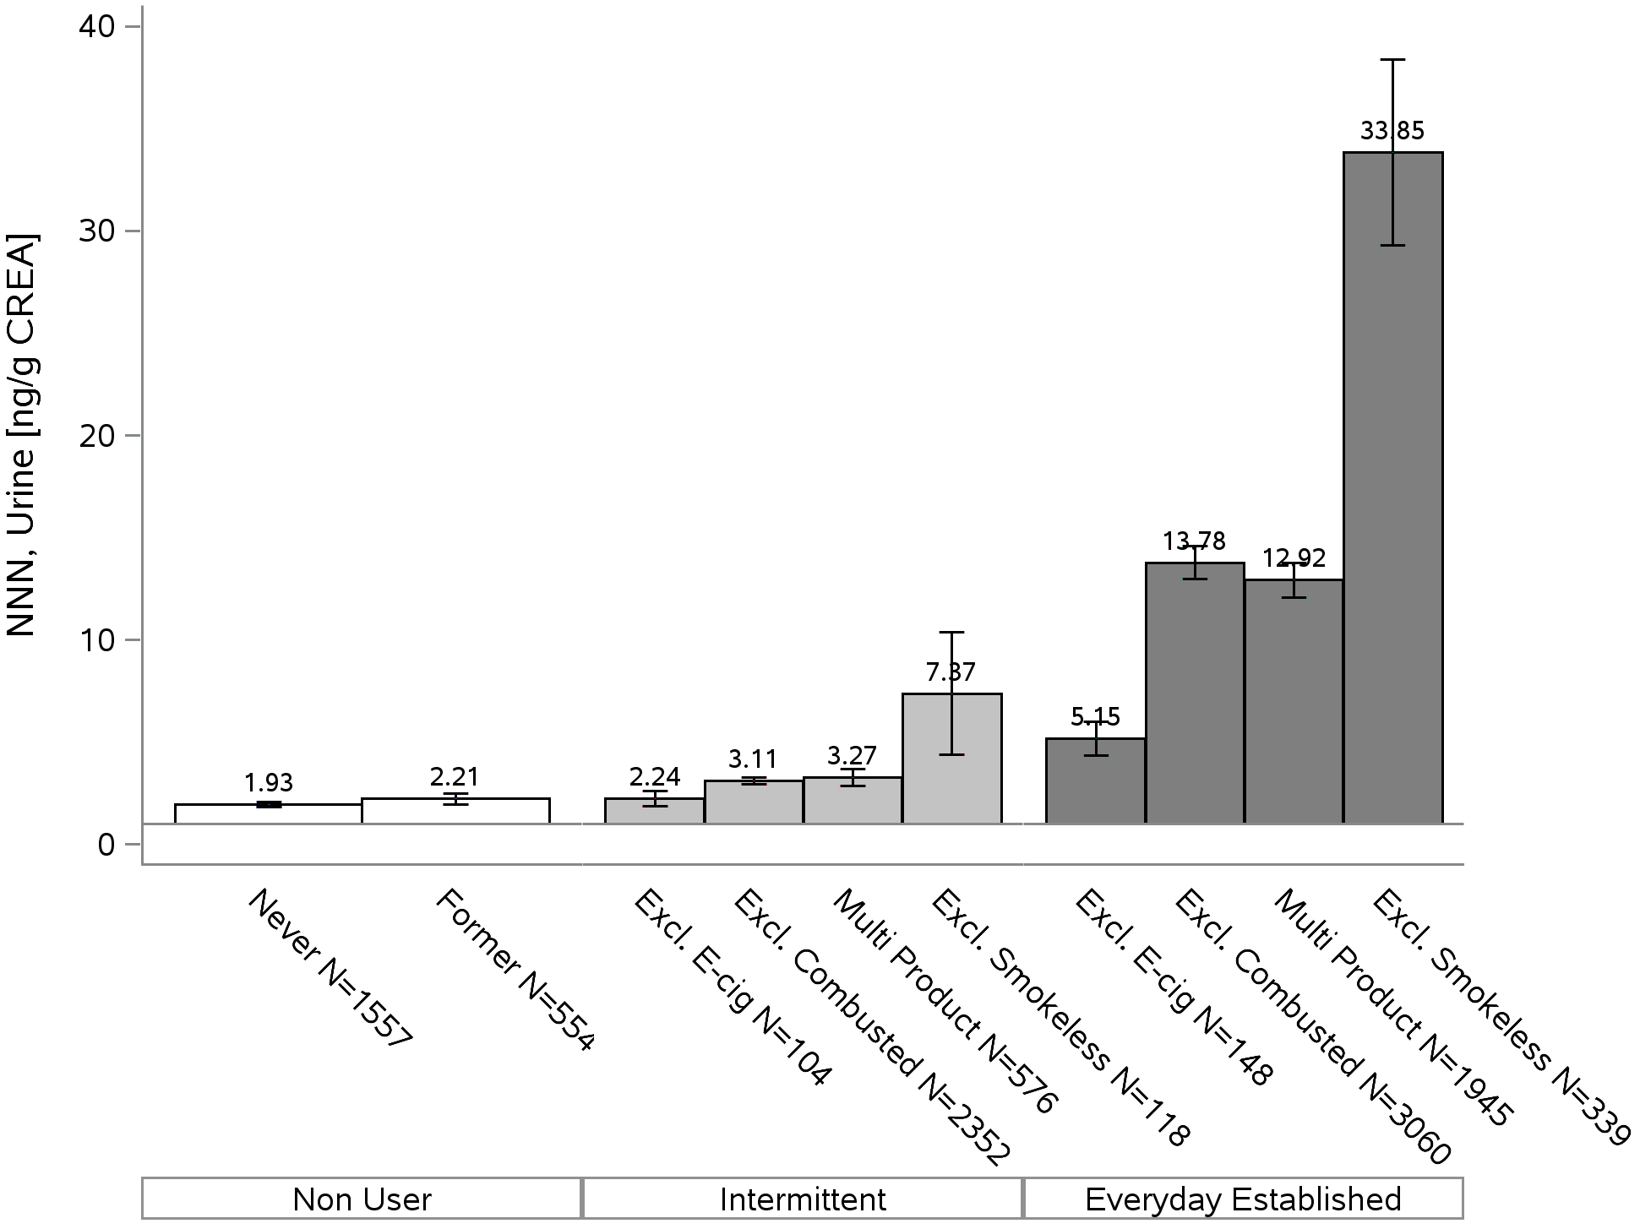
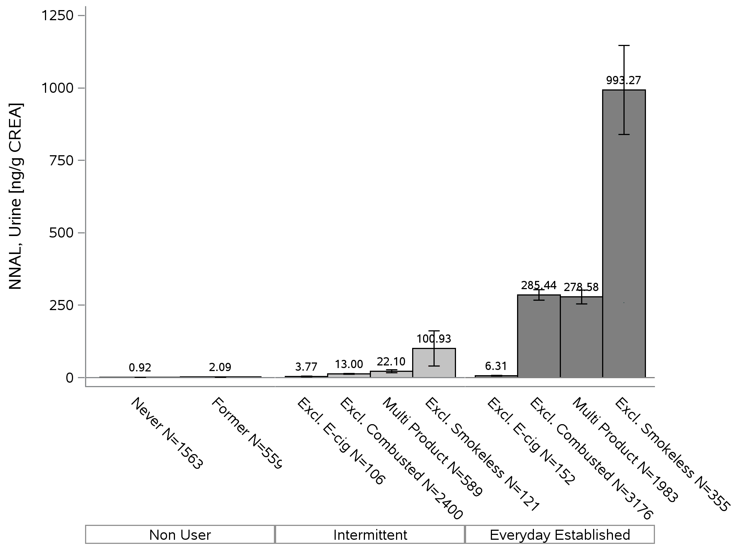
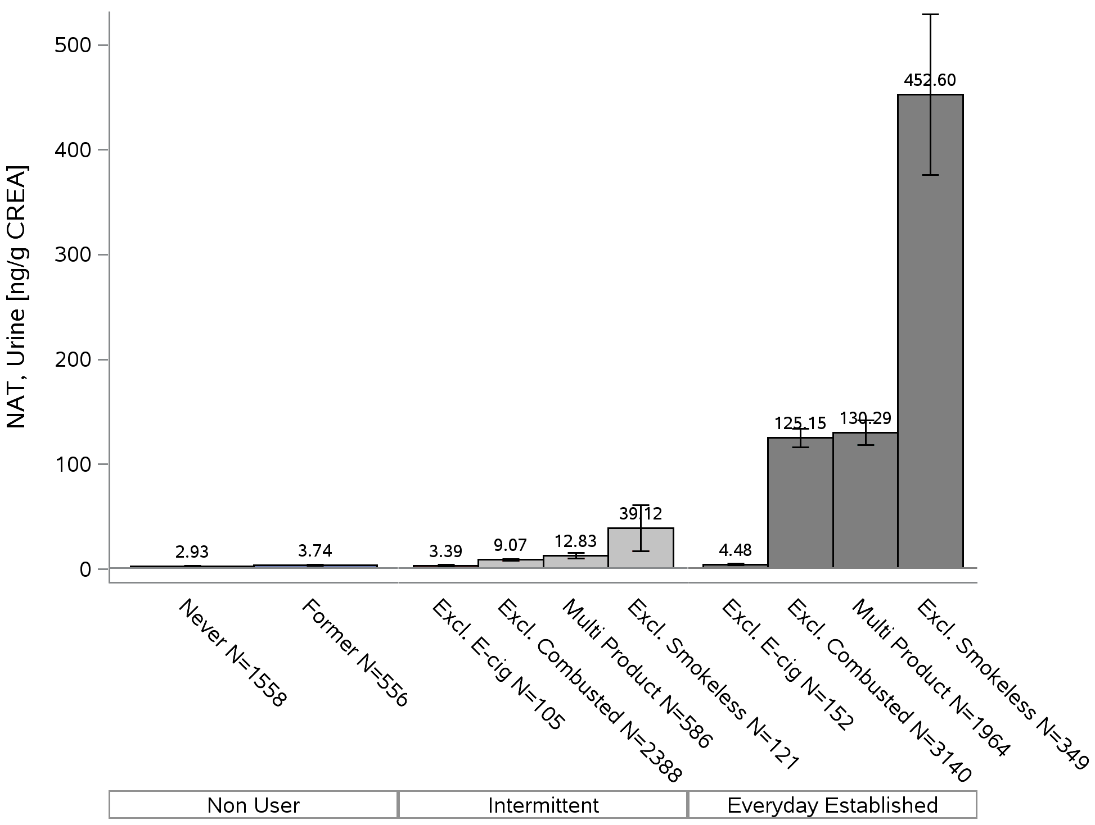
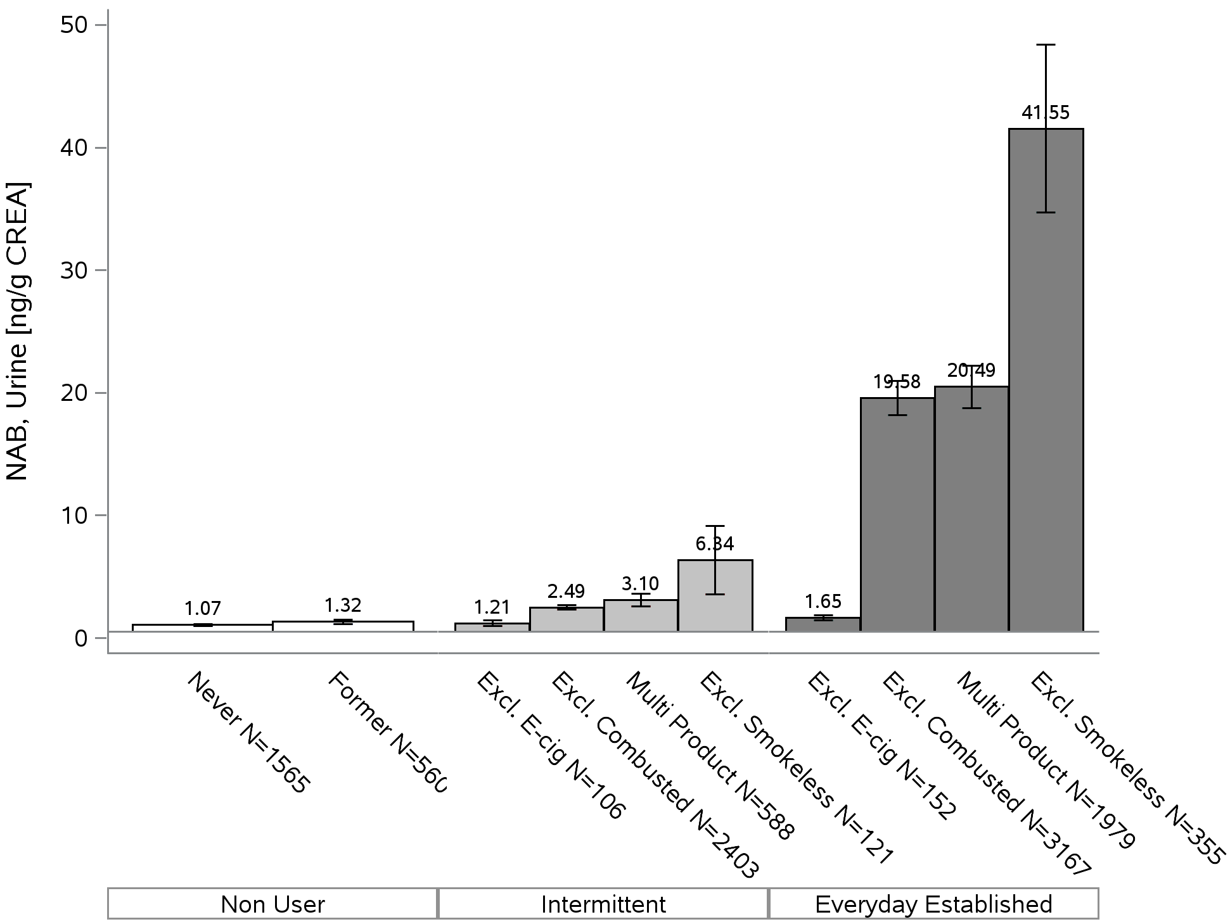
A
B
C
D

Figure S2. Distribution of NNAL among current established every day exclusive users and intermittent exclusive users*.
Every Day Median
Intermittent Exclusive Users
Every Day Exclusive Users
Intermittent Median

(*Distributions and medians are weighted. Darker areas represent overlap in every day and intermittent distributions.)

Figure S3. Scatter plots for TSNAs, COTT and TNE2 for all tobacco users*.
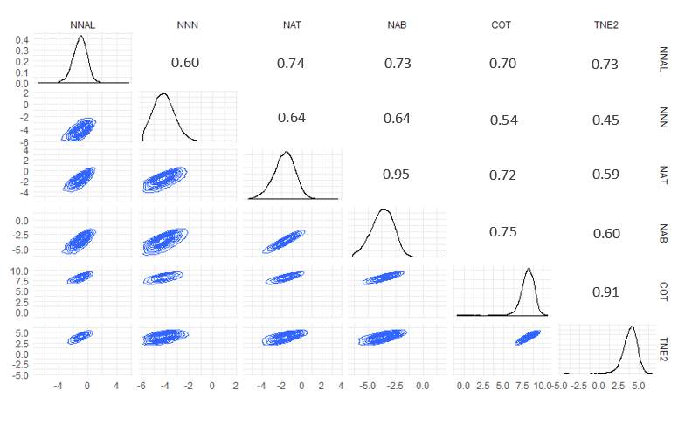

(*numbers in the table are sample-weighted Pearson Correlation Coefficients; all p< 0.001. All concentrations are natural log transformed.)

