Supporting Information:

Multiple Ion Transition Summation of Isotopologues for Improved Mass Spectrometric Detection of N-Acetyl-S-(1,2-dichlorovinyl)-L-cysteine

Cameron S. Movassaghi, Declan P. McCarthy, Deepak Bhandari,* Benjamin C. Blount, Víctor R. De Jesús

Centers for Disease Control and Prevention (CDC)
Division of Laboratory Sciences (DLS), Tobacco and Volatiles Branch (TVB)
Atlanta, GA 30341

Submitted for consideration for publication in the J. Am. Soc. Mass Spectrom.

Running Title: Signal Summing for Improved MS Detection

*Corresponding author:
Deepak Bhandari, Ph.D.
Centers for Disease Control and Prevention
Division of Laboratory Sciences, Tobacco and Volatiles Branch
4770 Buford Hwy NE, MS F-47, Atlanta, GA 30341
Email: dbhandari@cdc.gov
Phone: (770) 488-0939

Address reprint requests to the corresponding author.

Disclaimer: The findings and conclusions in this report are those of the authors and do not necessarily represent the official position of the Centers for Disease Control and Prevention. Use of trade names is for identification purposes only and does not imply endorsement by the Centers for Disease Control and Prevention, the Public Health Service, or the U.S. Department of Health and Human Services.
Supp. Info. 1: Benefits of the MITSI methodology
MITSI has several benefits to alternative signal summing techniques. Primarily, additional stable fragmentation patterns are not required. Since isotopologue ion transitions involve changes in isotopic composition, their measurement only requires shifting the m/z accordingly (e.g., [M – H]⁻ + 2 to measure a ³⁷Cl isotopologue of 1DCV instead of the ³⁵Cl isotopologue of 1DCV). Monitoring a different m/z value theoretically provides increased analyte specificity; interferences and matrix effects that are unique to one transition are not summed, providing a better representation of random noise. This is opposed to summing the same transition repeatedly, in which non-random external or chemical noise can begin to compound, jeopardizing S/N improvements.
Additionally, some data acquisition software will not monitor ion transitions with exactly the same mass and require a difference of at least 0.001 Da [1]. Although this mass difference is negligible for unit and low-resolution modes, it is a potential hindrance for utilizing high-resolution modes for the summation of the same transition. The MITSI method does not suffer from this drawback because different nominal masses are used.
MITSI also has the potential to identify co-eluates by isotopologue ratio. For example, while monitoring the area ratio of the isotopologue transitions, interfering transitions are less likely to have the same isotopic distributions. This is similar to quantification ion/confirmation ion agreement checks that are often utilized in clinical laboratories [2]. SRM2 (m/z 258 129) is currently used in our validated method as our confirmation transition while SRM1 (m/z 256 127) is our quantification transition for 1DCV [3]. For this reason, we do not explore achieving identical ion counting times as done in Pauwels et al. [4]; we are not adding an additional transition to our acquisition method, but rather summing two transitions already in the method, post-acquisition.
Furthermore, mass spectrometer manufacturers such as SCIEX recommend alternating different masses in between isobaric ion transitions to avoid cross-talk [5]. We predict our method to be more reliable than those methods that monitor replicate transitions since we monitor varying isotopologue masses.
As a benefit common to all signal summation methods, there is increased ease of integration. Time to manually integrate near-LOD peaks should decrease significantly while accuracy of peak picking algorithms should increase.
Lastly, computation speeds and mass spectrometer electronic switching times are becoming faster and more efficient. This affords possibilities for increased numbers of scans to be summed, and thus, even greater S/N increases. MITSI could increase the sensitivity of high resolution instruments by summing many high mass-resolution transitions together.

Supp. Info. 2: Guide to creating a sum multiple ions quantitation method using MultiQuant software [6]
- Once the data of interest, including any transitions to be summed, has been acquired, open the MultiQuant software. Make sure the most recent version is installed (at least 3.0.2 or beyond to include Sum Multiple Ions HotFix 1). | 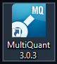
- Create a new results table by selecting the wand button, or by holding Ctrl+N.

- When prompted, browse for the folder containing the data files of interest and select it. Press OK. | 
- Select the .wiff data files to be analyzed, and press the right arrow (=>) to move them to the Selected column. | 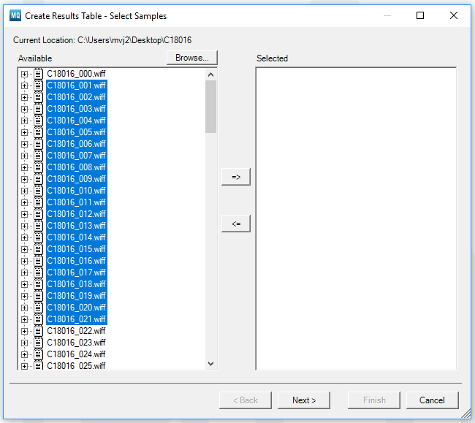
- Ensure all necessary data files have been selected and press Next >. | 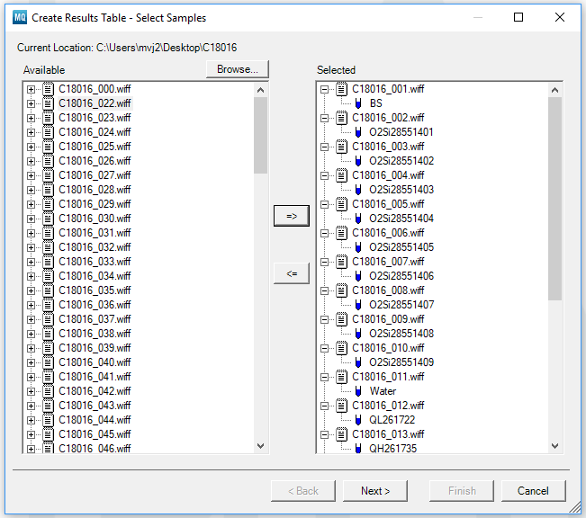
- If creating a method for the first time, select Create New Method. If editing an existing method to add a summed ion transition, select the method and hit Finish; then, reopen the quantitation method and skip to Step 9. | 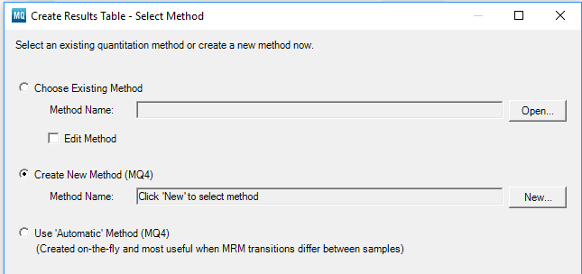
- When prompted, name the new quantitation method and press Save. | 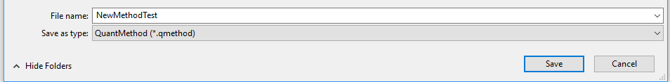
- Select a representative chromatogram to edit the user integration defaults. Press Next >. | 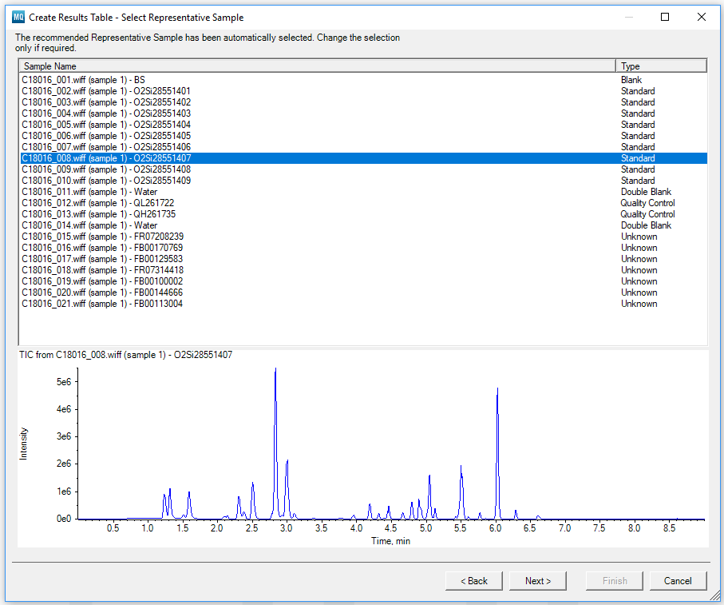
- Right-click and select Sum Multiple Ions from the drop-down. | 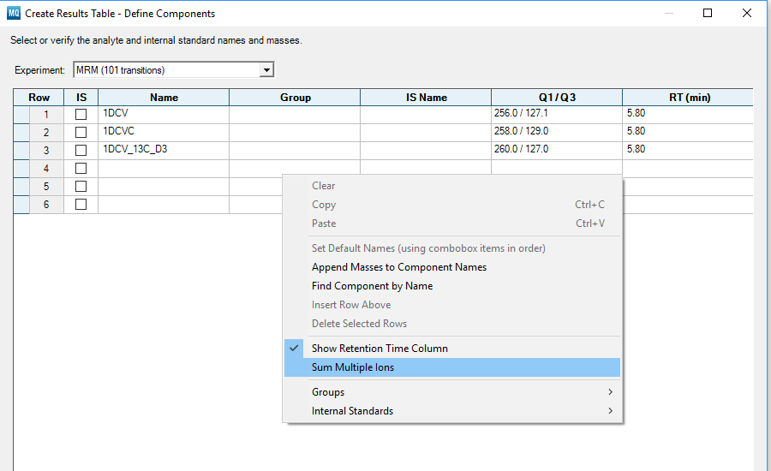
- Select the correct corresponding values for the data and method, such as internal standards (IS), compound names, compound groups, IS name, retention time, and ion transition (Q1/Q3-1). For those transitions to be summed, create an additional row with the summed ion transition name (e.g. 1DCV_SUM) and select the additional transition(s) to be summed (i.e. Q1/Q3-1, Q1/Q3-2, Q1/Q3-3...up to 10 if needed; additional columns may be added if more than 10 are needed). Click Next >. | 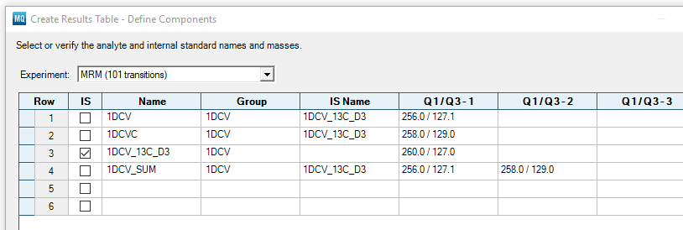
- Set up user integration defaults. These can be edited at a later time. | 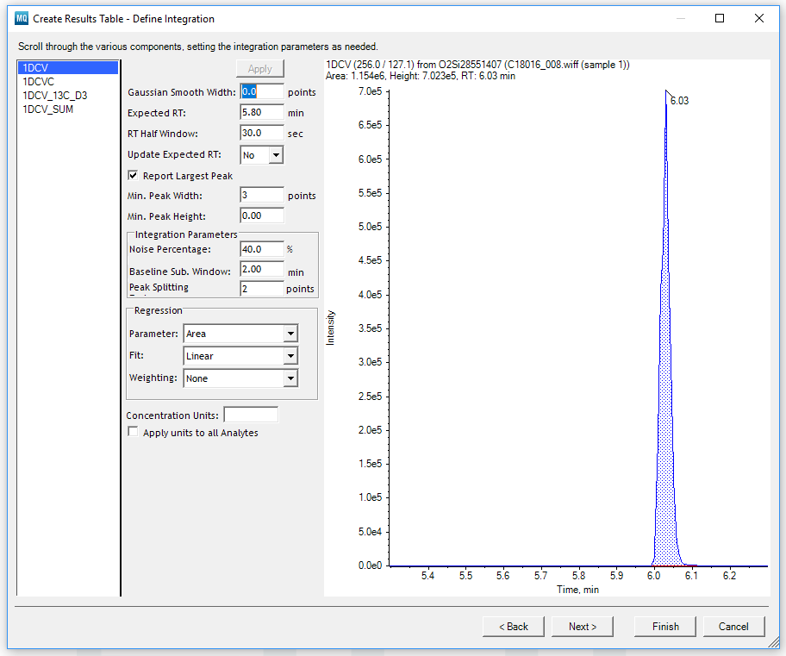
- Set up outlier settings. These can be edited at a later time. Press Finish. | 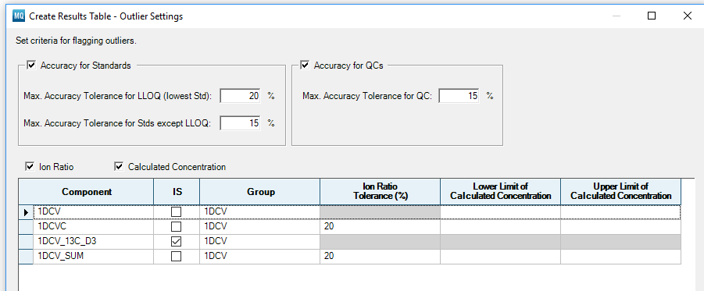
- Allow time for integration of all samples. All transitions, including sums of multiple ions, should be showing. If not, open and edit the quantitation method to ensure all steps were correctly followed. Alternatively, ensure correct version and installation of the software, or contact the software vendor for assistance. | 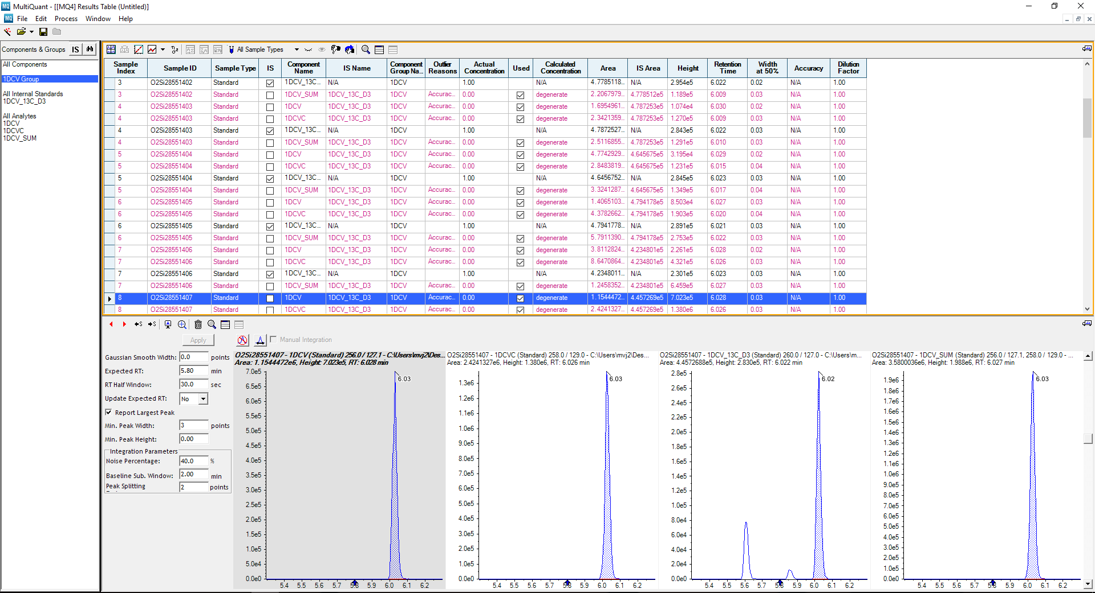

Supp. Info. 3: Supporting Tables & Figures

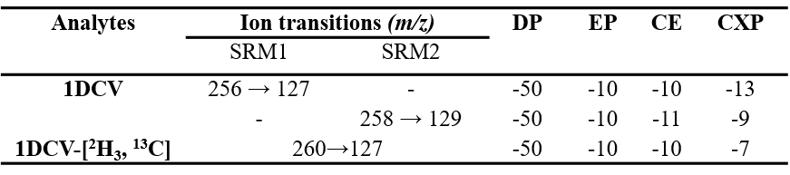
Supporting Table 1. Compound-specific mass spectrometric parameters for 1DCV.
*DP = declustering potential; EP = entrance potential; CE = collision energy; CXP = cell exit potential

Supporting Table 2. Average chromatographic peak area counts for two different QC materials, separated by ion transition and integration algorithm (N = 20).

Supporting Table 3. Average percent chromatographic peak area increases for the summed transition relative to the individual transitions, across two different QC materials, separated by ion transition and integration algorithm (N = 20).

Supporting Table 4. Average signal-to-noise ratios (S/N) with standard error of the mean for two different QC materials, separated by ion transition and integration algorithm (N = 20).

Supporting Table 5. Integration parameters for each integration algorithm used.

Supporting Table 6. Expected and actual percent signal-to-noise ratio enhancement factors (EFs)* for QC-1 and QC-2.

Supp. Info. 4: Derivation of the $\sqrt{n}$ proportion and MITSI-modified Equation
It is essential to investigate the applicability of the theorized $\sqrt{n}$ increase in S/N when summing n signals and how this may apply to MITSI.
If total summed signal ($S_{n}$) is the summation of some amount (n) of individually reproducible signals (S_{i}), then total noise ($N_{n}$) is the summation of its additive variance ${{(σ}_{N}}^{2})$across those signals [7]. Relating signal to a dc waveform, its summation is directly proportional to the number of signals added (Equation 1) [8].
$S_{n}=\sum_{i=1}^{n}{S_{i}}=n∙S_{i}$ (1)
Noise is assumed to be an ac waveform. Its sum is proportional to its root-mean-square value instead of its mean-square value (Equation 2) [7].
$N_{n}=\sqrt{\sum_{i=1}^{n}{{{(σ}_{N})}^{2}}}=\sqrt{n∙{{(σ}_{N})}^{2}}$ (2)
Equation 2 is the standard deviation of the noise – S/N is the quotient of mean signal divided by standard deviation (i.e., the inverse of relative standard deviation). Greater S/N values are associated with increases in precision because of these decreases in RSD [7]. To find S/N of n summed measurements,${\left(\frac{S}{N}\right)}_{n}$, as it relates to the individual ratio, ($\frac{S_{i}}{σ_{N}}$), Equation 1 is divided by Equation 2 to yield Equation 3. Thus, the $\sqrt{n}$ proportion is derived (Equation 3) [9].
${\left(\frac{S}{N}\right)}_{n}=\frac{n∙S_{i}}{\sqrt{n∙{{(σ}_{N})}^{2}}}=\sqrt{n}∙\frac{S_{i}}{σ_{N}}$ (3)
A modification needs to be made to Equation 3 as it applies to MITSI. Because we are not summing duplicate signals as assumed in the above derivation, but rather related signals of varying intensity, Equation 1 is modified thusly to fit the context of MITSI (Equation 4):
$S_{n}=\sum_{i=1}^{n}{{A_{i}S}_{R}}=S_{R}(A_{1}+A_{2}+…A_{i})$ (4)
where S_{R} is the signal of a relative ion transition and A_{i} is the relative abundance of the ion transitions to be summed. This does not change Equation 2, as noise is unaffected by signal. Dividing Equation 4 by Equation 2 yields Equation 5, which describes the theorized S/N enhancement for MITSI-applications such that:
${\left(\frac{S}{N}\right)}_{n}=\frac{S_{R}(A_{1}+A_{2}+…A_{i})}{\sqrt{n}{∙σ}_{N}}=\frac{(A_{1}+A_{2}+…A_{i})}{\sqrt{n}}∙\frac{S_{R}}{σ_{N}}$ (5)

References

1. Swamy, J., Kamath, N., Shekar, A., Srinivas, N., Kristjansson, F.: Sensitivity enhancement and matrix effect evaluation during summation of multiple transition pairs—case studies of clopidogrel and ramiprilat. Biomedical Chromatography. 24, 528-534 (2010)
2. Honour, J.W.: Development and validation of a quantitative assay based on tandem mass spectrometry. Annals of Clinical Biochemistry. 48, 97-111 (2011)
3. Alwis, K.U., Blount, B.C., Britt, A.S., Patel, D., Ashley, D.L.: Simultaneous analysis of 28 urinary VOC metabolites using ultra high performance liquid chromatography coupled with electrospray ionization tandem mass spectrometry (UPLC-ESI/MSMS). Analytica Chimica Acta. 750, 152-160 (2012)
4. Pauwels, S., Jans, I., Peersman, N., Billen, J., Vanderschueren, D., Desmet, K., Vermeersch, P.: Possibilities and limitations of signal summing for an immunosuppressant LC-MS/MS method. Anal. and Bioanal. Chem. 407, 6191-6199 (2015)
5. SCIEX. Analyst® 1.6.3 software user guide. https://sciex.com/Documents/manuals/selexion-selexion-plus-5500-6500-6500plus-user-guide-en.pdf. Accessed October 2018
6. SCIEX. MultiQuant software reference guide. https://sciex.com/documents/community/support/mq-glp-software-reference-guide.pdf. Accessed October 2018
7. Hieftje, G.M.: Signal-to-noise enhancement through instrumental techniques: Part I. Signals, noise, and S/N enhancement in the frequency domain. Anal. Chem. 44, 81A-88A (1972)
8. Hieftje, G.M.: Signal-to-noise enhancement through instrumental techniques. Part II. Signal averaging, boxcar integration, and correlation techniques. Anal. Chem. 44, 69A-78A (1972)
9. Hassan, U., Anwar, M.: Reducing noise by repetition: introduction to signal averaging. European Journal of Physics. 31, 453-465 (2010)

