Effect of an office-based intervention on visceral adipose tissue: The WorkACTIVE-P randomized controlled trial
Supplementary material
James L. Dorling Ph.D.¹, Christoph Höchsmann Ph.D.¹, Catrine Tudor-Locke Ph.D.^{1,2}, Robbie Beyl Ph.D.¹, Corby K. Martin Ph.D¹.
¹Pennington Biomedical Research Center, Baton Rouge, Louisiana, USA
²University of North Carolina Charlotte, Charlotte, North Carolina, USA (Present affiliation)

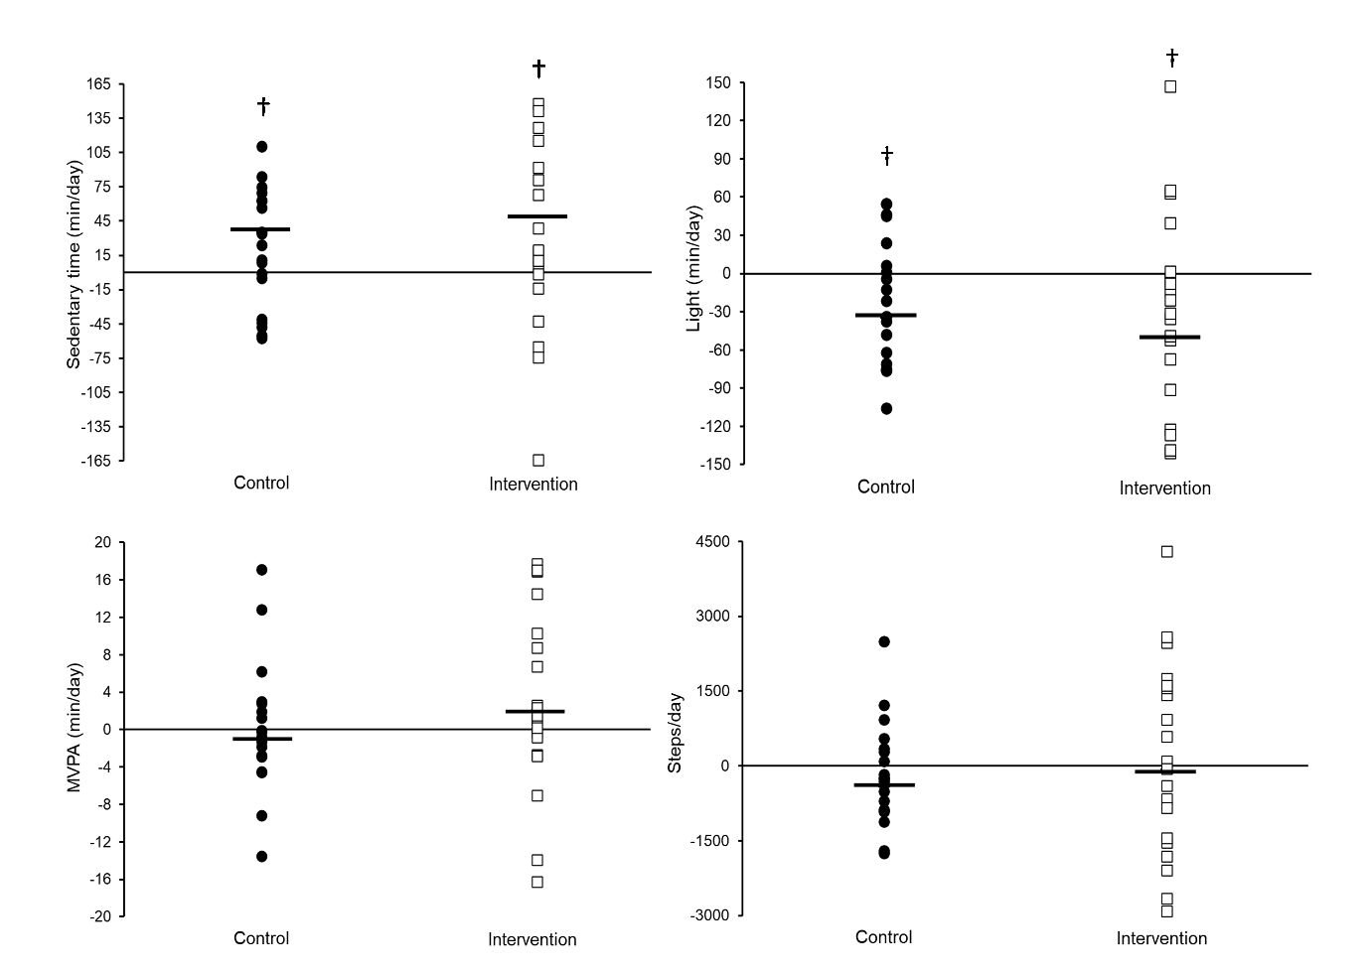
Figure S1. Individual change scores in physical activity and sedentary time within the control and intervention groups. Horizontal lines are least square means. †Significant within-group difference pre- versus post-intervention (P < 0.05).

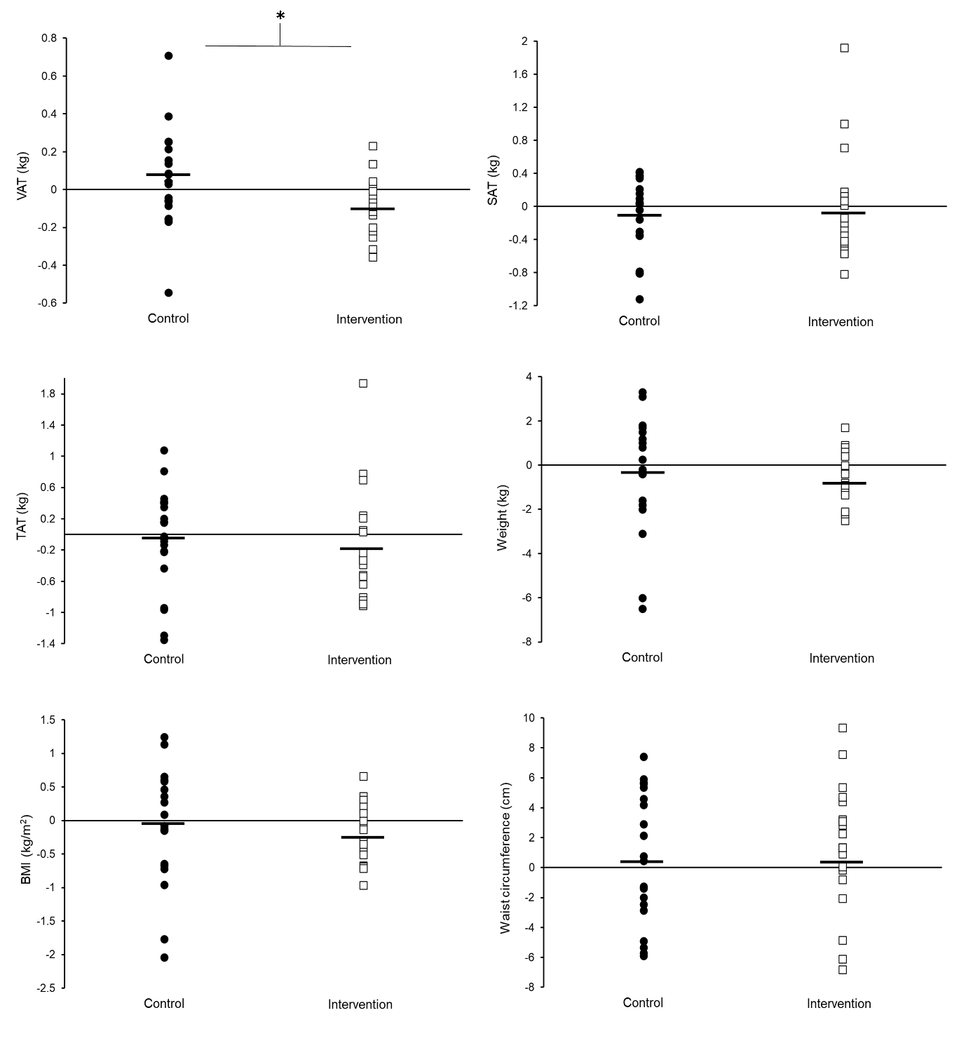
Figure S2. Individual change scores in adipose tissue and anthropometry within the control and intervention groups. Horizontal lines are least square means. *Significant difference between control and intervention group (P < 0.05). †Significant within-group difference pre- versus post-intervention (P < 0.05).

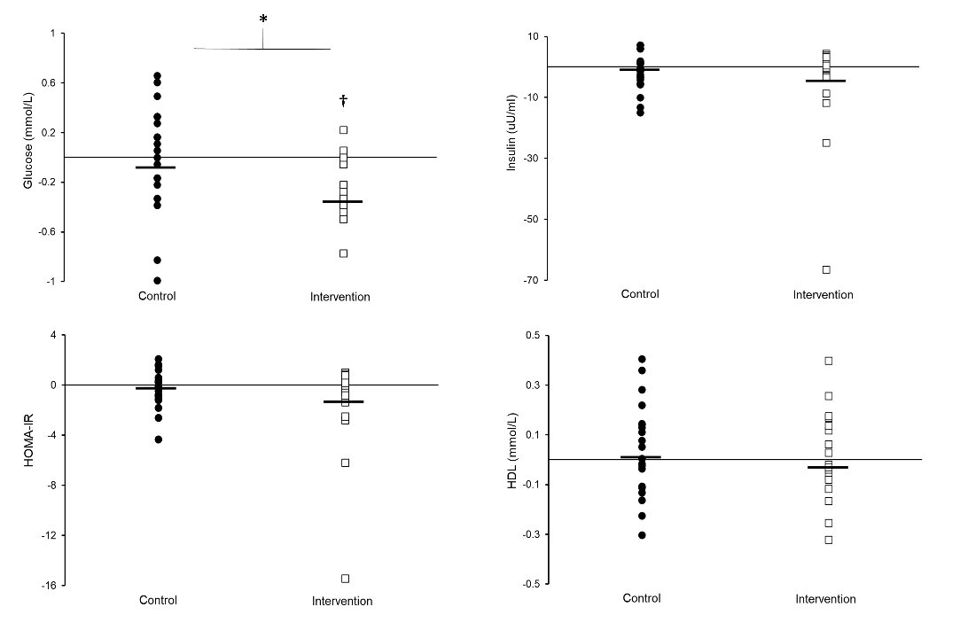
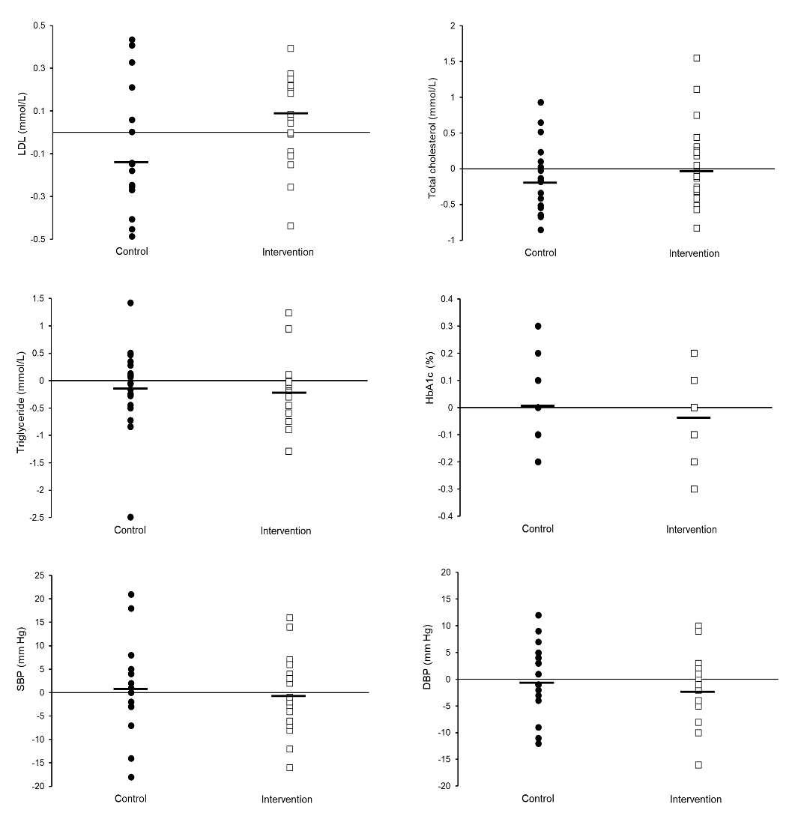
Figure S3. Individual change scores in cardiometabolic disease risk factors within the control and intervention groups. Horizontal lines are least square means. *Significant difference between control and intervention group (P < 0.05). †Significant within-group difference pre- versus post-intervention (P < 0.05).

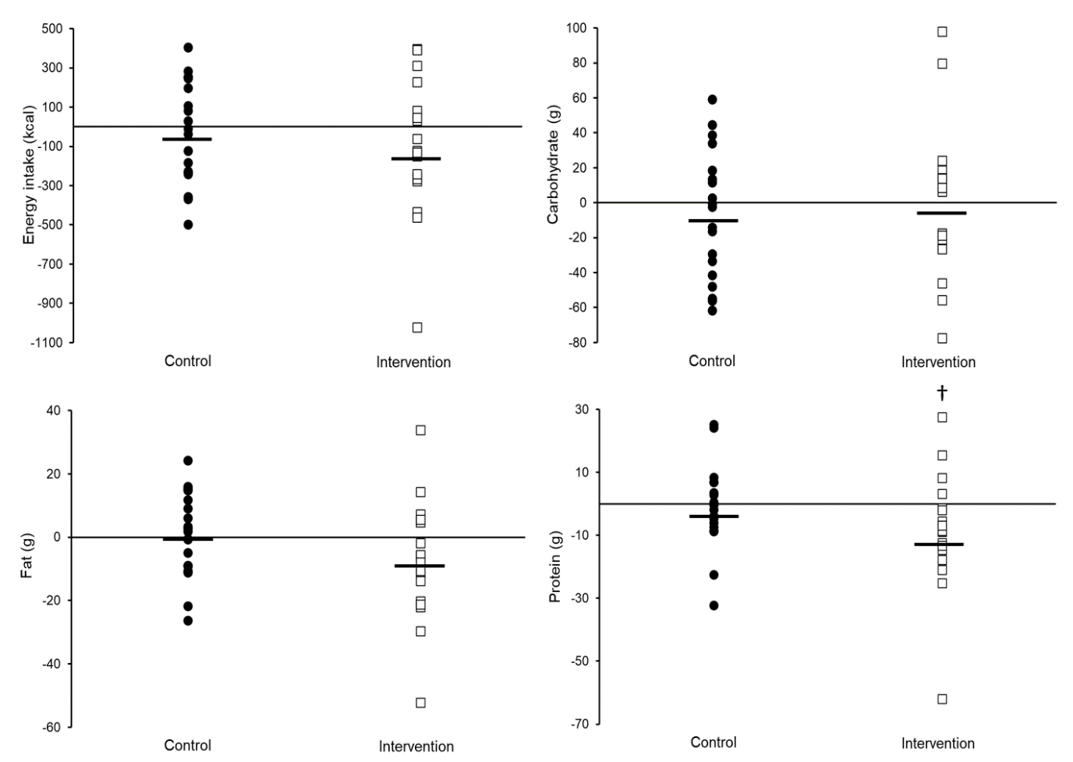
Figure S4. Individual change scores in food intake within the control and intervention groups. Horizontal lines are least square means. †Significant within-group difference pre- versus post-intervention (P < 0.05).

