Supplement for COVID-19 clinical phenotypes: presentation and temporal progression of disease in a cohort of hospitalized adults in Georgia, United States
Supplemental methods
Supplementary table 1: Bacterial, fungal and viral co-infections and antimicrobial use among adults hospitalized with COVID-19 (N = 305) — Georgia, United States, March 2020
Supplementary table 2: Treatments and infectious complications by cluster among adults hospitalized with COVID-19 (N = 305) — Georgia, United States, March 2020
Supplementary table 3: Median, 25th, and 75th, values and observations of repeated laboratory and vital sign measures by hospital length of stay among adults hospitalized with COVID-19 (N = 305) —Georgia, United States, March 2020
Supplementary table 4: Discharge disposition and causes of death among adults hospitalized with COVID-19 (N = 305) — Georgia, United States, March 2020
Supplement figure 1: Selected vital signs and laboratory values among adults hospitalized with COVID-19 by phenotype (n = 240) — Georgia, United States, March 2020

Supplemental materials:
Supplemental methods
To facilitate clustering analyses, missing data were imputed using a single stochastic imputation that used the clustering variables plus hospital site, use of renal replacement therapy (RRT) for AKI, invasive mechanical ventilation (IMV), and death.¹ The median proportion of imputed data per patient was 11.8%, and all imputed values were removed after clustering for subsequent analysis and visualization.
Presence of comorbidities, symptoms, and complications were considered as binary asymmetric variables, sex was considered as a categorical nominal variable, and numeric variables were considered as interval scaled variables. The final dissimilarity between observations is a weighted sum of dissimilarities for each variable.
The optimal number of clusters was selected by considering average, median, and maximum single-cluster silhouette scores², which measure the coherence of observations in clusters by comparing the similarity of observations within a cluster with observations in other clusters.

Supplementary table 1: Bacterial, fungal and viral co-infections and antimicrobial use among adults hospitalized with COVID-19 (N = 305) — Georgia, United States, March 2020
Characteristic | freq. (%)
Any coinfection | 29 (9.5)
Bacteremia/fungemia | 8 (2.6)
Staphylococcus aureus | 1 (12.5)
Other Staphylococcus spp. | 4 (50)
Candida albicans | 1 (12.5)
Pseudomonas aeruginosa | 1 (12.5)
Unspecified bacterial pathogen | 1 (12.5)
Pneumonia* | 13 (4.3)
Staphylococcus aureus | 3 (21.4)
Pseudomonas aeruginosa | 1 (7.7)
Klebsiella spp. | 4 (28.6)
Hemophilus influenzae | 3 (21.4)
Legionella antigen (n tested = 74) | 0 (0)
Streptococcus pneumoniae antigen (n tested = 15) | 0 (0)
Other | 3 (21.4)
Unspecified bacterial pathogen | 1 (7.1)
Other infections | 6 (2.0)
Clostridioides difficile | 1 (0.3)
Urinary tract infection** | 4 (1.3)
Antimicrobial administration | Total | Non-ICU | ICU
<48 hours after admission | 256/271 (94.5) | 145/159 (91.2) | 111/112 (99.1)
≥48 hours after admission | 99/192 (51.6) | 27/96 (28.1) | 72/96 (75.0)
Viral coinfections
Influenza (number tested = 283) | 8 (2.9)
Respiratory syncytial virus (n tested = 181) | 0 (0)
Rhinovirus spp./ Enterovirus spp. (number tested = 50) | 2 (4.0)
*Pathogens may add up to more than total infections because some patients had >1 pathogen present in respiratory cultures
** Urinary tract infections: E. coli (n=2), Enterococcus faecalis (n=1) and unspecified bacterial pathogen (n=1)

Supplementary table 2: Treatments and infectious complications by cluster among adults hospitalized with COVID-19 (N = 305) — Georgia, United States, March 2020
Treatments | Cluster A (n=53) | Cluster B (n=34) | Cluster C (n=39) | Cluster D (n=29) | Cluster E (n=61) | Cluster F (n=71)
Corticosteroid | 21% | 24% | 13% | 24% | 11% | 10%
Any antibiotics | 96% | 93% | 91% | 96% | 82% | 93%
<48 hours after admission | 100% | 93% | 92% | 92% | 92% | 94%
≥48 hours after admission | 87% | 38% | 41% | 33% | 41% | 33%
Remdesivir | 11% | 15% | 5% | 3% | 5% | 11%
Hydroxychloroquine | 70% | 38% | 44% | 24% | 30% | 28%
Azithromycin | 83% | 68% | 62% | 59% | 54% | 69%
Lopinavir/ritonavir | 24% | 11% | 0% | 43% | 0% | 0%
Oseltamivir | 32% | 13% | 7% | 33% | 9% | 11%
Baloxavir/marboxil | 0% | 0% | 0% | 0% | 0% | 0%
Ribavirin | 0% | 0% | 0% | 0% | 0% | 0%
Tocilizumab | 0% | 0% | 0% | 0% | 0% | 0%
Sarilumab | 0% | 0% | 0% | 0% | 0% | 0%
NSAIDs | 27% | 20% | 20% | 17% | 33% | 46%
Interferon alpha | 0% | 0% | 0% | 0% | 0% | 0%
Interferon beta | 0% | 0% | 0% | 0% | 0% | 0%
Antifungal | 37% | 14% | 7% | 0% | 10% | 0%
Inhaled nitrous oxide | 0% | 0% | 0% | 0% | 0% | 0%
Epoprostenol | 35% | 14% | 0% | 0% | 10% | 0%
Aspirin | 62% | 45% | 27% | 50% | 53% | 12%
Outcomes
Bacterial coinfection | 26% | 12% | 8% | 17% | 2% | 0%
Ventilator-associated pneumonia | 6% | 0% | 0% | 0% | 0% | 0%

Supplementary table 3: Median, 25th, and 75th, values and observations of repeated laboratory and vital sign measures by hospital length of stay among adults hospitalized with COVID-19 (N = 305) —Georgia, United States, March 2020
Laboratory value | Value, median (IQR) | Observations per patient, median (IQR)
Laboratory value | Value, median (IQR) | LOS < 3 days | LOS ≥ 3 days
Temperature (Celsius) | 37 (36.7–37.6) | 8 (6.25–8) | 28 (14–67.75)
Respiratory rate (/min) | 22 (18–26) | 11 (8–26) | 42.5 (21–140.75)
Heart rate (/min) | 88 (75–100) | 11.5 (8.25–25.5) | 44 (21.5–183.5)
Mean arterial pressure (mmHg) | 84 (75–95) | 10 (8.25–22.5) | 41.5 (20.25–174.75)
White blood cell count (10⁹/L) | 7.8 (5.4–11.3) | 2 (1–2) | 7 (4–14)
Absolute lymphocyte count (10⁹/L) | 1.1 (0.8–1.5) | 2 (1–2) | 3 (2–8)
Absolute neutrophil count (10⁹/L) | 5.6 (3.5–8.6) | 2 (1–2) | 3 (2–8)
Alkaline phosphatase (IU/L) | 64 (48–87) | 2 (1–2) | 5 (2–12)
Alanine aminotransferase (U/L) | 32 (19–63) | 2 (1–2) | 5 (2–12)
Aspartate aminotransferase (U/L) | 40 (26–73) | 2 (1–2) | 5 (2–12)
Total bilirubin (mg/dL) | 0.5 (0.4–0.8) | 2 (1–2) | 5 (2–12)
Blood urea nitrogen (mg/dL) | 19 (12–37) | 2 (1–3.75) | 8 (4–16)
Creatinine (mg/dL) | 1.1 (0.8–1.7) | 2 (1–3.75) | 8 (4–16)
C-reactive protein (mg/L) | 146.9 (80.9–239) | 1 (1–1) | 5 (2–10)
Lactate dehydrogenase (U/L) | 334 (265–439) | 1 (1–1) | 4.5 (2–10.25)
D-dimer (mcg/mL FEU) | 4349 (1535.5–13304.5) | 1 (1–1) | 5 (1–11)
Abbreviations: LOS, length of stay; IQR, interquartile range

Supplementary table 4: Discharge disposition and causes of death among adults hospitalized with COVID-19 (N = 305) — Georgia, United States, March 2020
 | n (%)
Discharge disposition
Discharged to pre-hospital level of care | 205 (67.2)
Discharged to higher level of care compared with pre-hospital baseline | 38 (12.5)
Discharged, baseline level of care unknown | 3 (1.0)
Deceased | 51 (16.7)
Still hospitalized | 8 (2.6)
Discharged with home health services | 20 (6.6)
Discharged to hospice | 5 (1.6)
New oxygen requirement at discharge | 37 (12.1)
New dialysis requirement at discharge | 6 (2.0)
Primary cause of death (n = 51)
Respiratory failure | 26 (51.0)
Multiorgan failure/Shock | 13 (25.5)
Other | 2 (3.9)
Unspecified | 10 (19.6)

Supplement figure 1: Selected vital signs and laboratory values among adults hospitalized with COVID-19 by phenotype (n = 240) — Georgia, United States, March 2020
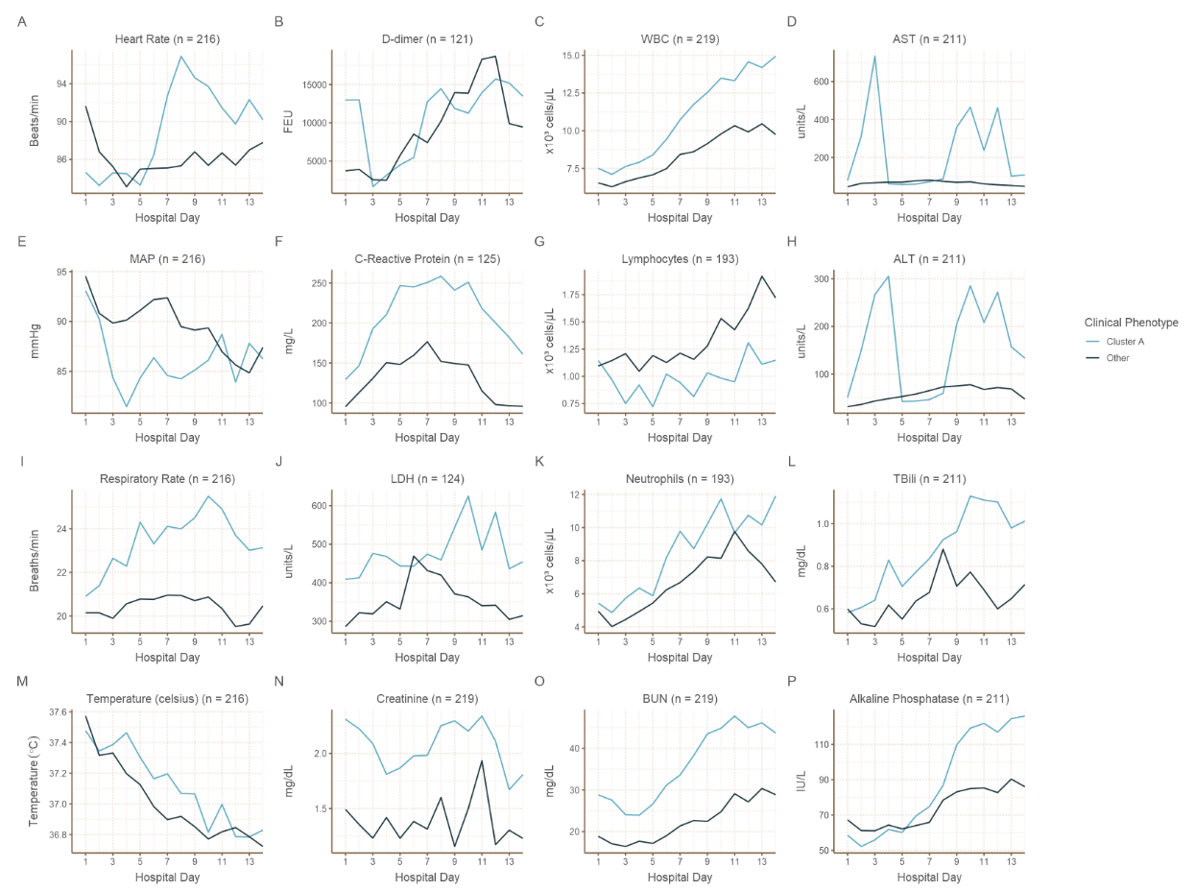
The average daily value among patients in Cluster A versus other clusters is shown for laboratory values and vital signs. For patients with multiple observations per day, the average is weighted inversely by the number of observations per patient per day.
Abbreviations: AST, aspartate aminotransferase; ALT, alanine aminotransferase; BUN, blood urea nitrogen; COVID-19, coronavirus disease 2019; LDH, lactate dehydrogenase; MAP, mean arterial pressure; TBili, total bilirubin; WBC, white blood cell count

Supplemental References
1. van Buuren S, Groothuis-Oudshoorn K. mice: Multivariate Imputation by Chained Equations in R. 2011. 2011;45(3):67 %J Journal of Statistical Software.
2. Rousseeuw PJ. Silhouettes: A graphical aid to the interpretation and validation of cluster analysis. Journal of Computational and Applied Mathematics. 1987;20:53-65.

