**Technical Appendix for Kalkowska et al: “Modeling undetected live poliovirus circulation after apparent interruption of transmission: Pakistan and Afghanistan”**

**A1: Brief description of the Pakistan and Afghanistan published model used as the basis for this work (Duintjer Tebbens et al., 2018)**

The following text briefly describes the model, based on the appendix of a prior publication (with references renumbered) (Duintjer Tebbens & Thompson, 2017). Figures A1-2 provide the model structure and Table A1 describes the generic inputs of the model (i.e., inputs that remain the same for any population).

“The differential equation-based poliovirus transmission and OPV evolution model (DEB model) (Duintjer Tebbens, Pallansch, Kalkowska, et al., 2013) tracks the movement of people between demographic age groups (grouped into mixing age groups that mix preferentially amongst themselves), and for each serotype between oropharyngeal and intestinal infection stages (resulting in potential oropharyngeal and fecal-oral transmission, respectively), immunity states, and waning stages. Figure A1 provides an overview of the model structure based on prior work (Duintjer Tebbens, Pallansch, Kalkowska, et al., 2013). Figure A1a depicts the immunity states with the flows that move individuals in and out of them and Figure A1b details how effectively vaccinated or infected individuals progress through different stages of infection and, in the event of infection with OPV, through OPV evolution stages. The model assumes that active immunity from prior vaccination or infection results in permanent protection from polio (disease), but only partial protection from subsequent infection and participation in transmission, depending on the nature of immunity (IPV-induced vs. LPV-induced or both) and time since the last exposure (i.e. waning stage). The model includes 5 waning stages, 6 fecal-oral and 6 oropharyngeal infection stages (2 latent and 4 infectious, with varying degrees of infectiousness), and also accounts for a delay between IPV receipt and development of the immune response that moves individuals to the next IPV immunity state. In Figure A1a, we note that the model assumes identical properties for “IPV and LPV” and “≥ 2 LPV infections” and that the recent waning stages of these immunity states represent the highest degree of immunity to transmission in the model. The model further tracks OPV evolution by moving individuals infected with the OPV parent strain (stage 0) through 20 successive reversion stages that can each transmit and that come with increasing paralysis-to-infection ratios and relative basic reproduction numbers (R0 values) compared to homotypic WPVs. The last reversion stage (stage 19) represents fully-reverted VDPVs with assumed paralysis-to-infection ratio and R0 equivalent to homotypic WPVs. For WPVs or any OPV reversion stage, the DEB model mimics die-out by setting the force-of-infection for the given strain to 0 whenever its effective prevalence of infections resides below a calibrated threshold of 5 per million people. Consequently, OPV-related viruses can only continue to transmit and thus evolve to cVDPVs through successive infections when low enough population immunity to transmission permits circulation of the OPV viruses introduced in the population through vaccination. We fixed the die-out process, model structure, and numerical model inputs that characterize them across all populations we modeled and Table A1 includes the corresponding generic model inputs. […]”

“Figure A2 summarizes the results of the model calibration process, based on prior work (Duintjer Tebbens, Pallansch, Kalkowska, et al., 2013). With the generic model inputs from Table A1 fixed, we compared our model behavior against i) data on children with non-polio acute flaccid paralysis who reported no receipt of OPV for northern India (modeled separately for Western Uttar Pradesh (WUP) and Bihar) and northwest (NW) Nigeria; ii) data on polio incidence and die-out of endemic WPV transmission for all situations and serotypes (shown in Figure A2 for WPV1 and WPV3 in northern India and northwest Nigeria and for all 3 WPV serotypes in the USA); iii) data from WPV importation outbreak behavior in the Netherlands, Tajikistan, and Albania; iv) data on age distributions of cases for all situations in which meaningful data was available (shown in Figure A2 for the Netherlands, Tajikistan, and Albania); v) available serogical data on the effect of secondary OPV immunity in the USA and Cuba (not shown); vi) indigenous emergence of cVDPVs (shown in Figure A2 for northern India, NW Nigeria (both serotype 2), Haiti, and Madura in Indonesia (both serotype 1); and vii) no indigenous emergence of cVDPVs in all other situations and serotypes (die-out of serotype 1 OPV-related viruses shows in Figure A2 for Cuba and Haiti). We subsequently applied the model to successfully reproduce the asymptomatic transmission of an imported WPV1 in Israel in 2013 (Kalkowska, Duintjer Tebbens, Grotto, et al., 2015)” (also see online supplement pages 1-2 of (Duintjer Tebbens & Thompson, 2017, online supplement pp. 1-2))

**A2: Increased vaccination coverage in under-vaccinated sub-populations of two alternative serotype 1 scenarios**

As mentioned in the main text, since WPV1 transmission does not die out in the deterministic model on the current path(Duintjer Tebbens et al., 2018), we choose two alternative serotype 1 scenarios by increasing relative SIA coverage in the two under-vaccinated subpopulations by 0.15 (“increased relative SIA coverage 0.15”) and 0.20 (“increased relative SIA coverage 0.20”), from 2018 onward. Table A2 presents SIA coverages as the result of this increase.

**A3: Transformation from deterministic model to stochastic model (Kalkowska, Duintjer Tebbens, Pallansch, et al., 2015) and added poliovirus surveillance component**

In order to transform the deterministic model to a stochastic one, at the time of the transformation we round the fractional number of individuals in each stock from the deterministic model to integer numbers by drawing random uniform numbers to determine the nearest integer below or above the fractional number. For the stochastic component, at each time step we first calculate all transition rates which change the current state. Next, for all calculated transition rates we use a set of random draws from the Poisson distribution with parameter equal to *transition rate* × *fixed time step* (where each random Poisson draw cannot exceed the size of the stock) to determine how many individuals will follow given transition. We apply probabilities of detecting an AFP case or a positive ES sample as described in the main text when AFP case occurs or when the ES site is active.

**A4: Assumptions about inputs for surveillance quality used to characterize the detection function (DF)**

We based our estimates for *p* values on the judgment of the author with subject matter expertise (MAP). We assume that the AFP surveillance system misses more cases after a longer period of time with no detected cases, but it improves following the detection of a cluster of cases such that the *p* values start low and increase within a cluster with *p* = (0.75, 0.80, 0.85, 0.90, …, 0.90). For the under-vaccinated subpopulations, we assume two sets of *p* values to convey the bounds of possible lower AFP surveillance quality: the upper bound of one-third lower p values (i.e., 0.50, 0.53, 0.57, 0.60, …, 0.60), and the lower bound of constantly low probabilities (i.e., 0.10, 0.10, …, 0.10).

For ES, Figure A3 illustrates the detection probability curves for different values. We compared GPEI data to environmental surveillance maps (Novel-T Innovative Solutions) to compile a list of ES sampling sites in Pakistan and Afghanistan, and the estimated populations in their catchment areas. We developed a list of 85 historically and/or currently active sites (18 in Afghanistan and 67 in Pakistan) and we estimated watershed populations for all of these (Table A3, top 18 rows correspond to sites in Afghanistan, bottom 67 rows correspond to sites in Pakistan) (Novel-T Innovative Solutions). We characterized monthly sampling activity and estimated isolation rates for each site for 2009-2017 by counting all samples positive for WPV1, VDPV2 and WPV3 for each site over time. For example, a site that detected WPV1 3 times, VDPV2 twice, and WPV3 once in 12 samples collected receives an isolation rate of 6/36 (i.e., the denominator multiplies the number of samples by 3 to reflect the assumption that each sample provides an opportunity to detect up to 3 viruses of interest for all 3 serotypes). Figure A4 illustrates the absolute growth in surveillance activity by country for the full time period. For the SS approach, we estimated the ${DL}_{50}^{i}$ value for each site by minimizing the difference between the observed isolation rates for each site and the modeled isolation rate (averaged over 1,000 stochastic iterations) as described in the main text and the prevalence (*EI/N*) from the deterministic differential-equation based model for each serotype between 2009-2017 (reciprocal presented in Table A3). For the SW approach, we determine the system-wide value of C by minimizing the difference between the estimated isolation rates (Table A4), and the modeled isolation rate using the same minimization method. We considered three distributions of ES sampling sites over the modeled subpopulations (described in the main text) for both ES approaches (see estimates in Tables A3 and A4).

Also, we looked at non-polio enterovirus (NPEV) detection rate, which represents a significant tool to measure the quality of polio surveillance. However, our analysis based on the samples positive for NPEV did not show any clear correlation between NPEV isolation rates and watershed population of the sites (nor isolation rates based on WPV1, VDPV2 and WPV3 positive samples) to further generalize the quality of the site.

**Table A1: Generic inputs of the DEB model (Duintjer Tebbens et al., 2014; Duintjer Tebbens, Pallansch, Kalkowska, et al., 2013) (adopted from the online supplement of Duinter Tebbens et al., 2017 (Duintjer Tebbens & Thompson, 2017))**

|  |  |  |
| --- | --- | --- |
| **Model input (symbol)** | **Best estimate** | **Source** |
| Relative susceptibility (*σ*) of recent immunity states (for PV1;PV2;PV3)   * Maternally immune * 1 successful IPV * 2 successful IPV * ≥ 3 successful IPV * 1 LPV infection * ≥ 2 LPV infections * IPV and LPV | 0.78;0.79;0.77  0.91;0.92;0.90  0.80;0.80;0.79  0.72;0.72;0.71  0.42;0.43;0.41  0.21;0.22;0.20  0.21;0.22;0.20 | (Duintjer Tebbens, Pallansch, et al., 2013a; Duintjer Tebbens, Pallansch, et al., 2013b) |
| Duration of latent period (*ξfec* or *ξoro*, in days) | ~ 3a | (Duintjer Tebbens, Pallansch, et al., 2013a; Duintjer Tebbens, Pallansch, et al., 2013b) |
| Duration of fecal infectiousness (*γfec*, in days) of recent immunity states (for PV1;PV2;PV3)   * Fully susceptible * Maternally immune * 1 successful IPV, * 2 successful IPV * ≥ 3 successful IPV * 1 LPV infection * ≥ 2 LPV infections * IPV and LPV | 28.0;27.8;28.3  24.6;24.6;24.6  24.5;24.4;24.7  21.1;20.8;21.3  18.0;17.7;18.2  11.6;10.5;10.5  10.1;8.9;8.9  10.1;8.9;8.9 | (Duintjer Tebbens, Pallansch, et al., 2013a; Duintjer Tebbens, Pallansch, et al., 2013b) |
| Duration of oropharyngeal infectiousness (*γoro*, in days) of recent immunity states (no serotype differences)   * Fully susceptible * Maternally immune * 1 successful IPV * 2 successful IPV * ≥ 3 successful IPV * 1 LPV infection * ≥ 2 LPV infections * IPV and LPV | 13.4  11.9  9.9  6.6  6.1  5.0  3.7  3.7 | (Duintjer Tebbens, Pallansch, et al., 2013a; Duintjer Tebbens, Pallansch, et al., 2013b) |
| Relative fecal infectiousness (*πfec*) of recent immunity states (for PV1;PV2;PV3)   * Maternally immune * 1 successful IPV * 2 successful IPV * ≥ 3 successful IPV * 1 LPV infection * ≥ 2 LPV infections * IPV and LPV | 0.96;0.96;0.95  0.92;0.92;0.91  0.70;0.69;0.68  0.61;0.59;0.59  0.39;0.43;0.43  0.20;0.23;0.23  0.20;0.23;0.23 | (Duintjer Tebbens, Pallansch, et al., 2013a; Duintjer Tebbens, Pallansch, et al., 2013b) |
| Relative oropharyngeal infectiousness (*πoro*) of recent immunity states (no serotype differences)   * Maternally immune * 1 successful IPV * 2 successful IPV * ≥ 3 successful IPV * 1 LPV infection * ≥ 2 LPV infections * IPV and LPV | 0.68  0.30  0.17  0.12  0.33  0.21  0.21 | (Duintjer Tebbens, Pallansch, et al., 2013a; Duintjer Tebbens, Pallansch, et al., 2013b) |
| Number of infection stages   * Latent period (*r*) * Infectious period (*s*) | 2  4 |  |
| Relative weight of infection stages, compared to average weight over the infectious period (*θj*, *j*=0,…,*r*+*s-1*)   * Infection stage 0 and 1 (latent stages) * Infectious stage 2 * Infectious stage 3 * Infectious stage 4 * Infectious stage 5 | 0  12/17  40/17  12/17  4/17 | (Duintjer Tebbens, Pallansch, et al., 2013a; Duintjer Tebbens, Pallansch, et al., 2013b) |
| IPV immunity delay (*φ*, in days) | 7 | (Duintjer Tebbens et al., 2005) |
| Number of waning stages (*nw*) | 5 |  |
| Shape of waning function (*zw*) | 5 | (Duintjer Tebbens, Pallansch, et al., 2013a; Duintjer Tebbens, Pallansch, et al., 2013b) |
| Average time to reach last waning stage (*ρ*, in days)   * Type 1&2 * Type 3 | 4×365  3×365 | (Duintjer Tebbens, Pallansch, et al., 2013a; Duintjer Tebbens, Pallansch, et al., 2013b) |
| Average time for maternal immunes to wane to fully susceptible (*ρMI*, in days) | 0.25×365 | (Duintjer Tebbens, Pallansch, et al., 2013a; Duintjer Tebbens, Pallansch, et al., 2013b) |
| Relative susceptibility (*σ*) for last waning stage (no serotype differences)   * 1 successful IPV * 2 successful IPV * ≥ 3 successful IPV * 1 LPV infection * ≥ 2 LPV infections * IPV and LPV | 1.0  1.0  1.0  0.8  0.7  0.7 | (Duintjer Tebbens, Pallansch, et al., 2013a; Duintjer Tebbens, Pallansch, et al., 2013b) |
| Duration of fecal infectiousness (*γfec*, in days) of last waning stage (for PV1;PV2;PV3)   * 1 successful IPV * 2 successful IPV * ≥ 3 successful IPV * 1 LPV infection * ≥ 2 LPV infections * IPV and LPV | 26.6;26.4;26.9  25.2;25.0;25.5  23.8;23.6;24.1  14.0;13.9;14.1  11.4;11.4;11.6  11.4;11.4;11.6 | (Duintjer Tebbens, Pallansch, et al., 2013a; Duintjer Tebbens, Pallansch, et al., 2013b) |
| Duration of oropharyngeal infectiousness (*γoro*, in days) of last waning stage (no serotype differences)   * 1 successful IPV * 2 successful IPV * ≥ 3 successful IPV * 1 LPV infection * ≥ 2 LPV infections * IPV and LPV | 11.4  6.7  6.6  6.7 4.0  4.0 | (Duintjer Tebbens, Pallansch, et al., 2013a; Duintjer Tebbens, Pallansch, et al., 2013b) |
| Relative fecal infectiousness (*πfec*) of last waning stage (no serotype differences)   * 1 successful IPV * 2 successful IPV * ≥ 3 successful IPV * 1 LPV infection * ≥ 2 LPV infections * IPV and LPV | 0.95  0.9  0.85  0.5  0.3  0.3 | (Duintjer Tebbens, Pallansch, et al., 2013a; Duintjer Tebbens, Pallansch, et al., 2013b) |
| Relative oropharyngeal infectiousness (*πoro*) of last waning stage (no serotype differences)   * 1 successful IPV * 2 successful IPV * ≥ 3 successful IPV * 1 LPV infection * ≥ 2 LPV infections * IPV and LPV | 0.43  0.25  0.13  0.5  0.3  0.3 | (Duintjer Tebbens, Pallansch, et al., 2013a; Duintjer Tebbens, Pallansch, et al., 2013b) |
| Number of reversion stages (*h*) | 20 |  |
| Shape of reversion function with respect to:   * R0 (*zr*) * ln (PIR) (*zp*) | 1  2.5 |  |
| Average time to reach last reversion stage (*ε*, in days) (for PV1;PV2;PV3) | 620.5; 408; 620.5 | (Duintjer Tebbens et al., 2014) |
| Paralysis-to-infection ratio for fully susceptible individuals infected with OPV (*PIR*0) (for PV1; PV2;PV3) | 0.26×10-6; 1.2×10-6; 1.8×10-6 |  |
| Paralysis-to-infection ratio for fully susceptible individuals infected with FRPV (*PIRh*-1) (for PV1; PV2;PV3) | 0.005; 0.0005;  0.001 | (Duintjer Tebbens, Pallansch, Kalkowska, et al., 2013; Duintjer Tebbens et al., 2005; Nathanson & Kew, 2010) |
| Relative R0 of OPV vs. FRPV (*τ0*) (for PV1; PV2; PV3) | 0.37;0.55;0.25 | (Duintjer Tebbens, Pallansch, et al., 2013a; Duintjer Tebbens, Pallansch, et al., 2013b; Duintjer Tebbens, Pallansch, Kalkowska, et al., 2013) |
| Effective infectious proportion below which we assume 0 force-of-infection (transmission threshold *EPI*\*) | 5/1,000,000 |  |
| Relative PIR for maternally immunes compared to fully susceptible individuals (*RPIR*MI) | 0.5 |  |
| Ratio of R0­­ by serotype in the same setting (PV1:PV2:PV3) | 1:0.9:0.75 | (Duintjer Tebbens et al., 2014) |
| Average incubation period (*δ*, in days) | 10 | (Duintjer Tebbens et al., 2005; Horstmann & Paul, 1947) |
| Demographics for all situations | Time series 1950-2100 | (Population Division of the Department of Economic and Social Affairs of the United Nations Secretariat, 2017) |

**Acronyms:** CDC = (U.S.) Centers for Disease Control and prevention;cVDPV = circulating vaccine-derived poliovirus; DEB = differential equation-based FRPV = fully-reverted poliovirus; GPLN = Global Polio Laboratory Network; IPV = inactivated poliovirus vaccine; LPV = live poliovirus; OPV = oral poliovirus vaccine; PIR = paralysis-to-infection ratio; PV (1,2,3) = poliovirus (type 1, 2, or 3, respectively); R0 = basic reproductive number; UN = United Nations; USA = United States of America; VAPP = vaccine-associated paralytic poliomyelitis; VP1 = viral protein 1; WPV (1,2,3) = wild poliovirus (type 1, 2, or 3, respectively)

**Notes:** a Mean estimates obtained from experts and used in the model for the different immunity states, serotypes, and excretion modes vary between 2.85 and 3.37 days

**Table A2: SIA coverage in general and under-vaccinated sub-populations in Pakistan and Afghanistan from 2018 on for the considered scenarios.**

|  |  |  |
| --- | --- | --- |
|  | Pakistan | Afghanistan |
| Size of under-vaccinated subpopulations relative to total population | 0.15 | 0.20 |
| True SIA coverage from 2018 on, general population | 0.80 | 0.70 |
| *“current path”* | | |
| Relative SIA coverage from 2018 on, under-vaccinated subpopulation | 0.25 | 0.20 |
| True SIA coverage from 2018 on, under-vaccinated subpopulation | 0.20 | 0.14 |
| *“increased relative SIA coverage 0.15”* | | |
| Relative SIA coverage from 2018 on, under-vaccinated subpopulation | 0.40 | 0.35 |
| True SIA coverage from 2018 on, under-vaccinated subpopulation | 0.32 | 0.245 |
| *“increased relative SIA coverage 0.20”* | | |
| Relative SIA coverage from 2018 on, under-vaccinated subpopulation | 0.45 | 0.40 |
| True SIA coverage from 2018 on, under-vaccinated subpopulation | 0.36 | 0.28 |

**Table A3:** ES sampling sites, estimated watershed populations, and DL50 estimates assuming three different allocation approaches.

|  |  |  |  |  |
| --- | --- | --- | --- | --- |
| Site No. | Watershed population (Novel-T Innovative Solutions) | 1/DL50 [people/  infections]  (ES sites distributed over the whole country) | 1/DL50 [people/  infections]  (ES sites distributed over the under- vaccinated subpopulation) | 1/DL50 [people/  infections]  (ES sites distributed over the general subpopulation) |
| 01 | 17,897* | 0 | 0 | 0 |
| 02 | 17,897* | 1,000 | 100 | 6,488,000 |
| 03 | 17,897* | 0 | 0 | 0 |
| 04 | 17,897* | 1,300 | 100 | 5,574,000 |
| 05 | 17,897* | 4,900 | 600 | 0 |
| 06 | 17,897* | 4,900 | 500 | 7,744,000 |
| 07 | 17,897* | 7,100 | 700 | 6,182,000 |
| 08 | 17,897* | 0 | 0 | 0 |
| 09 | 17,897* | 0 | 0 | 0 |
| 10 | 58,769 | 6,300 | 700 | 6,393,000 |
| 11 | 17,897* | 1,100 | 100 | 5,083,000 |
| 12 | 7 | 6,100 | 600 | 8,112,000 |
| 13 | 17,897* | 4,200 | 400 | 5,919,000 |
| 14 | 17,897* | 0 | 0 | 0 |
| 15 | 13,102 | 7,300 | 800 | 8,897,000 |
| 16 | 17,897* | 3,000 | 400 | 0 |
| 17 | 3,773 | 2,700 | 300 | 5,211,000 |
| 18 | 13,833 | 3,800 | 400 | 7,713,000 |
| 19 | 6,169 | 33,800 | 1,700 | 5,284,000 |
| 20 | 5,207 | 26,000 | 1,300 | 4,114,000 |
| 21 | 3,151 | 0 | 0 | 0 |
| 22 | 3,039 | 24,200 | 1,300 | 0 |
| 23 | 6,351 | 160,000 | 8,100 | 9,812,000 |
| 24 | 3,637 | 7,700 | 400 | 9,973,000 |
| 25 | 75,545 | 11,100 | 600 | 9,924,000 |
| 26 | 137,707** | 110,000 | 5,400 | 1,826,000 |
| 27 | 899,639 | 9,300 | 500 | 9,972,000 |
| 28 | 179 | 0 | 0 | 0 |
| 29 | 150,164 | 6,000 | 300 | 5,749,000 |
| 30 | 33,856 | 0 | 0 | 0 |
| 31 | 137,707** | 0 | 0 | 0 |
| 32 | 12 | 0 | 0 | 0 |
| 33 | 2,750 | 4,400 | 200 | 2,616,000 |
| 34 | 14 | 1,400 | 100 | 7,894,000 |
| 35 | 137,707** | 0 | 0 | 0 |
| 36 | 11,191 | 1,400 | 100 | 3,353,000 |
| 37 | 83,751 | 0 | 0 | 0 |
| 38 | 137,707** | 0 | 0 | 0 |
| 39 | 7,081 | 0 | 0 | 0 |
| 40 | 22,099 | 0 | 0 | 0 |
| 41 | 29,159 | 12,400 | 600 | 9,977,000 |
| 42 | 137,707** | 0 | 0 | 0 |
| 43 | 39,105 | 27,700 | 1,400 | 9,831,000 |
| 44 | 22709 | 0 | 0 | 0 |
| 45 | 438 | 8,400 | 400 | 3,691,000 |
| 46 | 2,381 | 0 | 0 | 0 |
| 47 | 308 | 0 | 0 | 0 |
| 48 | 1,501 | 0 | 0 | 0 |
| 49 | 777 | 600 | 0 | 4,324,000 |
| 50 | 137,707** | 0 | 0 | 0 |
| 51 | 458 | 3,900 | 200 | 9,795,000 |
| 52 | 14,470 | 4,900 | 200 | 9,965,000 |
| 53 | 117,615 | 4,500 | 200 | 9,921,000 |
| 54 | 117,658 | 0 | 0 | 0 |
| 55 | 117,615 | 0 | 0 | 0 |
| 56 | 47,379 | 3,000 | 200 | 9,812,000 |
| 57 | 750,514 | 3,300 | 200 | 9,988,000 |
| 58 | 564,875 | 4,400 | 200 | 9,863,000 |
| 59 | 137,707** | 11,000 | 500 | 6,815,000 |
| 60 | 137,707** | 12,200 | 600 | 9,867,000 |
| 61 | 4,342 | 0 | 0 | 0 |
| 62 | 1,050 | 0 | 0 | 0 |
| 63 | 27,583 | 2,600 | 100 | 3,299,000 |
| 64 | 11,228 | 0 | 0 | 0 |
| 65 | 137,707** | 0 | 0 | 0 |
| 66 | 7,218 | 9,200 | 500 | 9,996,000 |
| 67 | 137,707** | 0 | 0 | 0 |
| 68 | 123,650 | 18,400 | 900 | 6,591,000 |
| 69 | 137,707** | 29,600 | 1,600 | 0 |
| 70 | 351,339 | 4,200 | 200 | 9,910,000 |
| 71 | 137,707** | 0 | 0 | 0 |
| 72 | 137,707** | 4,400 | 200 | 9,932,000 |
| 73 | 140,720 | 5,500 | 300 | 9,908,000 |
| 74 | 418,750 | 10,800 | 500 | 9,843,000 |
| 75 | 10,486 | 110,000 | 5,500 | 0 |
| 76 | 44,206 | 21,900 | 1,100 | 9,965,000 |
| 77 | 15,278 | 14,900 | 700 | 9,981,000 |
| 78 | 137,707** | 0 | 0 | 0 |
| 79 | 952,116 | 0 | 0 | 0 |
| 80 | 137,707** | 49,900 | 4,500 | 7,084,000 |
| 81 | 100,727 | 24,900 | 1,400 | 0 |
| 82 | 887,315 | 49,900 | 4,000 | 0 |
| 83 | 1,148 | 0 | 0 | 0 |
| 84 | 300,865 | 3,700 | 200 | 9,979,000 |
| 85 | 465,948 | 3,500 | 200 | 9,676,000 |

Abbreviations: DL50 , detection limit; ES, environmental surveillance; NPEV, non-polio enterovirus; SLPV, Sabin-like polio virus

+ assumed active post Dec-2017

* Afghanistan’s average watershed population used in place of unknown

** Pakistan’s average watershed population used in place of unknown

**Table A4:** Estimated non-polio enterovirus (NPEV) isolation rates, Sabin-like poliovirus (SLPV) isolation rates, and wild poliovirus (WPV) and vaccine-derived poliovirus (VDPPV) isolation rates, and estimated C coefficients for Pakistan and Afghanistan combined assuming three different allocation approaches.

|  |  |  |  |  |  |  |
| --- | --- | --- | --- | --- | --- | --- |
| Country | Estimated NPEV isolation rate during 2009-2017 | Estimated  SLPV isolation rate during 2009-2017 | Estimated  WPV and VDPV isolation rate during 2009-2017 | C  (ES sites distributed over the whole country) | C  (ES sites distributed over the under- vaccinated subpopulation) | C  (ES sites distributed over the general subpopulation) |
| Pakistan and Afghanistan | 0.55 | 0.74 | 0.079 | 0.064 | 0.298 | 0.020 |

Abbreviations: C, fitting coefficients; ES, environmental surveillance; NPEV, non-polio enterovirus; SLPV, Sabin-like polio virus

**Figure A1: Schematic of the DEB model structure, adopted from Duintjer Tebbens et al. (2013) (Duintjer Tebbens, Pallansch, Kalkowska, et al., 2013, p. 706)**

**(a) Immunity states and flows between them due to epidemiological events**

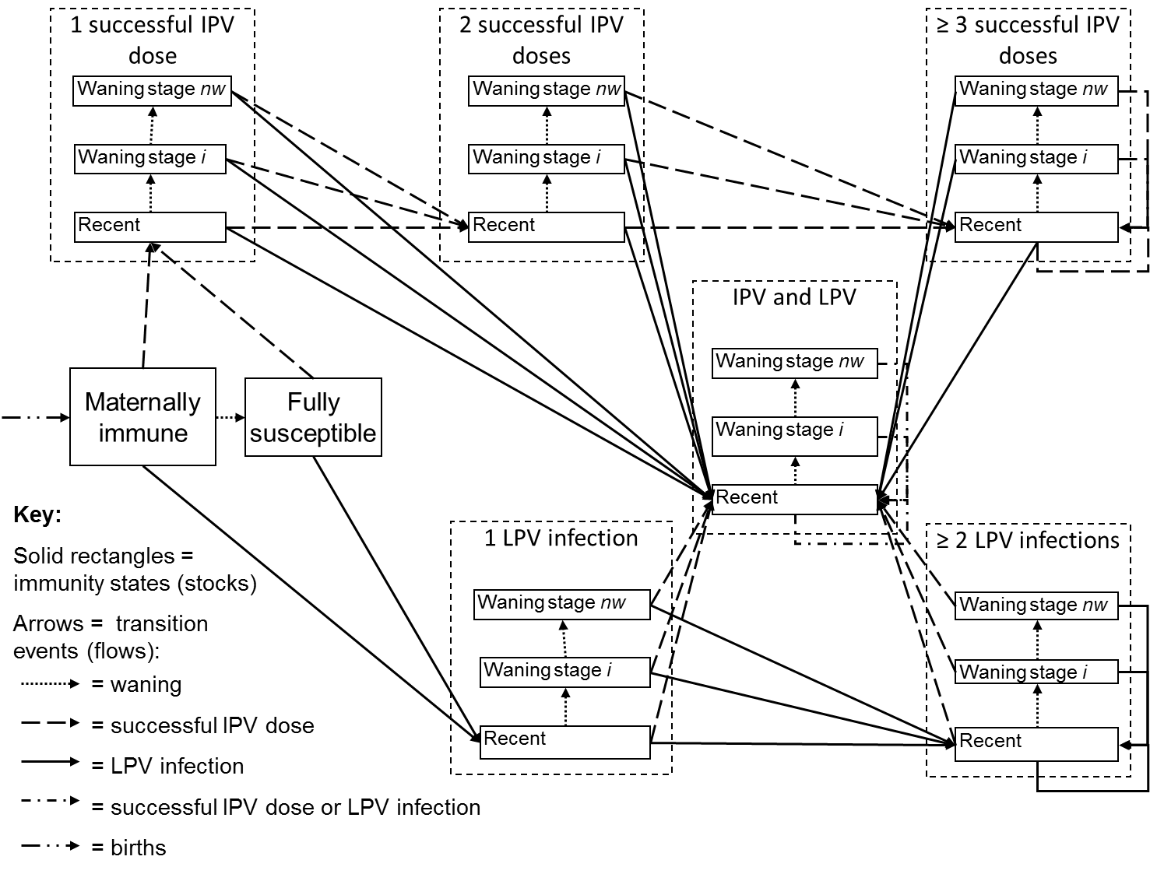

**(b) Progression through infection and reversion stages**

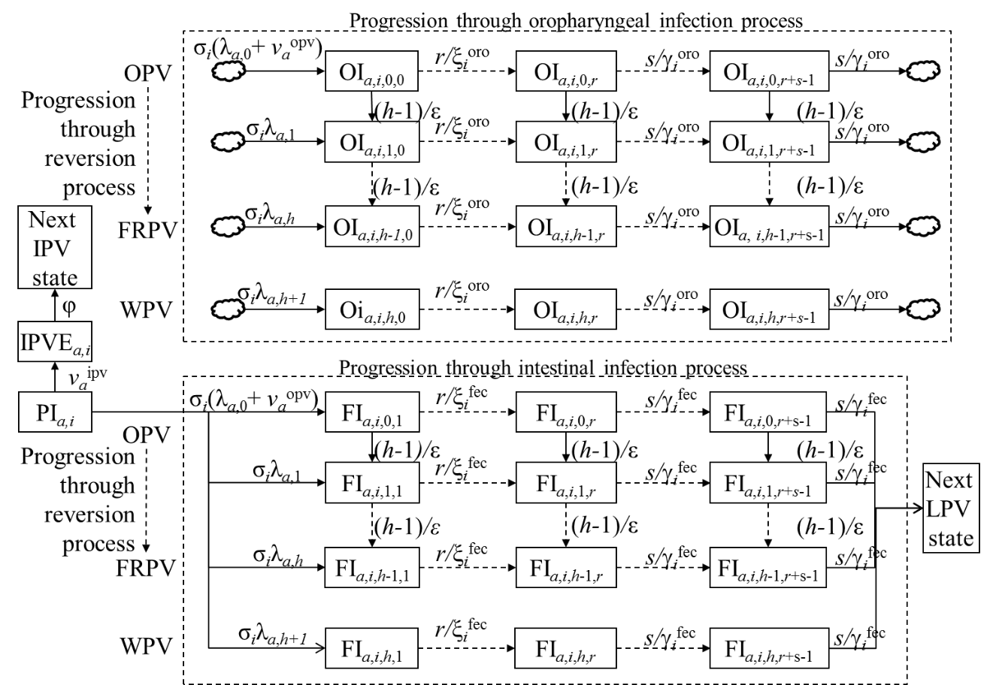

**“Acronyms:** FRPV = fully-reverted poliovirus; IPV = inactivated poliovirus vaccine; OPV = oral poliovirus vaccine; WPV = wild poliovirus**; Symbols:** PI*a,i* = partially infectible in age group *a* and immunity state *I*; IPVE*a,i* = IPV-exposed individual from immunity state *i* and age group *a*; FI*a,i,j,k* (OI*a,i,j,k*) = individual in age group a from immunity state *i*, infected with virus strain *j* and in fecal (oropharyngeal) infection stage *k*; λ*a,j* = force-of–infection to age group *a* for virus strain *j;* ν*a*ipv (ν*a*opv) = force-of-IPV (OPV)-vaccination to age group *a* as a result of routine and supplementary immunization; σ*i* = relative susceptibility for immunity state *i*; ξ*i*fec (ξioro) = average duration of the fecal (oropharyngeal) latent period for immunity state *i*; γ*i*fec (γioro) = average duration of the fecal (oropharyngeal) infectious period for immunity state *i*; *φ* = IPV immunity delay; *h* = number of reversion stages; *r* = number of latent stages; *s* = number of infectious stages”(Duintjer Tebbens, Pallansch, Kalkowska, et al., 2013, p. 706)

**Figure A2: Summary results from the model calibration process, adapted from Duintjer Tebbens et al. (2013) (Duintjer Tebbens, Pallansch, Kalkowska, et al., 2013)**

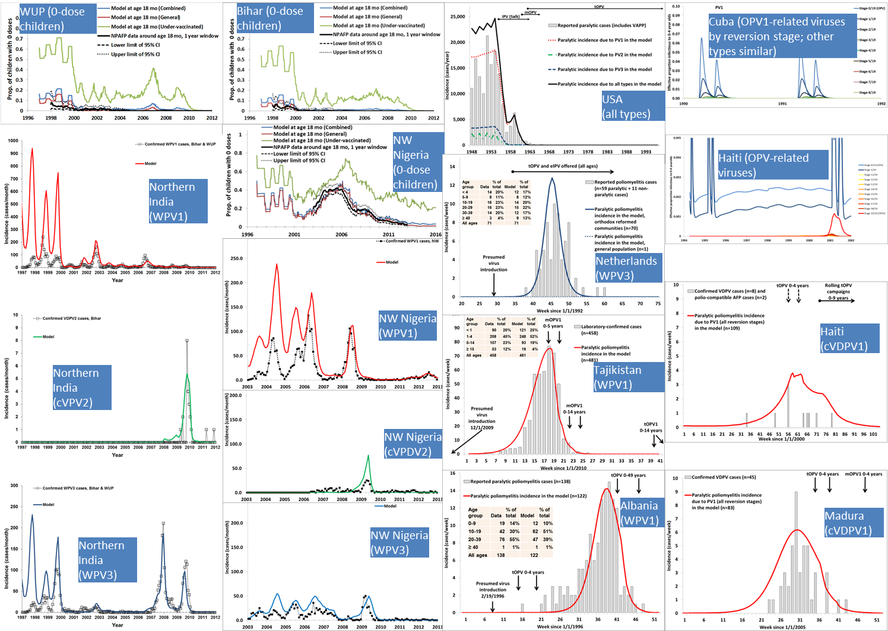

**Figure A3:** ES sampling site activity in given month during 2009-2017 period in Pakistan and Afghanistan

1. Site-specific approach

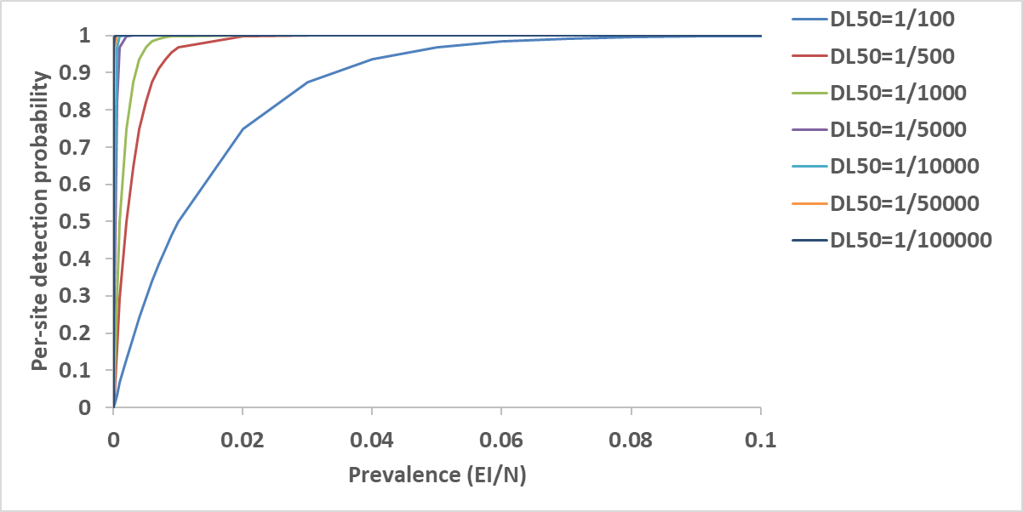

1. System-wide approach with C=0.064 (fitted values for sites distributed over whole country (NS), see Table A3)

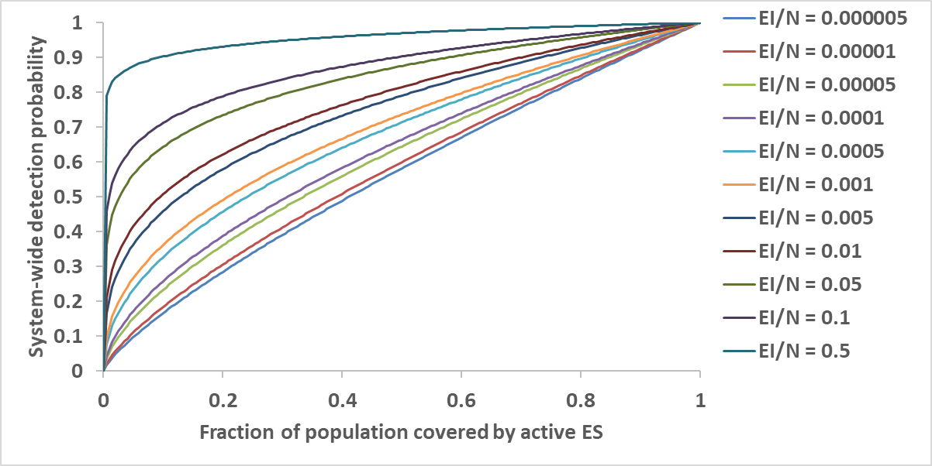

1. System-wide approach with C=0.298 (fitted values for sites distributed in the under-vaccinate subpopulations (US), see Table A3)

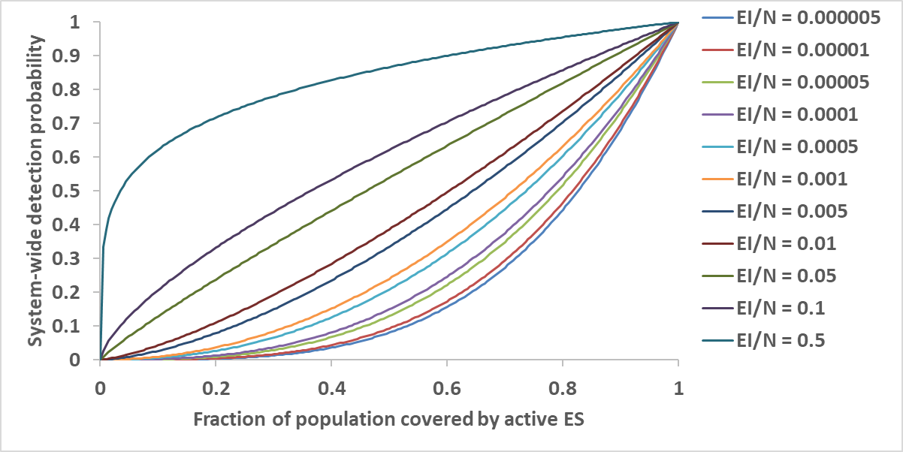

**Figure A4:** ES sampling site activity in given month during 2009-2017 period in Pakistan and Afghanistan

1. Number of active ES sampling sites

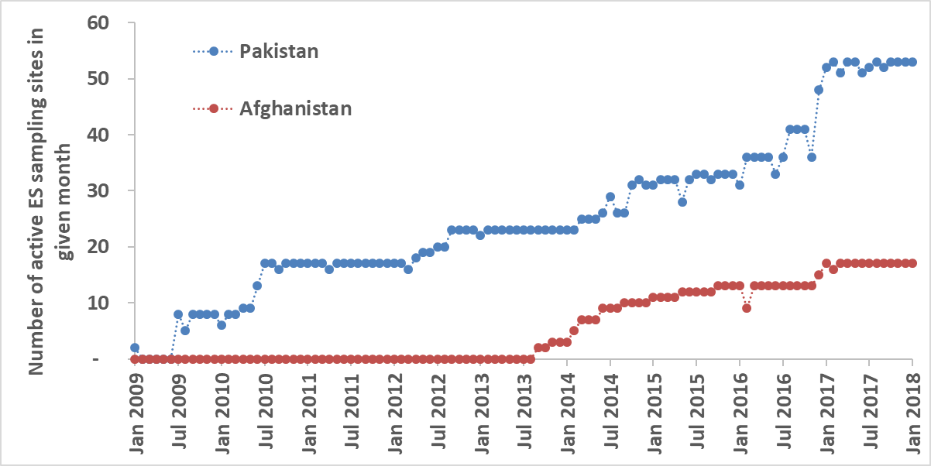

1. Total watershed population of active ES sampling sites

