Additional Material
Embryonic atrazine exposure and later in life behavioral and brain transcriptomic, epigenetic, and pathological alterations in adult male zebrafish

Katharine A Horzmann^{a,1}, Li F Lin^{b}, Boghos Taslakjianª, Chongli Yuan^{b},
Jennifer L Freeman^{a*}

ª School of Health Sciences, Purdue University, West Lafayette, IN, 47907, USA
^{b} School of Chemical Engineering, Purdue University, West Lafayette, IN, 47907, USA
¹ Current Affiliation: Department of Pathobiology, College of Veterinary Medicine, Auburn University, Auburn, AL 36849, USA
* Corresponding author: Jennifer L. Freeman, School of Health Sciences, 550 Stadium Mall Dr., West Lafayette, IN 47907 USA, Phone: (765) 494-1408, Fax: (765) 496-1377, E-mail: jfreema@purdue.edu

Table of Contents
Supplemental methods
Table S1. Primers used in qPCR analysis.
Table S2. Top pathways altered by embryonic 0.3 ppb ATZ exposure.
Table S3. Top pathways altered by embryonic 3 ppb ATZ exposure.
Table S4. Top pathways altered by embryonic 30 ppb ATZ exposure.
Table S5. List of genes with altered expression in males at 6 and 9 mpf by embryonic exposure.
Figure S1. Additional NTT results from male zebrafish with embryonic ATZ exposure.
Figure S2. Additional LDB results from male zebrafish with embryonic ATZ exposure.
Figure S3. OFT performance of male zebrafish with embryonic ATZ exposure.
Figure S4. Additional OFT results from male zebrafish with embryonic ATZ exposure.
Figure S5. Heat map of male brain microarray results.
Figure S6. Correlation between qPCR relative expression and microarray fold change in males.
Figure S7. Representative image of zebrafish brain used for morphometric evaluation.
Figure S8. Global methylation of male zebrafish with embryonic ATZ exposure.
Figure S9. β-actin expression across ATZ exposures.
Supplemental Methods
Evaluation of Global Brain Methylation
The zebrafish brains were homogenized in lysis buffer (50 mM Tris, 100 mM EDTA, 100 mM NaCl, 1% SDS, 100 µg/mL Proteinase K) and incubated overnight at 55°C with rocking agitation. The following day, samples were transferred to 1.5 Phase Lock Gel (PLG; QuantaBio, Beverly, MA) tubes. Phenol (phenol-Tris saturated, pH 8; Roche, Indianapolis, IN) and chloroform:isoamyl alcohol (American Bioanalytical, Natick, MA) were added and the samples centrifuged at room temperature for 5 minutes at 1500 rcf. The upper aqueous phase was transferred to a new PLG tube and the previous steps repeated. The upper aqueous phase was transferred to a 2 ml screw top microcentrifuge tube (Fisher Scientific, Hampton, NH) and 0.1X volume of 3M sodium acetate and 1X volume of isopropanol added and the tube inverted until the DNA started to aggregate. The samples were incubated at room temperature and then centrifuged at 4°C for 10 minutes at 800 rcf to form a DNA pellet. The pellet was washed in 70% ethanol twice, centrifuging at 4°C for 10 minutes at 800 rcf between washes. After the second wash, the pellet was centrifuged again and the sample allowed to dry to remove remaining ethanol. The sample was rehydrated in 1xTLE buffer and incubated overnight at 55°C with rocking agitation. The following morning the DNA quality and concentration was checked with a NanoDrop ND-1000 Spectrophotometer (Thermo Scientific, Wilmington, DE) and stored at 4°C until further analysis.

Table S1. Primers used in qPCR analysis
Seq ID | Gene Symbol | Primer Sequences
NM_181601 | β-actin | ctaaaaactggaacggtgaagg
 |  | aggcaaataagtttcggaacaa
NM_207059.1 | aqp1a | ggctgcgctaatctatgacttt
 |  | gggtcactttgaggacatctct
NM_131719.1 | cdk5 | cggatgtactgtttggtgctaa
 |  | gtctgccactgttcttctgttg
NM_212666.1 | cyp26b1 | tatccttcaacatggctgtacg
 |  | ggagtgagtctcttgctcgaat
NM_212924.2 | igfbp7 | tctgatctcaccgctcactaaa
 |  | caccatctggacaggaatatca
NM_199980.1 | itm2cb | gaaatccaaatgccgtactctc
 |  | atccgacagtggaagaaactgt
NM_198914.2 | sult2 | cacagctcgagtttctgctcta
 |  | gcctgatttagggaaagtgatg

Table S2. Top pathways altered by embryonic 0.3 ppb ATZ exposure
Diseases and Disorders
Name | p-valueª | # Molecules^{b}
Cancer | 9.23E-03 - 5.20E-09 | 115
Organismal Injury and Abnormalities | 9.78E-03 - 5.20E-09 | 116
Gastrointestinal Disease | 8.24E-03 - 1.42E-08 | 108
Endocrine System Disease | 9.14E-03 - 2.65E-06 | 44
Reproductive System Disease | 7.47E-03 - 2.65E-06 | 64
Molecular and Cellular Functions
Name | p-valueª | # Molecules^{b}
Cell Morphology | 7.96E-03 - 1.66E-05 | 31
Cellular Compromise | 5.16E-03 - 1.66E-05 | 12
Cellular Development | 9.11E-03 - 1.30E-04 | 24
Cellular Growth and Proliferation | 7.33E-03 - 1.30E-04 | 23
Cell Cycle | 9.73E-03 - 2.20E-04 | 23
Physiological System Development and Function
Name | p-valueª | # Molecules^{b}
Organ Morphology | 8.53E-03 - 2.65E-06 | 33
Reproductive System Development and Function | 7.25E-03 - 2.65E-06 | 22
Tissue Morphology | 7.31E-03 - 7.02E-06 | 41
Connective Tissue Development and Function | 8.24E-03 - 3.43E-05 | 21
Organismal Development | 9.78E-03 - 5.22E-05 | 54
ªDerived from the likelihood of observing the degree of enrichment in a gene set of a given size by chance alone.
^{b}Classified as being differentially expressed that relate to the specified function category; a gene may be present in more than one category.

Table S3. Top pathways altered by embryonic 3 ppb ATZ exposure
Diseases and Disorders
Name | p-valueª | # Molecules^{b}
Connective Tissue Disorders | 1.19E-02 - 1.12E-06 | 90
Organismal Injury and Abnormalities | 1.19E-02 - 3.15E-05 | 88
Skeletal and Muscular Disorders | 1.19E-02 - 7.71E-05 | 30
Reproductive System Disease | 1.19E-02 - 1.15E-04 | 78
Endocrine System Disorders | 1.19E-02 - 1.57E-04 | 7
Molecular and Cellular Functions
Name | p-valueª | # Molecules^{b}
Cellular Development | 1.19E-02 - 4.83E-05 | 22
Molecular Transport | 1.19E-02 - 9.44E-05 | 10
Cellular Growth and Proliferation | 1.19E-02 - 1.03E-04 | 20
Cellular Movement | 1.08E-02 - 3.69E-04 | 26
Cell-to-Cell Signaling and Interaction | 1.19E-02 - 4.51E-04 | 11
Physiological System Development and Function
Name | p-valueª | # Molecules^{b}
Organismal Development | 1.19E-02 - 3.89E-07 | 32
Embryonic Development | 1.19E-02 - 4.90E-07 | 28
Digestive System Development and Function | 1.19E-02 - 1.84E-06 | 14
Nervous System Development and Function | 1.19E-02 - 6.55E-06 | 25
Organ Development | 1.19E-02 - 6.55E-06 | 29
ªDerived from the likelihood of observing the degree of enrichment in a gene set of a given size by chance alone.

204
^{b}Classified as being differentially expressed that relate to the specified function category; a gene may be present in more than one category.

Table S4. Top pathways altered by embryonic 30 ppb ATZ exposure
Diseases and Disorders
Name | p-valueª | # Molecules^{b}
Cancer | 1.48E-02 - 2.77E-07 | 113
Organismal Injury and Abnormalities | 1.48E-02 - 2.77E-07 | 114
Gastrointestinal Disease | 1.03E-02 - 9.50E-06 | 103
Renal and Urological Disease | 1.03E-02 - 9.94E-05 | 31
Hereditary Disorder | 1.48E-02 - 3.17E-04 | 42
Molecular and Cellular Functions
Name | p-valueª | # Molecules^{b}
Amino Acid Metabolism | 1.03E-02 - 2.64E-05 | 12
Small Molecule Biochemistry | 1.25E-02 - 2.64E-05 | 33
Molecular Transport | 1.25E-02 - 7.07E-05 | 20
Cell-to-Cell Signaling and Interaction | 1.24E-02 - 2.25E-05 | 13
Cellular Assembly and Organization | 1.24E-02 - 2.25E-05 | 22
Physiological System Development and Function
Name | p-valueª | # Molecules^{b}
Tissue Development | 1.26E-02 - 1.03E-04 | 24
Tissue Morphology | 1.35E-02 - 1.29E-04 | 37
Humoral Immune Response | 1.48E-02 - 2.61E-04 | 3
Cardiovascular System Development and Function | 1.16E-02 - 3.15E-04 | 23
Organ Morphology | 1.45E-02 - 3.91E-04 | 24
ªDerived from the likelihood of observing the degree of enrichment in a gene set of a given size by chance alone.
^{b}Classified as being differentially expressed that relate to the specified function category; a gene may be present in more than one category.

Table S5 List of genes with altered expression in males at 6 and 9 mpf by embryonic exposure.
Name | Gene Symbolª | Biological Function^{b}
Genes altered in 0.3 ppb exposure at 6 mpf and 9 mpf
Beta-1,3-glucuronyl-transferase 3 | B3GAT3 | Carbohydrate metabolic process; chondroitin sulfate metabolic process; glycosaminoglycan biosynthesis; protein glycosylation
Bruton tyrosine kinase | BTK | Adaptive immune response; apoptotic process; B cell activation, affinity maturation and receptor signaling; mast cell histamine release
Caveolae associated protein 4 | CAVIN4 | Cardiac myofibril assembly; cell differentiation; muscle development; regulation of gene expression; Rho protein signal transduction
Cyclin dependent kinase 5 | CDK5 | Associative learning; dopaminergic and glutamatergic synaptic transmission; neuron and oligodendrocyte development and differentiation
Complement factor H | CFH | Cellular response to hydrogen peroxide, interferon-gamma, and lipopolysaccharide; complement activation; regulation of cytolysis
Carboxypeptidase M | CPM | Anatomical structure morphogenesis; C-terminal protein lipidation; peptide metabolic process; protein processing; proteolysis
Cytochrome P450, family 2, subfamily ac, peptide 1 | CYP2AC1 | --
Eosinophil peroxidase | EPX | Defense response; eosinophil migration; Regulation of interleukin-10, interleukin-5, and interleukin-4 production
Glutamic--pyruvic transaminase | GPT | Biosynthetic process; cellular amino acid biosynthetic process; L-alanine catabolic process
Hypoxia inducible factor 3 alpha subunit | HIF3A | Angiogenesis; apoptotic process; cellular response to hypoxia; protein ubiquitination; regulation of transcription
Hydroxysteroid 11-beta dehydrogenase 2 | HSD11B2 | Glucocorticoid biosynthesis and metabolism; response to glucocorticoid, hypoxia, insulin, and steroid hormone stimulus
HtrA serine peptidase 2 | HTRA2 | Adult locomotor behavior; response to herbicide; forebrain development; negative regulation of cell cycle; neuron development; proteolysis
Interferon induced protein 44 | IFI44 | Response to virus
Insulin like growth factor binding protein 7 | IGFBP7 | Cell adhesion; cellular response to hormone stimulus; post-translational protein modification; regulation of steroid biosynthesis
Integral membrane protein 2C | ITM2C | Negative regulation of amyloid precursor protein; nervous system development and differentiation; regulation of apoptosis
Kynurenine 3-monooxygenase | KMO | Kynurenine metabolism; NAD biosynthesis and metabolism; pyridine biosynthesis; quinolinate biosynthesis; tryptophan catabolism
L-2-hydroxyglutarate dehydrogenase | L2HGDH | 2-oxoglutarate metabolic process; cellular protein metabolic process; oxidation-reduction process
Membrane palmitoylated protein 1 | MPP1 | GDP metabolic process; GMP metabolic process; regulation of neutrophil chemotaxis; signal transduction
Protein disulfide isomerase family A member 6 | PDIA6 | Apoptotic cell clearance; cell redox homeostasis; platelet activation and aggregation; post-translational protein modification and folding
Protein phosphatase Mg²⁺/Mn²⁺ dependent 1L | PPM1L | MAPK cascade; protein dephosphorylation; sphingolipid biosynthesis; transmembrane receptor protein serine/threonine kinase signaling
Protein regulator of cytokinesis 1 | PRC1 | Cell cycle; cell division; cytokinesis; microtubule bundle formation; microtubule cytoskeleton organization; mitotic spindle elongation
Pleckstrin and Sec7 domain containing 3 | PSD3 | ARF protein signal transduction; positive regulation of GTPase activity; regulation of ARF protein signal transduction
Solute carrier family 43 member 1 | SLC43A1 | Amino acid transport; L-amino acid transport; neutral amino acid transport; transmembrane transport; transport
Sp8 transcription factor | SP8 | Dorsal/ventral and proximal/distal pattern formation; embryonic limb morphogenesis; regulation of transcription
Sulfotransferase family 2B member 1 | SULT2B1 | Sulfate conjugation of hormones, xenobiotic compounds, and neurotransmitters; lipid metabolic process; steroid metabolic process
Troponin I2, fast skeletal type | TNNI2 | Regulation of muscle contraction; co-activator of estrogen receptor-related receptor alpha; positive regulation of transcription
Zinc finger protein 729 | ZNF729 | Regulation of transcription
Genes altered in 3 ppb exposure at 6 mpf and 9 mpf
Aminoacylase 1 | ACY1 | Cellular amino acid metabolic process; protein catabolic process; proteolysis; xenobiotic metabolic process
Caveolae associated protein 4 | CAVIN4 | Cardiac myofibril assembly; cell differentiation; muscle development; regulation of gene expression; Rho protein signal transduction
Cyclin dependent kinase 5 | CDK5 | Associative learning; dopaminergic and glutamatergic synaptic transmission; neuron and oligodendrocyte development and differentiation
Cytochrome P450, family 2, subfamily ac, peptide 1 | CYP2AC1 | --
Cytochrome P450 family 2 subfamily J member 2 | CYP2J2 | Arachidonic acid, icosanoid, and linoleic acid metabolism; negative regulation of collagen biosynthesis; xenobiotic metabolic process
Distal-less homeobox 2 | DLX2 | Hippocampus, subpallium, olfactory bulb, and cerebral cortex development; nerve morphogenesis; oligodendrocyte differentiation
EH domain binding protein 1 like 1 | EHBP1l1 | Rab effector protein; vesicle trafficking
Erb-b2 receptor tyrosine kinase 4 | ERBB4 | Apoptotic process; cell fate; cell migration; cell proliferation; central nervous system morphogenesis; synapse maturation
Coagulation factor X | F10 | Blood coagulation; ER to Golgi vesicle-mediated transport; peptidyl-glutamic acid carboxylation; protein kinase B signaling cascade
GSH2, GS homeobox 2 | GSX2 | Central nervous system development; forebrain and hindbrain morphogenesis; neuron fate; oligodendrocyte differentiation
Histidine decarboxylase | HDC | Carboxylic acid metabolism; catecholamine biosynthesis; cellular amino acid metabolism; histamine biosynthesis and metabolism
HtrA serine peptidase 2 | HTRA2 | Adult locomotor behavior; response to herbicide; forebrain development; negative regulation of cell cycle; neuron development; proteolysis
Insulin like growth factor binding protein 7 | IGFBP7 | Cell adhesion; cellular response to hormone stimulus; post-translational protein modification; regulation of steroid biosynthesis
Integral membrane protein 2C | ITM2C | Negative regulation of amyloid precursor protein; nervous system development and differentiation; regulation of apoptosis
N-acetyltransferase 1 | NAT1 | Digestive tract development; response to hypoxia; response to lipopolysaccharide; xenobiotic metabolic process
Protein disulfide isomer-ase family A member 6 | PDIA6 | Apoptotic cell clearance; cell redox homeostasis; platelet activation and aggregation; post-translational protein modification and folding
Ribonuclease P/MRP subunit p21 | RPP21 | Response to drug; rRNA processing; tRNA 5'-leader removal; tRNA processing
Solute carrier family 5 member 1 | SLC5A1 | Carbohydrate and glucose transport; intestinal absorption; intestinal glucose absorption; ion transport; metanephros development
Sp8 transcription factor | SP8 | Dorsal/ventral and proximal/distal pattern formation; embryonic limb morphogenesis; regulation of transcription
Sulfotransferase family 2B member 1 | SULT2B1 | Sulfate conjugation of hormones, xenobiotic compounds, and neurotransmitters; lipid metabolic process; steroid metabolic process
Tryptophan 2,3-dioxygenase | TDO2 | Oxidation-reduction process; protein homotetramerization; tryptophan catabolism to acetyl-CoA and to kynurenine
Troponin I2, fast skeletal type | TNNI2 | Regulation of muscle contraction; co-activator of estrogen receptor-related receptor alpha; positive regulation of transcription
Zinc finger protein 385B | ZNF385B | Apoptotic process; signal transduction by p53 class mediator resulting in induction of apoptosis
Genes altered in 30 ppb exposure at 6 mpf and 9 mpf
Aminoacylase 1 | ACY1 | Cellular amino acid metabolic process; protein catabolic process; proteolysis; xenobiotic metabolic process
Adenylate kinase 7 | AK7 | Axoneme assembly; brain development; cell projection organization; inflammatory response to antigenic stimulus; spermatogenesis
ATPase Na⁺/K⁺ trans-porting subunit beta 1 | ATP1B1 | ATP metabolic process; blastocyst development; cell communication; cellular calcium and potassium ion homeostasis; metal ion transport
Beta-1,3-glucuronyltransferase 3 | B3GAT3 | Carbohydrate metabolic process; chondroitin sulfate metabolic process; glycosaminoglycan biosynthesis; protein glycosylation
Bruton tyrosine kinase | BTK | Adaptive immune response; apoptotic process; B cell activation, affinity maturation and receptor signaling; mast cell histamine release
Caveolae associated protein 4 | CAVIN4 | Cardiac myofibril assembly; cell differentiation; muscle development; regulation of gene expression; Rho protein signal transduction
Cyclin dependent kinase 5 | CDK5 | Associative learning; dopaminergic and glutamatergic synaptic transmission; neuron and oligodendrocyte development and differentiation
Carboxypeptidase M | CPM | Anatomical structure morphogenesis; C-terminal protein lipidation; peptide metabolic process; protein processing; proteolysis
Dystrobrevin beta | DTNB | Metal ion binding; protein binding; zinc ion binding
Engrailed homeobox 1 | EN1 | Cerebellum, mid-, and hind brain development; dopaminergic neuron differentiation; neuron development; locomotor and social behavior
Eosinophil peroxidase | EPX | Defense response; eosinophil migration; Regulation of interleukin-10, interleukin-5, and interleukin-4 production
Family with sequence similarity 43 member B | FAM43B | Negative regulation of cell proliferation
Glutamic--pyruvic transaminase | GPT | Biosynthetic process; cellular amino acid biosynthetic process; L-alanine catabolic process
Hemoglobin subunit epsilon 1 | HBE1 | Blood coagulation; oxygen transport; response to organic cyclic compound
Hypoxia inducible factor 3 alpha subunit | HIF3A | Angiogenesis; apoptotic process; cellular response to hypoxia; protein ubiquitination; regulation of transcription
Hydroxysteroid 11-beta dehydrogenase 2 | HSD11B2 | Glucocorticoid biosynthesis and metabolism; response to glucocorticoid, hypoxia, insulin, and steroid hormone stimulus
HtrA serine peptidase 2 | HTRA2 | Adult locomotor behavior; response to herbicide; forebrain development; negative regulation of cell cycle; neuron development; proteolysis
Insulin like growth factor binding protein 7 | IGFBP7 | Cell adhesion; cellular response to hormone stimulus; post-translational protein modification; regulation of steroid biosynthesis
Integral membrane protein 2C | ITM2C | Negative regulation of amyloid precursor protein; nervous system development and differentiation; regulation of apoptosis
L-2-hydroxyglutarate dehydrogenase | L2HGDH | 2-oxoglutarate metabolic process; cellular protein metabolic process; oxidation-reduction process
Membrane palmitoylated protein 1 | MPP1 | GDP metabolic process; GMP metabolic process; regulation of neutrophil chemotaxis; signal transduction
Peroxiredoxin 3 | PRDX3 | Cell redox homeostasis; regulation of proliferation; myeloid cell differentiation; regulation of neuron apoptotic process  217
Protein kinase C delta | PRKCD | Phospholipase C and protein kinase activity; regulation of glial apoptosis; interleukin-10 and -12 production; histone phosphorylation
Protein kinase C epsilon | PRKCE | Apoptotic process; cell cycle; locomotory exploration behavior; protein ubiquitination; regulation of GABAergic synaptic transmission
Solute carrier family 43 member 1 | SLC43A1 | Amino acid transport; L-amino acid transport; neutral amino acid transport; transmembrane transport; transport
Slingshot protein phosphatase 1 | SSH1 | Actin cytoskeleton organization; regulation of excitatory postsynaptic membrane potential; regulation of synaptic plasticity; axonogenesis
Sulfotransferase family 2B member 1 | SULT2B1 | Sulfate conjugation of hormones, xenobiotic compounds, and neurotransmitters; lipid metabolic process; steroid metabolic process
Tryptophan 2,3-dioxygenase | TDO2 | Oxidation-reduction process; protein homotetramerization; tryptophan catabolism to acetyl-CoA and to kynurenine
Troponin I2, fast skeletal type | TNNI2 | Regulation of muscle contraction; co-activator of estrogen receptor-related receptor alpha; positive regulation of transcription
ª Human ortholog of zebrafish gene

191
^{b} Determined via Ingenuity Pathway Analysis

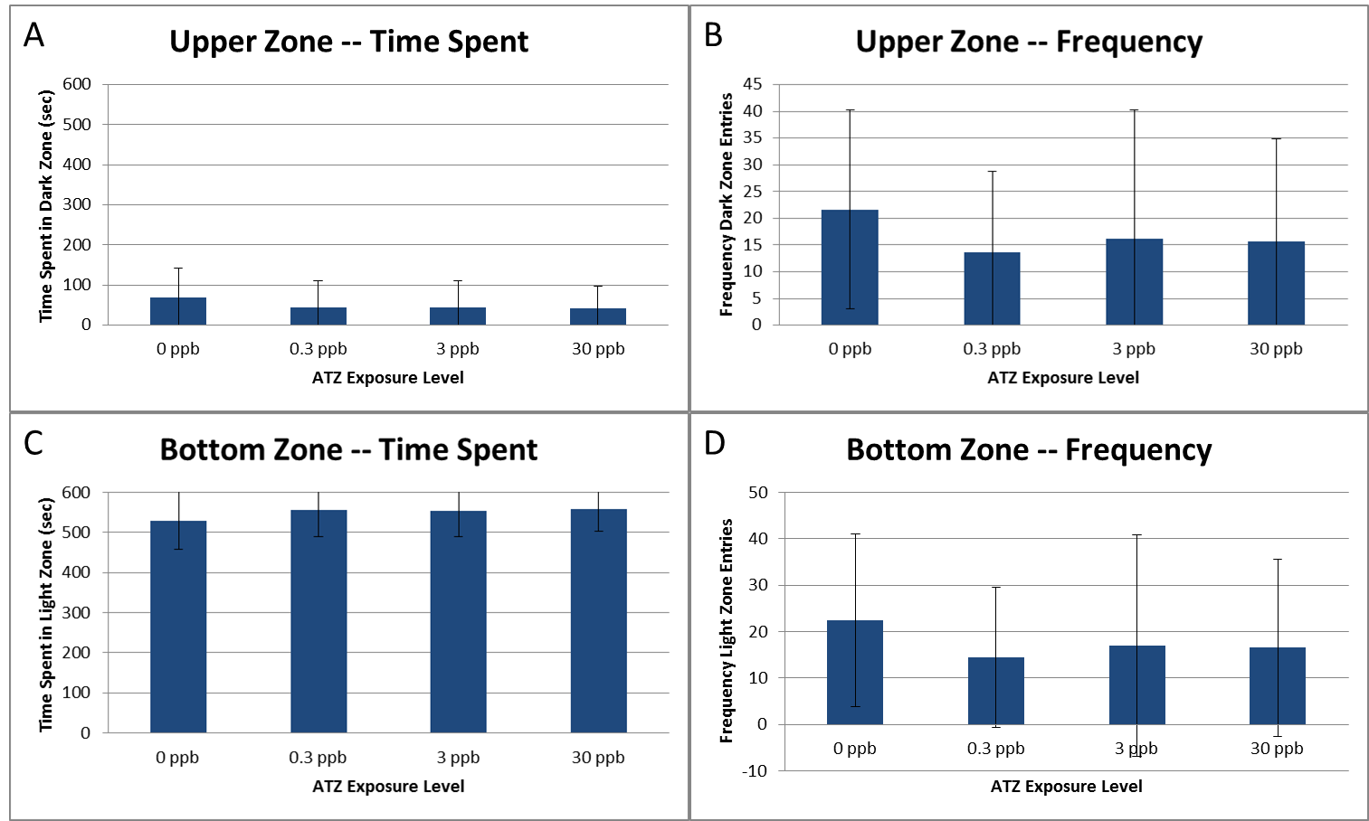

Figure S1. Additional NTT results from male zebrafish with embryonic ATZ exposure. There was no significant difference in the time spent in the upper zone (A), frequency of upper zone entries (B), time spent in the bottom zone (C), or frequency of bottom zone entries (D). N = 4, 10 subsamples per treatment per replicate to total 40 fish per treatment, error bars represent standard deviation, p>0.05.

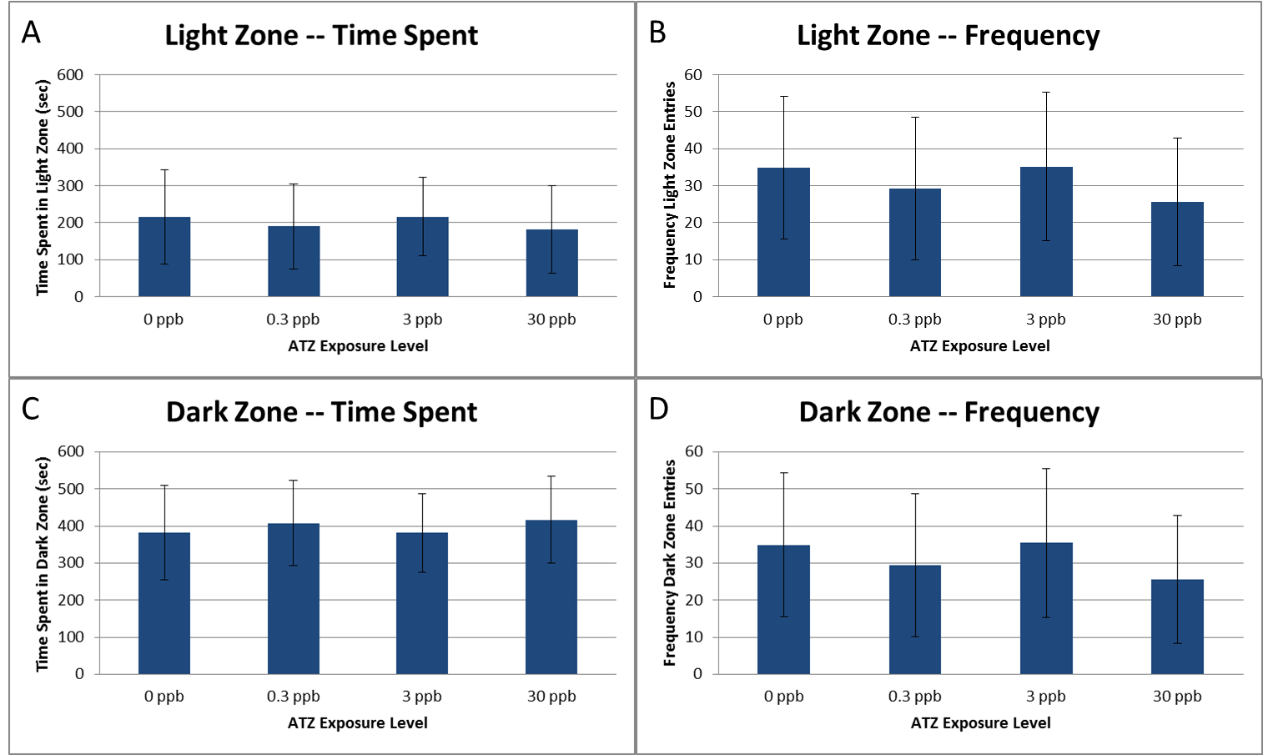
Figure S2. Additional LDB results from male zebrafish with embryonic ATZ exposure. There was no significant difference in the time spent in the light zone (A), frequency of light zone entries (B), time spent in the dark zone (C), or frequency of dark zone entries (D). N = 4, 10 subsamples per treatment per replicate to total 40 fish per treatment, error bars represent standard deviation, p>0.05.

218
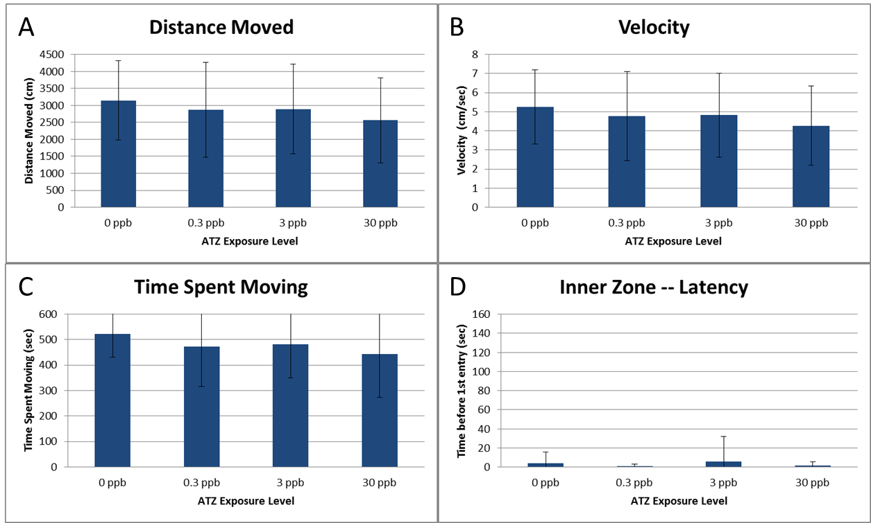
Figure S3. OFT performance of male zebrafish with embryonic ATZ exposure. Male zebrafish had a trend towards decreasing activity with increasing embryonic ATZ exposure, however, it did not reach significance for distance moved (A), velocity (B), or time spent moving (C). There was no significant differences in the latency to the first inner zone entry (D) between treatments. N = 4, 10 subsamples per treatment per replicate to total 40 fish per treatment, error bars represent standard deviation, p>0.05.
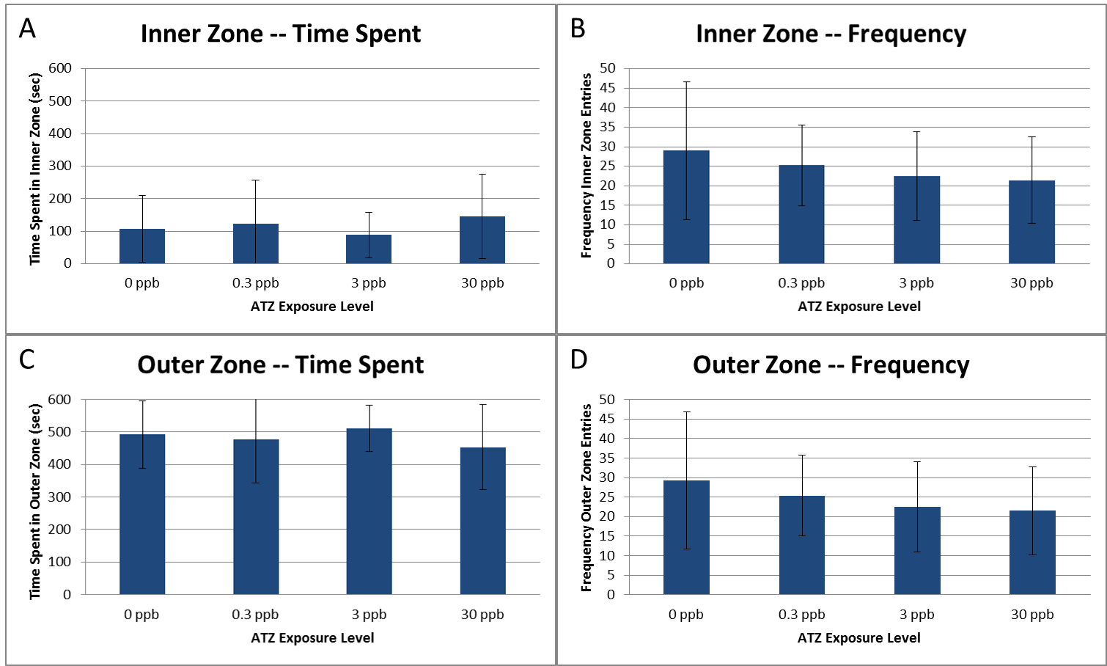
Figure S4. Additional LDB results from male zebrafish with embryonic ATZ exposure. There was no significant difference in the time spent in the light zone (A), frequency of light zone entries (B), time spent in the dark zone (C), or frequency of dark zone entries (D). N = 4, 10 subsamples per treatment per replicate to total 40 fish per treatment, error bars represent standard deviation, p>0.05

Figure S5. Heat map of the male brain microarray results. N = 4.

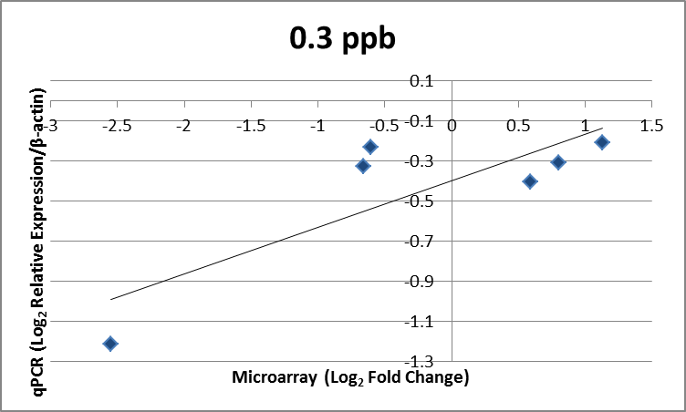
A

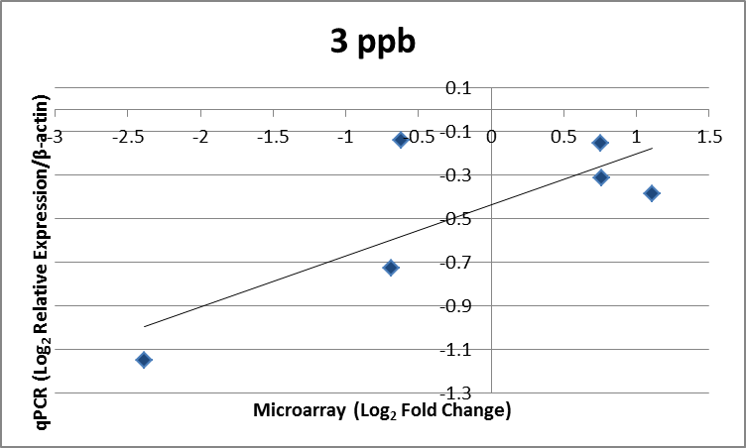
B

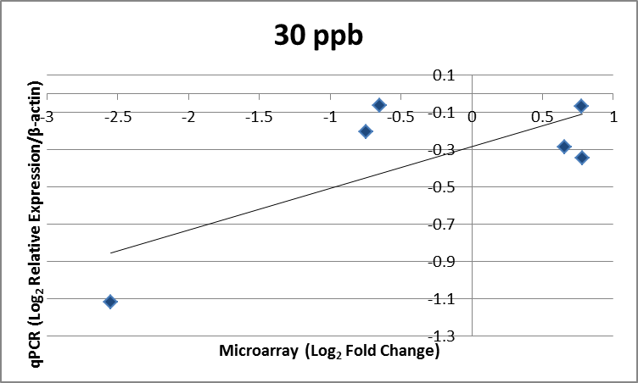
C

Figure S6. Correlation between qPCR relative expression and microarray fold change in males. There was a strong positive correlation between the log2 relative expression determined by qPCR and the microarray log2 fold change for all treatments (0.3 ppb: r=0.8285; 3 ppb: r=0.7875; 30 ppb: r=0.7466). The correlation was significant for males with embryonic exposure to 0.3 (A), 3 (B), and 30 ppb (C) ATZ (p<0.05). N = 4, 6 genes were evaluated.
Figure S7. Representative image of zebrafish brain used for morphometric evaluation. Green area outlines the dorsal telencephalon. The yellow labels the posterior tuberculum. The red outlines a portion of the raphe populations (superior raphe does not appear in this plane of section). Scale bar represents 600 µm.

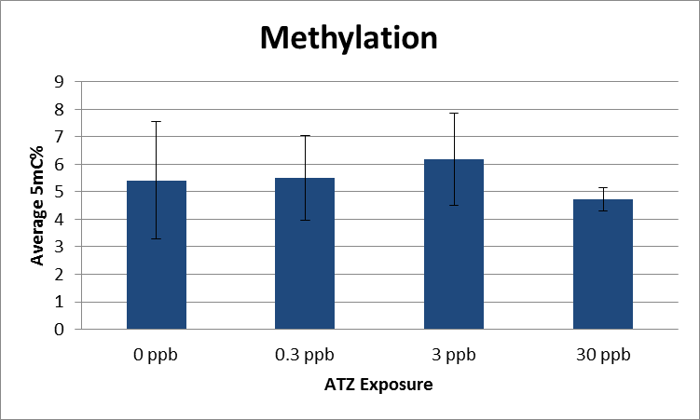
Figure S8. Global methylation of male zebrafish with embryonic ATZ exposure. There was no significant difference in percent 5mC between exposure groups (p>0.05). N=6-7.

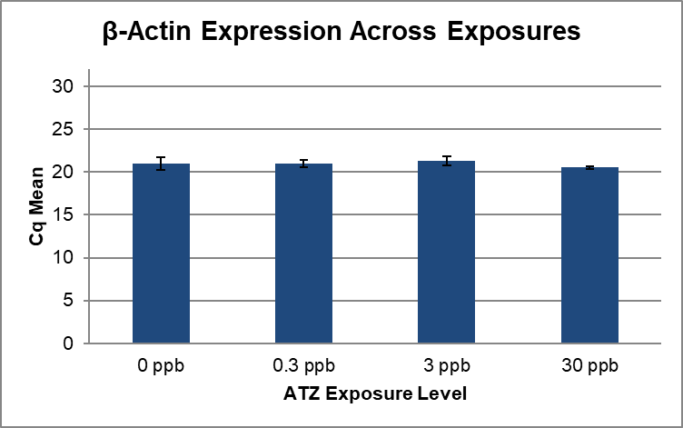
Figure S9. β-actin expression across ATZ exposure samples. In a pre-analysis assessment, several reference genes were first tested to determine, which was the most consistently expressed among our samples. The expression of β-actin was not significantly different between ATZ exposures (p=0.1632) and was identified as the most consistently expressed among our samples. Thus, β-actin was included as the reference gene in the qPCR analysis. N = 4, qPCR run in triplicate, error bars represent standard deviation.

