Supplementary Material
Supplement to: Can pneumococcal meningitis surveillance be used to assess the impact of pneumococcal conjugate vaccine on total invasive pneumococcal disease? A case-study from South Africa, 2005-2016
Table of contents
Supplementary Figure 1. Trends of invasive pneumococcal disease (IPD) incidence from 2005 – 2016, by specimen type used for diagnosis, South Africa. | 2
Supplementary Table 1. Percentage difference in rates of total invasive pneumococcal disease (tIPD) and pneumococcal meningitis (PM) between 2005-2008 (pre-PCV introduction) and 2012 (post-PCV introduction) and percentage effect difference in rate changes between 2005-2008 and 2012 for PM compared to tIPD, South Africa, 2005-2012 | 3
Supplementary Table 2. Percentage difference in rates of total invasive pneumococcal disease (tIPD) and pneumococcal meningitis (PM) between 2005-2008 (pre-PCV introduction) and 2016 (post-PCV introduction) and percentage effect difference in rate changes between 2005-2008 and 2016 for PM compared to tIPD, South Africa, 2005-2016 | 4
Supplementary Table 3. Percentage difference in rates of non-meningitis invasive pneumococcal disease (nmIPD) and pneumococcal meningitis (PM) between 2005-2008 (pre-PCV introduction) and 2012 (post-PCV introduction) and percentage effect difference in rate changes between 2005-2008 and 2012 for PM compared to nmIPD, South Africa, 2005-2012 | 5
Supplementary Table 4. Percentage difference in rates of non-meningitis invasive pneumococcal disease (nmIPD) and pneumococcal meningitis (PM) between 2005-2008 (pre-PCV introduction) and 2016 (post-PCV introduction) and percentage effect difference in rate changes between 2005-2008 and 2016 for PM compared to nmIPD, South Africa, 2005-2016 | 6
Supplementary Figure 2. Prevalence of HIV infection amongst non-meningitis invasive pneumococcal disease (nmIPD) and pneumococcal meningitis (PM) cases from GERMS-SA enhanced surveillance sites by age, 2005-2016, South Africa. | 7
Supplementary Table 5. Comparison of the characteristics of patients with pneumococcal meningitis (PM) and non-meningitis invasive pneumococcal disease (nmIPD) for the pre-PCV period (2005-2008). OR-odds ratio, 95%CI-95% confidence interval………………………………………………………………. | 8
Supplementary Table 6. Comparison of the characteristics of patients with pneumococcal meningitis (PM) and non-meningitis invasive pneumococcal disease (nmIPD) for the post-PCV period (2013-2016). OR-odds ratio, 95%CI-95% confidence interval………………………………………………………………. | 10
List of GERMS-SA collaborators 2005-2016.………………………………………. | 12

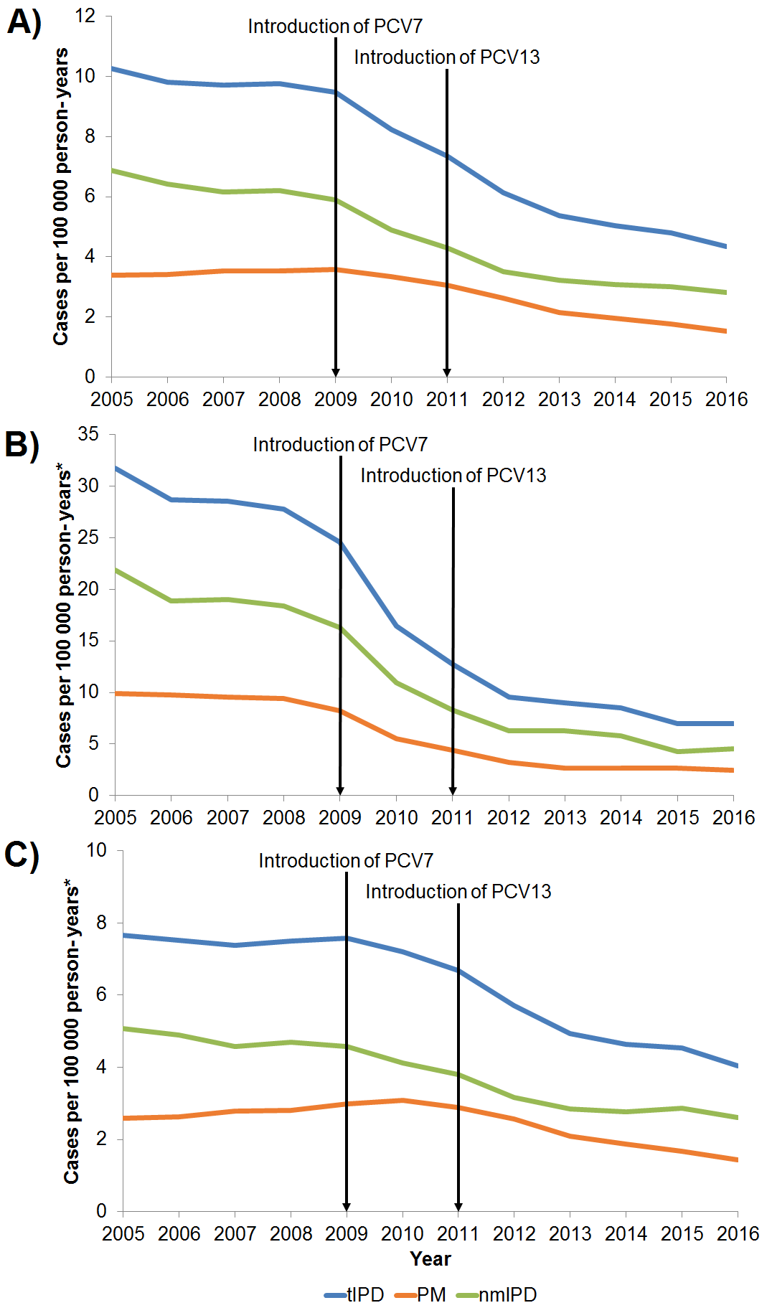
Supplementary Figure 1. Trends of invasive pneumococcal disease (IPD) incidence from 2005 – 2016, by specimen type used for diagnosis, South Africa. A) In all ages, B) in those <5 years old, and C) in those ≥5 years old.

Supplementary Table 1. Percentage difference in rates of total invasive pneumococcal disease (tIPD) and pneumococcal meningitis (PM) between 2005-2008 (pre-PCV introduction) and 2012 (post-PCV introduction) and percentage effect difference in rate changes between 2005-2008 and 2012 for PM compared to tIPD, South Africa, 2005-2012
Serotype groups | tIPD % difference  (95% CI) | PM % difference  (95% CI) | % effect difference  PM vs. tIPDª  (p value)
Children aged <5 years
PCV7 serotypes | -88.4 (-90.3 to -86.0) | -89.9 (-92.8 to -85.8) | -12.8 (0.49)
Additional PCV13 serotypes | -66.2 (-71.3 to -60.1) | -70.2 (-78.7 to -58.4) | -12.0 (0.50)
Non-PCV13 serotypes | 12.8 (-1.3 to 28.8) | 25.0 (1.1 to 54.5) | 10.8 (0.42)
All serotypes^{b} | -67.4 (-70.1 to -64.4) | -66.7 (-71.3 to -61.3) | 2.0 (0.82)
Individuals aged ≥5 years
PCV7 serotypes | -55.0 (-59.0 to -50.7) | -47.1 (-54.0 to -39.2) | 17.7 (0.06)
Additional PCV13 serotypes | -28.3 (-33.2 to -23.0) | -26.5 (-35.3 to -16.5) | 2.5 (0.74)
Non-PCV13 serotypes | 22.1 (14.5 to 30.1) | 61.4 (47.6 to 76.4) | 32.2 (<0.01)
All serotypes^{b} | -22.3 (-25.5 to -19.0) | -3.2 (-9.2 to 3.1) | 24.6 (<0.01)
Individuals of all ages
PCV7 serotypes^{c} | -70.4 (-72.7 to -67.9) | -66.2 (-70.2 to -61.6) | 14.3 (0.08)
Additional PCV13 serotypes^{c} | -38.3 (-42.1 to -34.1) | -37.2 (-44.2 to -29.3) | 1.7 (0.80)
Non-PCV13 serotypes^{c} | 20.3 (13.5 to 27.4) | 54.9 (42.7 to 68.1) | 28.8 (<0.01)
All serotypes^{d} | -37.2 (-39.5 to -34.8) | -23.0 (-27.3 to -18.4) | 22.5 (<0.01)
Abbreviations: CI: confidence intervals; PCV: pneumococcal conjugate vaccine; PCV7 serotypes: 4, 6B, 9V, 14, 18C, 19F and 23F; Additional PCV13 serotypes: 1, 3, 5, 6A, 7F and 19A; Non-PCV13 serotypes: all serotype not in PCV13.
ª Percentage effect difference calculated as the rate ratio of the interaction term for PCV period (2012 vs. 2005-2008) and syndrome (PM vs. tIPD) term minus 1 multiplied by 100
^{b} Model adjusted by serotype groups: PCV7, additional PCV13 and non-PCV13 serotypes.
^{c} Model adjusted by age groups: individuals <5 and ≥5 years of age.
^{d} Model adjusted by serotype and age groups.

Supplementary Table 2. Percentage difference in rates of total invasive pneumococcal disease (tIPD) and pneumococcal meningitis (PM) between 2005-2008 (pre-PCV introduction) and 2016 (post-PCV introduction) and percentage effect difference in rate changes between 2005-2008 and 2016 for PM compared to tIPD, South Africa, 2005-2016
Serotype groups | tIPD % difference  (95% CI) | PM % difference  (95% CI) | % effect difference  PM vs. tIPDª  (p value)
Children aged <5 years
PCV7 serotypes | -95.5 (-96.6 to -93.9) | -96.5 (-98.0 to -93.9) | -23.6 (0.41)
Additional PCV13 serotypes | -92.1 (-94.4 to -89.1) | -94.4 (-97.3 to -88.2) | -28.8 (0.42)
Non-PCV13 serotypes | 29.3 (14.0 to 46.6) | 33.9 (8.9 to 64.5) | 3.5 (0.78)
All serotypes^{b} | -76.0 (-78.3 to -73.5) | -74.7 (-78.7 to -70.0) | 5.4 (0.60)
Individuals aged ≥5 years
PCV7 serotypes | -79.4 (-81.9 to -76.7) | -79.6 (-83.4 to -74.8) | -0.6 (0.96)
Additional PCV13 serotypes | -70.3 (-73.1 to -67.1) | -78.5 (-82.6 to -73.3) | -27.6 (0.01)
Non-PCV13 serotypes | 26.3 (18.7 to 34.3) | 17.5 (6.6 to 29.6) | -6.9 (0.23)
All serotypes^{b} | -44.7 (-47.3 to -42.1) | -45.7 (-49.8 to -41.3) | -1.7 (0.71)
Individuals of all ages
PCV7 serotypes^{c} | -86.6 (-88.1 to -85.0) | -86.9 (-89.2 to -84.1) | -2.1 (0.85)
Additional PCV13 serotypes^{c} | -75.8 (-78.0 to -73.4) | -82.2 (-85.5 to -78.1) | -26.5 (0.01)
Non-PCV13 serotypes^{c} | 26.8 (20.0 to 34.0) | 20.3 (10.2 to 31.4) | -5.1 (0.32)
All serotypes^{d} | -54.7 (-56.6 to -52.8) | -54.4 (-57.5 to -51.0) | 0.7 (0.87)
Abbreviations: CI: confidence intervals; PCV: pneumococcal conjugate vaccine; PCV7 serotypes: 4, 6B, 9V, 14, 18C, 19F and 23F; Additional PCV13 serotypes: 1, 3, 5, 6A, 7F and 19A; Non-PCV13 serotypes: all serotype not in PCV13.
ª Percentage effect difference calculated as the rate ratio of the interaction term for PCV period (2016 vs. 2005-2008) and syndrome (PM vs. tIPD) term minus 1 multiplied by 100
^{b} Model adjusted by serotype groups: PCV7, additional PCV13 and non-PCV13 serotypes.
^{c} Model adjusted by age groups: individuals <5 and ≥5 years of age.
^{d} Model adjusted by serotype and age groups.

Supplementary Table 3. Percentage difference in rates of non-meningitis invasive pneumococcal disease (nmIPD) and pneumococcal meningitis (PM) between 2005-2008 (pre-PCV introduction) and 2012 (post-PCV introduction) and percentage effect difference in rate changes between 2005-2008 and 2012 for PM compared to nmIPD, South Africa, 2005-2012
Serotype groups | nmIPD % difference  (95% CI) | PM % difference  (95% CI) | % effect difference  PM vs. nmIPDª  (p value)
Children aged <5 years
PCV7 serotypes | -87.6 (-90.1 to -84.5) | -89.7 (-92.6 to -85.7) | -17.3 (0.35)
Additional PCV13 serotypes | -64.6 (-70.7 to -57.2) | -70.3 (-78.8 to -58.5) | -16.1 (0.37)
Non-PCV13 serotypes | 5.9 (-10.7 to 25.6) | 25.0 (1.1 to 54.5) | 18.0 (0.23)
All serotypes^{b} | -67.7 (-70.9 to -64.0) | -66.7 (-71.3 to -61.3) | 3.1 (0.74)
Individuals aged ≥5 years
PCV7 serotypes | -59.7 (-64.3 to -54.6) | -47.1 (-54.0 to -39.2) | 31.4 (0.01)
Additional PCV13 serotypes | -29.0 (-34.8 to -22.7) | -26.6 (-35.4 to -16.6) | 3.4 (0.67)
Non-PCV13 serotypes | -6.5 (-14.8 to 2.7) | 61.5 (47.7 to 76.5) | 72.6 (<0.01)
All serotypes^{b} | -33.1 (-36.7 to -29.2) | -3.3 (-9.2 to 3.1) | 44.5 (<0.01)
Individuals of all ages
PCV7 serotypes^{c} | -72.8 (-75.6 to -69.8) | -66.2 (-70.2 to -61.6) | 24.6 (0.01)
Additional PCV13 serotypes^{c} | -38.6 (-43.2 to -33.7) | -37.3 (-44.3 to -29.4) | 2.2 (0.77)
Non-PCV13 serotypes^{c} | -3.8 (-11.3 to 4.4) | 54.9 (42.7 to 68.1) | 61.0 (<0.01)
All serotypes^{d} | -44.8 (-47.4 to -42.0) | -23.0 (-27.4 to -18.4) | 39.4 (<0.01)
Abbreviations: CI: confidence intervals; PCV: pneumococcal conjugate vaccine; PCV7 serotypes: 4, 6B, 9V, 14, 18C, 19F and 23F; Additional PCV13 serotypes: 1, 3, 5, 6A, 7F and 19A; Non-PCV13 serotypes: all serotype not in PCV13.
a Percentage effect difference calculated as the rate ratio of the interaction term for PCV period (2012 vs. 2005-2008) and syndrome (PM vs. nmIPD) term minus 1 multiplied by 100
b Model adjusted by serotype groups: PCV7, additional PCV13 and non-PCV13 serotypes.
c Model adjusted by age groups: individuals <5 and ≥5 years of age.
d Model adjusted by serotype and age groups.

Supplementary Table 4. Percentage difference in rates of non-meningitis invasive pneumococcal disease (nmIPD) and pneumococcal meningitis (PM) between 2005-2008 (pre-PCV introduction) and 2016 (post-PCV introduction) and percentage effect difference in rate changes between 2005-2008 and 2016 for PM compared to nmIPD, South Africa, 2005-2016
Serotype groups | nmIPD % difference  (95% CI) | PM % difference  (95% CI) | % effect difference  PM vs. nmIPDª  (p value)
Children aged <5 years
PCV7 serotypes | -94.9 (-96.4 to -92.8) | -96.6 (-98.1 to -93.9) | -32.8 (0.24)
Additional PCV13 serotypes | -91.4 (-94.1 to -87.6) | -94.0 (-97.1 to -87.7) | -30.5 (0.38)
Non-PCV13 serotypes | 26.8 (8.1 to 48.6) | 33.7 (8.8 to 64.4) | 5.5 (0.69)
All serotypes^{b} | -76.7 (-79.4 to -73.6) | -74.7 (-78.6 to -70.0) | 8.5 (0.44)
Individuals aged ≥5 years
PCV7 serotypes | -79.4 (-82.4 to -75.8) | -79.5 (-83.4 to -74.8) | -0.8 (0.95)
Additional PCV13 serotypes | -66.8 (-70.4 to -62.7) | -78.4 (-82.6 to -73.2) | -35.1 (<0.01)
Non-PCV13 serotypes | 32.5 (22.4 to 43.5) | 17.6 (6.7 to 29.7) | -11.2 (0.06)
All serotypes^{b} | -44.2 (-47.4 to -40.9) | -45.6 (-49.7 to -41.2) | -2.5 (0.62)
Individuals of all ages
PCV7 serotypes^{c} | -86.5 (-88.3 to -84.4) | -86.9 (-89.2 to -84.1) | -3.2 (0.79)
Additional PCV13 serotypes^{c} | -73.2 (-76.0 to -70.1) | -82.1 (-85.4 to -78.0) | -33.1 (<0.01)
Non-PCV13 serotypes^{c} | 31.3 (22.3 to 41.0) | 20.4 (10.2 to 31.5) | -8.3 (0.13)
All serotypes^{d} | -54.9 (-57.2 to -52.5) | -54.3 (-57.5 to -51.0) | 1.3 (0.78)
Abbreviations: CI: confidence intervals; PCV: pneumococcal conjugate vaccine; PCV7 serotypes: 4, 6B, 9V, 14, 18C, 19F and 23F; Additional PCV13 serotypes: 1, 3, 5, 6A, 7F and 19A; Non-PCV13 serotypes: all serotype not in PCV13.
a Percentage effect difference calculated as the rate ratio of the interaction term for PCV period (2016 vs. 2005-2008) and syndrome (PM vs. nmIPD) term minus 1 multiplied by 100
b Model adjusted by serotype groups: PCV7, additional PCV13 and non-PCV13 serotypes.
c Model adjusted by age groups: individuals <5 and ≥5 years of age.
d Model adjusted by serotype and age groups.
Supplementary Figure 2. Prevalence of HIV infection amongst non-meningitis invasive pneumococcal disease (nmIPD) and pneumococcal meningitis (PM) cases from GERMS-SA enhanced surveillance sites by age, 2005-2016, South Africa.
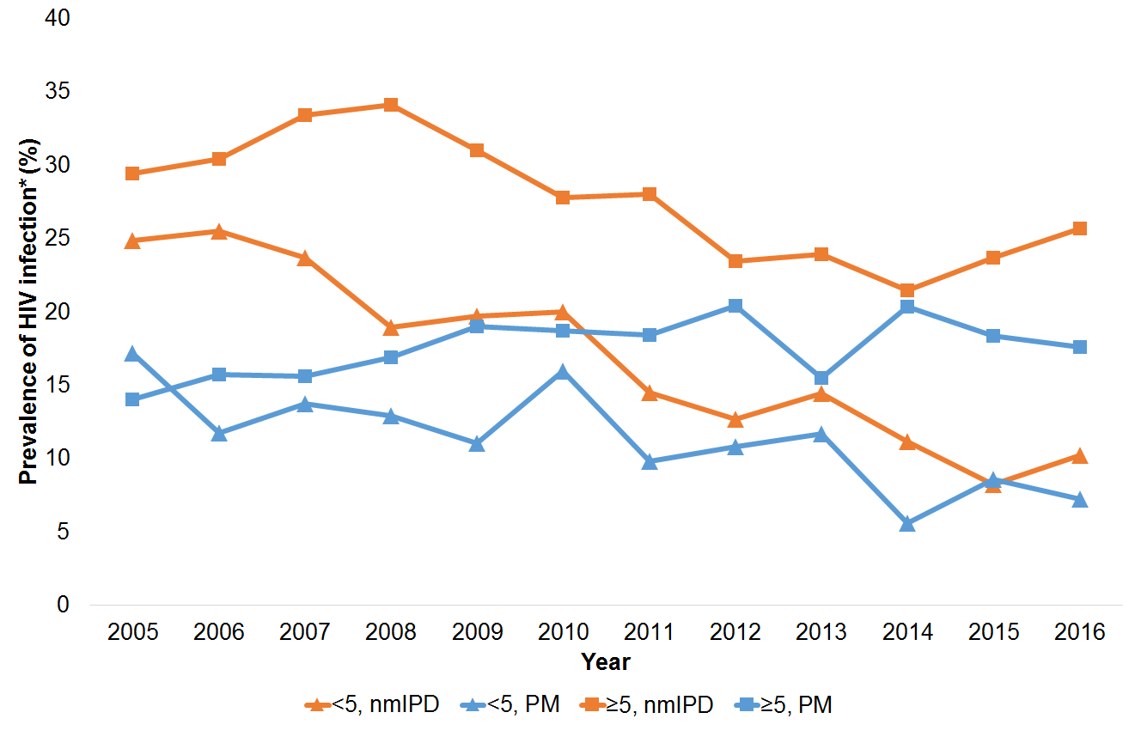
Supplementary Table 5. Comparison of the characteristics of patients with pneumococcal meninigits (PM) and non-meningitis invasive pneumococcal diease (nmIPD) for the pre-PCV period (2005-2008).
 | PM | nmIPD | Univariate analysis |  | Multivariable analysis
Variable | n/N (%) | n/N (%) | OR (95% CI) | p-value | aOR (95% CI) | p-value
Sex (N=8,773)
Female | 1,151/2,214 (52) | 3,301/6,559 (50) | 1.1 (1.0-1.2) | 0.05 | - | -
Male | 1,063/2,214 (48) | 3,258/6,559 (50) | Reference | - | - | -
Age (N=8,711)
<1 years | 533/2,183 (24) | 1,062/6,528 (16) | 1.6 (1.4-1.9) | <0.01 | 1.5 (1.2-1.9) | <0.01
1-14 years | 476/2,183 (22) | 1,551/6,528 (24) | Reference | - | Reference | -
15-64 years | 1,145/2,183 (53) | 3,690/6,528 (57) | 1.0 (0.9-1.1) | 0.86 | 0.8 (0.7-1.0) | 0.12
>64 years | 29/2,183 (1) | 225/6,528 (3) | 0.4 (0.3-0.6) | <0.01 | 0.5 (0.2-1.4) | 0.19
Province (N=8,853)
Eastern Cape | 135/2,233 (6) | 111/6,620 (2) | 5.2 (3.9-7.0) | <0.01 | 4.5 (2.5-8.0) | <0.01
Free State | 162/2,233 (7) | 386/6,620 (6) | 1.8 (1.4-2.3) | <0.01 | 2.0 (1.4-2.8) | <0.01
Gauteng | 960/2,233 (43) | 3,863/6,620 (58) | 1.1 (0.9-1.3) | 0.40 | 1.6 (1.3-2.1) | <0.01
KwaZulu-Natal | 346/2,233 (16) | 1,027/6,620 (16) | 1.5 (1.2-1.8) | <0.01 | 1.4 (1.0-2.0) | 0.09
Limpopo | 82/2,233 (4) | 60/6,620 (1) | 5.9 (4.1-8.5) | <0.01 | 4.9 (2.3-10.4) | <0.01
Mpumalanga | 155/2,233 (7) | 102/6,620 (2) | 6.6 (4.9-8.7) | <0.01 | 10.8 (6.1-18.9) | <0.01
Northern Cape | 62/2,233 (3) | 83/6,620 (2) | 3.2 (2.2-4.6) | <0.01 | 3.8 (2.0-7.1) | <0.01
North West | 104/2,233 (5) | 9/6,620 (0) | 49.8 (24.8-100.0) | <0.01 | 21.2 (4.0-111.5) | <0.01
Western Cape | 227/2,233 (10) | 979/6,620 (15) | Reference | - | Reference | -
HIV status (N=5,477)
Uninfected | 278/1,224 (23) | 764/4,253 (18) | Reference | - | Reference | -
Infected | 946/1,224 (77) | 3,489/4,253 (82) | 0.7 (0.6-0.9) | <0.01 | 0.7 (0.6-0.9) | <0.01
Serotype groupª (N=6,723)
Non-PCV13 | 523/1,861 (28) | 1,128/4,862 (23) | 1.3 (1.1-1.5) | <0.01 | 1.4 (1.1-1.7) | <0.01
PCV13 | 1,338/1,861 (72) | 3,734/4,862 (77) | Reference | - | Reference | -
Duration of hospital stay (N=7,354)
0 – 5 days | 676/1,767 (38) | 2,422/5,587 (43) | Reference | - | Reference | -
≥6 days | 1,091/1,767 (62) | 3,165/5,587 (57) | 1.2 (1.1-1.4) | <0.01 | 2.4 (1.9-3.0) | <0.01
Pre-disposing conditions^{b} (N=7,384)
Absent | 1,581/1,771 (89) | 4,530/5,613 (81) | Reference | - | Reference | -
Present | 190/1,771 (11) | 1,083/5,613 (19) | 0.5 (0.4-0.6) | <0.01 | 0.4 (0.3-0.6) | <0.01
Smoking (N=8,853)
No | 2,150/2,233 (96) | 6,165/6,620 (93) | Reference | - | - | -
Yes | 83/2,233 (4) | 455/6,620 (7) | 0.5 (0.4-0.7) | <0.01 | - | -
Antibiotic use 24 hours prior to admission (N=5,341)
No | 1,207/1,295 (93) | 3,954/4,046 (98) | Reference | - | Reference | -
Yes | 88/1,295 (7) | 92/4,046 (2) | 3.1 (2.3-4.2) | <0.01 | 2.3 (1.5-3.5) | <0.01
Antibiotic use during admission (N=8,504)
No | 459/2,126 (22) | 1,130/6,378 (18) | Reference | - | - | -
Yes | 1,667/2,126 (78) | 5,248/6,378 (82) | 0.8 (0.7-0.9) | <0.01 | - | -
Outcome of hospitalization (N=7,283)
Discharged | 988/1,767 (56) | 4,250/5,516 (77) | Reference | - | Reference | -
Died | 779/1,767 (44) | 1,266/5,516 (23) | 2.6 (2.4-3.0) | <0.01 | 5.0 (4.0-6.4) | <0.01
OR-odds ratio, 95%CI-95% confidence interval ª Serotype groups classified by 13-valent pneumococcal conjugate vaccine. Non-PCV: all serotypes not in PCV13, compared to serotypes in PCV13-4, 6B, 9V, 14, 18C, 19F, 23F, 1, 3, 5, 7F and 19A. ^{b} Pre-disposing conditions defined as any one or more of the following: burns, chronic lung disease (including asthma, chronic obstructive pulmonary disorder, cystic fibrosis), chronic liver disease, chronic renal disease, cardiac conditions (including valvular disease and heart failure), cerebrovascular accident, stroke, neuromuscular diseases, cerebral palsy, metabolic diseases (including diabetes mellitus), head injury, surgery, cerebrospinal fluid leaks, ventricular shunts, cochlear implants, primary immunodeficiency conditions, complement deficiency, immunosuppression treatment (steroids/chemo/cancer treatment) protein-energy malnutrition, functional or anatomic asplenia (including sickle cell disease), malignancy, organ transplant, chromosomal conditions (including down syndrome), prematurity and aplastic anaemia.

Supplementary Table 6. Comparison of the characteristics of patients with pneumococcal meninigits (PM) and non-meningitis invasive pneumococcal diease (nmIPD) for the post-PCV period (2013-2016).
 | PM | nmIPD | Univariate analysis |  | Multivariable analysis
Variable | n/N (%) | n/N (%) | OR (95% CI) | p-value | aOR (95% CI) | p-value
Sex (N=3,912)
Female | 578/1,145 (51) | 1,373/2,767 (50) | 1.0 (0.9-1.2) | 0.63 | -
Male | 567/1,145 (50) | 1,394/2,767 (50) | Reference | - | - | -
Age (N=3,896)
<1 years | 182/1,139 (16) | 299/2,757 (11) | 2.1 (1.6-2.8) | <0.01 | 1.9 (1.3-2.9) | <0.01
1-14 years | 126/1,139 (11) | 441/2,757 (16) | Reference | - | Reference | -
15-64 years | 812/1,139 (71) | 1,819/2,757 (66) | 1.6 (1.3-1.9) | <0.01 | 1.0 (0.7-1.4) | 0.95
>64 years | 19/1,139 (2) | 198/2,757 (7) | 0.3 (0.2-0.6) | <0.01 | 0.2 (0.1-0.4) | <0.01
Province (N=3,923)
Eastern Cape | 128/1,148 (11) | 107/2,775 (3.9) | 6.5 (4.7-9.2) | <0.01 | 7.7 (4.7-12.5) | <0.01
Free State | 53/1,148 (5) | 115/2,775 (4.1) | 2.5 (1.7-3.7) | <0.01 | 3.0 (1.8-5.0) | <0.01
Gauteng | 432/1,148 (38) | 1,280/2,775 (46.1) | 1.8 (1.4-2.4) | <0.01 | 1.4 (1.0-2.0) | 0.03
KwaZulu-Natal | 164/1,148 (14) | 413/2,775 (14.9) | 2.2 (1.6-2.9) | <0.01 | 1.8 (1.2-2.7) | <0.01
Limpopo | 48/1,148 (4) | 43/2,775 (1.5) | 6.1 (3.8-9.7) | <0.01 | 4.8 (2.3-9.9) | <0.01
Mpumalanga | 80/1,148 (7) | 108/2,775 (3.9) | 4.1 (2.8-5.8) | <0.01 | 2.2 (1.2-3.9) | 0.01
Northern Cape | 47/1,148 (4) | 110/2,775 (4) | 2.3 (1.6-3.5) | <0.01 | 2.3 (1.4-3.9) | <0.01
North West | 99/1,148 (9) | 68/2,775 (3) | 8.0 (5.5-11.6) | <0.01 | 25.1 (11.3-55.9) | <0.01
Western Cape | 97/1,148 (8) | 531/2,775 (19) | Reference | - | Reference | -
HIV status (N=3,000)
Uninfected | 268/888 (30) | 755/2,112 (36) | Reference | - | - | -
Infected | 620/888 (70) | 1,357/2,112 (64) | 1.3 (1.1-1.5) | <0.01 | - | -
Serotype groupª (N=3,168)
Non-PCV13 | 684/927 (74) | 1,429/2,241 (64) | 1.6 (1.3-1.9) | <0.01 | 1.6 (1.3-2.0) | <0.01
PCV13 | 243/927 (26) | 812/2,241 (36) | Reference | - | Reference | -
Duration of hospital stay (N=3,627)
0 – 5 days | 357/1,046 (34) | 1,079/2,581 (42) | Reference | - | Reference | -
≥6 days | 689/1,046 (66) | 1,502/2,581 (58) | 1.4 (1.2-1.6) | <0.01 | 3.2 (2.4-4.2) | <0.01
Pre-disposing conditions^{b} (N=3,856)
Absent | 894/1,100 (81) | 1,785/2,706 (66) | Reference | - | Reference | -
Present | 206/1,100 (19) | 921/2,706 (34) | 0.4 (0.4-0.5) | <0.01 | 0.4 (0.3-0.6) | <0.01
Smoking (N=3,923)
No | 1,045/1,148 (91) | 2,444/2,775 (88) | Reference | - | - | -
Yes | 103/1,148 (9) | 331/2,775 (12) | 0.7 (0.6-0.9) | 0.01 | 0.7 (0.5-1.0) | 0.03
Antibiotic use 24 hours prior to admission (N=2,995)
No | 781/859 (91) | 2,057/2,136 (96) | Reference | - | Reference | -
Yes | 78/859 (9) | 79/2,136 (4) | 2.6 (1.9-3.6) | <0.01 | 2.3 (1.6-3.5) | <0.01
Antibiotic use during admission (N=3,557)
No | 51/1,027 (5) | 226/2,530 (9) | Reference | - | Reference | -
Yes | 976/1,027 (95) | 2,304/2,530 (91) | 1.9 (1.4-2.5) | <0.01 | 1.7 (1.0-2.7) | 0.03
PCV status (N=3,328)
Not vaccinated | 791/949 (83) | 1,967/2,379 (83) | Reference | - | - | -
Partial for age | 115/949 (12) | 371/2,379 (16) | 0.8 (0.6-1.0) | 0.02 | - | -
Complete for age | 43/949 (5) | 41/2,379 (2) | 2.6 (1.7-4.0) | <0.01 | - | -
Outcome of hospitalization (N=3,676)
Discharged | 594/1,044 (57) | 1,886/2,561 (74) | Reference | - | Reference | -
Died | 450/1,044 (43) | 675/2,561 (26) | 2.1 (1.8-2.5) | <0.01 | 4.3 (3.2-5.6) | <0.01
OR-odds ratio, 95%CI-95% confidence interval ª Serotype groups classified by 13-valent pneumococcal conjugate vaccine. Non-PCV: all serotypes not in PCV13, compared to serotypes in PCV13-4, 6B, 9V, 14, 18C, 19F, 23F, 1, 3, 5, 7F and 19A. ^{b} Pre-disposing conditions defined as any one or more of the following: burns, chronic lung disease (including asthma, chronic obstructive pulmonary disorder, cystic fibrosis), chronic liver disease, chronic renal disease, cardiac conditions (including valvular disease and heart failure), cerebrovascular accident, stroke, neuromuscular diseases, cerebral palsy, metabolic diseases (including diabetes mellitus), head injury, surgery, cerebrospinal fluid leaks, ventricular shunts, cochlear implants, primary immunodeficiency conditions, complement deficiency, immunosuppression treatment (steroids/chemo/cancer treatment) protein-energy malnutrition, functional or anatomic asplenia (including sickle cell disease), malignancy, organ transplant, chromosomal conditions (including down syndrome), prematurity and aplastic anaemia.

List of GERMS-SA collaborators 2005-2016
Adhil Maharj, Adrian Brink (Ampath laboratories), Adrian Duse, Alan Karstaedt, Ananta Nanoo, Andre Moller (Free State), Andrew Rampe (North West), Andrew Whitelaw (Western cape), Andries Dreyer, Angela Ahlquist, Angeliki Messina, Anne Schuchat, Anne von Gottberg, Anne-Marie Pretorius (Free State), Anthony Smith, Anwar Hoosen, Arvinda Sooka, Asmeeta Burra, Babatyi Kgokong, Barry Spies (Mpumalanga), Ben Prinsloo (LANCET laboratories), Bhavani Poonsamy, Bonnie Maloba, Brian Eley, Carel Haumann, Caroline Maluleka, Catherine Samuel, Cecilia Miller, Charl Verwey, Charles Feldman, Charles Mutanda, Charlotte Sriruttan, Cheryl Cohen, Chetna Govind, Chikwe Ihekweazu, Chris van Beneden, Claire Heney (Lancet laboratories), Claire von Mollendorf, Collleen Bamford, Cynthia Whitney (CDC), Dania Perez (Eastern Cape), Danie Cilliers (North West), David Moore, David Spencer, Deliwe Nkosi (NICD), Dena van den Bergh, Desiree du Plessis (NICD), Dhamiran Naidoo, Dominique Goedhals, Donald Ngwira, Ebrahim Variava, Eduard Silberbauer (North West), Elizabeth Prentice, Elizabeth Wasserman (Western Cape), Elizabeth Zell, Erika Britz, Erna du Plessis (North West), Eugene Elliot (Free state), Eunice Weenink (Northern cape), Fathima Naby, Frans Radebe, Fred Angulo (CDC), Gary Reubenson, Genevie Ntshoe, Gerhard Weldhagen, Gillian Hunt, Greta Hoyland, Halima Dawood (KwaZulu Natal), Heather Finalyson, Heidi Orth, Helena Rabie, Hlengani Mathema, Hluphi Mpangane, Inge Zietsman, Jabulani Ncayiyana (NICD), Jacob Lebudi (Mpumalanga), James Nuttal, Jaunita Smit (Lancet laboratories), Jay Patel, Jaymati Patel, Jeannette Wadula (Gauteng), Jeffrey Ramalivhana, Jennifer Coetzee (AMPATH), Jennifer Verani (CDC), Jeremy Nel, John Black, John Frean, Joy Ebonwu, Juanita Smit, Justyna Wojno, Kamal Baba, Kamaldeen Baba, Karen Keddy, Karin Swart (Netcare), Katherine Robinson (CDC), Kathy Lindeque, Keith Klugman (Emory), Ken Hamese (Limpopo), Keith Bauer, Kerrigan McCarthy (NICD), Keshree Pillay (LANCET), Kessendri Reddy, Khatija Ahmed, Khatija Dawood, Khine Sweswe, Koleka Mlisana, Kureshnee Pillay, Languta Sibiya, Leigh Dini (SMI), Linda de Gouveia, Linda Erasmus, Linda Meyer, Linda Wende (Free State), Lino Sono (North west), Lisha Sookan, Louis Marcus, Louise Cooke, Lynne Liebowitz, Madeleine Pieters (Free State), Maomokgethi Moshe, Maphoshane Nchabeleng, Maria Botha, Mark Cruz da Silva (AMPATH laboratories), Mark Nicol, Marshagne Smith, Martha Bodiba, Martha Makgoba, Marthinus Senekal (PathCare), Mbhekiseni Khumalo, Melony Fortuin-de Smidt, Mike Dove, Mireille Cheyip, Mirriam Selekisho, Mmakgomo Rakhudu, Moherndran Archary, Mohlamme John Mathabathe, Motshabi Modise, Nancy Rosentein-Messonier, Nazir Ismail, Nazlee Samodien, Nelesh Govender, Neo Legare, Nevashan Govender, Ngoaka Sibiya (Limpopo), Nicola Page, Nicolette du Plessis, Nireshni Naidoo, Nolan Janse van Rensburg, Nomonde Dlamini, Norma Bosman, Ntsieni Ramalwa, Nuraan Paulse, Olga Perovic, Oliver Murangandi, Patricia Hanise, Penny Crowther-Gibson, Peter Smith, Phumeza Vazi, Pieter Ekermans, Pieter Jooste (Northern Cape), Portia Mutevedzi, Praksha Ramjathan, Prasha Mahabeer, Prashini Moodley, Prathna Bhola, Preneshni Naicker (Western Cape), Prudence Ive, Pyu-Pyu Sein, Ramola Naidoo, Ranmini Kularatne, Relebohile Ncha, Rena Hoffmann, Riezaah Abrahams (Northern Cape), Riyadh Manesen, Romola Naidoo, Ruth Mpembe, Ruth Lekalakala, Ruth Mpembe, Samantha Iyaloo, Sandeep Vasaikar (Eastern Cape), Sarona Lengana, Shabir Madhi, Shareef Abrahams (Western Cape), Sharona Seetharam, Sheeba Varughese, Sibongile Walaza, Sindisiwe Sithole (KwaZulu Natal), Sindiswa Makate (Northern Cape), Siseko Martin (Western Cape), Sonwabo Lindani, Stan Harvey, Stephanie Schrag (CDC), Steve Oliver (Western cape), Sumayya Haffejee, Sumayya Haffejee (Kwa-Zulu Natal), Sunnieboy Njikho, Susan Gould, Susan Meiring, Suzy Budavari (LANCET), Takalani Muditambi (Limpopo), Taskeen Khan, Tendesayi Kufa-Chakezha, Thejane Motladiile, Theunis Avenant, Tom Chiller, Trusha Nana, Trusha Vanmali, Ute Hallbauer (Free state), Vanessa Pearce (Eastern Cape), Vanessa Quan (NICD), Veerle Msimang, Verushka Chetty (NICD), Vicky Kleinhans (Free State), Victor Fernandez, Vindana Chibabhai (Gauteng), Vivek Bhat (Eastern Cape), Vusi Nokeri (NICD), Warren Lowman (Vermaak and Vennote), Wim Sturm, Xoliswa Poswa (Ampath laboratories), Yacoob Coovadia (Kwa-Zulu Natal) and Yesho Mahabeer.

