**Figure S1.** Elimination of BDE28 with residence time (1.5 years) in Australia for the single subject selected for half-life determination. Red dots show actual measured concentration and blue lines show median concentration and 2.5th and 97.5th percentiles of concentration estimates from 10,000 iterations (see Materials and methods for underlying assumptions). Green lines show median and 2.5th and 97.5th percentiles of the Australian subjects.

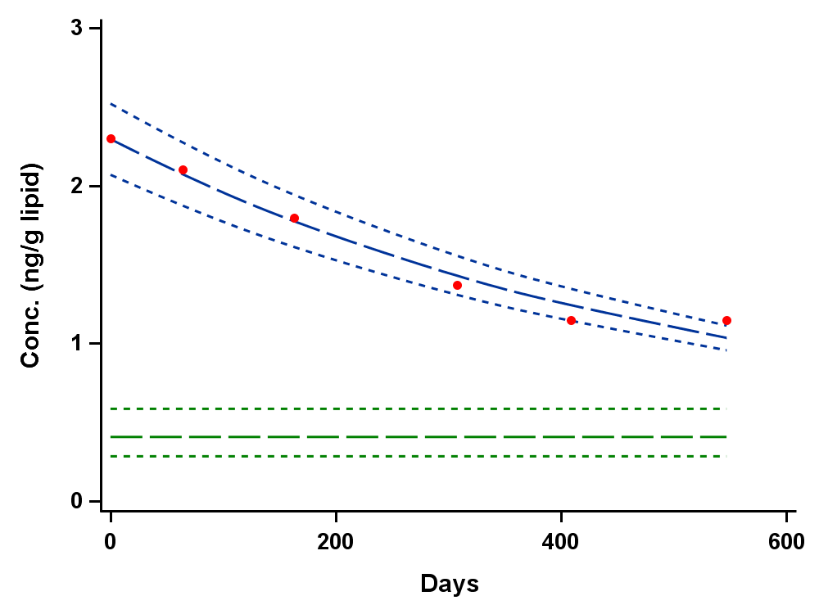

**Figure S2.** Elimination of BDE99 with residence time (1.5 years) in Australia for the single subject selected for half-life determination. Red dots show actual measured concentration and blue lines show median concentration and 2.5th and 97.5th percentiles of concentration estimates from 10,000 iterations (see Materials and methods for underlying assumptions). Green lines show median and 2.5th and 97.5th percentiles of the Australian subjects.

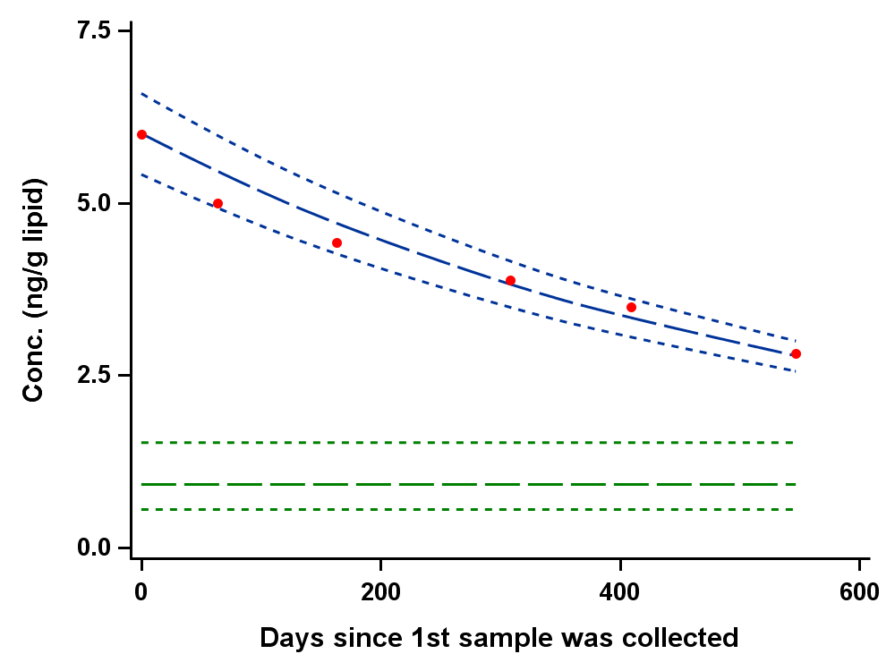

**Figure S3.** Elimination of BDE100 with residence time (1.5 years) in Australia for the single subject selected for half-life determination. Red dots show actual measured concentration and blue lines show median concentration and 2.5th and 97.5th percentiles of concentration estimates from 10,000 iterations (see Materials and methods for underlying assumptions). Green lines show median and 2.5th and 97.5th percentiles of the Australian subjects.

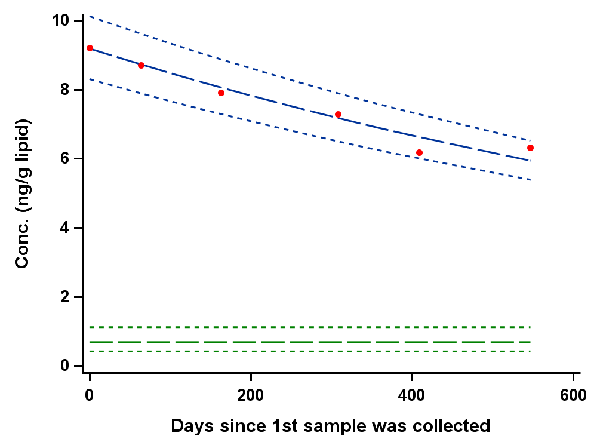

**Figure S4.** Elimination of BDE153 with residence time (1.5 years) in Australia for the single subject selected for half-life determination. Red dots show actual measured concentration and blue lines show median concentration and 2.5th and 97.5th percentiles of concentration estimates from 10,000 iterations (see Materials and methods for underlying assumptions). Green lines show median and 2.5th and 97.5th percentiles of the Australian subjects.

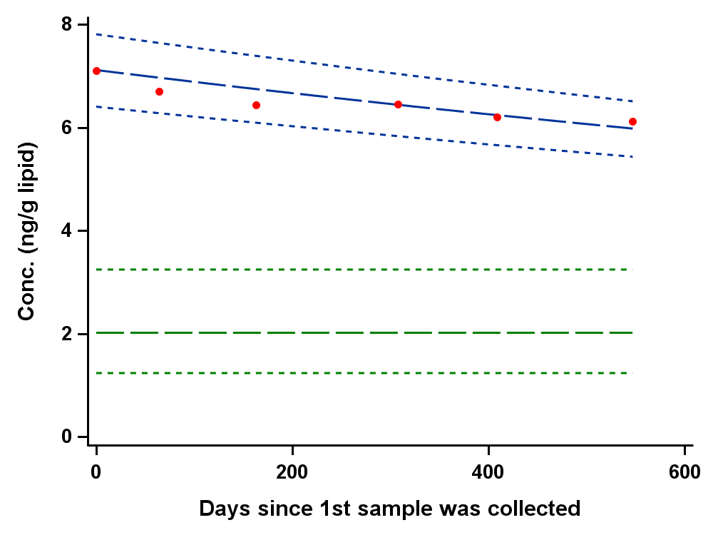

**Figure S5.** Regression of predicted vs. measured serum concentration for BDE28 in samples collected 100 days after entering Australia, excluding subject used for deriving half-life estimate. Data below the limit of detection has been excluded.

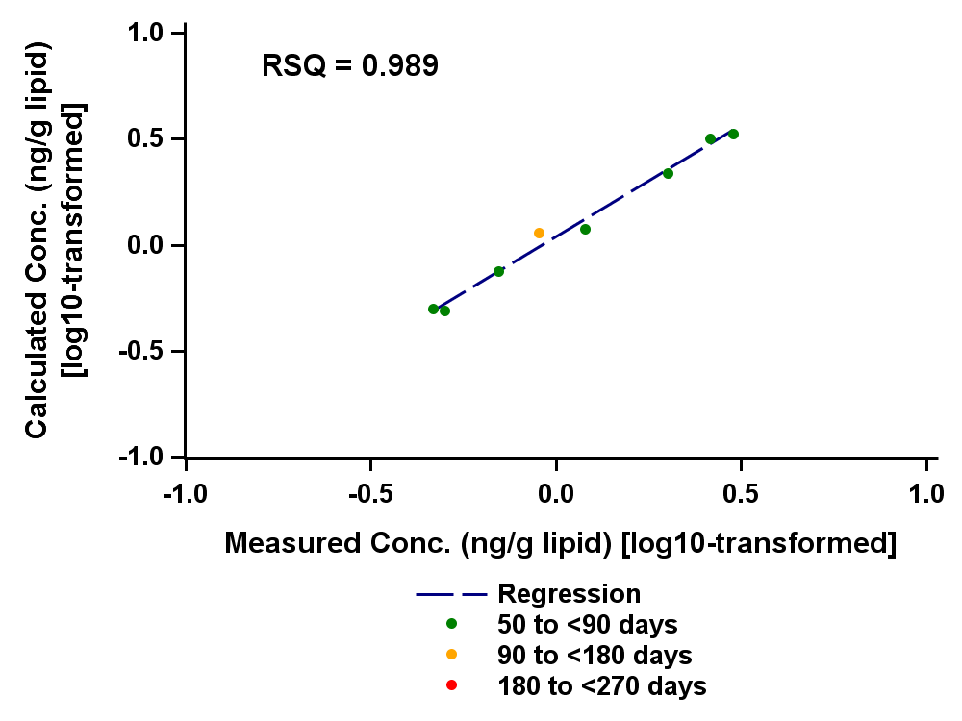

**Figure S6.** Regression of predicted vs. measured serum concentration for BDE47 in samples collected 100 days after entering Australia, excluding subject used for deriving half-life estimate. Data below the limit of detection has been excluded.

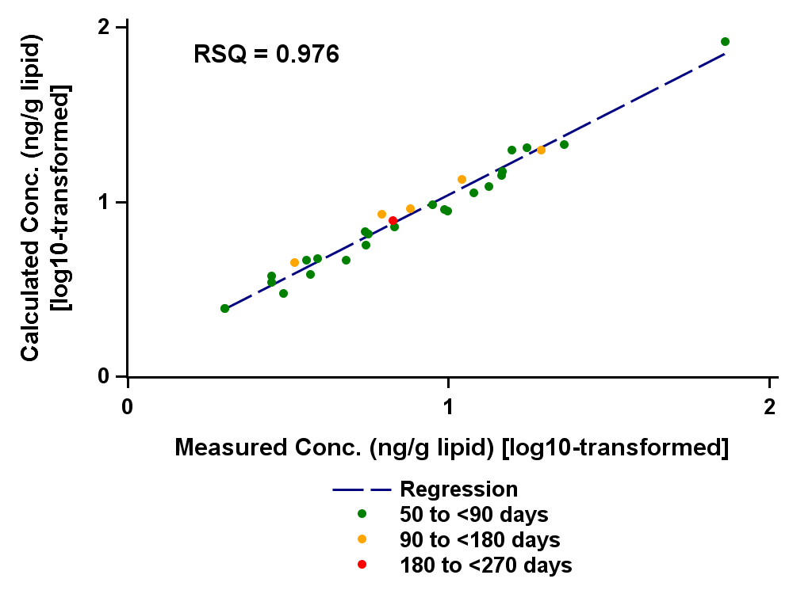

**Figure S7.** Regression of predicted vs. measured serum concentration for BDE99 in samples collected 100 days after entering Australia, excluding subject used for deriving half-life estimate. Data below the limit of detection has been excluded.

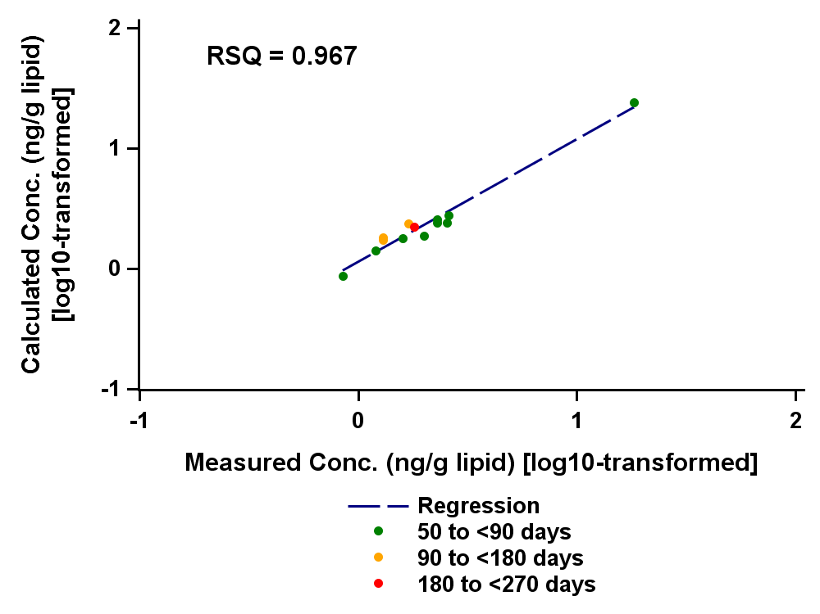

**Figure S8.** Regression of predicted vs. measured serum concentration for BDE100 in samples collected 100 days after entering Australia, excluding subject used for deriving half-life estimate. Data below the limit of detection has been excluded.

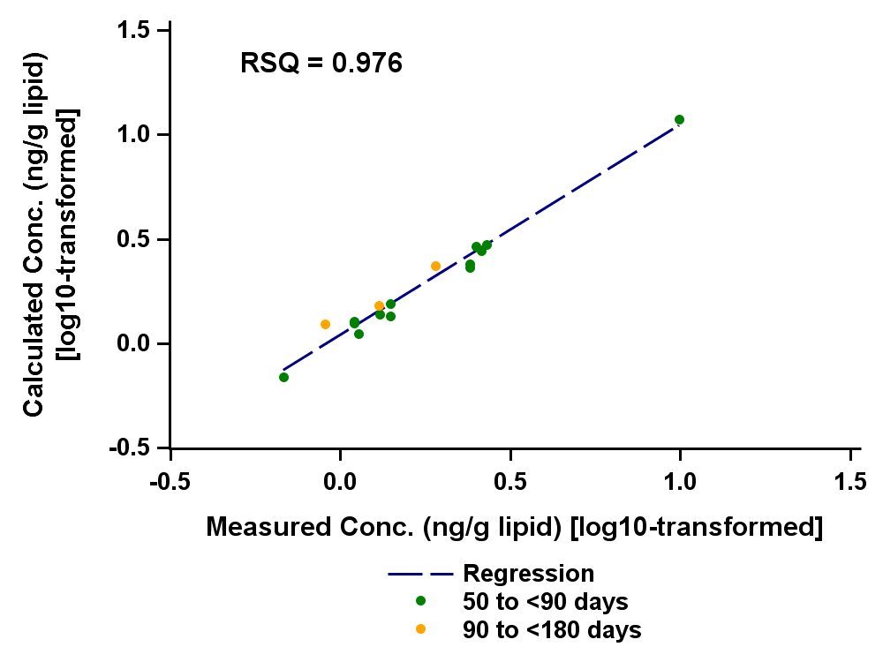

**Figure S9.** Regression of predicted vs. measured serum concentration for BDE153 in samples collected 100 days after entering Australia, excluding subject used for deriving half-life estimate. Data below the limit of detection has been excluded.

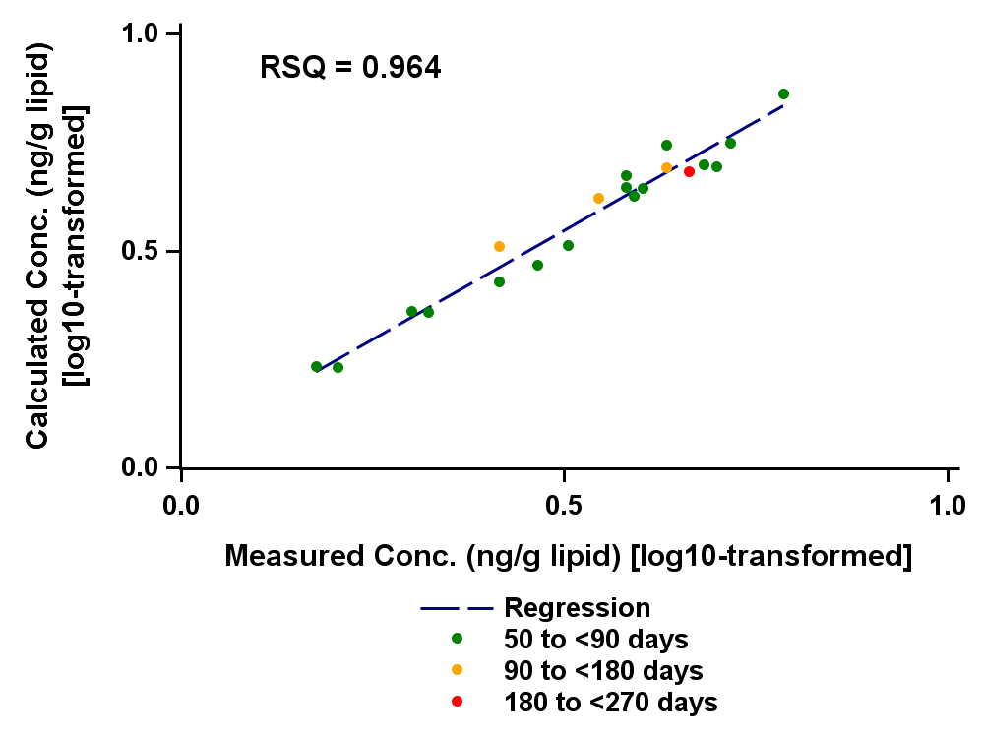

**Table S1.** CV of quality control samples, 13C-internal standard recovery and limit of detection for measured PBDE congeners.





**Table S3.** Intra class correlation coefficient (ICC) and change in PBDE concentration by year for Australian residents calculated from a simple linear random effect mixed model where subject is a random effect and time by year is a fixed effect independent variable.



**References**

1. U.S. Environmental Protection Agency: Washington, D., Jun 22, 2017 Polybrominated Diphenyl Ethers (PBDEs) , Assessing and Managing Chemicals under TSCA. <https://www.epa.gov/assessing-and-managing-chemicals-under-tsca/polybrominated-diphenyl-ethers-pbdes> (Accessed: October 18, 2018),

2. Viberg, H.; Fredriksson, A. *et al.* Neurobehavioral derangements in adult mice receiving decabrominated diphenyl ether (PBDE 209) during a defined period of neonatal brain development. *Toxicol Sci* **2003,** *76*, 112.

3. Viberg, H.; Fredriksson, A. *et al.* Neonatal exposure to polybrominated diphenyl ether (PBDE 153) disrupts spontaneous behaviour, impairs learning and memory, and decreases hippocampal cholinergic receptors in adult mice. *Toxicol Appl Pharmacol* **2003,** *192*, 95-106.

4. Viberg, H.; Fredriksson, A. *et al.* Neonatal exposure to the brominated flame retardant 2,2',4,4',5-pentabromodiphenyl ether causes altered susceptibility in the cholinergic transmitter system in the adult mouse. *Toxicol Sci 67*, 104.

5. Eriksson, P.; Jakobsson, E. *et al.* Brominated flame retardants: a novel class of developmental neurotoxicants in our environment? *Environ Health Perspect* **2001,** *109*, 903-908.

6. McDonald, T. A. A perspective on the potential health risks of PBDEs. *Chemosphere* **2002,** *46*, 745-755.

7. Harley, K. G.; Chevrier, J. *et al.* Association of prenatal exposure to polybrominated diphenyl ethers and infant birth weight. *Am J Epidemiol* **2011,** *174*, 885-92.

8. Eskenazi, B.; Chevrier, J. *et al.* In utero and childhood polybrominated diphenyl ether (PBDE) exposures and neurodevelopment in the CHAMACOS study. *Environ Health Perspect* **2013,** *121*, 257-62.

9. Adgent, M. A.; Hoffman, K. *et al.* Brominated flame retardants in breast milk and behavioural and cognitive development at 36 months. *Paediatr Perinat Epidemiol* **2014,** *28*, 48-57.

10. Braun, J. M.; Kalkbrenner, A. E. *et al.* Gestational exposure to endocrine-disrupting chemicals and reciprocal social, repetitive, and stereotypic behaviors in 4- and 5-year-old children: the HOME study. *Environ Health Perspect* **2014,** *122*, 513-20.

11. Herbstman, J. B.; Sjodin, A. *et al.* Birth delivery mode modifies the associations between prenatal polychlorinated biphenyl (PCB) and polybrominated diphenyl ether (PBDE) and neonatal thyroid hormone levels. *Environ Health Perspect* **2008,** *116*, 1376-82.

12. Chevrier, J.; Harley, K. G. *et al.* Polybrominated diphenyl ether (PBDE) flame retardants and thyroid hormone during pregnancy. *Environ Health Perspect* **2010,** *118*, 1444-9.

13. Chevrier, J.; Harley, K. G. *et al.* Prenatal exposure to polybrominated diphenyl ether flame retardants and neonatal thyroid-stimulating hormone levels in the CHAMACOS study. *Am J Epidemiol* **2011,** *174*, 1166-74.

14. Vuong, A. M.; Webster, G. M. *et al.* Maternal Polybrominated Diphenyl Ether (PBDE) Exposure and Thyroid Hormones in Maternal and Cord Sera: The HOME Study, Cincinnati, USA. *Environ Health Perspect* **2015,** *123*, 1079-85.

15. Harley, K. G.; Marks, A. R. *et al.* PBDE concentrations in women's serum and fecundability. *Environ Health Perspect* **2010,** *118*, 699-704.

16. Stapleton, H.; Dodder, N. *et al.* Polybrominated diphenyl ethers in house dust and clothes dryer lint. *Environ Sci Technol* **2005,** *39*, 925-931.

17. Sjodin, A.; Papke, O. *et al.* Concentration of polybrominated diphenyl ethers (PBDEs) in household dust from various countries. *Chemosphere* **2008,** *73*, (1 Suppl), S131-6.

18. Schecter, A.; Haffner, D. *et al.* Polybrominated Diphenyl Ethers (PBDEs) and Hexabromocyclodecane (HBCD) in Composite U.S. Food Samples. *Environ Health Perspect* **2010,** *118*, 357-362.

19. Alaee, M.; Arias, P. *et al.* An overview of commercially used brominated flame retardants, their applications, their use patterns in different countries/regions and possible modes of release. *Environ Int* **2003,** *29*, 683-9.

20. Thuresson, K.; Hoglund, P. *et al.* Apparent half-lives of hepta- to decabrominated diphenyl ethers in human serum as determined in occupationally exposed workers. *Environ Health Perspect* **2006,** *114*, 176-81.

21. Geyer, H. J.; Schramm, K.-W. *et al.* Terminal elimination half-lives of the brominated flame retardants TBBPA, HBCD, and lower brominated PBDEs in humans. *Organohalogen Comp* **2002,** *66*, 3820-3825.

22. Wong, F.; Cousins, I. T. *et al.* Bounding uncertainties in intrinsic human elimination half-lives and intake of polybrominated diphenyl ethers in the North American population *Environ Int* **2013,** *59*, 168-174.

23. Sjödin, A.; Jones, R. *et al.* Polybrominated Diphenyl Ethers and Other Persistent Organic Pollutants in Serum Pools from the National Health and Nutrition Examination Survey: 2001−2002. *Environ Sci Technol Letters* **2014,** *1*, 92-96.

24. Toms, L. L.; Sjodin, A. *et al.* Temporal trends in serum polybrominated diphenyl ether concentrations in the Australian population, 2002-2013. *Environ Int* **2018,** *121*, 357-364.

25. Comonwealth of Australia, Department of Health and Ageing, National Industrial Chemicals Notification and Assessment Scheme: Robert Garran Offices, National Circuit, Canberra ACT 2600, 2007; pp 5-6.

26. Sjödin, A.; Jones, R. *et al.* Semiautomated high-throughput extraction and cleanup method for the measurement of polybrominated diphenyl ethers, polybrominated biphenyls, and polychlorinated biphenyls in human serum. *Anal. Chem.* **2004,** *76*, 1921-1927.

27. Jones, R.; Edenfield, E. *et al.* Semi-automated extraction and cleanup method for measuring organic pollutants in human serum. *Organohalogen Comp* **2012,** *74*, 97-97.

28. Russell, M. H.; Waterland, R. L. *et al.* Calculation of chemical elimination half-life from blood with an ongoing exposure source: The example of perfluorooctanoic acid (PFOA). *Chemosphere* **2015,** *129*, 210-216.

29. Harrison, R. L. Introduction to Monte Carlo simulation. *AIP Conf Proc* **2010,** *1204*, 17-21.

30. Toms, L.; Sjödin, A. *et al.* Serum polybrominated diphenyl ether (PBDE) levels are higher in children (2-5 years of age) than in infants and adults. *Environ Health Perspect* **2009,** *117*, 1461-1465.

31. Toms, L.; Guerra, P. *et al.* Brominated flame retardants in the Australian population: 1993-2009. *Chemosphere* **2012,** *89*, 398-403.

32. Sjödin, A.; Wong, L.-Y. *et al.* Serum Concentrations of Polybrominated Diphenyl Ethers (PBDEs) and Polybrominated Biphenyl (PBB) in the United States Population: 2003–2004. *Environ Sci Technol* **2008,** *42*, 1377-1384.

33. Sjödin, A.; Jones, R. S. *et al.* Polybrominated Diphenyl Ethers, Polychlorinated Biphenyls, and Persistent Pesticides in Serum from the National Health and Nutrition Examination Survey: 2003−2008. *Environ Sci Technol* **2014,** *48*, 753-760.

34. Thuresson, K.; Höglund, P. *et al.* Apparent half-lives of hepta- to decabrominated diphenyl ethers in human serum as determined in occupationally exposed workers. *Environmental Health Perspectives* **2006,** *114*, 176-181.

35. Sjödin, A.; Jones, R. S. *et al.* Polybrominated diphenyl ethers and biphenyl in serum: time trend study from the National Health and Nutrition Examination Survey for years 2005/06 through 2013/14. *Environ Sci Technol* **2019,** *53*, 6018-6024.