eFigure 1. Flowchart for development of analytic sample.

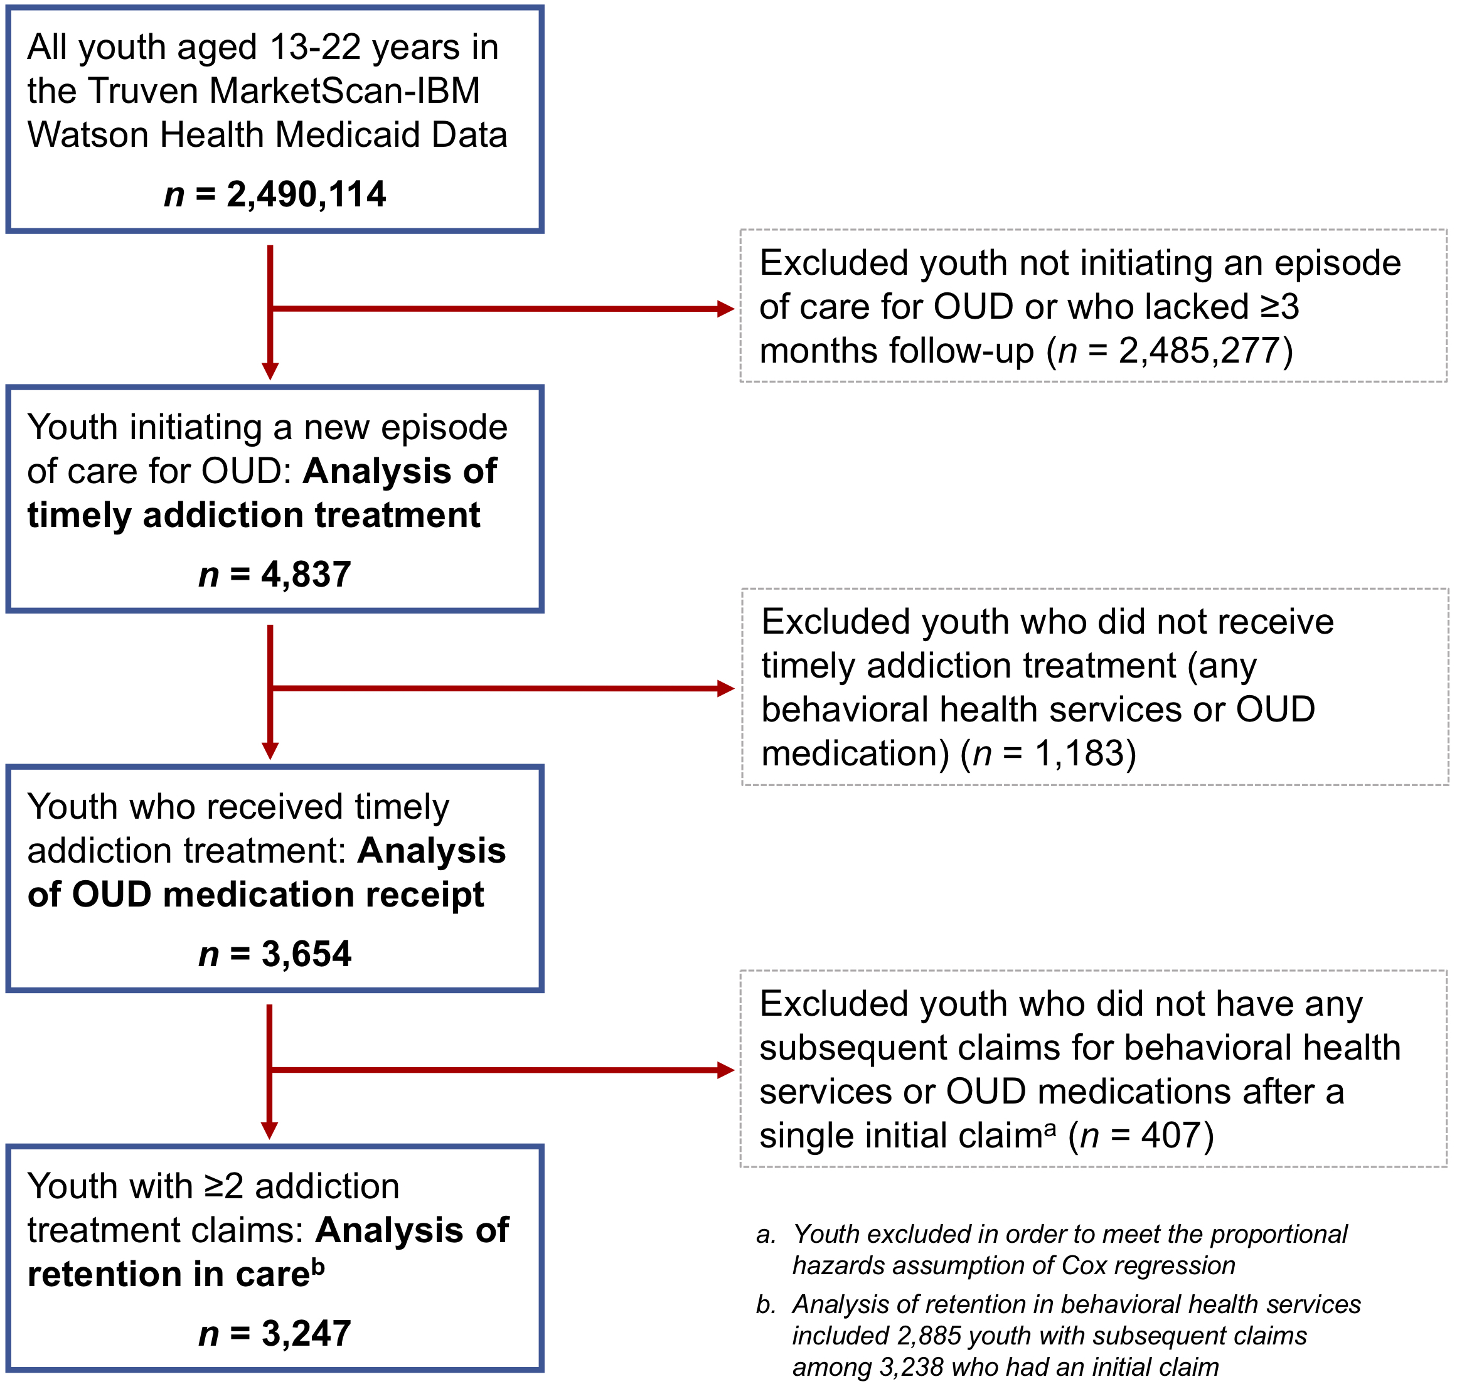

eTable 1. Current Procedural Terminology (CPT) and Healthcare Common Procedure Coding System (HCPCS) codes used to identify utilization.
Service | CPT and HCPCS codes
Behavioral health services (i.e., mental health or substance use disorder treatment)ª | Behavioral health services in any setting:  90791-90792, 90832-90834, 90836-90840, 90853, 90863, 90875-90876, G0396, G0397, H0001, H0002, H0004, H0005, H0007-H0011, H0012, H0013, H0014, H0015, H0016, H0019, H0022, H0031, H0034-H0037, H0039, H0040, H0047, H2000, H2001, H2010-H2020, H2035, H2036, M0064, S0201, S9480, S9484, S9485, T1006, T1012  Among above codes, those indicating detoxification services:  H0008-H0014  Among above codes, those indicating intensive outpatient care:  H0015  Among above codes, those indicating partial hospitalization:  H0035  Among above codes, those indicating residential care:  H0012, H0013, H0017-H0019  Among above codes, those indicating inpatient care:  H0008-H0011
a. Adapted from Harris et al.²⁶

eTable 2. National drug codes used to identify pharmacy claims for OUD medications.
Medication | National Drug Codes
Buprenorphine | 149075701, 12496075701, 12496075705, 54569141600, 54569141601, 54017613, 93537856, 228315603, 378092393, 12496127802, 35356055530, 49999063830, 50383092493, 68308020230, 54017713, 93537956, 228315303, 378092493, 12496131002, 35356055630, 49999063930, 50383093093, 63874117303, 68308020830, 74201201, 74201232, 409201232, 21695051510, 38779088800, 38779088801, 38779088803, 38779088806, 38779088809, 49452129201, 49452129202, 49452129203, 49452825301, 49452825302, 49452825303, 51552076501, 51552076502, 51552076505, 51552076506, 51552076509, 51552076510, 51552076550, 51927101200, 62991158301, 62991158302, 62991158303, 62991158304, 62991158306, 62991158307, 62991158308, 63275992201, 63275992202, 63275992203, 63275992204, 63275992205, 63275992207, 63370090506, 63370090509, 63370090510, 63370090515, 54018813, 93572056, 228315403, 228315473, 406192303, 12496128302, 16590066630, 42291017430, 49999039507, 49999039515, 49999039530, 50383029493, 52959074930, 54569549600, 54868575000, 55700018430, 63629402801, 63874108503, 65162041603, 68071151003, 68258299903, 54018913, 93572156, 228315503, 228315573, 406192403, 12496130602, 35356000407, 35356000430, 42291017530, 43063018407, 43063018430, 50383028793, 52959030430, 54569573900, 54569573901, 54569573902, 54569640800, 54868570700, 54868570701, 54868570702, 54868570703, 54868570704, 55045378403, 63629403401, 63629403402, 63629403403, 63874108403, 65162041503, 66336001630, 68071138003, 40042001001, 42023017901, 42023017905, 55390010010, 35356060704, 59011075004, 35356060504, 54569632500, 59011075104, 35356060604, 54569632600, 59011075204, 12496120201, 12496120203, 12496120801, 12496120803, 54569639900, 55700014730, 12496120401, 12496120403, 12496121201, 12496121203, 54123091430, 54123095730, 59011075804, 59385001201, 59385001230, 59385001401, 59385001430, 59385001601, 59385001630, 59011075704, 54123098630, 54123011430, 54123092930, 63481016101, 63481016160, 63481020701, 63481020760, 63481034801, 63481034860, 63481051901, 63481051960, 63481068501, 63481068560, 63481082001, 63481082060, 63481095201, 63481095260
Naltrexone | 56001122, 56001130, 56001170, 56007950, 56008050, 185003901, 185003930, 406009201, 406009203, 406117001, 406117003, 555090201, 555090202, 16729008101, 16729008110, 42291063230, 43063059115, 47335032683, 47335032688, 50436010501, 51224020630, 51224020650, 51285027501, 51285027502, 52152010502, 52152010504, 52152010530, 54868557400, 65694010003, 65694010010, 68084029111, 68084029121, 68094085362, 68115068030, 49452483501, 51927275300, 51927360200, 51927354800, 63459030042, 65757030001, 65757030202, 38779088703, 38779088704, 38779088705, 38779088706, 38779088708, 49452480801, 49452480802, 49452483502, 51552073701, 51552073702, 51552073704, 51927437700, 52372075101, 52372075102, 52372075103, 55812033301, 55812033302, 55812033303, 63370015810, 63370015815, 63370015825, 63370015835, 63370015845, 60966014404, 60966024403, 60966034402, 62991124301, 62991124302, 62991124303, 62991124304

eTable 3. International Classification of Diseases, 9th Revision (ICD-9) diagnosis codes for medical and psychiatric comorbidity.
Diagnosis | ICD-9-CM diagnosis codes
Pregnancyª | Obtained using Healthcare Cost and Utilization Project Clinical Classifications Software groups 177-196
Depression^{b} | 296.2-296.39, 311, 300.4, 296.9-296.99
Anxiety disorder^{b} | 300-300.3, 300.5-300.9, 309.21, 309.81
ADHD^{b} | 314-314.9
Acute pain condition^{c} | 282.62, 338.11, 338.12, 338.18, 338.19, 522.5, 522.7, 574, 577, 592, 733.1, 800, 801, 802, 803, 804, 805, 806, 807, 808, 809, 810, 811, 812, 813, 814, 815, 816, 817, 818, 819, 820, 821, 822, 823, 824, 825, 826, 827, 828, 829, 830, 831, 832, 833, 834, 835, 836, 837, 838, 839, 840, 841, 842, 843, 844, 845, 846, 847, 848, 850, 851, 852, 853, 854, 860, 861, 862, 863, 864, 865, 866, 867, 868, 869, 870, 871, 872, 873, 874, 875, 876, 877, 878, 879, 880, 881, 882, 883, 884, 885, 886, 887, 890, 891, 892, 893, 894, 895, 896, 897, 900, 901, 902, 903, 904, 910, 911, 912, 913, 914, 915, 916, 917, 918, 919, 920, 921, 922, 923, 924, 925, 926, 927, 928, 929, 930, 931, 932, 933, 934, 935, 936, 937, 938, 939, 940, 941, 942, 943, 944, 945, 946, 947, 948, 949, 950, 951, 952, 953, 954, 955, 956, 957, 958, 959
Chronic pain condition^{c} | 338.21, 338.22, 338.28, 338.29, 338.4, 346.0, 346.1, 346.2, 346.3, 346.4, 346.5, 346.6, 346.7, 346.8, 346.9, 307.81, 710, 711, 712, 713, 714, 715, 716, 717, 718, 719, 720, 721, 722, 723, 724, 725, 726, 727, 728, 729
Alcohol use^{d} | Alcohol withdrawal, intoxication, and abuse:  291.0, 291.3, 291.4, 291.81, 303.0, 305.0  Alcohol dependence:  291.1, 291.2, 291.5, 291.8, 291.82, 291.89, 291.9, 303.9
Other drug use^{d} | Drug withdrawal, intoxication, and abuse:  292.0, 292.1, 292.2, 292.81, 305.2-305.7  Drug dependence:  292.82-292.89, 292.9, 304.1-304.6
- Available from the Agency for Healthcare Research and Quality²⁹
- Adapted from Bardach et al.³⁰
- Adapted from the Centers for Disease Control and Prevention³¹
- Adapted from Pletcher et al.³²

eTable 4. Time to receipt of any treatment (i.e., behavioral health services or OUD medication) or of any OUD medication (buprenorphine, naltrexone, or methadone) after diagnosis: January 1, 2014 to September 30, 2015.
Time After Diagnosis (Months) | Number in Sampleª, N | Received Any Treatment,  N (%) | Received OUD Medication,  N (%)
1 | 5,173 | 3,598 (69.6) | 906 (17.5)
2 | 5,024 | 3,678 (73.2) | 1,071 (21.3)
3 | 4,837 | 3,654 (75.5) | 1,139 (23.5)
6 | 3,764 | 2,981 (79.2) | 1,013 (26.9)
9 | 2,584 | 2,144 (83.0) | 751 (29.1)
12 | 1,663 | 1,417 (85.2) | 509 (30.6)
- Sample limited to youth providing follow-up for all months listed (i.e., youth who were censored are not included)

eTable 5. Characteristics of 1,139 youth who received timely OUD medication according to pharmaceutical receivedª.
Characteristic | Buprenorphine  (n = 936),  N (%) | Naltrexone  (n = 135),  N (%) | Methadone  (n = 68),  N (%) | p Value
Age of diagnosis |  |  |  | <0.001
21-22 years | 549 (83.1) | 61 (9.2) | 51 (7.7)
18-20 years | 365 (82.2) | 62 (14.0) | 17 (3.8)
16-17 years | 22 (73.3) | 8 (26.7) | 0 (0.0)
13-15 years | 0 (0.0) | 4 (100.0) | 0 (0.0)
Sex |  |  |  | 0.019
Male | 332 (80.0) | 63 (15.2) | 20 (4.8)
Female | 604 (83.4) | 72 (9.9) | 48 (6.6)
Race/ethnicity |  |  |  | 0.404
White non-Hispanic | 763 (82.2) | 111 (12.0) | 54 (5.8)
Black non-Hispanic | 28 (77.8) | 3 (8.3) | 5 (13.9)
Hispanic | 9 (90.0) | 0 (0.0) | 1 (10.0)
Other | 136 (82.4) | 21 (12.7) | 8 (4.8)
Medicaid-eligible due to disability |  |  |  | 0.812
No | 18 (90.0) | 1 (5.0) | 1 (5.0)
Yes | 918 (82.0) | 134 (12.0) | 67 (6.0)
Pregnancy^{b} |  |  |  | <0.001
No | 717 (80.6) | 124 (13.9) | 49 (5.5)
Yes | 219 (88.0) | 11 (4.4) | 19 (7.6)
Depression^{b} |  |  |  | <0.001
No | 708 (83.0) | 85 (10.0) | 60 (7.0)
Yes | 228 (79.7) | 50 (17.5) | 8 (2.8)
Anxiety disorder^{b} |  |  |  | 0.005
No | 725 (82.1) | 96 (10.9) | 62 (7.0)
Yes | 211 (82.4) | 39 (15.2) | 6 (2.3)
Attention deficit hyperactivity disorder^{b} |  |  |  | 0.013
No | 874 (82.8) | 117 (11.1) | 65 (6.2)
Yes | 62 (74.7) | 18 (21.7) | 3 (3.6)
Alcohol use disorder^{b} |  |  |  | 0.168
No | 876 (82.5) | 121 (11.4) | 65 (6.1)
Yes | 60 (77.9) | 14 (18.2) | 3 (3.9)
Other substance use disorder^{b} |  |  |  | 0.142
No | 582 (83.7) | 72 (10.4) | 41 (5.9)
Yes | 354 (79.7) | 63 (14.2) | 27 (6.1)
Acute pain condition^{b} |  |  |  | 0.031
No | 660 (80.5) | 103 (12.6) | 57 (7.0)
Yes | 276 (86.5) | 32 (10.0) | 11 (3.4)
Chronic pain condition^{b} |  |  |  | 0.023
No | 644 (80.5) | 99 (12.4) | 57 (7.1)
Yes | 292 (86.1) | 36 (10.6) | 11 (3.2)
- Youth who received multiple medications during the first 3 months following diagnosis are classified according to the first medication they received
- At or during the 90 days prior to receiving diagnosis of OUD

