SUPPLEMENTAL INFORMATION

In vitro intestinal toxicity of commercially available spray disinfectant products advertised to contain colloidal silver

Kim R. Rogers^{1*}, Taylor E. Henson², Jana Navratilova¹, Mark Surette¹, Michael F. Hughes²,
Karen D. Bradham¹, Aleksandr B. Stefaniak³, Alycia K. Knepp³ and Lauren Bowers³

¹Watershed and Ecosystem Characterization Division, Center for Environmental Measurement and Modeling, USEPA, RTP, NC 27711
²Methods and Characterization Division, Center for Environmental Measurement and Modeling, USEPA, RTP, NC 27711
³National Institute for Occupational Safety and Health, Morgantown, WV

*Corresponding author: 109 T.W. Alexander Drive, U.S. EPA, Research Triangle Park, NC 27711, United States, Telephone: +1-919-541-3086; Email: rogers.kim@epa.gov

Table S-1. Characteristics of Colloidal Silver Product Suspensions
____________________________________________________________
Product pH Cl⁻ (ppm) S (ppm)
____________________________________________________________
1 6.6 BDL 27.9
2 7.9 39.8 40.4
3 10.6 25.1 BDL
4 10.0 25.3 BDL
5 2.5 10.6 9.8
____________________________________________________________
BDL Below Detection Limit

Table S-2. Estimated Total Ag Doses from Recommended Product Use

Product Product Application Total Measured Ag Recommended Dose Dose/Day (External, Internal) (mg/L) (mL) (ug Ag)
___________________________________________________________________________________
1 Internal 18.9 0.4 7.6
2 Both 961 1 961
3 External 6.0 Light Spray ND
4 External 6.1 Light Spray ND
5 External 8.7 Hard Surface Spray ND
___________________________________________________________________________________
ND Not Determined
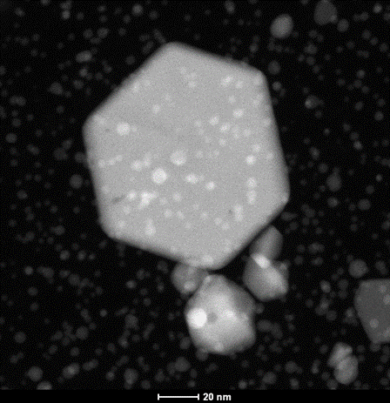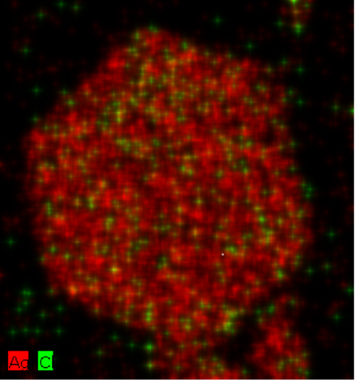
A

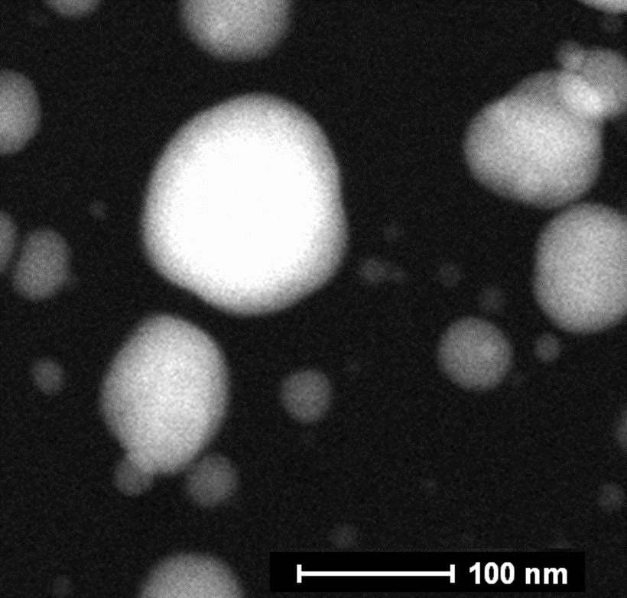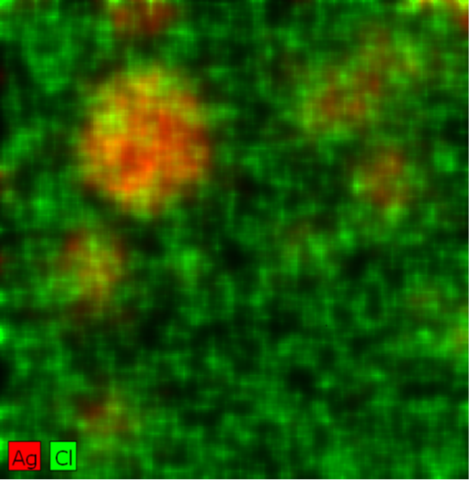

B

Figure S-1 TEM Images and EDS False Color Images. Product 2 (A) without exposure to SSF or (B) with exposure to SSF. Red represents Ag, green represents Cl.

