**Supplementary Figure 1**

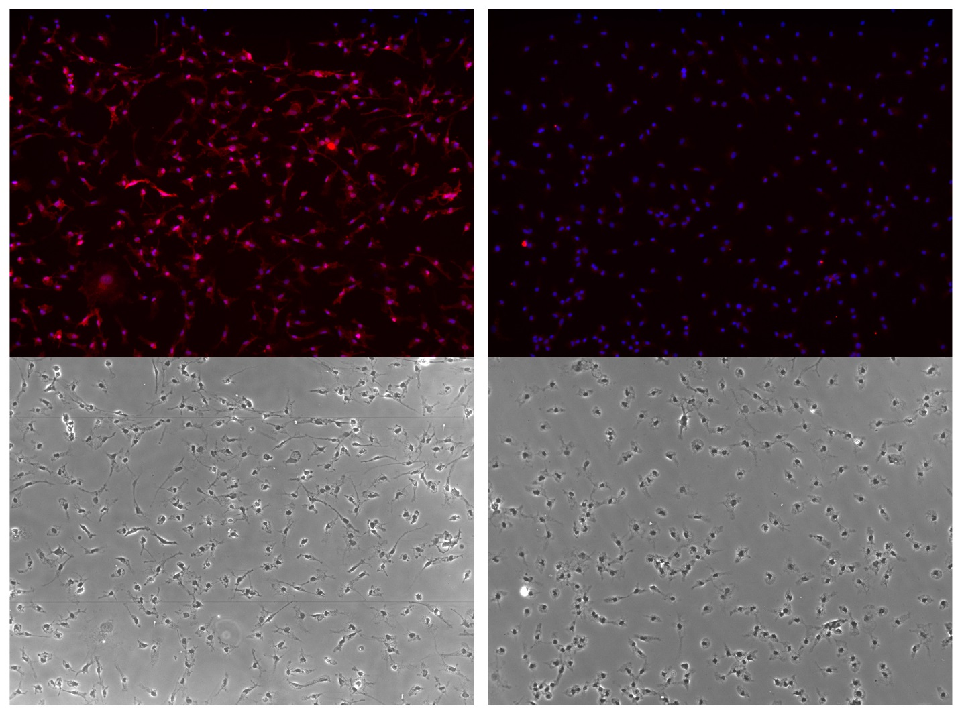

**Supplementary Figure S2**

**Supplementary Figure S3**

