Supporting Information

Automated and dynamic control of chemical content in droplets for scalable screens of small animals

Guillaume Aubry, Marija Milisavljevic, and Hang Lu*

File Name: Supporting Information
Description: Supporting Figures and Notes

File Name: Movie S1
Description: Automated single-animal encapsulation. Red rectangle indicates the ROI used for detecting the animal. Movie’s speed is in real-time.

File Name: Movie S2
Description: Liquid exchange with an adult animal in the droplet. Video captured using darkfield and fluorescence imaging to visualize both the animal and fluorescence dye demonstrating liquid exchange. Movie’s speed is in real-time.

File Name: Movie S3
Description: Temporal chemical profile in droplet for linear steps down and up. A series of droplets of different concentrations flow through the liquid exchanger creating advanced patterns. Movie’s speed is 6x real-time.

File Name: Movie S4
Description: Operation of the Adder. Part 1: Sequence used to characterize chemical profile shown in SI Fig. 4c. Part 2: Sequence demonstrating the addition of 21 droplets successively. Movie’s speed is 2x real-time.

File Name: Movie S5
Description: Automation for a standard protocol consisting of encapsulation, storing, stimulation, and 60 s long behavior recording. For the first part, movie’s speed is 2x real-time and, for the second part, movie’s speed is 4x real-time.

File Name: Movie S6
Description: Behavioral response of C. elegans adult animal to food cues. Part 1: Alternation of buffer droplets and droplets with bacteria. Part 2: Control experiment using an alternation of buffer droplets only. Dots on the videos mark the droplet exchanges; red is for the bacteria cue, and white is for the buffer solution. Movie’s speed is 4x real-time.

File Name: Movie S7
Description: Monitoring neuronal activity in C. elegans adult animal. Part 1: Assay in bright-field imaging and whole field-of-view. The animal is transferred from a buffer droplet to a 500 mM NaCl solution droplet. Part 2: Fluorescence imaging of ASH sensory neuron. Videos have been processed to track the neuron during the exchange. The first sequence shows ASH response upon exposure to 500 mM NaCl solution. The second sequence is a control assay and shows ASH response to an exchange with an identical buffer solution. Dots on the videos mark the droplet exchange; red is for the 500 NaCl solution, and white is for the buffer solution. Movie’s speed is in real-time.

File Name: Movie S8
Description: Squared temporal chemical profile created in a liquid exchanger scaled down for first larval stage animals. Movie’s speed is 2x real-time.

File Name: Movie S9
Description: Series of liquid exchange with C. elegans first larval stage animal. The same buffer solution is used in this series of exchange to highlight the robustness of the system. Width of the main channel is 180 𝜇m. Movie’s speed is 2x real-time.

File Name: Movie S10
Description: Monitoring neuronal activity in C. elegans first larval stage animal. ASH response upon exposure to 100 mM NaCl solution. Insert shows a zoom-in view of the animal swimming in the droplet and re-centered on ASH neuron. Movie’s speed is in real-time.

SI Note S1: Modulation of physical environment

Understanding how animals adapt to and move through different substrates is of great interest to the neuroscience community and to researchers in robotics.^{[1,2]} C. elegans moves through many different physical environments in its natural habitat, from swimming in liquids to crawling on a solid. Although behavior experiments are frequently performed using animals on agar plates, this limits the conditions and environments that can be used. Here we demonstrate the ability to precisely control the media environment in droplets and elicit behaviors on the spectrum from crawling to swimming. To enable animal crawling in droplets requires increasing the viscosity of the droplet liquid. Using methylcellulose solutions at concentrations between 0 and 2 % (0 cP to 4000 cP), we demonstrated the proper operation of the Adder unit for a wide range of viscous environments and observed that, through these different environments, the animals transition from swimming motion to crawling (Figure S8, Supporting Information). This additional functionality will expand the palette of phenotypes accessible with the droplet platforms, as it is now possible to modulate not only soluble chemical cues, but also the physical environment of animals.

References:
[1] Aguilar, J., et al. A review on locomotion robophysics: the study of movement at the intersection of robotics, soft matter and dynamical systems. Reports on Progress in Physics 79 (2016).
[2] Astley, H.C., et al. Surprising simplicities and syntheses in limbless self-propulsion in sand. Journal of Experimental Biology 223, jeb103564 (2020).

SI Note S2: Guidelines for generalizing the platform to other systems

The different components presented in this work can be scaled up or down to suit other biological organisms. The detailed layouts for all components are provided in Figure S10, Supporting Information, to serve as a guide for design decisions. The Liquid Exchanger is the most complex unit to design because of the multiple geometric features that are essential to its operation. The key principle to successful scaling is to meet the condition on Laplacian pressures at different channel cross-sections (see Figure S2, Supplementary Information). The depth of the main channel should be slightly larger than the characteristic dimension of the biological organism. The cross-section of the restriction channels should be slightly smaller than the smallest characteristic dimension of the biological organism in order to retain the organism inside the storage area. Finally, the cross-section of the bypass channel can be set at twice the cross-section of the restriction channel. This factor of two ensures meeting the requirement on Laplacian pressures while allowing enough working range to operate the system without being too sensitive to pressure fluctuations. Similar reasoning can be applied for the encapsulation unit and the Adder.
Figure S1. Reservoir toggling system for maintaining the animal suspension homogenous.

(a) Set-up: The animal reservoir is attached to a servo motor. The servo motor is controlled via a uC32 Arduino and the LabVIEW GUI used for the rest of the platform. (b) Operation: When the reservoir is in the upright position, animals are injected into the device. With time, animals settle down in the reservoir (state A). Then, the tubing to the device is closed with a pinch valve, and the reservoir is rotated upside-down for 3 s (state B). Finally, the reservoir is turned back in the upright position, maintaining a homogenous animal suspension (state A’). The pinch valve is released, reopening the access to the device.

Figure S2. Liquid Exchanger principle.

(a) Laplacian pressure at the water/oil interface is described as a function of the water/oil interfacial tension ϒ and the curvature radii R₁ and R₂ corresponding to the curvature of the interface at point A. Red represents a horizontal plane. (b) The Liquid Exchanger design relies on the modulation of Laplacian pressure at the water/oil interfaces in the bypass and restriction channels. The schematic illustrates a situation where two droplets merge, and the oil phase cannot flow through the bypass. The different geometries of the bypass channels and restriction channels create different energetic barriers: the smaller cross-section corresponds to a higher energetic barrier. Because we set the bypass cross-section smaller than the restriction channel cross-section, the droplet flow through the restriction channels. (c) Temporal variation of the pressure at the rear of the droplet trapped in the chamber during the different operation phases. P_{bypass} is the threshold pressure for which the droplet may flow through the bypass channels, and P_{restriction} is the threshold pressure for which the droplet may flow through the restriction channels.

Figure S3. Characterization of the Liquid Exchanger unit.

(a) Design parameters tested to optimize the device operation speed: the number of restriction channels N_{restriction_channels} and the number of bypass channels N_{bypass_channels}. To scan a large range of numbers of restriction channels, a single-arm bypass configuration (top) and a double-arm bypass configuration (bottom) were implemented. (b) Phase diagram of the operation range of Liquid Exchanger unit when varying the number of restriction channels (single-arm bypass configuration, N_{bypass channels} = 12). (c) Maximal operation speed when varying the number of bypass channels (N_{restriction_channels} = 9). (d) Maximal operation speed using silicone oils of different viscosities.

Figure S4. The Adder allows for creating mixtures in-situ, storing droplets, and stimulating animals.

(a) Merging droplets performs the addition of droplet contents. (b) Layout of the chamber. Droplets flowing to the chamber get trapped and merge with the droplet already present in the chamber. The chamber volume is ~600 nL; a droplet large enough to encapsulate an adult animal represents half the storing capacity. The remaining space allows for flexibility in creating different chemical profiles by adding one or multiple stimulants over time. The sensitivity is determined by the smallest droplet volume accessible, set by the channel’s physical dimension (trapping rail): 30 nL. The yellow arrows represent the oil flow deflected around the chamber. The blue ellipsoids represent a growing droplet trapped in the chamber. (c) Demonstration of multiple sequential droplet additions and precise mixture preparation in a dilution scheme.

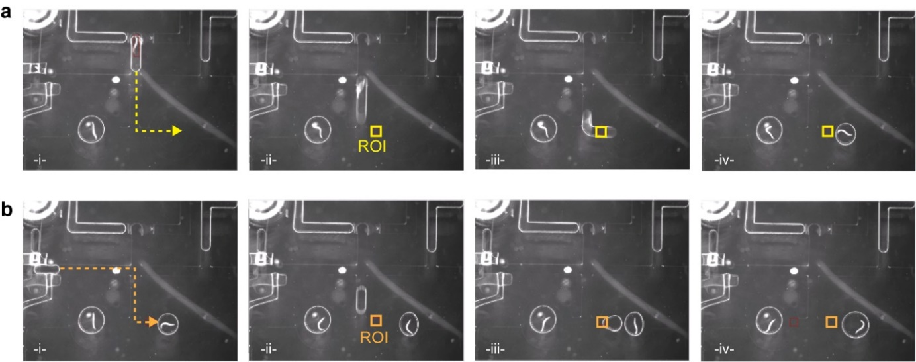

Figure S5. Droplet transport control in the microchannel network. Selective opening of on-chip valves determines the desired flow path, and real-time image processing is used to determine when an action is complete.

(a) Example of a droplet containing an animal flowing to the right storage chamber. (b) Example of a reagent droplet delivering a stimulus to the animal stored in the right chamber. In both cases, the droplet arrival in the chamber is detected by monitoring the standard deviation of the pixel intensities inside the ROI and triggers stopping the oil flow.

Figure S6. Graphic User Interface in LabVIEW.

The interface is composed of a central panel displaying the camera view and a selective menu that allows switching from manual control of the pressure source (1) to the automated mode of operation of the platform (2), connection parameters that index the pressure outlets to reservoirs and on-chip valves (3), schematic view of the microfluidic systems with labels of inlets and outlets (4), and a set of parameters for the camera, servo motor, and data saving (5). A demonstration of the automation mode can be viewed in Movie S5.

Figure S7. Programming of complex multistep protocols.

(a) Flowpath is determined by the open/close status of on-chip valves, i.e., the open/close states of pressure source outlets. The states of the pressure source outlets corresponding to the different protocol steps are binary encoded in an excel sheet (“1” for pressure On and “0” for pressure Off). The last row encodes either for the duration of the state or a cue referring to an ROI-triggered event. (b) The protocol is then loaded in the LabVIEW GUI. Each step is executed sequentially, sending the pressure command to the pressure sources and waiting for a given duration or ROI-triggered event before moving to the next step. (c) Left: Illustration of several flow paths executed for a routine to encapsulate, load, and stimulate animals for a single chamber system (corresponding to the program shown in (a)). Right: Full map of flow paths corresponding to the same device on the right and using the two chambers for assaying animals as well as sorting capability. This map shows the complete flowpath of the protocol used for the mock forward genetic screen experiment (see Figure 5).

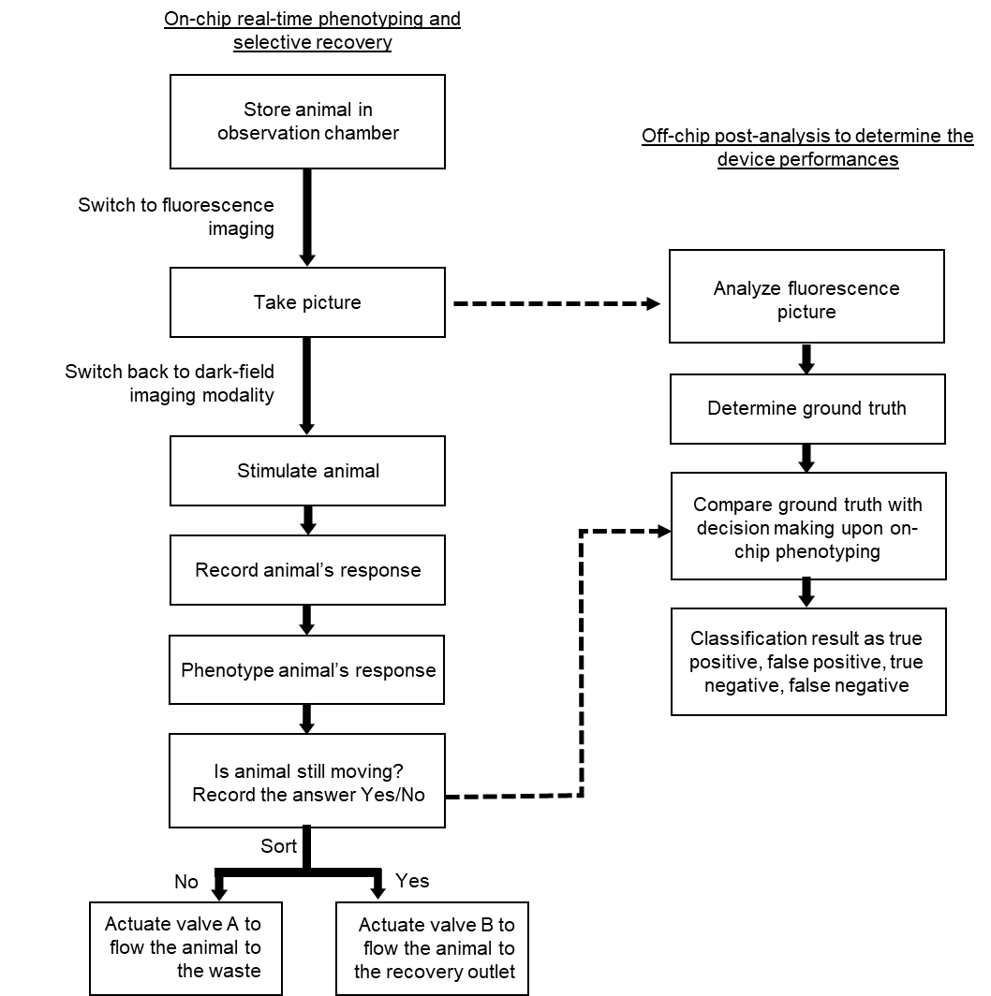

Figure S8. Flow chart of the operation protocol used for the mock forward genetic screen.

Figure S9. Thrashing behavior in various viscous environments.

(a) Thrashing activity quantified for methylcellulose solution from 0 % to 2 %. The animals slow down with increasing viscous forces (n = 10 per condition, error bars are SEM). (b) Time-lapse sequences of an animal in a buffer droplet (top row) and an animal in a 2 % methylcellulose solution (bottom row). The animal body’s C-curve shape and S-curve shape indicate a change from swimming to crawling-like motion and an adaptation of the animal to the physical environment. Scale bar is 500 µm.

Figure S10. Scaled layouts of (a-d) the main microfluidic components and (e) one example of device integration.

The red dashed lines in (a-d) indicate a change of channel height. (e) On-chip valves are represented in purple. The other colors indicate the main microfluidic channel network, and different colors represent different channel heights. The areas in blue correspond to the channels with rounded cross-sections. Scale bars are 1 mm (a-c), 200 um (d), and 3 mm (e).

